|  |  |
| --- | --- |
| **Council 2021 Virtual consultation of councillors, 8-18 June 2021** |  |
|  |  |
|  |  |
| **Agenda item: ADM 4** | **Addendum 1 to Document C21/50-E** |
| **4 June 2021** |
| **Original: English** |
| Report by the Chairperson of the  Council Working Group on Financial and Human Resources (CWG-FHR) | |
|  | |

|  |
| --- |
| **Summary**  This document presents a report on the deliberations of the virtual meeting of the CWG-FHR, which was held on 3 June 2021.  **Action required**  Councillors are invited **to take note** of the work of the CWG-FHR and also to **consider** and **offer views**, as appropriate, on the actions identified in the report.  CWG-FHR recommends that the ITU secretariat create a dashboard to enable systematic monitoring of the implementation of the approved PWC’s recommendations and report to CWG-FHR and Council on its progress (including the status of all PWC recommendations).  ____________  **References**  [*C20/50*](http://www.itu.int/md/S20-CL-C-0050/en) *and* [*Council Decision 563*](https://www.itu.int/md/S19-CL-C-0142/en) |

***Annexes:*** *2*

# Introduction

1.1 Council Decision 616, adopted at the ninth Plenary Meeting of Council 2019, instructed the Secretary-General to recruit and hire an independent external management consultancy to perform a comprehensive programmatic, strategic, and financial assessment and review of ITU’s regional presence programme in accordance with the terms of reference set forth in the Annex, taking into consideration contributions from the ITU membership, and submit a report with recommendations to the 2021 session of the Council for action. In its decision, the Council provided detailed Terms of Reference for guidance of the consultancy.

1.2 Following a competitive bidding process, PWC was selected to perform this independent study. PWC conducted its work and its final report was delivered to the secretariat in July 2020.

1.3 The PWC report was presented to the Second Virtual Consultation of Council (VCC2) in November 2020 in [Document C20/74](https://www.itu.int/md/S20-CL-C-0074/en), together with a Secretariat Note on the PWC Report providing initial view on PWC’s report and the recommendations made ([Document C20/75](https://www.itu.int/md/S20-CL-C-0075/en)).

1.4 Council referred the consideration of the PWC review to CWG-FHR.

1.5 At its meeting on 26 January 2021 (see Document [CWG-FHR-12/17](https://www.itu.int/md/S21-CWGFHR12-C-0017/en)), CWG-FHR decided to convene an Ad Hoc Group to review and analyse the recommendations of the PWC Report presented by the Secretary-General in Document C20/74, taking into account proposals of the ITU Member States and the comments of the secretariat, to analyse the possible financial implications of various options for optimizing the structure of the ITU regional presence, and to prepare and submit recommendations to the next CWG-FHR.

1.6 Ms. Stella Erebor of Nigeria was appointed as Chairwoman of the Ad Hoc Group, with the six (6) Vice Chairs of CWG-FHR as Vice-Chairs of the Ad Hoc Group. Participation in the Group is open to all Members States and Sector Members. The Terms of Reference of the Ad Hoc Group are contained in document [CWG-FHR-AH-RegPres-1/3](https://www.itu.int/md/S21-AHGFHR1-C-0003/en).

# Deliberations of the Ad Hoc Group

First Meeting

2.1 The first meeting of the Ad Hoc Group was convened on 23 March 2021 and considered the following contributions:

1. Contribution by the Russian Federation on the assessment of the possible financial implications of various options for optimizing the structure of the ITU regional presence by PWC, contained in Document [CWG-FHR-AH-RegPres-1/2](https://www.itu.int/md/S21-AHGFHR1-C-0002/en);
2. Contribution by Egypt on ITU Regional Presence [CWG-FHR-AH-RegPres-1/5](https://www.itu.int/md/S21-AHGFHR1-C-0005/en);
3. Submission by the secretariat on the Summary of PWC recommendations on ITU regional presence contained in Document [CWG-FHR-AH-RegPres-1/4](https://www.itu.int/md/S21-AHGFHR1-C-0004/en).

2.2 The Group discussed the documents presented, and it was agreed that before considering the detailed recommendations made by PWC, the Group would consider and decide on the Strategic Vision for the Regional Presence. The Chairwoman requested and recommended that members present contributions based on paragraph 6 of the PWC report which deals with the Strategic Implications of the ITU Regional Presence, in preparation for the next meeting. The Summary Record of the first meeting of the Ad Hoc Group is contained in Document [[CWG-FHR-AH-RegPres-1/6](https://www.itu.int/md/S21-AHGFHR1-C-0006/en)](https://www.itu.int/md/S21-AHGFHR1-C-0006/en).

Second Meeting

2.3 The second meeting of the Ad Hoc Group was convened on 20 April 2021. The following contributions were received from Member States:

1. Contribution by the United States of America contained in Document [CWG-FHR-AH-RegPres-2/3](https://www.itu.int/md/S21-AHGFHR2-C-0003/en);
2. Contribution by Australia contained in Document [CWG-FHR-AH-RegPres-2/4](https://www.itu.int/md/S21-AHGFHR2-C-0004/en);
3. Contribution by Switzerland contained in Document [CWG-FHR-AH-RegPres-2/5](https://www.itu.int/md/S21-AHGFHR2-C-0005/en);
4. Multi-country contribution by the Arab Republic of Egypt, Kuwait and South Africa contained in Document [CWG-FHR-AH-RegPres-2/6](https://www.itu.int/md/S21-AHGFHR2-C-0006/en).

2.4 A submission was also made by the secretariat on the Financial Implications of the PWC recommendations (see Document [CWG-FHR-AH-RegPres-2/2](https://www.itu.int/md/S21-AHGFHR2-C-0002/en)).

2.5 The Chair provided comments seeking to frame the discussion. The Chair outlined the three Annexes provided by the secretariat with PWC’s recommendations which divided the recommendations into categories based on the level of decision making required. The Chair noted that at the first meeting it had been agreed to focus on overall strategic directions for regional presence guided by Chapter 6 of PWC’s report, and to restrict discussions on structure to Option 1 (referred to by the group as the “Status Quo” option comprising both Regional Offices and Area Offices)[1] and Option 2, which comprises PWC’s preferred recommended configuration of “Area Offices only”.

2.6 Each of the Member States’ contributions was presented to the Group, and the options were discussed in detail.

# 3 Outcomes of the Ad Hoc Group on ITU Regional Presence

3.1 Based on the contributions made (written and oral) to the meetings of the Ad Hoc Group, the following decisions were reached:

1. The high-level strategic principles for the regional presence proposed in the PWC Report were agreed, subject to the need to also consider the views and needs of ITU membership, as follows:
   * clarity of purpose;
   * drive for impact;
   * accountability;
   * One ITU;
   * part and parcel of the UN family; and,
   * managed transition.
2. The Ad Hoc Group supported maintaining the current structure of ITU’s Regional Presence which would include both Regional and Area Offices, noting that the details of the configuration should be consistent with the strategic principles, and it was noted that any changes would need further detailed consideration.
3. The Ad Hoc Group noted and endorsed the work in progress and already completed by the secretariat, and supported the secretariat continuing to implement those recommendations that can be implemented based on the previous decisions and that will enhance and strengthen the regional presence.
4. The secretariat should continue to report regularly to CWG-FHR and Council on its progress (including the status of all PWC recommendations).
5. The secretariat was asked to provide the following further inputs as part of the report of the Ad Hoc Group to CWG-FHR:
6. Responses by the secretariat to the specific requests contained in the contributions by Switzerland and Australia;
7. An updated status report and workplan for the PWC recommendations, based on the decisions of the Ad Hoc Group.

3.2 The above documents have been prepared by the secretariat and are provided as Annexes 1 and 2, respectively.

ANNEX 1

**secretariat reponses to member contributions**

# 1 Contribution by Switzerland

Switzerland’s contribution (document [CWG-FHR-AH-RegPres-2/5](https://www.itu.int/md/S21-AHGFHR2-C-0005/en)) highlighted the following matters:

**Strategic Planning**

**Switzerland: Switzerland notes that in its comment in *Annex 3* of Document *CWG-FHR-AH-RegPres-1/4, the Secretariat* lays out “*that these matters would require significant revision of Council working methods related to the ITU Strategic and Operational Plans”.* Switzerland sought more information from the Secretariat on how the interplay of strategic and operational planning processes at all levels could be improved, with the aim of supporting a coherent programmatic focus in the Union’s mandate delivery through its regional presence.**

ITU is committed to further integrate and enhance the mandate, role and objectives for the regional presence in the development of the new Strategic Plan. The Secretariat has already begun assessing how the overall strategic and operational planning process can be improved at all levels and will provide this input to Member States within the Council Working Group on Strategic and Financial Plans (CWG-SFP).

The Secretariat agrees that a review of the Strategic and Planning Framework would result in better alignment with the RBM approach already being implemented by BDT, and would make for more effective, focussed and achievable targets for the ROs. From a BDT perspective, the discussions underway by membership in the TDAG Working Group on the ITU-D Contributions to the ITU Strategic and Operational Plans, could help in achieving these reforms. Strategic Planning is conducted ITU wide, and the PwC recommendations propose effective alignment of Strategy not only for the BDT, but for the whole of the ITU.

The process for the development of the new strategic plan -and the framework, will officially be initiated by the 2021 Session of Council (see document C21/64 on the proposal for the establishment of CWG-SFP). Regarding the new strategic framework, indeed the aim of the Secretariat is to assist membership in its review of the RBM implementation and lessons learned, and assist membership to adjust the components of the overall framework (i.e. review the mission statement, redesign the “architecture” of the framework and the different levels -strategic goals/objectives/targets, including the consideration of any related proposals from the PWC Report -e.g. attaching effective/focused/achievable targets at the RO level), while following best practice and experience from other UN/development agencies as well.

At the BDT level, in line with the strategic priorities recommended by the TDAG Working Groups, BDT has initiated a refinement of its Theory of Change (ToC) model to begin conceptualizing how its results-based management (RBM) framework and service-delivery model will need to reposition for the future. This ToC design will continue adjusting as needed to align with the direction of the CWG-SFP as the future priorities are finalized during the drafting of the new ITU Strategy.

This ToC model is applying an increased client-driven approach to the Thematic Priorities defined by Membership to enhance BDT’s efficiency in focusing products, support and results along these strategic pathways towards the longer-term goals of the [Connect 2030 Agenda](https://itu.foleon.com/itu/connect-2030-agenda/home/). This ToC model for the new Thematic Priorities will serve as the framework for future planning and evaluation, enforcing a common structure between Strategic and Operational Plans.

**Figure 1: TDAG recommendations on Thematic Priorities and corresponding ToC for BDT RBM**

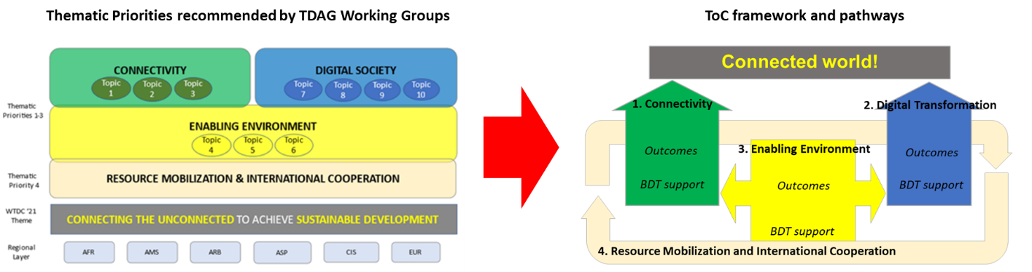

As part of this effort BDT is also refining the sequencing and integration of its products and services, mapping the most logical order for technical support and conditions for success along the new Thematic Priority ToC pathways for more evidence-driven matching of services with need.

Additionally, to strengthen the client-driven focus of BDT’s operational planning, the ToC data model includes more dynamic integration of the country statistics and survey data provided by Members. This innovation will improve BDT’s operational planning through automated data feeds of key trends at regional and country level, as well as by LDC, LLDC and SIDS groups. Through this overlay of data feeds onto the new ToC model’s Thematic Priority pathways, BDT aims to be more agile in adapting our support and service offering to evolving trends and changing needs of our Members.

To further guide coherent programmatic focus in the mandate delivery at all levels and through ITU’s regional presence, the BDT ToC framework is designed for full regional-level synchronization of RBM, Thematic Priority pathways, operational planning, sequenced technical support offerings and portfolio performance assessments. This regional ToC synchronization will help regions to strategically match BDT technical support according to their Regional Initiatives and specific local trends, while also maintaining alignment with the global vision and mission defined in the ITU Strategic Plan.

**Figure 2: Regional ToC synchronization with global vision and mandate**

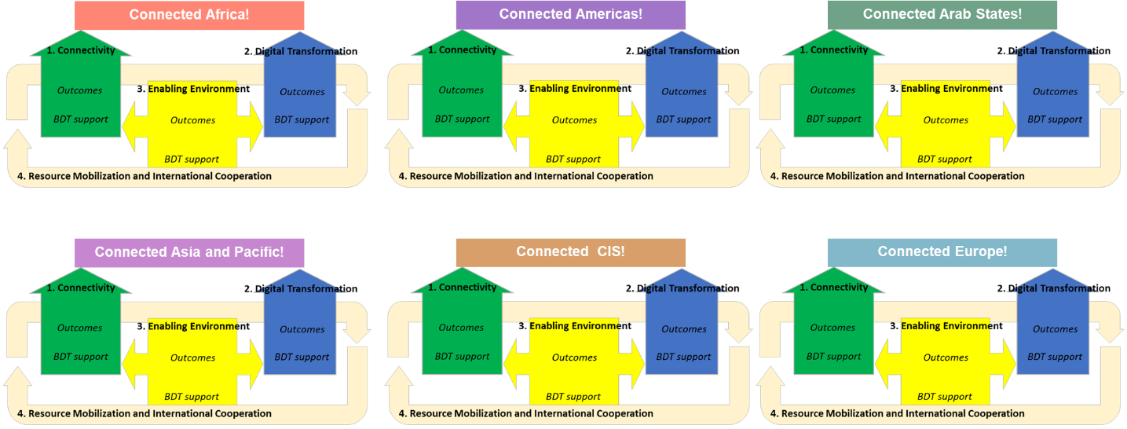

**Opportunities in context of UN processes**

**Switzerland: It is Switzerland’s view that collaboration within the multilateral system and the reform of the UN Development system (UNDS) offers opportunities for increased impact, effectiveness and efficiency. Switzerland would welcome the Secretariat’s views on potential avenues for collaboration as well as opportunities the Secretariat sees in the current UNDS reform for the ITU’s mandate delivery in the regions.**

ITU, through the BDT, has already embarked upon enhanced engagement with the UN Development System.

ITU has developed a phased approach to engagement with UNDCO in which ITU has identified and agreed with UNDCO the ITU offerings by region, shared a joint commitment (between ITU and UNDCO) with all RCs globally, and agreed on a list of focal countries for initial engagement. Awareness of ITU’s work is being raised through webinars with RCs in each region, and we have already begun our engagement through CCAs and Country Frameworks in many of the focal countries.

We have also engaged in the UNSG’s Digital Cooperation Roadmap and we are actively involved in the Roadmap Response Team. Currently BDT is working, through our statistics department to assist the UN in defining the KPIs which will underpin the achievement and measurement of the Roadmap’s targets, and ITU leads two of the focus areas for the roadmap in implementation efforts with UNDCO.

ITU engages on an increasing basis in the various UN level assessments, including the Quadrennial review, but perhaps more importantly, BDT has increasingly begun to use the findings of these reviews as criteria for improved performance through internal monitoring and evaluation.

Finally, the BDT Liaison Office was established in the ITU’s office in New York from 1 May 2021, which will provide an additional layer of coordination and engagement with the UN and significantly strengthen our ability to participate fully in the UNDS globally and will fully connect the web of our regional offices, with the UN system. This office has been specifically focussed on engagement within LDCs, LLDCs, and SIDS, so will also enhance ITU’s effectiveness in providing support to those countries most in need, through better engagement with the UN system.

**Coordination, Coherence and Oversight:**

**Switzerland: While it does not seem advisable to redeploy TSB and BR staff to regional offices, Switzerland is of the view that it is important that field offices can benefit as much as possible from the specific technical expertise at headquarters. Direct contact and communication between staff at regional offices and headquarters should be supported best possibly. A small coordination team could support mandate delivery also in the long-term.**

The issue of more effective collaboration with the BR and TSB within the regional presence is one part of the ongoing efforts to coordinate between the Bureaux across ITU. The suggestions made in the PWC report are noted in this regard and the Secretariat continues to review these options.

The Secretariat notes the comments submitted by Switzerland on the implementation of a One ITU approach to the regional presence. It is noted that the PwC recommendations (1.1-1.3) propose a significant increase in the presence of BR and TSB in regional and area offices, including proposals for the reassignment of members of staff from BR and TSB (a total of 8 staff) to regional offices. The Secretariat has reviewed this proposal, and the BR and TSB consider that the approach would not be practical. There are concerns that it would detract from the highly specialized technical nature of the work and staff of the BR and TSB and would (particularly over-time) result in reducing the effectiveness and added technical value of such assignments to the regions.

The Secretariat considers the form of arrangement proposed by Switzerland of a coordination team being responsible for optimal provision of BR and TSB support to regional offices, may be an appropriate way forward. It is noted that this would essentially be an enhancement of the current methods of working which comprises regular coordination between BDT regional staff, and BR and TSB, and which has been improved over the last year. The Secretariat proposes to develop this concept and fully implement it over the next 12 months, as reflected in the workplan submitted to the Ad Hoc Group.

The Secretariat will consider the following issues in determining the optimal way to implement improvements in this critical area:

* Convening of a coordinating committee, with clear Terms of Reference, an appropriate periodic meeting schedule, and effective electronic monitoring and evaluation methods;
* Ensuring engagement by Regional and Area Offices with member states on needs for assistance on matters pertaining to BR, TSB and the General Secretariat;
* Providing a clear framework for provision of assistance from all Bureaux and the General Secretariat to meet member needs.

The Secretariat will continue to report on progress in this area, together with the other recommendations made by PWC.

# 2 Contribution by Australia

**In its contribution (document** [**CWG-FHR-AH-RegPres-2/4**](https://www.itu.int/md/S21-AHGFHR2-C-0004/en)**) Australia requested that the Secretariat outline its further reflections on how the regional presence can best support mandate delivery in a coherent and coordinated manner.**

The Secretariat considers that the PWC report provides valuable insights on methods for improving mandate delivery by the ITU regional presence and considers that the significant extent to which the recommendations made by PWC had already been commenced by the Secretariat, underscores the Secretariat’s effective positioning to assess and improve delivery of ITU’s mandate. The Secretariat repeats the points made above in the context of the questions from Switzerland and notes that the overall approach by the Ad Hoc Group, to establish the core strategic principles against which implementation should be taken, and to have the Secretariat embark on a process of implementation of the PWC recommendations with frequent reporting to council for advice and review, is perhaps most effective. In that framework, the Secretariat would address implementation of each PWC recommendation considering the relevant strategic criteria based on current and relevant information.

In this regard, the Secretariat notes that where necessary recommendations could be presented for Council and member state consideration on a case-by-case basis where they are outside the Secretariat’s competency or mandate. This would apply, as currently, to matters such as the opening or closure of offices and significant changes in structure or operation of offices.

The implementation plan being developed by the Secretariat (see Annex 2 of the Report of the Ad Hoc Group) provides a clear framework for oversight for Council regarding the recommendations and the efforts to strengthen the regional presence.

ANNEX 2

UPDATE ON STATUS OF PWC RECOMMENDATIONS

# 1 Introduction

This document sets out the update on the status of the implementation of the recommended improvements and enhancements proposed by PWC, by the Secretariat. PwC recommended an action plan for the strengthening of ITU’s Regional Presence with four implementation streams, broken down into fifteen recommendations and 50 supporting actions.

It should be noted that many of the recommendations have already been implemented or are in the progress of being implemented by the BDT and ITU in pursuit of other efforts at improving ITU’s effectiveness, or addressing recommendations made by previous assessments of ITU, including Audit recommendations, IMAC recommendations or Council decisions.

**2 Workplan**

The Secretariat has created a workplan which plans for full implementation of the sections of the PWC report which are within the Secretariat’s ability to implement (based on the decisions made by the Ad Hoc Group) by the end of 2023.

The proposed workplan is divided into three charts, separating 60 actions derived from the PWC report into the following categories:

1. Actions in progress:
2. Completed recommendations; and
3. Recommendations requiring council decisions.

It should be noted that the third category has not been scheduled, and the timeline for completion will depend on the nature and timeline of Council’s decisions on their subject matter.

The chart below summaries the current status of the actions.

**Chart 1 – Summary status of regional presence actions**

Charts 2 to 4 provide further detail on the recommendations in each category, with Chart 2 providing proposed timelines for implementation.

**Chart 2 – Recommendations in progress**

This chart contains the recommendations that are currently under implementation by ITU and includes currently proposed timelines for implementation of each recommendation.

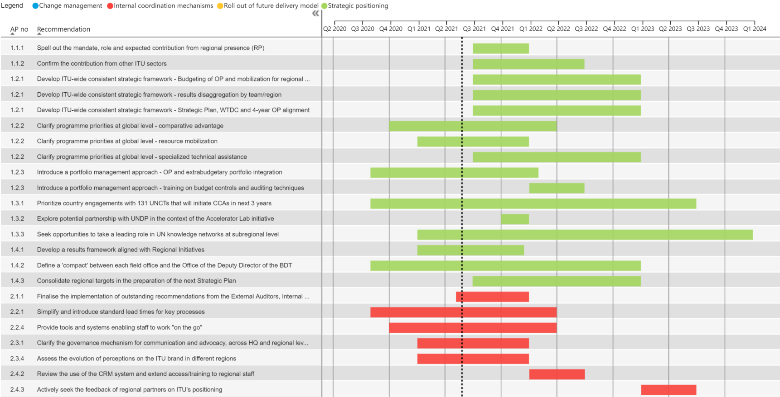

**Chart 3 – Completed recommendations**

This chart contains recommendations that ITU has already fully implemented.

**Chart 4 – Recommendations requiring Council Decisions**

This chart contains those recommendations which require decisions by Council prior to implementation.

___________________

1. It is noted that the Option 1 in the PWC Report includes new offices and closure of some offices. The Ad Hoc Group neither supports nor opposes the addition of new offices, and there were strong objections by some member states to the closure of specific offices. Therefore, no decision was made on any closure, consolidation or opening of offices. The Ad Hoc Group decision relates only to maintenance of both categories of office (Regional and Area) as in the current structure.