Council 2021  Virtual consultation of councillors, 8-18 June 2021 | 
Agenda item: ADM 5 | Document C21/47-E
Agenda item: ADM 5 | 7 April 2021
Agenda item: ADM 5 | Original: English
Report by the Secretary-General
STATUS REPORT ON IMPLEMENTATION OF
COUNCIL DECISIONS 600 AND 601 (UIFN, IIN)

Summary
Following the approval of Decisions 600 and 601 at the Council 2017 session, ITU has been in the process of implementing these Decisions. This report summarizes the status of the implementation and the consultations with Member States.
This document was originally prepared as C20/47 for submission to the 2020 session of the Council but was not reviewed.

Action required
The Council is invited to note the conclusions provided in section 5.
____________

References
Document C17/133; C17/134; C18/100; CWG-FHR 9/14; CWG-FHR 9/15; C19/47, C19/120; C20/47

1 Background
1.1 Following the approval of Decisions 600 (C17/133) and 601 (C17/134) at the Council 2017 session, the ITU secretariat has been in the process of implementing these Decisions.
1.2 TSB presented document C19/47 to Council 2019 which provided updates of the status of implementation of Council Decisions 600 and 601, including the status of the contacts for UIFN service providers and IIN assignees.
1.3 Council 19 approved the recommendations captured in Section 2.2.25 of the summary record of the ninth and last council plenary meeting in document C19/120.

2 Financial updates
2.1 UIFN (Council Decision 600)
In 2018, the invoices for the UIFN annual maintenance fee represented CHF 744 400. An amount of CHF 349 033 has been cancelled per Council 2019 recommendations for entities that are no longer in business. To date 94% of the valid invoices amounting to CHF 395 367 have been paid and CHF 21 700 still needs to be recovered.
In 2019 the invoices sent represented CHF 193 100 and 99% of the payments have been received. The remainder still needs to be recovered.
In 2020 the invoices sent represented CHF 141 400 and 68% of the payments have been received. The remainder still needs to be recovered.
As of 23.03.2021, the total amount to be recovered for UIFN maintenance fee for 2018, 2019, and 2020 is CHF 66 400.
Annex B lists the entities for which TSB has a valid contact, that have been billed in 2018, 2019, and/or 2020 and have not paid their bills to date. The secretariat seeks the assistance of Members States in recovering this debt.
2.2 IIN (Council Decision 601)
The invoices for IIN annual maintenance fee for 2018, 2019, and 2020 have not been generated yet as the secretariat continues to seek confirmation of contacts from national Administrations/regulators or authorized agencies for IIN assignees.

3 Status of the contacts for UIFN service providers and IIN assignees
3.1 In accordance with Council 19 approved recommendations captured in Section 2.2.25 document C19/120, this section provides an update on the status of UIFN service providers and IIN assignees:
3.1.1 The list of UIFN service providers in Annex A will be marked as “not reachable” in the ITU database. The records for these UIFN service providers are subject to removal from the ITU database and the UIFNs assigned to them are subject for reclamation based on confirmations/notifications from national Administrations/regulators. Among these UIFN service providers, for the ones to whom invoices for the maintenance fee for 2018 have been sent, the invoices will be cancelled.
3.1.2 If the invoices sent to the UIFN service providers in Annex B remain unpaid for an extended period, the secretariat will seek assistance from Member States to recover the debt.
3.1.3 National Administrations/regulators or authorized agencies are encouraged to provide assistance in identifying the up-to-date contact or status of the UIFN service providers (e.g., if they are no longer in business) listed in Annex C.
3.1.4 The list of IINs for which contact information is pending will be published on ITU website as IINs with the status “assignee not reachable” and will be announced in the ITU Operational Bulletin. National Administrations/regulators or authorized agencies are encouraged to provide assistance in identifying their up-to-date status and/or contact information.
3.1.5 For the UIFNs and IINs which are still under consultation with national Administrations/regulators or authorized agencies, their status should be confirmed before 31 October 2021. If no objection is received from national Administrations/regulators or authorized agencies, the corresponding UIFNs and IINs will be considered as no longer active and removed from ITU databases.
3.2 As of 15 March 2021, the contact information status of 849 IINs kept in ITU database is shown in the figure below.
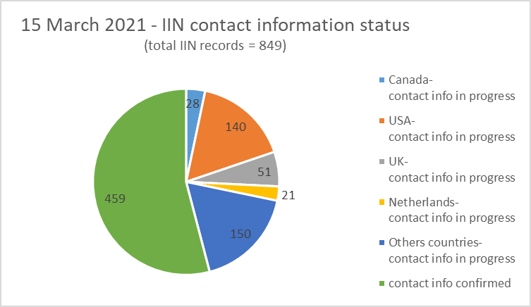
Note: the number of IIN records for the countries listed in the above figure include geographic areas under their Administrations.
4 Observations
Based on notifications and responses received from national Administrations/regulators or authorized agencies, the number of IIN record updates per year since 2014 is provided in the table below:
Year | New | Deletion | Update | Total/year
2014 | 22 | 3 | 12 | 37
2015 | 24 | 1 | 6 | 30
2016 | 22 | 1 | 14 | 37
2017 | 22 | 7 | 83 | 112
2018 | 35 | 29 | 154 | 218
2019 | 17 | 7 | 71 | 95
2020 | 38 | 3 | 8 | 49
As of  15 March 2021 | 7 | 1 | 1 | 9

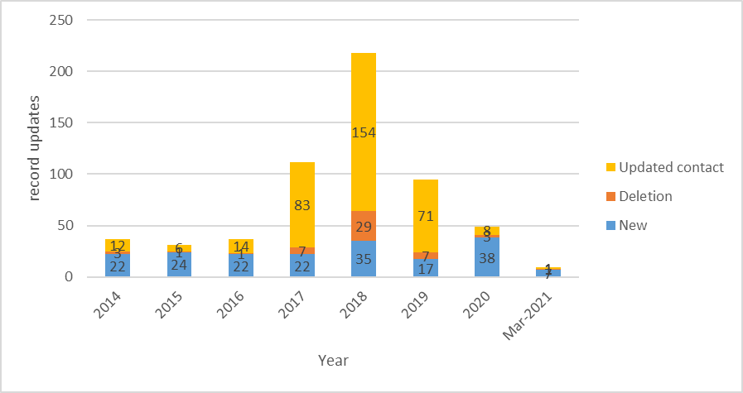

It shows a sharp increase in the number of IIN record updates per year following the approval of Council Decision 601. This process improves the precision of the IIN records kept in the ITU database.

5 Conclusion
The secretariat continues the implementation of Council Decision 600 and 601.
In accordance with Council 2019 recommendations captured in Section 2.2.25 of the summary record of the ninth and last council plenary meeting in document C19/120:
The secretariat seeks the continued assistance of Members States in recovering the debt identified in Annex B.
National Administrations/regulators or authorized agencies are encouraged to aid the secretariat in identifying up-to-date status and/or contact information for UIFN identified in Annex C and IIN contacts.

Annex A - list of UIFN service providers subject for removal
None

Annex B - list of UIFN service providers pending payment for 2018, 2019, and 2020

year | Amount | currency | UIFN quantity | Company's name | Country/  Geographic Area | note
2020 | 200.00 | CHF | 2 | Telefónica de Argentina S.A | Argentina
2020 | 13,900.00 | CHF | 139 | BICS SA | Belgium
2018 | 100.00 | CHF | 1 | Telecom Itália Móbile S.p.A. (TIM)  (ex-INTELIG Telecomunicações Ltda.) | Brazil
2018 | 500.00 | CHF | 5 | Colombia Telecomunicaciones S.A. ESP - Telecom Colombia | Colombia
2020 | 300.00 | CHF | 3 | O2 Czech Republic a.s. | Czech Republic
2018 | 200.00 | CHF | 2 | Telia Eesti AS (formerly Elion Ettevõtted AS) | Estonia
2018 | 200.00 | CHF | 2 | Télécom Développement | France | Altice/SFR
2018 | 100.00 | CHF | 1 | TelePassport AG | Germany | acquisition by mobilcom-debitel GmbH
2020 | 400.00 | CHF | 4 | PLANinterNET VoIP-GmbH | Germany
2019 | 400.00 | CHF | 4 | OTEGLOBE S.A. | Greece
2018 | 100.00 | CHF | 1 | Empresa Hondureña de Telecommunicaciones (HONDUTEL) | Honduras
2018 | 400.00 | CHF | 4 | HKBN Enterprise Solutions HK Limited (ex-WTT HK Limited) | Hong Kong, China
2020 | 16,600.00 | CHF | 166 | PCCW - HKT | Hong Kong, China
2018 | 14,000.00  [partial payment:  CHF 2800] | CHF | 140 | Bezeq International | Israel
2020 | 6,800.00 | CHF | 68 | Partner Land-Line Communications Solutions LP | Israel
2018 | 1,000.00 | CHF | 10 | Eutelia S.p.A. | Italy | partially purchased by CloudItalia with no UIFN responsibility, however,  3 UIFNs are reachable
2020 | 100.00 | CHF | 1 | JSC Kazakhtelecom | Kazakhstan
2018 | 100.00 | CHF | 1 | SIA LATTELEKOM | Latvia
2020 | 400.00 | CHF | 4 | Telia Lietuva AB / TEO LT, AB | Lithuania
2020 | 2,100.00 | CHF | 21 | Telekom Malaysia Berhad | Malaysia
2018 | 100.00 | CHF | 1 | Vodafone New Zealand | New Zealand
2020 | 700.00 | CHF | 7 | Cable & Wireless Panamá S.A. | Panama
2018 | 300.00 | CHF | 3 | Telefonica del Peru | Peru
2018 | 100.00 | CHF | 1 | Telecable de Asturias SA | Spain
2018 | 900.00 | CHF | 9 | Tele 2 AB | Sweden
2020 | 2,700.00 | CHF | 27 | CAT Telecom | Thailand
2018 | 500.00 | CHF | 5 | Kingston communications/Affiniti | United Kingdom
2018 | 300.00 | CHF | 3 | PRIMUS Telecommunications Ltd. | United Kingdom
2019 | 100.00 | CHF | 1 | ComoreTel Limited | United Kingdom
2018 | 5,600.00 | CHF | 56 | International Telcom Ltd. | United States

Annex C - list of UIFN service providers requiring further information

year | Amount | currency | UIFN quantity | Company's name | country/  Geographic Area | note
2018 | - | - | 3 | IT-Austria GmbH | Austria
2018 | - | - | 1 | AES Comunicaciónes Bolivia S.A. | Bolivia
2018 | - | - | 2 | BellSouth Chile | Chile
2018 | - | - | 9 | Inclarity PLC (ex ABS Telecom plc) | United Kingdom
_____________________

