|  |  |
| --- | --- |
| **Council 2021 Virtual consultation of councillors, 8-18 June 2021** |  |
|  |  |
|  |  |
| **Agenda item: ADM 18** | **Document C21/44-E** |
| **31 March 2021** |
| **Original: English** |
| Report by the Secretary-General | |
| REPORT OF THE INTERNAL AUDITOR ON INTERNAL AUDIT ACTIVITIES | |

|  |
| --- |
| Summary  This report covers the internal audit activities for the period from May 2020 to March 2021.  **Action required**  This report is transmitted to the Council **for consideration**.  ____________  References  [*ITU Financial Regulations and Rules (2018), Article 29*](https://www.itu.int/en/council/Documents/Financial-Regulations/S-GEN-REG_RGTFIN-2018-PDF-E.pdf) |

# Introduction

1. This report is transmitted to the ITU Council and responds to Article 29 of the Financial Regulations (2010). In accordance with the ITU Internal Audit charter,[1] this report is submitted to the Secretary-General and presented to the Council for consideration. The current report covers activities from the period between May 2020 and March 2021.
2. For the period reported on, the Internal Audit Unit comprised three Professional staff – a P.5 (Head of the Unit), a P.3 (Internal Auditor), and a P2 (Junior Internal Auditor). A General Services staff (Audit Assistant) was working in the Unit on a full-time basis until end of January 2021 when the incumbent retired from ITU. The General Services post was abolished and a P4 (Senior Internal Auditor) post was established and advertised on 15 February 2021. Currently the Unit consists thus of four professional posts, of which one is vacant pending recruitment in the course of 2021.
3. Internal Audit (IA) confirms that it conducts its audits in accordance with the International Standards for the Professional Practice of Internal Auditing and the Code of Ethics established by the Institute of Internal Auditors (IIA),[2] as well as with the provisions of the ITU Internal Audit Charter.[3] In addition, IA confirms that, for the period reported on, its staff had no managerial authority over, nor responsibility for any of the activities audited and did not perform accounting or operational functions within ITU.

# Orientation and scope of the internal audit activities

1. For 2020, the IA work plan was drawn up in a shorter version mid-2020, mainly because the IA had been heavily involved in investigations work which continued well into 2020. Audit work commenced sometime later in 2020. In line with the IA Charter, the IA plan for 2021 was reviewed by the Independent Management Advisory Committee (IMAC) at its 28th meeting and on 29 March 2021 approved by the Secretary-General. The allotted time for investigations was for 2021 minimized as to allow IA to conduct the core of its mandate. IA’s work on investigations is based on the Internal Audit Charter stipulating also that *IA shall investigate allegations, or presumptions, of fraud or mismanagement* as well as that *Internal Audit may provide consulting services within ITU*.
2. IA systematically shares copies of internal audit reports with the ITU External Auditor and with the IMAC. In accordance with ITU Financial Regulation 29.5, final internal audit reports can be made available to Member States or their designated representatives. A facilitated mechanism for accessing internal audit reports has been put in place since October 2015. During the period reported on, no requests for accessing internal audit reports were received via the online mechanism.

# Objectives and conclusions of the assurance engagements

1. The objectives of the assurance engagements are to assess: (i) the governance aspects of the Union’s operations audited; (ii) the risk management practices; and (iii) the effectiveness of (internal) controls. The priority of the recommendations resulting from the audit work is classified according to the impact and likelihood of the deficiency (high, medium, low).
2. The implementation of recommended actions is followed up by IA, as and when required. Since early 2021 a compliance dashboard is for that purpose Union-wide available and facilitates the tracking of recommendation implementation for concerned managers, yet does not relieve the IA’s responsibility to follow up on its earlier made recommendations, as per IIA Standard 2500[4].

# Investigations by Internal Audit

1. IA, in its investigative capacity, completed six investigations. IA also provided extensive support to an external investigator for a harassment type of investigation.
2. Six investigations were completed by IA:
   1. Three formal investigations into complaints related to alleged non-authorized outside activities (running and/or owning a company);
   2. A formal investigation into a staff member’s alleged fraudulently obtaining allowances and/or entitlements;
   3. A formal investigation further to a complaint related to several staff members’ alleged encouraging, witnessing and/or actively sharing externally of potentially confidential/sensitive information; and
   4. A formal investigation into one is further to a complaint related to a staff member’s alleged destruction and/or concealment of ITU records.

Upon completion of the investigations and in accordance with the ITU Investigation Guidelines, IA provided the Secretary-General with confidential investigation reports. The investigation under d. above resulted in a closure report since it was concluded that the allegations were not founded. With respect to the investigation under c. above, and given that it concerns a case of fraud or presumption of fraud, it was in February 2021 reported to the external auditor (in accordance with the ITU Financial Regulation art. 28.9). For this case it was found that the staff member had received an amount of CHF 11,279.25 representing an excess in entitlements.

1. Extensive support was provided to an external investigator recruited to conduct a formal investigation into alleged inappropriate behavior of an ITU staff member versus a number of other staff members. Administrative follow-up on all investigations is conducted by the Human Resources Management Department, on behalf of the Secretary-General.

# Consulting services by Internal Audit

***Selection process for the ITU External Auditor***

1. Upon recommendation by the IMAC, the Secretary-General requested IA to lead, for the secretariat, the process of selecting a new External Auditor. At its 2018 session, the Council appointed the individuals recommended by the six regional telecommunication organizations to serve as members of an Appraisal Committee and report to Council 2019 on the outcome of its work. With the support of the ITU secretariat, the Appraisal Committee conducted its work on the tender process for identifying a Supreme Audit Institution (SAI) of an ITU Member State that best meets the criteria set out in a Request for Proposal (RFP) for auditing the accounts of the Union.
2. IA continued throughout the process to assist the members of the Appraisal Committee for conducting their work and provided guidance on procedural and audit technical matters as appropriate. A report of the Appraisal Committee’s work was submitted to the first Virtual Consultation of Councilors 2020, after which the answers to the various questions raised at that session were coordinated by IA. After the second Virtual Consultation of Councilors 2020, a consultation by correspondence was undertaken and the external auditor selection was confirmed for appointment ([Council Decision 621](https://www.itu.int/md/S20-CL-C-0083/en)).

***Forensic audit***

1. Council 2019 adopted [Decision 613](https://www.itu.int/md/S19-CL-C-0130/en) instructing the Secretary-General to conduct a forensic audit. IA developed an “Expression of interest” document jointly with the Procurement Division, and subsequently a “Request for Proposal” was published for which six bidders (out of ten submissions) were considered in the further evaluation. The winning bidder was contracted in January 2021 and is conducting the forensic audit work with IA as focal point. The Secretary-General submits to Council 2021 separately the report of the specialized firm.

# Follow-up of internal audit recommendations

1. Throughout the period reported on, IA continued to follow up on recommendations made in previous audit reports. Further progress was noted over the last 12 months and statistics on the implementation (as at 31 March 2021) are as follows:

|  |  |  |  |  |  |  |  |  |  |  |  |
| --- | --- | --- | --- | --- | --- | --- | --- | --- | --- | --- | --- |
| **Year** | **2011** | **2012** | **2013** | **2014** | **2015** | **2016** | **2017** | **2018** | **2019** | **2020** | **Total** |
| Number of audit reports/notes | 2 | 0 | 4 | 4 | 7 | 4 | 5 | 4 | 2 | 2 | **34** |
| Rec. – Total | 17 | - | 113 | 55 | 34 | 22 | 30 | 26 | 15 | 9 | **321** |
| In Progress | 0 | - | 4 | 2 | 1 | 6 | 8 | 12 | 11 | 4 | **48** |
| Delayed | 3 | - | 0 | 0 | 0 | 0 | 0 | 0 | 0 | 0 | **3** |
| Closed | 14 | - | 109 | 53 | 33 | 16 | 22 | 14 | 4 | 5 | **270** |
|  |  |  |  |  |  |  |  |  |  |  |  |
| % of rec. In Progress | 0% | - | 4% | 4% | 3% | 27% | 27% | 46% | 73% | 44% | **15%** |
| % of rec. Delayed | 18% | - | 0% | 0% | 0% | 0% | 0% | 0% | 0% | 0% | **1%** |
| % of rec. Closed | 82% | - | 96% | 96% | 97% | 73% | 73% | 54% | 27% | 56% | **84%** |
|  |  |  |  |  |  |  |  |  |  |  |  |

1. An overview of the criticality of the recommendations still in progress is as follows:

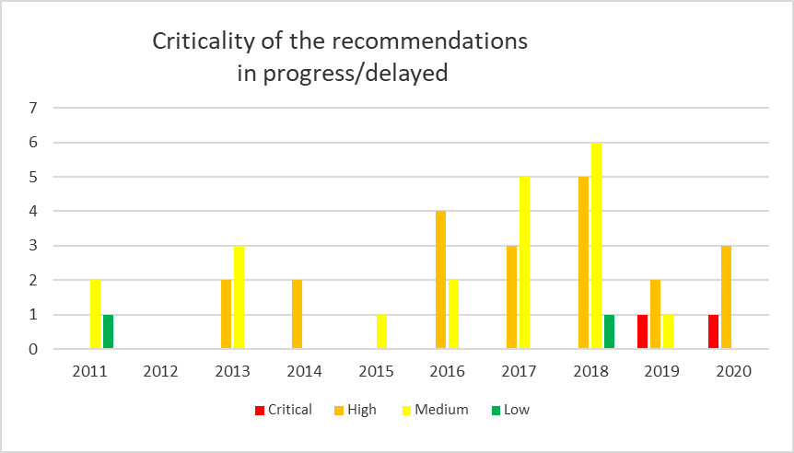

1. The critical recommendations from 2019 and 2020 stem from the management letter that IA issued, further to the investigation into the fraud case. They relate mainly to the need for HRMD to introduce ITU-wide competitive procedures and reinforced controls with respect to the hiring of external experts (under Special Service Agreements). For earlier made recommendations, Management informed IA (and IMAC) regularly of the progress and the working group on internal controls chaired by the BDT Director monitored more intensely the implementation of the earlier made recommendations.

_______________

1. Service Order 13/09, promulgated by the Secretary-General on 27 June 2013
2. Institute of Internal Auditors, [www.theiia.org](http://www.theiia.org)
3. Service Order 13/09, promulgated by the Secretary-General on 27 June 2013
4. 2500. A1 – The chief audit executive must establish a follow-up process to monitor and ensure that management actions have been effectively implemented or that senior management has accepted the risk of not taking action.