|  |  |
| --- | --- |
| **COUNCIL WORKING GROUP  ON CHILD ONLINE PROTECTION** 16th meeting, Geneva, 4 February 2020 |  |
|  |  |
|  |  |
|  | **Document CWG-COP-16\2-E** |
| **17 January 2020** |
| **English only** |

**Information document by the Office of Electronic Communications (Poland)**

THE UKE CAMPAIGN “CLICK SENSIBLY #KEEP CTRL”

**#keepCTRL - new UKE educational campaign**

Violence, hate, patostream, sexting - these are just some of the phenomena that young people face today using the Internet. That is why the Office of Electronic Communications (UKE, Poland) [has launched a new educational project “Click sensibly #keepCTRL”](http://www.uke.gov.pl/en/newsroom/click-sensibly-keepctrl-new-uke-educational-campaign,243.html), during which UKE experts will warn children and their guardians about dangerous phenomena on the network and teach how to use the internet responsibly.

There is a need to know a scale of phenomena, according to the data that comes from a report from a consumer survey of children and parents for 2019, commissioned by UKE:

- 90% of children use the Internet;

- 50% of parents do not control how their children use the telephone/Internet;

- 53% of parents of children aged 13-15 admit that they do not limit their access to the network at all;

- 80% of children aged 13-15 use social media;

- 87% of children know the hate phenomenon;

- 50% of children know the Internet challenges of cyberbulling and trolling;

- 30% of children know sexting and patostream.

[Here you can find similar report for 2018](http://www.uke.gov.pl/en/newsroom/consumer-survey-on-children-2018,152.html). The report for 2019 is being translated.

Almost 9 out of 10 children use the Internet every day. It mainly serves them to play online (69%), listen to music (59%) and watch movies (53%). Consumer research conducted by Danae and Realization commissioned by UKE shows that inappropriate age content that children most often encountered online was violence and cruelty, nudity and sexual acts. According to the majority of parents, there is too much violence, sex and swearing on the internet. Less than half of the parents use parental controls in the context of children's Internet use.

Contact with inappropriate content can result in learning problems, emotional disorders, alienation, complexes, and health problems. That is why the education of children and their guardians in the safe use of the Internet is so important.

[**The action Click sensibly #keepCTRL**](http://cik.uke.gov.pl/en/educational-events/keepctrl,4.html), addressed to children in grades 6-8, aims to draw attention to phenomena such as online challenges, sexting/sextortion, hate and FOMO, MOMO, FOJI and JOMO. As part of the UKE educational campaign, four films were made showing the above-mentioned phenomena. We show them to young people during special classes conducted at schools throughout Poland. The shows are accompanied by meetings with UKE experts who advise on how to protect yourself from cyberbullying. We have been conducting pilot classes since September in the Mazowieckie Province. The nationwide campaign started in December 2019.

**Education with UKE in reference to the “Click sensibly #keepCTRL”**

There are 14,500 primary schools in Poland, with three million students.

Consumer protection is one of the four pillars of the strategy of the President of UKE (consumer protection, market competitiveness, infrastructure and broadband services, UKE 3.0).

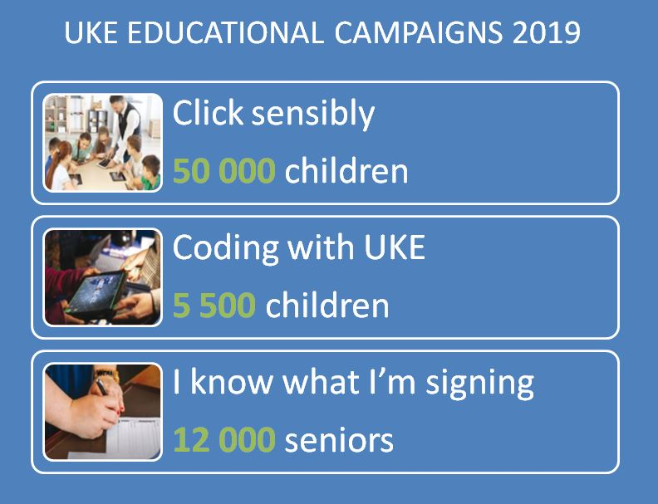

**Education priorities:**

- spending time creatively

- skills development

- online security

- shaping imagination

- learning through play

UKE runs three educational campaigns targeted at children and seniors. One of them is *Click sensibly*, which has so far covered children aged 6-12. During the classes we talk about how to safely navigate the network and use telecommunications devices. We teach how to deal with aggression, protect data and avoid high bills. So far, we have organized 1400 meetings attended by 130,000 children.

Other UKE educational campaigns include *Coding with UKE*, where children learn the basics of programming and *I know what I am signing*, protecting older people from the practices of dishonest sales representatives representing operators. As part of these actions, we have already trained 10,000 and 25,000 people.

**The main access channels are:**

- schools: cooperation with class principals and tutors, IT and ethics teachers in organizing classes for students. An important aspect of activities in this area is the role of the school in providing information to parents and guardians of students during e.g. meetings, including paying attention to areas related to threats and information on aspects of the campaign. Participation of UKE experts at both levels + films.

- media action – news, journalism, workshops from UKE

- internet + social media

- participation in public events

- UKE – websites, social media, experts-educators, participation in events

- cooperation with research centers, involvement of scientists and practitioners.

Mr. Marcin Czubak, Specialist International Organizations Unit, Department of Foreign Affairs (tel: +48 22 534 92 10, e-mail: [marcin.czubak@uke.gov.pl](mailto:marcin.czubak@uke.gov.pl)) and Mr. Łukasz Kiwicz, Senior Specialist, Department of Consumer Policy (tel: +48 22 5349298, e-mail: Lukasz.kiwicz@uke.gov.pl) are the contact persons in reference to any questions.

__________________