|  |  |
| --- | --- |
| **Council 2020 Geneva, 9-19 June 2020** |  |
|  |  |
|  |  |
|  | **Document C20/INF/17-E** |
| **9 June 2020** |
| **English only** |
| Note by the Secretary-General | |
| ICT Development Index (IDI) | |

|  |
| --- |
| Summary  This document provides background information and facts about the ICT Development Index.  Action required  This report is transmitted to the Council **for information**.  ____________  References  [PP Res 131 (Rev. Dubai)](https://www.itu.int/en/council/Documents/basic-texts/RES-131-E.pdf)  [WTDC Resolution 8 (Rev. Buenos Aires)](https://www.itu.int/en/ITU-D/Conferences/WTDC/WTDC17/Documents/WTDC17_FinalReport_en.pdf) |

# Introduction

The ICT Development Index (IDI) is a composite index designed to allow assessing and comparing the state of ICT development within and between countries. The IDI allows monitoring changes in the development of ICTs over time so that forward-looking policy can be informed. The IDI was first released in 2009, and since published annually until 2017. The IDI is based on a three-stage conceptual framework aimed to broadly represent the flow of how ICTs contribute to economic and social impacts. In a first stage, ICT infrastructure needs to be in place, and it needs to be widely accessible. Second, the infrastructure needs to be used with the effects magnified through the capability (or skills) for effective use. These two stages in turn drive outcomes (third stage). The IDI was therefore grouped into three sub-indices that measure ICT access, ICT use and ICT skills. The development of the IDI followed a standard process encompassing the selection of indicators, imputation of missing data, multivariate analysis, weighting and aggregation, and sensitivity analysis.

The need to continuously improve measurement methods and to update the composition of the IDI in response to technological developments was recognized from the beginning. As broadband and advanced wireless connectivity have become more critical for countries to fully realize the benefits of ICTs, the initial set of indicators needed to be reviewed. To address these issues, in 2016 the ITU launched a process of revising the indicators included in the IDI, through an external consultancy and a subgroup of the Expert Group on Telecommunication/ICT Indicators (EGTI). The results of the two studies were discussed at an Extraordinary Meeting of EGTI and EGH, held in March 2017. The meeting adopted a revised set of indicators to be included in the IDI (called ‘revised IDI’ hereafter to distinguish it from the original IDI) as of 2018. Table 1 shows the indicators included in the original and the revised IDI.

While the extraordinary meeting in 2017 agreed on the list of indicators to be included in the revised IDI, it did not engage in the methodological aspects involved in the development and calculation of a composite index (aggregation methods, methods for imputing missing data points, statistical analysis, sensitivity analysis). This technical work was carried out by the ITU Secretariat.

**Table 1: Original and revised indicators for the ICT Development Index (IDI)**

|  |  |  |
| --- | --- | --- |
| **Original IDI** | **Change** | **Revised IDI** |
| **ICT Access** | | |
| Percentage of households with a computer | No change | Percentage of households with a computer |
| Percentage of households with Internet access | No change | Percentage of households with Internet access |
| International internet bandwidth (bit/s) per Internet user | No change | International internet bandwidth (bit/s) per Internet user |
| Fixed-telephone subscriptions per 100 inhabitants | Dropped | N/A |
| Mobile-cellular subscriptions per 100 inhabitants | Dropped | N/A |
| N/A | Added new indicator | Percentage of the population covered by mobile networks   * At least 3G * At least LTE/WiMax |
| N/A | Added new indicator | Fixed broadband subscriptions by speed tiers as % of total fixed broadband subscriptions   * 256 Kbit/s to 2 Mbit/s * 2 to 10 Mbit/s * Equal to or above 10 Mbit/s |
| **ICT Use** | | |
| Percentage of individuals using the Internet | No change | Percentage of individuals using the Internet |
| Fixed‐broadband subscriptions per 100 inhabitants | Dropped | N/A |
| Active mobile‐broadband subscriptions per 100 inhabitants | No change | Active mobile‐broadband subscriptions per 100 inhabitants |
| N/A | Added new indicator | Mobile broadband Internet traffic per mobile broadband subscription |
| N/A | Added new indicator | Fixed broadband Internet traffic per fixed broadband subscription |
| N/A | Added new indicator | Percentage of individuals who own a mobile phone |
| **ICT Skills** | | |
| Mean years of schooling | No change | Mean years of schooling |
| Gross enrollment ratio (secondary level) | No change | Gross enrollment ratio (secondary level) |
| Gross enrollment level (tertiary level) | No change | Gross enrollment level (tertiary level) |
| N/A | Added new indicator | Proportion of individuals with ICT skills |
| **11 indicators** | **3 dropped indicators, 6 new indicators** | **14 indicators** |

# IDI 2018

In 2018, after collecting the data for 2017 from Member States, the ITU Secretariat started to develop the methodology to calculate the revised IDI. However, this exercise did not come to a fruitful conclusion and it was not possible to calculate a robust and methodologically sound index. This conclusion and the reasons leading to it were first communicated in Circular SG/BDT/010 of 5 December 2018, at the 16th World Telecommunication/ICT Indicators Symposium (WTIS) on 10-12 December 2018, and in a [Background Document](https://www.itu.int/en/ITU-D/Statistics/Documents/IDI2019consultation/IDI_BackgroundDocument_E.pdf) that was also included in [Circular/BDT/DKH/IDA/026](https://www.itu.int/en/ITU-D/Statistics/Documents/IDI2019consultation/BDT_Cir_026_DKH_IDA_E.pdf) of 3 October 2019 as Annex 1. The sections below build on the latter document, providing additional and/or updated information where relevant.

1. Data availability

One of the main reasons for not publishing the revised IDI in 2018 was the unacceptably low data availability: only 42 percent of all data points required to calculate the IDI would have been based on data submitted by countries. As much as 58 percent of data points would have had to be estimated. For those new indicators that were not part of the original IDI, the share of missing data points reached 77 percent.

Recently, the ITU Secretariat refined its analysis and pulled out the data for reference year 2017. Since 2018, when the initial analysis was carried out, data availability for year 2017 has slightly improved, but remains too low (51 percent). Figures 1 and 2 below report the share of available data by country group and by indicator, respectively. Figure 1 shows that for low income ITU Member States only 37 percent of the data is available from official sources. It remains low even among high income Member States. Furthermore, only 89 Member States submitted more than 50 percent of the data required to compute the revised IDI, and only 25 more than 90 percent. Figure 2 shows that for more than half of the indicators and underlying indicators needed to compute the revised IDI, missingness exceeds 50 percent.

**Figure 1: Data availability by income group, 2017\***Share (%) of data points among ITU Member States

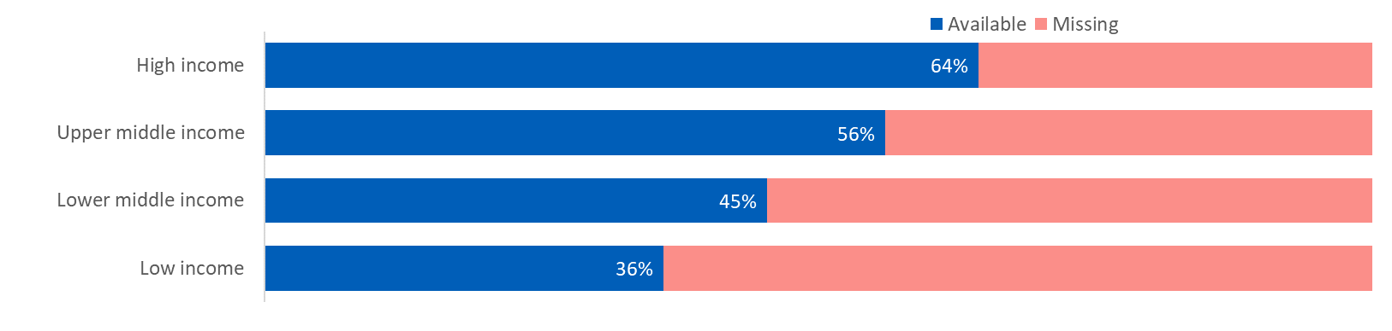  
* Based on 192 Member States for which income group classification (World Bank, FY 2020/21) is available.  
Source: ITU Secretariat analysis

**Figure 2: Data availability by component of the revised IDI, 2017\***Share (%) of data points among ITU Member States

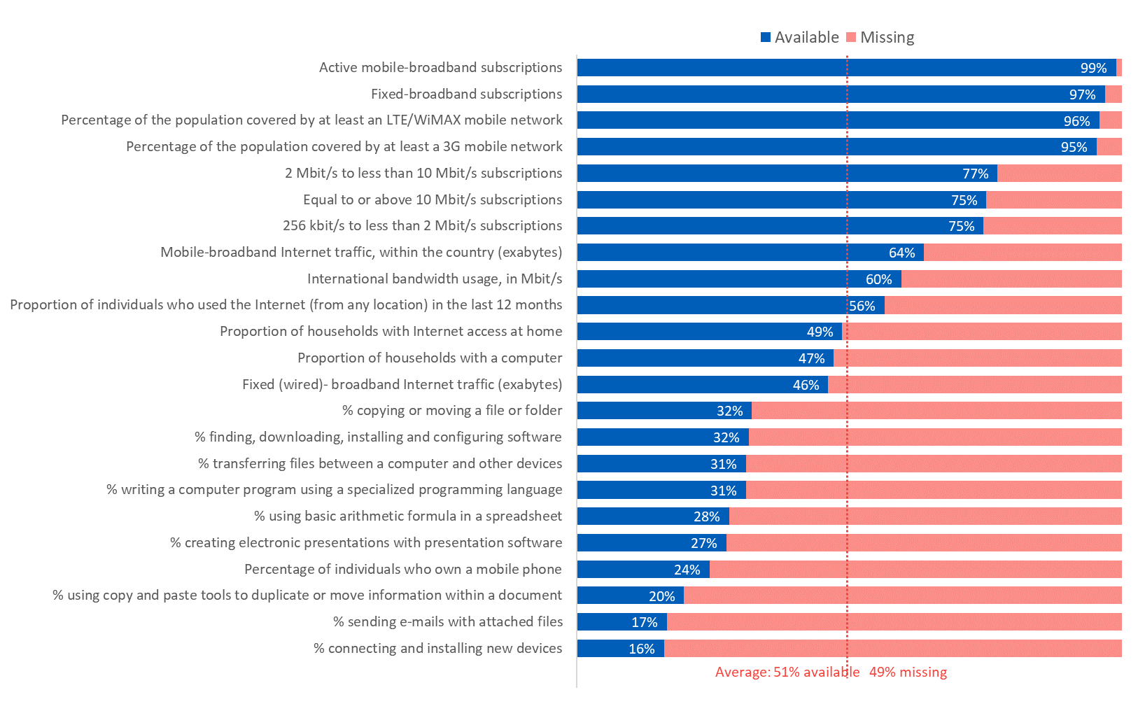  
* Some of the 14 indicators of the revised IDI are composed of several underlying indicators. The list in Figure 2 comprises all the indicators and underlying indicators whose data is submitted directly to ITU. The three education-related indicators sourced from UNESCO are excluded from the analysis.  
Source: ITU Secretariat analysis

The ITU Secretariat is committed to treating developing and developed countries on an equal footing and such commitment should be reflected in an index that achieves the largest possible coverage of ITU membership. With the revised IDI, the coverage would be limited to a limited subset of Member States for which data availability is satisfactory.

Estimation would normally allow to fill the data gaps. However, in the case of the updated/revised IDI, the share of missing data is simply too large to produce reliable estimates. Any imputation exercise becomes extremely hazardous and therefore misguided, because the quality of the estimates depends to a large extent on the ratio between the number of missing data points and the number of available data points to be used for estimating those missing data points.

In the present case, if estimates were produced, they would have such large margins of error that they would provide no guidance. The high degree of uncertainty of individual estimates would compound at the aggregate level. This means that the overall results and rankings of the IDI would be fraught with an even higher degree of uncertainty.

Producing an index under these circumstances and without addressing the other methodological challenges raised in this document would disregard fundamental United Nations statistical principles and, as a result, undermine the credibility of the Union as the UN agency for ICTs[1]. Such new index would further fail to reflect the real development of the ICT sector as mandated by PP Resolutions 71, 131 and WTDC Resolution 8.

1. Data quality

The verification of the data also revealed that some of the data submitted by countries were not in line with ITU’s agreed definition resulting in the data not being sufficiently harmonized. Indicators such as fixed-broadband Internet traffic and individuals with ICT skills were not mature enough yet to be included in the revised IDI, as emphasized by the fact that these indicators have subsequently been subject to further discussions by EGTI and EGH.

For example, the indicator “Proportion of individuals with ICT skills” is based on nine activities that people carry out on a computer[2], which can be aggregated into three categories: basic, standard, and advanced skills. Normally, more people will have carried out activities in the basic skills category than in the advanced skills category. In countries that have collected skills data already for a significant number of years, the ratio between the proportion of individuals with basic and advanced skills varies from 5 to 18. In countries that have only recently started to collect these data, the spread of this ratio is much larger, from 3 to 97. This wider spread is more likely to be an artefact of the data collection than reflecting the real situation in these countries (see Figure 3).

**Figure 3: Ratio of individuals with basic and advanced skills**

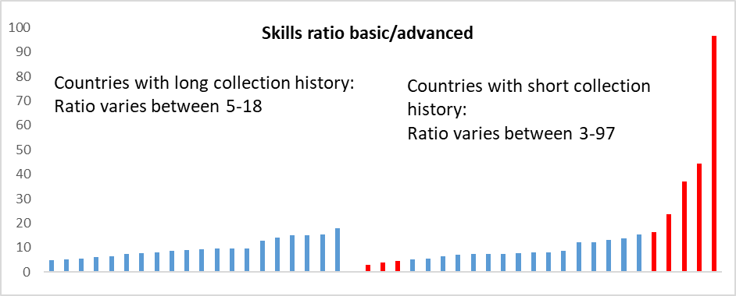

Source: ITU Secretariat analysis

1. Indicator selection

As highlighted in the OECD *Handbook on Constructing Composite Indicators* (2008)[3]: “Index construction is normally a long and iterative process of selecting indicators that are widely available for many countries and that best fit the index framework and then testing them and retaining those that have explanatory power. Creating an index is thus as much about art as science. The ‘composite index builder’ requires deep understanding of the subject matter as well as statistical techniques.”

When the ITU Secretariat started the methodological work related to the revised indicator set, including checking for the availability of data, testing the indicators for their fit with the conceptual framework and conducting a sensitivity analysis, a number of issues appeared which illustrated the flaws that occurred in the process of revising the indicators included in the IDI. This underlines the necessity for the analysts involved in producing an index to have the freedom they require to determine exactly which indicators should be included in the index, based on statistical and technical analysis.

For example, the newly added indicator “Fixed broadband by speed tiers” has some undesirable features. To illustrate the problem, a country with a total of 10 fixed-broadband subscriptions, all at high speed (> 10 Mbps), would score 1 out of 1 (perfect score) for that indicator, while a country with 10 million fixed-broadband subscriptions, but only half at the highest speed and half between 2 and 10 Mbps, would have a score <1 for that indicator. This would be an inaccurate depiction of the actual state of fixed-broadband diffusion in those two countries.[4] Figure 4 shows that there are many countries, which would score high on this indicator, despite a low number of fixed-broadband subscriptions.

**Figure 4: Fixed broadband by speed tier score vs. fixed-broadband penetration**

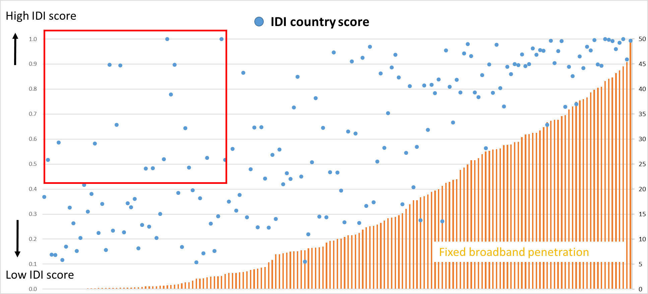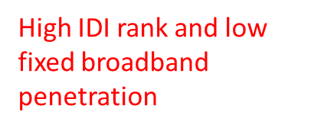

Source: ITU Secretariat analysis

Another example is the newly added indicator “fixed-broadband traffic per fixed broadband subscription”. By using the number of fixed-broadband subscriptions as denominator, a country with only a few fixed-broadband subscriptions, but which are all intensive data users[5], would score higher than a country with millions of fixed-broadband subscriptions with a less intensive data usage. Figure 5 shows that there is a group of countries with a low number of fixed-broadband subscriptions that would score high on this indicator, whereas there is another group of countries with a large number of fixed-broadband subscriptions that would score very low on this indicator. This also would not be a true reflection of the level of ICT development in these countries.

**Figure 5: Fixed-broadband traffic per fixed-broadband subscription vs. fixed-broadband penetration**

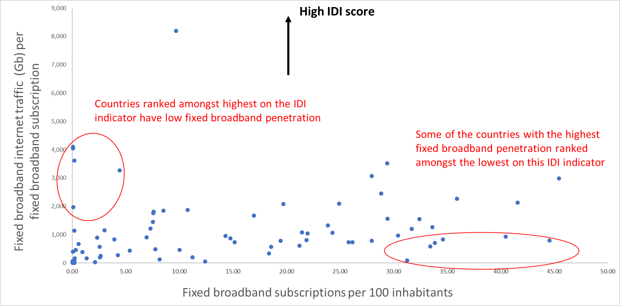

Source: ITU Secretariat analysis

# IDI 2019

In Circular Letter SG/BDT/010 of 5 December 2018, the Secretary General informed the membership that ITU had decided to postpone the publication of the revised IDI until 2019, because of the amount of estimations needed to calculate the index, and concerns about the quality of some of the underlying data, as explained above.

During TDAG 2019, a breakout session on ICT data and statistics was held on 4 April 2019, to – among other topics - inform Member States about the challenges faced with the publication of the IDI and brainstorm on the way forward. Participants suggested to revisit the conceptual framework, develop methodologies on emerging topics and new services, and work in partnership with other relevant organizations, Study Groups and other ITU sectors.

After collecting and verifying the data in 2019 for reference year 2018, it was found that, despite two rounds of capacity building workshops in all the regions, the amount of data received for the revised set of IDI indicators did not improve significantly and remained well below what is deemed acceptable.

In lights of those developments, in Circular Letter [Circular/BDT/DKH/IDA/026](https://www.itu.int/en/ITU-D/Statistics/Documents/IDI2019consultation/BDT_Cir_026_DKH_IDA_E.pdf) of 3 October 2019, the Director of BDT announced that the IDI (based on the 2017-agreed indicators) could still not be published in 2019 as no satisfactory solutions had been found to the problems above. A [background document](https://www.itu.int/en/ITU-D/Statistics/Documents/IDI2019consultation/IDI_BackgroundDocument_E.pdf) that was part of that circular letter explained these problems in more detail. Further, the Circular Letter recommended to exceptionally use the original IDI methodology only for publication in 2019 and announced an informal consultation on that subject. Circular [BDT/DKH/IDA/027](https://www.itu.int/en/ITU-D/Statistics/Documents/IDI2019consultation/BDT-cir_027E_DKH-IDA.pdf) of 16 October 2019 presented the results of that consultation, concluding that there was no consensus, and therefore no IDI would be published. The Circular Letter also announced that going forward, BDT, in collaboration with the membership and internationally-recognized experts, would continue to work on a more transparent, robust and reliable methodology with a view to publishing an index in 2020, taking into consideration PP Resolution 131 and WTDC Resolution 8.

# Towards a new ITU index

Circular [BDT/DKH/IDA/028](https://www.itu.int/en/ITU-D/Statistics/Documents/events/egmITUindex2020/BDT-cir_028E_DKH-IDA.pdf) of 21 November 2019 invited Administrations of ITU Member States and Resolution 99 to attend the 1st Expert Group Meeting on a new ITU index on 10 February 2020 to present and discuss the draft concept and framework for an ITU index. The [Summary Report](https://www.itu.int/en/ITU-D/Statistics/Documents/events/egmITUindex2020/Summary_EGM_10_Feb_2020.pdf) of that meeting noted that participants welcomed the proposal of the ITU secretariat to develop and publish a new ITU index to assess the extent to which digital technologies contribute to achieving the SDGs.

On 25 March 2020, a [TDAG Web Dialogue on the new ITU index](https://www.itu.int/en/ITU-D/Conferences/TDAG/Pages/TDAG25/default.aspx) was held. The revised draft concept and framework of the new index was presented and discussed. Participants supported the development of a new index linking digital technologies to the achievement of the SDGs. Concerns raised during the meeting included a request for further specification of the indicators and the elaboration of the framework and observed the tight timeline. Participants also provided suggestions for collaboration with international agencies and the private sector. The secretariat was asked to ensure full transparency of the process, regular communication with Member States and consultation with relevant other stakeholders.

[Circular BDT/DKH/IDA/038](https://www.itu.int/en/ITU-D/Statistics/Documents/events/2ndegmITUindex2020/BDT-CIR-0038PDF-E.pdf) of 17 March 2020 provided a summary of the 1st EGM and invited Administrations of ITU Member States and Resolution 99 to the 2nd Expert Group Meeting on a new ITU index, that took place on 17 April 2020. At the [2nd EGM meeting](https://www.itu.int/en/ITU-D/Statistics/Pages/events/2ndegmITUindex2020/default.aspx), the ITU secretariat presented a background document including the further revised conceptual framework of the new index, as well as a preliminary list of indicators that could be considered.

The points raised during the series of open and transparent consultations and meetings revealed the diversity of views, positions, and expectations among Member States regarding the process that should guide the development of a methodologically sound, world-class, impartial index. The main issues include:

* Whether, and how, a formal decision was taken on the (dis-)continuation of the publication of the IDI, in accordance with Resolution 131.
* Questions about the implementation of Resolution 131 with respect to the governance and the process underpinning the development of a new index.
* Whether to continue developing a new index or seek guidance and decision from the Plenipotentiary Conference in 2022.
* Several Member States requested more time to provide feedback and suggested extending the timeline for the development and eventual release of the index.

Resolution 131 does not provide for a mechanism to address the lack of consensus on the overall direction of the index and on various methodological aspects, including the selection of indicators to include.

1. United Nations, “Fundamental Principles of Official Statistics” Resolution A/RES/68/261 from 29 January 2014.
2. This indicator has subsequently been revised by the Expert Group on Households, and now consists of 11 activities carried out by individuals during the last three months, independent of the (digital) device(s) used.
3. See <https://www.oecd.org/sdd/42495745.pdf>.
4. In particular, because many popular video and audio streaming applications operate adequately with bandwidth of less than 5 Mbps, therefore speeds of 2 to 10 Mbps are in most cases sufficient for a normal usage pattern.
5. Often these are businesses, which have a higher data usage than households.