|  |  |
| --- | --- |
| **Council 2020** |  |
|  |  |
|  |  |
| **Agenda item: ADM 4** | **Revision 1 to Document C20/14-E** |
| **5 October 2020** |
| **Original: English** |
| Note by the Secretary-General | |
| SUPPORT FOR TSB | |

|  |
| --- |
| Summary  The ITU Standardization Sector has seen a significant increase in new members, new communities, new activities and meetings than in previous years. PP-18 and WTSA-16 have new instructs in various resolutions for additional work for TSB to execute. Workload for TSB staff has kept increasing considerably, while the number of posts in TSB has stayed constant over the last two decades with around 65 posts. TSB kindly requests additional staff resources:  1 P2 for Smart City KPIs and U4SSC  1 P2 for Numbering Resources  1 P4 and 1 G6 for financial inclusion  1 P4 staff for an expert in applying Machine Learning to communication networks.  1 P1 and 1 P2 for IT Tools and Applications  Action required  The Council is invited to **discuss** and to approve the requests contained in part 4 of this present document. The information document INF/7(Rev.1) gives further background.  ____________  References  [*Document C20/INF/7(Rev.1)*](http://www.itu.int/md/S20-CL-INF-0007) |

Contents

1 Introduction 2

2 ITU Services and tools 4

3 Request for additional resources for Study Group activities 6

3.1 Cities around the world are using ITU’s Smart Sustainable City KPIs 6

[3.2 International Numbering Resources (INRs),   
the backbone of communication networks 6](#_Toc37930308)

3.3 Digital financial services can include 2 billion unbanked people in the economy 7

3.4 Expert in applying Machine Learning to ICT Infrastructure and services 8

4 Summary of requested resources 9

# 1 Introduction

1.1 ICTs have become an indispensable lifeline of our society, pervading all areas of work and life. All industry sectors make use of ICTs. This trend of the growing intersection between ICTs and various other verticals/industries is also reflected in the work programme with new activities such as digital financial inclusion, intelligent transport systems, smart cities, smart grid, distributed ledger technologies, artificial intelligence/machine learning and quantum information technology, which in turn led to an increase in ITU-T membership.

1.2 In 2019, there have been 34 new ITU-T Associates (net increase: +27) and 20 new ITU-T Sector Members (net increase +11). In 2018, there have been 31 new ITU-T Associates (net increase +20) and 14 new ITU-T Sector Members (net increase 0). The increase in income in 2019 compared to 2017 is about 200 kCHF from ITU-T Sector Members and about 450 kCHF from ITU-T Associates.

1.3 ITU-T membership has maintained growth in 2020 despite the impact of Covid-19. Between January and September, 9 Sector Members and 23 Associates joined ITU-T, amounting to a total of 32 new members. Overall, ITU-T currently has a net increase of 18 members in 2020. Table 1 shows the total number of ITU-T Sector Members and ITU-T Associates between 2016 to September 2020, including estimated figures for the remainder of 2020.

1.4 There may be confusion reconciling the increase in ITU-T membership (numbers and revenue) with the reported deficit between budgeted and actual revenue membership contributions. As it turned out, the *budgeted revenue* from ITU-T Sector Members and ITU-T Associates in the last decade has always been higher than the *actual revenue*: the variance between budgeted revenue versus actual revenue for ITU-T Sector Members varied between -249k and -1.4 million in the period 2010 – 2019. Actual revenue for ITU-T Sector Members and ITU-T Associates from 2017 to 2019 are found in Table 2.

1.5 As the ITU-T membership has expanded, TSB continues to experience a significant increase in requests for services and support to the various activities of ITU-T. For example, the number of electronic meetings organized by TSB staff has almost doubled in the last two years, from around 1100 in 2017 to around 1900 in 2019. Using advanced technologies such as machine learning, TSB has improved its existing services, as well as alleviate some of the increasing and manual labour that they will be experiencing. The Council-20 Information document [C20/INF/7 (Rev.1)](https://www.itu.int/md/S20-CL-INF-0007/en) “The extensive use of ICT leads to new activities, new communities, a net increase in ITU-T membership, new ICT tools, and more meetings” gives details.

|  |  |  |  |  |  |  |  |
| --- | --- | --- | --- | --- | --- | --- | --- |
|  | 2016 | 2017 | 2018 | 2019 | 2020  (Estimated) | 2020 (September) |  |
| Sector Members  *(-Withdrawn +New)* | 253  (-17 +5) | 257  (-5 +9) | 257  (-14 +14) | 268  (-9 +20) | 272  (-9 +13) | 271  (-6 +9) |  |
| Associates  *(-Withdrawn +New)* | 128  (-21 +21) | 137  (-12 +21) | 157  (-11 +31) | 184  (-7 +34) | 216  (-9 +40) | 199  (-8 +23) |  |
| Combined Totals  *(Net increase)* | **381**  **-12** | **394**  **+13** | **414**  **+20** | **452**  **+38** | **488**  **+35** | **471**  **+18** |  |

Table 1: The total number of ITU-T Sector Members and ITU-T Associates from 2016 to September 2020, including estimated figures for the remainder of 2020

*\*Note: The ‘2020 (Estimated)’ column represents members expected to be withdrawn in 2020 as well as prospective members that have formally initiated the membership admission process and are now subject to approval from their respective National Administrations.* *These figures do not take into account possible exclusions and fee-exempted admissions to be decided at Council 2020.*

|  |  |  |
| --- | --- | --- |
| Year | ITU-T Sector Members Actual Revenue - kCHF | ITU-T Associates Actual Revenue - kCHF |
| 2017 | 6,184 | 1,321 |
| 2018 | 6,218 | 1,529 |
| 2019 | 6,376 | 1,784 |

Table 2: Actual revenues from ITU-T Sector Members and ITU-T Associates from 2017 to 2019.

1.6 PP-18 and WTSA-16 have new instructs in various resolutions for additional work for TSB to execute. For example, the number of applications for shared international codes has increased significantly because of industry needs for IoT/M2M identifiers. Workload for TSB staff has kept increasing considerably, while the number of posts in TSB has stayed constant over the last two decades with around 65 posts. Work overload for staff leads to increased stress-related sick leave, which in turn causes yet more work for the other colleagues, which leads to yet more stress-related sick leave.

1.7 An ITU Wellbeing survey conducted from 7 February to 30 April 2020 (Copenhagen Psychosocial Questionnaire; 281 ITU colleagues responded; TSB response rates was 56% which is pretty high) shows that about 4 out of 5 TSB colleagues feel that work drains energy and has a negative effect on their private life; for about 2 out of 5 TSB colleagues, work has to a (very) large extent a negative impact on private life.

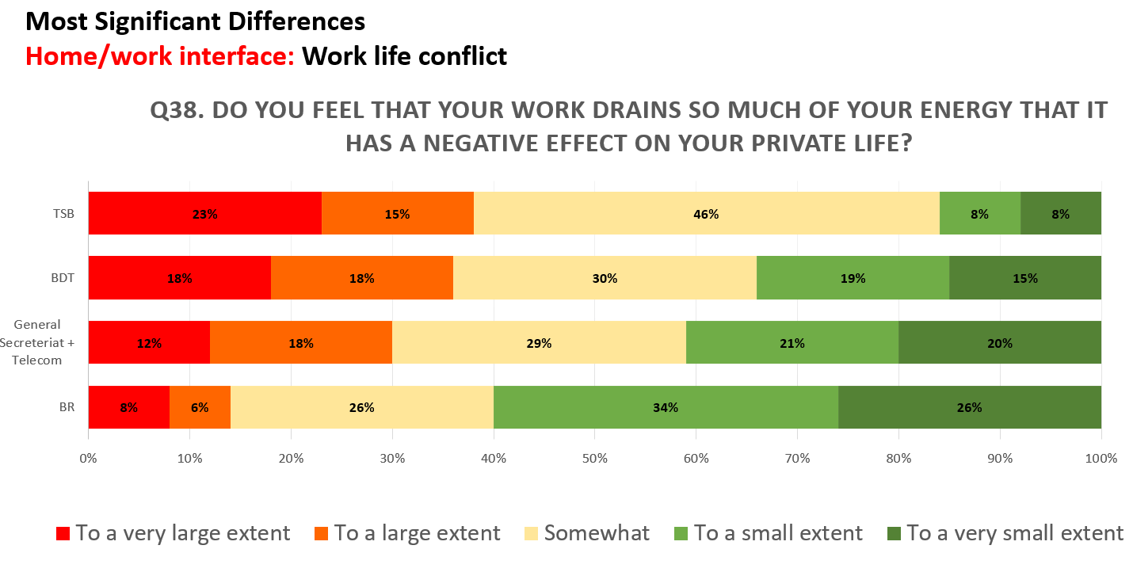

Figure 1: Data on work / life balance in ITU

# 2 ITU Services and tools

2.1 Over the past few years, TSB has experienced a significant increase in the request for the services and support of the Sector’s activities. ICTs have progressed enormously in the past decade to the point where they now play a pivotal role in the following key areas: automation of tasks, in-depth examination of problem areas to facilitate decision-making,  recording and tracking of event activities in a secured and reliable manner. Using these advanced technologies, TSB can address the increasing demands of the members for the enhancement of the Sector, maintain and update its existing services, as well as alleviate some of the manual labour experienced by staff.

2.2 Since the beginning of the 2017-2020 Study Period, and in parallel to the existing services supporting ITU-T Work Programme activities and publications, the TSB has developed the following solutions to adapt to the ever-changing demand of the Sector:

* [**AI-based SDG Mapping Tool**](https://aisdg.itu.int/) - A TSB application has been developed using Artificial Intelligence (AI) to provide statistical analysis on the relevance of ITU-T activities (e.g., Recommendations, Technical Specifications, etc.) to UN SDGs and to map those activities from a wide range of data sources (e.g. websites, databases, etc.) to specific UN SDGs using semantic relevance.
* [**MyWorkspace**](https://www.itu.int/myworkspace/) – A one-stop shop that facilitates the access to a wide range of applications and services such as:
  + [MyMeetings](https://www.itu.int/myworkspace/#/my-workspace/remote_participation): Remote participation service based on an open-source solution customized in-house to support requirements of both statutory and non-statutory ITU-T meetings.
  + [MyEvents](https://www.itu.int/myworkspace/#/my-workspace/myevents): Events management platform providing real time ITU-T events agenda, list of registered participants, speakers, and exhibitors, as well as a ‘matchmaking’ function to facilitate networking among participants.
  + [All/Today’s Events](https://www.itu.int/myworkspace/#/my-workspace/allevent): Simplified calendar view of upcoming events, with filter options and access to the event and registration page to participate in events.
  + [ITU Translate](https://www.itu.int/myworkspace/#/my-workspace/translate): Machine translation tool based on neural network, trained in-house on ITU documents, and supporting translation in any of the six (6) UN official languages.
  + [ITU-T Cloud](https://tsbcloud.itu.int/nextcloud/login): ITU premises cloud storage service allowing users to share and exchange files for up to 10 GB per user.
  + [Mailing list](https://www.itu.int/myworkspace/#/my-workspace/mails): Subscription service for ITU mailing lists.
  + [Community](https://www.itu.int/myworkspace/#/my-workspace/community): MyWorkspace user’s directory.
  + [Suggested meeting documents](https://www.itu.int/myworkspace/#/my-workspace/documents): Suggested list of documents based on users’ interests.
  + [Profile](https://www.itu.int/myworkspace/#/profile): Profile page containing user’s personal information and interests.
* [**ITUSearch**](http://www.itu.int/search)- A search engine that provides an access to all ITU’s digital resources, including publications, meeting documents, social media content and webinars.
* [**ICT Standards Landscape**](https://www.itu.int/net4/ITU-T/landscape#?topic=0&workgroup=1&searchValue=&page=1&sort=Revelance) - An online tool used by experts to classify standards in their respective domains.

2.3 TSB applications have played an important role in the access to documents, services, and organization of events. Remote participation tools provide an opportunity to increase access to meetings and events. Overall, the total number of meetings (including both statutory and non-statutory) organized using remote participation tools and the number of attendees (people who participated in meeting sessions) have increased considerably between 2017 and 2020. In 2019, TSB organized 1878 meetings and had a total of 10798 attendees. From January to August 2020, 2958 meetings were held with 48309 attendees (see Table 3).

2.4 MyWorkspace has also seen an important rise in the number of users, going from 100 users in January 2018 to almost 4000 in September 2020, and is expected to have an even greater number of users by the end of 2020. Other TSB tools, such as the ITU Translate, have been responsible for the rise of participants in events such as *Bridging the Standardization Gap* *training* *sessions* (113 participants in 2017 vs. 348 participants in 2019)*.*

2.5 TSB’s remote participation tool, MyMeetings, is “WCAG 2.0 AA” (Web Content Accessibility Guidelines 2.0 AA) compliant to address the needs of participants with disabilities. Enhancements are ongoing to make other applications and platforms such as MyWorkspace, ITUSearch, ITU Translate, ITU-T Landscape and ITU-T websites WCAG 2.0 AA compliant.

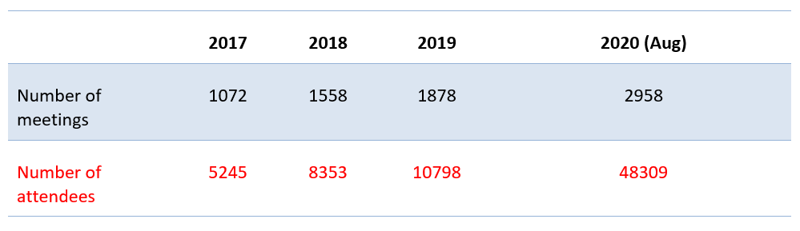

Table 3: Number of meetings and attendees in 2017, 2018, 2019 and 2020

2.6 In this period Covid-19, ICTs offer the only opportunity to cope with social distancing while ensuring business continuity. Several sectors, such as the Healthcare systems, Education, Trade, Food Service and Entertainment, have used one or several IT services to connect and communicate with people and access information. Since March 2020, TSB has been able to use various IT tools, many of which are developed in-house, to allow for a rapid transition of offline undertakings to online activities. The high dependency on these IT solutions within the framework of WTSA Resolution 32 and the need to provide services that are conformant with WTSA Resolution 69 has never been greater before than it is today. Further efforts need to be put in place to enhance and maintain ITU’s IT solutions to meet the growing demands bought about by the COVID-19 pandemic. Therefore, the need to increase staff within the IT domain of critical importance and a priority for TSB.

2.7 It is important for TSB to maintain and improve its tools and services to meet the demands of the Sector and maintain business continuity. Consequently, the Bureau requests for one **P1** **staff** and one **P2** **staff** to support the existing tools and services as well as to innovate, update and continuously improve them, with the goal of providing the best support to the Membership and activities of the ITU-T.

# 3 Request for additional resources for Study Group activities

## 3.1 Cities around the world are using ITU’s Smart Sustainable City KPIs

3.1.1 More than 100 cities worldwide are measuring their progress towards becoming smart and sustainable cities and communities by using ‘Key Performance Indicators for Smart Sustainable Cities’ based on ITU standards. ITU case studies have evaluated the progress achieved in the smart city projects of Dubai (UAE), Singapore, Moscow (Russian Federation), Ålesund (Norway), Bizerte (Tunisia), Riyadh (Saudi Arabia), and Pully (Switzerland), evaluations undertaken using the Key Performance Indicators.

3.1.2 ITU’s key performance indicators are also promoted by the ‘[United for Smart Sustainable Cities (U4SSC) initiative](https://www.itu.int/en/ITU-T/ssc/united/Pages/default.aspx)’. The U4SSC initiative is supported by 16 UN bodies, advocates for public policy to ensure that ICTs – and ICT standards in particular – play a definitive role in the transition to smart cities. A range of city ‘fact sheets’ developed under the auspices of U4SSC was launched at the 9th ITU Green Standards Week. The fact sheets address the relationship between smart city initiatives and the Sustainable Development Goals, sharing insight into cities’ experiences in this regard.

3.1.3 WTSA-Resolution 98 “Enhancing the standardization of Internet of things and smart cities and communities for global development” instructs the TSB Director “to continue to support the United for Smart Sustainable Cities Initiative (U4SSC), launched by ITU together with the United Nations Economic Commission for Europe (UNECE) in May 2016 […]”.

3.1.4 Additional resources are needed to manage the increasing requests for additional cities to implement the ITU-T’s KPI standards in support of U4SSC, to provide adequate secretariat support to the U4SSC initiative, and to feedback the learnings and new requirements to the relevant ITU-T Study Groups.

3.1.5 TSB is requesting one additional **P2 staff** to support the activities of ITU’s Smart Sustainable City KPIs and U4SSC.

## 3.2 International Numbering Resources (INRs), the backbone of communication networks

3.2.1 ITU assigns about twenty types of International Numbering Resources (INRs), either directly or indirectly. Recommendation ITU-T E.195 proposes the formation and functions/responsibilities of the centralized ITU Numbering Administration Group (ITU-NAG) within TSB. It provides recommended procedures to ensure that all requests for resources are handled in an impartial, uniform, consistent, and effective manner.

3.2.2 Notifications of national numbering/identification plan updates and assignments or reclamations of national numbering/identification resources are received and published in the [ITU Operational Bulletin](http://www.itu.int/pub/T-SP-OB). The ITU Operational Bulletin is published in the six official languages of the Union twice a month. Some 20 annexes are maintained on numbers and codes allocated in accordance with the following recommendations:

* ITU-T E.164 "The international public telecommunication numbering plan"
* ITU-T E.118 "The international telecommunication charge card"
* ITU-T E.212 "The international identification plan for public networks and subscriptions"
* ITU-T E.218 "Management of the allocation of terrestrial trunk radio Mobile Country Codes"
* ITU-T Q.708 "Assignment procedures for international signalling point codes".

3.2.3 ITU-T E.156 "Guidelines for ITU-T action on reported misuse of E.164 number resources" is under revision to include new cases of misuse and to investigate more efficient means of combating misuse.

3.2.4 A prototype of a new repository of national numbering plans has been developed and is available at: <https://www.itu.int/net4/itu-t/nnp>. The prototype responds to WTSA Resolution 91 (Hammamet, 2016) on "Enhancing access to an electronic repository of information on numbering plans published by the ITU Telecommunication Standardization Sector".

3.2.5 With the increasing number of companies applying for shared codes (E.212 and E.164), the Numbering Coordination Team (NCT) has an experienced a significant increase in its workload. The NCT is supported by TSB where the SG2 Counsellor provides technical advice, and where TSB manages the application workflow from request to assignment within the time limits set by relevant ITU-T Recommendations in force. Annex 5 shows the increase growth of companies applying for INRs.

3.2.6 TSB has experienced a sharp rise in the resources required to provide timely response to notification requests by member states, publish operational bulleting publications in six languages every two weeks, implementing WTSA Res. 91 on NNP, and manage new company applications through the NCT.

3.2.7 TSB is requesting one additional **P2** staff to support the increasing numbering-related activities.

## 3.3 Digital financial services can include 2 billion unbanked people in the economy

3.3.1 Today there are about 2 billion unbanked people in the world. Of these, three quarters own a mobile phone. There is a huge opportunity to include the unbanked in the economy and make their life better – by using the mobile phone as a bank account.

3.3.2 About fifteen years ago, digital financial services (DFS) were pioneered in developing countries, first in the Philippines, then – and most famously – in Kenya with M-PESA. However, the take-up of digital financial services in developing countries around the world over the last dozen years has not (yet) shown the success that was expected. Some developing countries are more successful than others in building up a DFS infrastructure and DFS culture. Why is that? What is the secret to make DFS work in developing countries?

3.3.3 ITU, supported by the Bill and Melinda Gates Foundation, is working to answer this question. WTSA-16 Resolution 89 instructs the Director of the Telecommunication Standardization Bureau, in collaboration with the Directors of the other Bureaux

“2 to support the development of reports and best practices on digital financial inclusion […]”,

“3 to establish a platform or, where possible, connect to those already existing, for peer learning, dialogue and experience-sharing in digital financial services among countries and regions, regulators from telecommunication and financial services sectors, industry experts and international and regional organizations;”

“4 to organize workshops and seminars for the ITU membership in collaboration with other relevant SDOs and institutions with primary responsibility for financial services standards development, implementation and capacity building, in order to raise awareness and identify regulators' particular needs and challenges in enhancing financial inclusion.”

3.3.4 PP Resolution 204, instructs the Directors of TSB and BDT

“2. to support the development of reports, studies and best practices on digital financial inclusion […]”.

3. to support relevant platforms or, where possible, connect to those already existing, for peer learning, dialogue and experience-sharing in digital financial services among countries and regions, regulators from the telecommunication and financial services sectors, industry experts and international and regional organizations.

4. to continue organizing workshops and seminars for the ITU membership in collaboration with other relevant SDOs and institutions in order to raise awareness and identify regulators' needs and challenges in enhancing financial inclusion,

3.3.5 The Bill and Melinda Gates Foundation have funded a P4, and a P2 current activities for the last three years. This funding will end in June 2020.

3.3.6 TSB is requesting one additional **P4 staff** and one **G6 staff** to fulfil the instructions of PP Resolution 204 and WTSA Resolution 89 to support the activities for financial inclusion.

## 3.4 Expert in applying Machine Learning to ICT Infrastructure and services

3.4.1 Artificial Intelligence (AI) will be the dominant technology of the future and will impact every corner of society. In particular AI / ML (machine learning) will shape how communication networks will be run and ICT services will be fit to user requirements. Many companies in the ICT sector are exploring how to make best use of AI/ML.

3.4.2 ITU has been at the forefront of this endeavour exploring how to best apply AI/ML in future networks environments including 5G networks and industrial private networks and has already approved four specifications which form part of a toolkit to build Machine Learning into communication networks: use cases (Supplement 55 to ITU-T Y.3170 series); frameworks for architecture (ITU-T Y.3172), intelligence level evaluation of networks (ITU-T Y.3173), and data handling (ITU-T Y.3172).

3.4.3 Further standards are in the pipeline: a standard supporting the interoperability of Machine Learning marketplaces (marketplaces hosting repositories of Machine Learning models); a standard describing “Machine Learning Sandboxes” (“sandboxes” offer isolated environments hosting separate Machine learning pipelines to train, test and evaluate Machine Learning applications before deploying them in a live network); and a standard on the ‘Machine Learning Function Orchestrator’ to help manage networks.

3.4.4 To solve relevant problems in 5G using Machine Learning, ITU is also conducting a global ITU AI/ML 5G Challenge on the theme “How to apply ITU's ML architecture in 5G networks". Participants will be able to solve real world problems, based on standardized technologies developed for ML in 5G networks. Teams will be required to enable, create, train and deploy ML models such that participants will acquire hands-on experience in AI/ML in areas relevant to 5G.

3.4.5 To support ITU’s AI/ML work, TSB is requesting **one P4 staff** for an expert in applying Machine Learning to communication networks.

# 4 Summary of requested resources

4.1 Table 4 below summarizes the costs for the additional resources required.

|  |  |
| --- | --- |
| **Study Group activities:** | **Annual cost** |
| 1 P2, Smart City KPIs and U4SSC | 120 |
| 1 P2, numbering resources | 120 |
| 1 P4, financial inclusion | 150 |
| 1 G6, financial inclusion | 110 |
| 1 P4, Machine Learning applications for ICT infrastructure | 150 |
| **IT Tools and applications:** |  |
| 1 P1 | 110 |
| 1 P2 | 120 |
| **Total** | **880k** |

Table 4: Costs for the additional resources required

4.2 The proposed source for funding could come either from a surplus in 2020, voluntary contributions, the reserve account as a last option, and or any combination thereof.

________________