|  |  |
| --- | --- |
| **Council 2020 Geneva, 9-19 June 2020** |  |
|  |  |
|  |  |
| **Agenda item: ADM 20** | **Document C20/7-E** |
| **29 April 2020** |
| **Original: English** |
| Report by the Secretary-General | |
| PROGRESS REPORT ON THE UNION’S HEADQUARTERS PREMISES PROJECT | |

|  |
| --- |
| Summary  To provide a progress report and follow-up, on the progress made to date for the design and construction of the Union’s Headquarters Premises Project.  Action required  The Council is invited **to consider** this report.  References  [Council Decision 588](https://www.itu.int/md/S16-CL-C-0124/en); [Resolution 212 (Dubai, 2018)](https://www.itu.int/en/council/Documents/basic-texts/RES-212-E.pdf); [C18/123+Add 1](https://www.itu.int/md/S18-CL-C-0123/en); [DL/12](https://www.itu.int/md/S19-CL-190610-DL-0012/en), [C16/7](https://www.itu.int/md/S16-CL-C-0007/en); [C19-ADD/2(Rev.1)](https://www.itu.int/md/S19-CLADD-C-0002/en); [Council Decision 619](https://www.itu.int/md/S19-CLADD-C-0005/en); [Document C20/37](https://www.itu.int/md/S20-CL-C-0037/en); [Document C20/29](https://www.itu.int/md/S20-CL-C-0029/en); [Document C20/53](https://www.itu.int/md/S20-CL-C-0053/en); [Document C20/15](https://www.itu.int/md/S20-CL-C-0015/en) |

1. **Introduction**
   1. Decision 619 was adopted at the additional session of the Council held in Geneva on 27 September 2019, approving the final direct Project cost of the Union’s New Headquarters Building of CHF 170,139,000, as described in C19-ADD/2, financed entirely by the available funding of CHF 150,000,000 host country loan, CHF 15,140,000 sponsorships and donations, and CHF 5,000,000 new building fund;
2. **Background**

**2.1** At its extraordinary session, the Council instructed the Secretary-General to provide progress on activities that must be pursued and to report back at the Council session in June 2020.

1. **Project Status Report**

**3.1 Design up-date**

Beginning January 2020, the Building Project Division (BPD) initiated the successive design stages in line with the SIA (Swiss Society of Engineers and Architects) standard and local practice. Phases 4.32 and 4.33 will be developed in parallel as the Project evolves.

Construction Project (translation for Detailed Design) is the phase where the design is refined and plans, specifications and estimates are created. The Construction Project design will include outputs such as 2D and 3D drawings, cost build up estimates, procurement plans etc. This phase is where the full cost (at 10% certainty in line with the SIA standard) of the Project is identified. In this context the following activities are taking place:

**3.1.1 Construction Project Stage (phase 4.32)**

The Construction Project is sometimes referred to as “[developed design](https://www.designingbuildings.co.uk/wiki/Developed_design)” or “definition”. It is the process of taking on and developing the [approved](https://www.designingbuildings.co.uk/wiki/Approved) [concept design](https://www.designingbuildings.co.uk/wiki/Concept_design). By the end of the Construction Project stage, the [design](https://www.designingbuildings.co.uk/wiki/Design) should be dimensionally correct and coordinated, describing all the [main](https://www.designingbuildings.co.uk/wiki/Mains) [components](https://www.designingbuildings.co.uk/wiki/Component) of the [building](https://www.designingbuildings.co.uk/wiki/Building) and how they fit together. [The](https://www.designingbuildings.co.uk/wiki/Detailed_design) Construction Project Stage should provide sufficient [information](https://www.designingbuildings.co.uk/wiki/Information) for applications for [statutory approval](https://www.designingbuildings.co.uk/wiki/Statutory_approvals) to be made.

Basis: Concept Design (translated from French, Avant-Projet), preliminary decisions of the permit-issuing authorities.

Goals: Construction Project and cost optimized; schedule defined.

* Jan to July - Workshops to confirm programme and functional business requirements to proceed with the design.
* July onwards - Stakeholder engagement on business requirements and space allocation proposals.
* Jan to Nov - Cost monitoring and value engineering[1] to ensure that the required functions in the Project are met at the lowest cost.

**3.1.2 Construction Permit Request (phase 4.33)**

Permit-obtaining procedure, submission of the documentation provided in the Construction Project stage.

Goals: obtain construction permit authorization from the local authorities.

* March to October - Consultation of local authorities see point 3.3
* October 2020 - Submission of draft Permitting Request
* December - Submission of Permitting request to local authorities

Estimated time to obtain the construction permit is between 3 to 6 months.

**3.3 Consultation of Local Authorities**

In order to ensure a smooth and fast approval process, consultations with local authorities are taking place to anticipate the construction permit authorization. In fact, as from lessons learned from other construction projects, it is known that the different local offices give their consent if they have been informed and consulted on eventual critical issues at an early stage and that solutions are developed jointly prior to the submission of the permitting authorization documentation. The list of consultation is available [here](https://www.itu.int/en/council/2020/Documents/007/INF%20A_Preconsultations.pdf).

**3.4 Implementation of UNDSS requirements for UN MOSS compliance on the public domain**

The requirement for the implementation of UNDSS requirements is part of a separate process initiated together with the Host Country to address UN MOSS compliance on the public domain.

A coordination meeting on security risk assessment and initiation of feasibility study lead by the Host Country took place in January 2020. The following response time was anticipated:

* Jan – Mar 2020: Scope of Work including stakeholder requirements (all parties concerned – not only ITU)
* Apr – Aug 2020: Call for bid and selection of awardee
* Sep – May 2021: Feasibility study

The outcome of the Host Country feasibility analysis and cost estimate will be discussed in dedicated Coordination meetings (Security Working Group, consisting of Permanent Mission of Switzerland, the Swiss Federal Police and ITU).

The Host Country has also clarified that the implementation of the UN MOSS security requirements on the public domain has to be achieved through a separate design and permitting approval process. As such, ITU has been instructed to pursue its construction permitting request for the new building construction on the ITU parcel in an independent process. The Suisse Mission has nevertheless reassured ITU and confirmed that the competent Swiss Authorities will address the UN-MOSS requirements and that they are considering how best to achieve the result in line with the construction schedule and planned new building opening date.

A letter received from the Permanent Mission of Switzerland to the United Nations Office and to the other international organizations in Geneva confirming their engagement addressing the ITU security requirements available [here](https://www.itu.int/en/council/2020/Documents/007/INF%20B_Letter%20MIGE_s%C3%A9curit%C3%A9%20p%C3%A9riph%C3%A9rique.pdf).

**3.6 Sponsorship and Donations**

Since the adoption of Decision 619, ITU has not received additional Sponsorship nor Donation.

According to Decision 619 *decides 4*, any future sponsorships or donations will only be applied to offset the final direct project cost without creating any new indirect costs or further delays to the project, and will not increase the amount of the approved final direct project cost of CHF 170,139,000. This makes it unlikely that there will be further sponsorship.

As an example, a sponsor might wish to enhance the building by offering a marble floor in the lobby instead of the basic concrete floor. This would increase the project cost but would not increase the cost to ITU and could even reduce the cost to ITU as the cost of the concrete floor would be deducted from total cost to ITU.

The Secretariat therefore requested MSAG to discuss and advise the Council to reconsider decides 4 in order that additional sponsorship and donations would be acceptable even if they resulted in an increase in the project direct and/or indirect costs but provided they do not increase the cost to ITU.

**3.7 Submission of second loan request**

The technical documentation for the request for the second part of the CHF 150,000,000 loan (CHF 138,000,000) was submitted on 9 December 2019 to the Swiss authorities.

On April 22nd, the Federal Council approved a loan of CHF95.6 million (Federal share of the second part of the loan) with the Canton of Geneva contributing the remaining CHF 42,400,000 for the financing of the demolition and reconstruction project of the ITU headquarters. The next step will be the transmission and processing of the dossier by the parliamentary chambers during the autumn and winter sessions 2020:

* The Message is submitted to the competent parliamentary committees;
* The first Chamber approves during the autumn session of September 2020;
* The second Chamber approves during the winter session of December 2020;

Funds are expected to be potentially available from early 2021. In the meantime, funds from the first part of the loan remain available from the Host Country until June 2021.

**3.8 Risk Register**

A comprehensive risk register has been developed for the Additional Council session held in September 2019. The register is part of an overall risk management strategy in connection with design and construction activities assessing the programme regularly to identify the potential impact of future programme execution.

Risk workshops are held frequently in order to identify/update risks and their potential impacts, as well as mitigation strategies. The results of these workshops are used to develop recommendations for the effective allocation of contingency funding.

This approach is in line with the International Standard ISO 31000:2009, Risk management – Principles and Guidelines.

The contingency represents approximately 8% (12.6 MCHF) of the CFC budget 1 to 9 and will have to be used in the case of services not provided and/or unexpected expenditures due to hazards and unforeseen work during the demolition and construction periods. Beforehand, an operational and financial analysis of unforeseen services through a report, justifying the relevance and validity of the work, will be established by HILL International in order to justify the merits of the additional interventions.

In order to make risk management effective, a number of principles have been defined and followed (see Annex A). A framework has been developed, implemented and monitored whose purpose is to integrate the process for managing risk into the organization’s overall governance, strategy and planning processes.

The objective is to ensure that it is ingrained in the organization’s management and reporting processes and policies

MSAG has noted that with the present proposed allocation of only CHF 500.000 the fund will not reach the required CHF 12.6 million within an acceptable timeframe. MSAG has estimated an average yearly allocation of CHF 1.8 million over the 7 years project duration period. Consequently, the Secretariat proposed to MSAG that ASHI fund contributions should go instead to the Risk Register fund and that any monies left in this account at the end of construction will be placed in the ASHI fund instead of the Reserve Account. This would require an amendment to Decision 619.

As of 31 December 2019, the Risk Register Funds amounts to CHF1’425’000.

The updated Risk Register is available [here](https://www.itu.int/en/council/2020/Documents/007/INF%20C_Risk%20register.xlsx).

**3.9 Schedule of expenditures or cost tracker**

Since the project started, task progress - the amount of work done on tasks or the percentage of the tasks that are completed – is tracked and updated.

A cost tracker has been established combining the actual costs of completed work with the estimated costs for remaining work - project scheduled vs projected costs. More importantly, it calculates the difference between the scheduled and baseline costs. This difference, or cost variance, identifies whether the Project is on budget.

The schedule of expenditure is available [here](https://www.itu.int/en/council/2020/Documents/007/INF%20D_Schedule%20of%20expenditure%2017_27_EN.xlsx).

**3.10 Preliminary Project Schedule**

Hill International, with substantive input from the Design consortium CDTK and in coordination with the Building Project Division team, is responsible to monitor, review and update the design and construction schedule.

The Preliminary Project Schedule is available [here](https://www.itu.int/en/council/2020/Documents/007/INF%20E_Schedule.pdf).

**3.11 Financial impact on the value of the Tower when retaining the use of the Popov conference room**

Following an RFP, a contract was issued to SPG Intercity a real estate expert to provide a financial/economic analysis for the option of retaining the use of the room after the sale of the Tower.

The outcome of the study shows that the financial impact on the value is relatively limited compared to the overall value of the building.

|  |  |  |
| --- | --- | --- |
|  | **Tower 100% vacant - Expected sale in 2027** | |
| **Market Value[2]**  Estimated amounts[3] in CHF | **Without use of Popov** | **With use of Popov** |
| **33'730’000** | **33'110’000** |

The study highlights however that investors could perceive the retaining of the Popov room as a negative factor since it would represent a limitation for the exploitation of the overall basement and would compromise any other operation other than conference rooms the future landlord might wish, increase the complexity in carrying out required renovation works, and make the total conversion of the site impossible. Consequently, the study does not recommend retaining the “Popov” room.

In consideration of a future sale of the site, a recommendation for a “*sale & lease-back*” alternative is made by the study as an interesting strategy to explore further. It would have several advantages:

* For a private investor, such a transaction ensures an immediate rental income over a fixed period, allowing the minimization of the negative impact of the rental vacancy on the pricing.
* Offering rental security over a certain period brings an attractiveness to the investment and attracts a larger number of investors and potentially increases competition between buyers.
* The *lease-back* period allows the buyer to anticipate the future of the building, define a development strategy, prepare the renovation work phase and pre-market all or part of the surfaces. This induces a reduced total vacancy period compared to an acquisition of a vacant building.
* Such a sale would occur earlier than 2027 and would, subject to the impact of recent events (Covid-19), benefit from a favourable real estate environment, particularly in terms of the current market prices.

|  |  |  |
| --- | --- | --- |
|  | **“Lease-back “duration 3 years – Sale in 2023** | |
| **Market Value²**  Estimated amounts in CHF³ | **Without use of Popov** | **With use of Popov** |
| **41'850’000** | **41'220’000** |

Nevertheless, this recommendation would entail a certain cost for the ITU, namely rent and operating costs for the site for a period estimated at 3 years. Based on the estimate of the lease-back rent and the history of the site's operating costs, the overall costs for the ITU would be around CHF 3,580,000 / year.

The methodology and the parameters used for the calculation of the different scenarios are included [here](https://www.itu.int/en/council/2020/Documents/007/INF%20F_Expertise%20Tour_R%C3%A9sum%C3%A9.pdf).

**3.12 Combination of Facilities Management Division and Building Project Division**

The Facilities Management Division (FMD) and the Building Project Division (BPD) have been combination into one: “Facilities Management & Building Project Division” effective 1 April 2020. This is to optimize resources currently available and ensure a successful and smooth transition in the context of the Varembé building demolition, the staff relocation, and the new building construction. In particular extensive space management activities will have to take place before, during and after the construction period, and in addition some of the previous FMD resources will be involved in the implementation of temporary arrangements to ensure the continuity of services (electrical, heating and ventilation, etc.) during the relocation period and being part of the commissioning and hand-over process at the building delivery.

* 1. The combination of the Divisions has allowed savings to be used to part fund the creation of a temporary position (for the duration of the project) of a Space Planning Officer. Once recruited, he/she will engage with staff, take care of the temporary arrangements during the staff relocation and establish the final space allocation in line with the workspace recommendations in the new building.

**4 Financial Up-date**

**4.1 Confirmation of available budget**

Decision 619 was adopted at the additional session of the Council held in Geneva on 27 September 2019, approving the final direct Project cost of the Union’s New Headquarters Building of CHF 170,139,000, as described in C19-ADD/2, financed entirely by the available funding of:

* CHF 150,000,000 host country loan – as described under §3.7 of this report, the request for a CHF 150M loan has been submitted.
* CHF 5,000,000 new building fund.
* CHF 15,140,000 sponsorships and donations – breakdown of funds currently available and actually received from sponsorship and donations is as follows:

|  |  |  |  |  |  |  |  |  |  |  |  |  |  |  |  |  |  |  |  |  |  |
| --- | --- | --- | --- | --- | --- | --- | --- | --- | --- | --- | --- | --- | --- | --- | --- | --- | --- | --- | --- | --- | --- |
| |  |  |  | | --- | --- | --- | | **Funding Type** | **Country** | **Received** | | Sponsorship | Saudi Arabia (CHF 10,000,000) | 2,000,000.00 | | Sponsorship | United Arab Emirates (CHF 5,000,000) | 1,000,000.00 | | Donation | Czech Republic (USD 100.000) | 95,251.40 | | Donation | Ghana (CHF 40,000) | 40,000.00 | | Other | Architectural Contest Inscription Fees | 46,935.47 | |  | **TOTAL in CHF** | **3,182,186.87** | |
|  |

The Council decided at the extraordinary session held in September 2019 to create an additional Risk Register fund (Decides 3 of Decision 619) to provide an additional financial cushion for the non-mitigated risks and to be financed by subsequent Council decisions beginning in 2020. CHF 1,425,000 is currently allocated to the Risk Register fund.

**4.2 Cash flow**

The cash flow and the monitoring of the cash flow performed by Hill int. is one of the more critical activities of the Project. The cash flow gives a clear early indication when a project is starting to deviate from the planned progress. To avoid such a deviation, a tested report that graphically details the planned vs. actual, including reasonable fluctuations, is used in order that any issues are promptly identified, mitigation actions can be implemented.

Currently the Project activities are funded via the first Host Country CHF 12M loan. The availability of the funds until June 2021 is ensured to provide a continuing cash flow and allow for the time for the approval of the second loan of CHF 138M and signature of the loan contract with FIPOI.

The financing schedule (see Annex B), determines the projected expenses that ITU will have to incur during the entire conception and execution period of the new building works and this according to the CFC distribution as requested by the Host Country. The amounts appearing in the table are partly effective amounts (2017 to present), but for the majority the prices indicated are amounts estimated on the basis of the provisional planning of studies and works transmitted by the designers and within the framework of the budget approved at the additional session of the Council held in Geneva on September 27, 2019.

**4.3 Expense to date**

The current expenses (see Annex B) are exclusively generated by the fees of the Architects’ Consortium, CDTK and Project Management Support, Hill int. The expense to date is in line with the projected expenses that are reported on a quarterly basis to the Host Country and fundraising requests are processed every quarter to cover the ongoing Project expenditures.

After verification and validation of the estimated amounts, the required amount is transferred to the ITU bank account.

The calls for funds represented in the table below are made on a quarterly basis as stipulated above. They are made not only on the basis of a schedule transmitted by the service providers (CDTK and HILL International) but also on potential expenses (for analysis, boreholes, topographic surveys, etc.) that may occur during the design phase that the first tranche of the loan supports.

**4.4 Foreseen vs. expended**

The graph presented in Annex C represents the actual expenses (red sticks) compared to the planned expenses (blue sticks). This graph allows a monthly and measurable monitoring of the expenses in order to bring, if necessary, the corrective measures in a reactive manner. In addition, it also allows to monitor the amount linked to the risk register (black dashed line) as the project progresses. The contingency (green line) will change as and when we draw from the contingency according to the approach specified in chapter 3.8.

**4.5 Indirect project costs**

In accordance with Council Decision 619 and as per the table presented at CWG-FHR in February 2020, CHF 935K will be allocated for indirect costs. The indirect project costs table is presented in Annex D.

Indirect costs are to be provisioned annually according to the indications presented in the table below and are included in the ITU operating budget during the Project period.

1. **Definition of Easement Instalments prior to the Permitting Request Submission**

Prior to the submission of the construction permit request, existing and new easement instalments must be identified and addressed. The Secretariat is currently in the process of appointing the Notary familiar with the history of the ITU buildings, as well as with ITU status, privileges and immunities. Prior to the establishment of the notarial acts, consultations with different landowners and/or beneficiaries will have to take place to agree on the modalities of the form of written agreement that has to be part of the permitting request. The notary will certify the agreement and then proceed with the establishment of every single easement instalment.

1. **Development of file classification to move towards a paperless environment**

As ITU transitions to its new building, the need for flexible working and paperless procedures becomes urgent, and although ITU has been adopting electronic working methods for many years, many processes are not fully digital as has been highlighted in the current crisis. ITU staff, members, and other stakeholders need to be able to access and use information online from multiple sources, in real-time and anytime (24/7), and there is a growing demand for more collaborative tools.  [Document C20/53](https://www.itu.int/md/S16-CL-C-0124/en)Business Continuity - Information management and [Document C20/15](https://www.itu.int/md/S20-CL-C-0015/en) ORMS Status report provide further details.

1. **Business Continuity – Conferences during Varembé demolition and new building construction**

After having obtained the room requirements from all sectors of ITU from mid-2022 to 2025/2026, working sessions were held between ITU and FIPOI/CICG in order to respond to all requests (except for the ITU-R Working Parties and some ITU-T Working Groups, venues of these meetings are to be decided). This research work is now complete and a compilation with all these proposals will be submit to ITU sectors. Each sector will then have to study the rooms and dates proposals before validating them with C&P and therefore with FIPOI/CICG. Once the dates are approved they will be notified in the [Doc. C20/2](https://www.itu.int/md/S20-CL-C-0002/en) on Proposed dates and duration of the 2021, 2022, 2023, 2024, 2025, and 2026 sessions of the Council and the CWG clusters for 2020 and 2021 and the [Doc. C20/37](https://www.itu.int/md/S20-CL-C-0037/en) on the schedule of future conferences, assemblies and meetings of the Union 2020-2023.

1. **Internal and external communication in the context of the new building construction**

ITU has developed a communication strategy with regard to internal and external communications about the future ITU Headquarters and related change management issues in the context of the Staff Working Conditions Strategy and Implementation Plan. The recruitment of a temporary P3 Officer for internal and external communications to drive the implementation of the strategy is in process.

**9 Impact on Covid-19**

As the entire ITU, the BPD team has been teleworking since mid-March. All design activities including thematical workshops, technical coordination meetings with CDTK and their subcontractors, internal stakeholder consultations for the confirmation of functional, specifically, technical requirements have been pursued and have taken place remotely. Because of the Covid-19 contamination, several team members on the contractor’s side had to take sick leave and BPD has been as flexible as possible in adapting the contractor’s schedule of deliverables to ensure business continuity.

The other critical milestone this year is the submission of the permitting request at end of 2020. In this context, ITU has to consult the local authorities that are closed until further notice. Depending on the length of the period of closure, BPD will have to postpone the engagement process and probably also the subsequent submission of the permitting request.

Also, another consequence of the Covid19 emergency is that the Parliaments’ Spring Session was cancelled. Nevertheless, the Host Country confirmed that, at this stage, there is currently no reason to worry about the processing of the ITU loan application. The message needs to get through to Parliament in fall / winter and that the cancellation of the spring session has no effect on the ITU message.

The risks have changed, and the Risk register is being updated taking into account the actual crisis, re-evaluating the likelihood, impact and mitigation measures. On the other hand, there are also some positive lessons to be learned as it is a good demonstration of the power of technology, and it has proved that ITU can work effectively using teleworking and to the extent possible electronically. Member states are showing flexibility, meeting virtually and taking necessary decisions. ITU organizational Resilience is being tested and ITU Council20 being inform of needs and requirements (cf. [Document C20/53](https://www.itu.int/md/S20-CL-C-0053/en)Business Continuity - Information management and Document [C20/15](https://www.itu.int/md/S20-CL-C-0015/en) ORMS Status report) to advance resiliency and ensure business continuity. ITU management meet virtually on a regular basis, minimizing the impact on internal decision making.

The current restriction on access to the Varembé building may have an impact on the move of the BR archive.

Unfortunately, nobody can, at this point in time, anticipate the real impact the Covid-19 will have on the project duration and its eventual financial impact. ITU will do its best to minimize its impact as much as possible in recovering eventual delays later, once the consequences of the pandemic will be known.

Nevertheless, an item has been added to the Risk Register to cover and anticipate for eventual changes that might occur in the design from a post Covid19 impact analysis on the new building programme requirements.

**Annex A.**

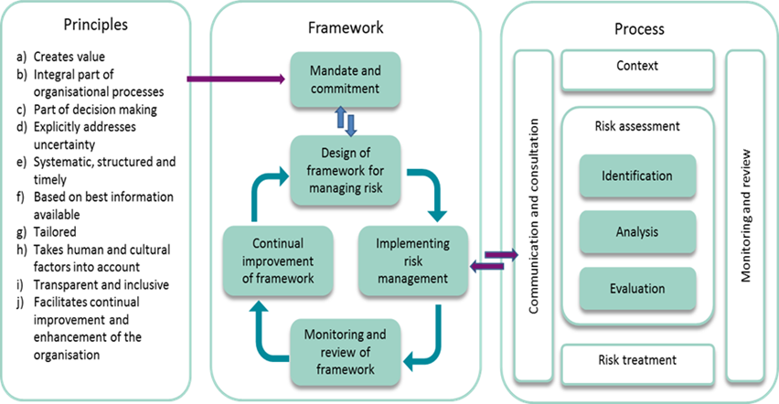

**Figure A. Relationships between risk management principles, framework and process.**

**Annex B**

**Figure B - Cash Flow in CHF (March 2020)**



**Figure C - Financial Planning of the first loan (March 2020)**



**Annex C**

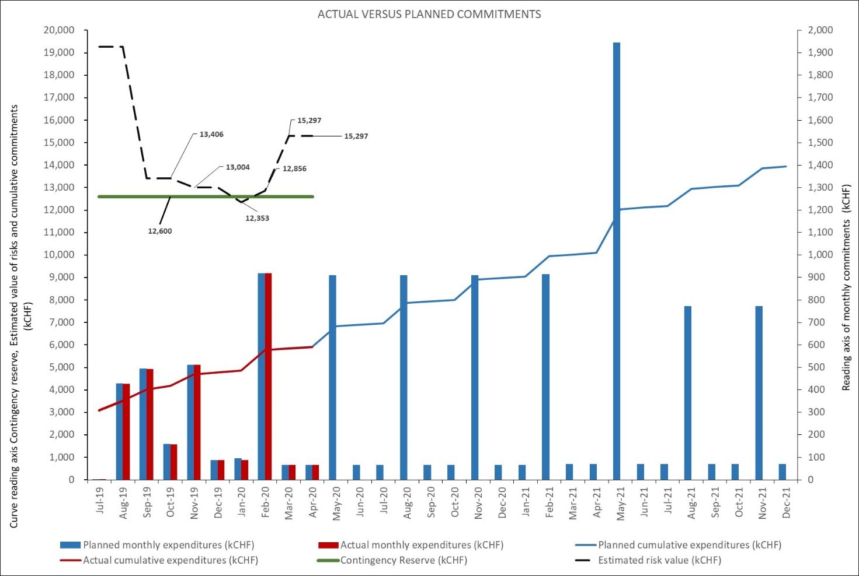

**Annex D**

**Table of anticipated indirect costs for 2020.**



1. Value engineering promotes the substitution of materials and methods with less expensive alternatives, without sacrificing functionality.
2. Value calculated on data from December 2019.
3. The calculation for a period about 10 years from April 1, 2020 to March 31, 2030.