|  |  |
| --- | --- |
| **Council Working Group on the Use of the six official languages of the Union** |  |
| **9th meeting, Geneva, 28 January 2019** |  |
|  |  |
|  | **Document CWG-LANG/9/2-E** |
| **13 December 2018** |
| **English only** |

**Report by the Secretary-General**

PURSUANT TO RESOLUTION 154 (REV. DUBAI, 2018)  
AND RESOLUTION 1372

The present report, submitted by the Secretary-General through the good offices of the CWG-LANG, aims at updating the ITU Council on the implementation of Resolution 154 (Rev. Dubai, 2018) regarding the use of ITU’s six official languages on an equal footing and adheres, further, to provisions in Council Resolution 1372, as revised in 2016.

In this session, the Council Working Group is invited to provide guidance as to the potential areas of interest for the implementation of Resolution 154 (Rev. Dubai, 2018) over the period 2019-2022 (See annex I).

The Secretariat is pleased to note that steady progress continues to be made on all fronts leading to full, equitable use of ITU’s six official languages, as evidenced below:

1. **Evolution of the budget for translation of documents to the six official languages of the Union since 2010**

As requested by CWG-LANG, budgetary figures for translation services are submitted broken down in three items: cost of translation, cost of associated services and total cost.

|  |  |  |  |  |  |  |  |  |  |
| --- | --- | --- | --- | --- | --- | --- | --- | --- | --- |
| **Budget** | **2010** | **2011** | **2012** | **2013** | **2014** | **2015** | **2016** | **2017** | **2018[1]** |
| Cost of translation | 9,581,423 | 8,655,905 | 9,030,507 | 8,188,442 | 9,860,763 | 9,819,529 | 8,249,744 | 8,432,974 | 8,210,178 |
| Associated costs | 6,732,789 | 6,633,103 | 5,901,474 | 5,545,850 | 5,841,177 | 5,841,094 | 5,645,752 | 5,716,247 | 5,258,170 |
| **Total Translation** | **16,314,211** | **15,289,009** | **14,931,981** | **13,734,291** | **15,701,940** | **15,660,623** | **13,895,496** | **14,149,220** | **13,468,348** |
| Interpretation | 3,011,402 | 2,116,911 | 4,396,547 | 1,943,702 | 3,242,056 | 3,743,931 | 2,027,299 | 2,228,510 | 2,435,145 |
| **Total Language services** | **19,325,613** | **17,405,920** | **19,328,528** | **15,677,993** | **18,943,996** | **19,404,554** | **15,922,795** | **16,377,730** | **15,903,493** |

Translation volumes continue to reflect full equality of treatment of all 6 ITU official languages.

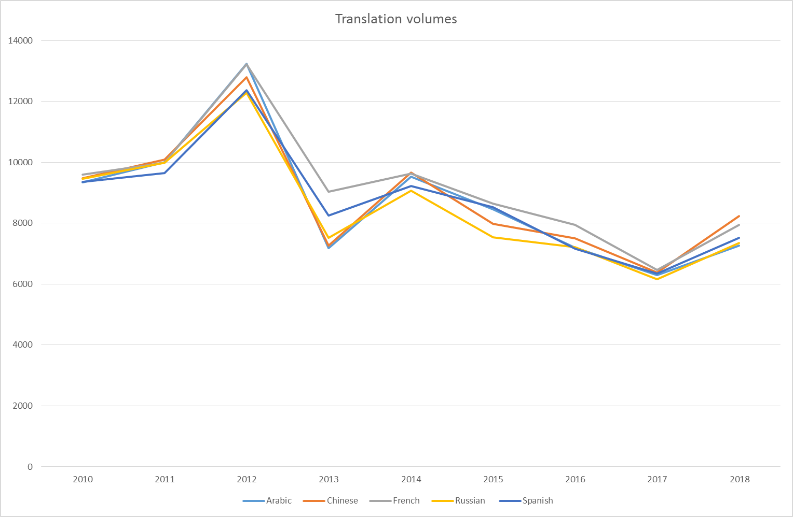

Translation output figures between 1 January 2018 and 30 November 2018 are as follows

|  |  |  |  |  |  |  |  |
| --- | --- | --- | --- | --- | --- | --- | --- |
|  |  |  |  |  |  |  |  |
|  | Arabic | Chinese | English | French | Russian | Spanish | **TOTAL** |
| Output translation | 7267 | 8239 | 1486 | 7952 | 7357 | 7597 | **39898** |

On average, almost **28%** of the work was outsourced. Translation operations continue to show consistent savings, with actual disbursements revealing savings of as much as **14%** for 2018.

**2. Procedures adopted by other international organizations inside and outside of the UnitedNations system and benchmark studies on their costs of translation**

Through its active participation in the International Annual Meeting on Language Arrangements, Documentation and Publications (IAMLADP) and its working groups and task-forces, plus the Joint Inter-Agency Meeting on Computer-Aided Translation and Terminology (JIAMCATT), ITU keeps abreast of procedures and IT tools adopted by other IOs and adapts its business model and procedures to the best practices resulting from such interaction.

The 2018 International Annual Meeting on Language Arrangements, Documentation and Publications (IAMLADP) took place in Montreal, Canada, from 26 to 28 June.

IAMLADP members noted that the full implementation of the multilingualism mandates remained a challenge for international and intergovernmental organizations. Innovation had become essential for member organizations to be able to adapt to evolving demands and stay ahead of the changes in the environment in which they operate. IAMLADP members also noted the importance of ensuring the accessibility and sustainability of their conference services and the inclusiveness of their communications through specifically dedicated resources.

**3. Initiatives undertaken by the General Secretariat and the three Bureaux to increase efficiencies and cost savings on the implementation of Res.154 (Rev. Busan, 2014) and Res. 1372**

**Document Production System**: The Secretariat notes that the roll-out of the basic version of DCPMS, the Document Production System developed by UNODC in Vienna mentioned in previous reports, took place in July 2017, and its customization started in early 2018:

* In the course of 2018, DCPMS content moved from the structure in UN Vienna to a new team in UN New York, where they are developing a new document workflow software - GDoc2.0. This move has made impossible the further implementation/customization of DCPMS in ITU.
* GDoc2.0 will be implemented across UN offices during 2019 and will become available to their other clients during 2020.
* As a consequence, ITU will keep working in parallel with the two document workflow systems (DPS for documents and DCPMS for publications and Recommendations) until the full implementation of GDoc2.0.

**Use of external sources for translation – The optimum mix:** The translation of documents is provided by C&P, using either internal staff (permanent, fixed term and short-term) or external collaborators (individuals, companies and organizations), or a combination of the two, with a view to ensure timely delivery, cost effectiveness and required quality levels.

**4. Alternative translation procedures**

Council-17 decided to establish an internal committee of the Union, the **Group on Study and Evaluation of the Translation Procedures**, chaired by the Deputy Secretary-General to consider the implementation of the best and most economically effective solutions to the provision of translation and simultaneous interpretation services at an appropriate cost, while maintaining quality of service; to study making use of approved external sources to translate Union documents. The Group met in January 2019, and its report is included in Annex II to this document.

The Union is constantly evaluating, testing and implementing viable and innovative translation procedures. In addition to outsourcing of translation work to recognized translation companies and freelance translators through calls for tender, significant progress is noted in the areas below:

* With regards to the current **machine translation project**, statistical machine translation is now in full production and available in all language pairs, translators have easy access via an add-in. Neural MT models are currently being prepared and will be published shortly for public use as well as in the translators’ toolkit.
* The recent round of negotiations on the Agreement between the UN/CEB and the AIIC (*Association Internationale des Interprètes de Conférence*) was held in November 2018, aiming at putting in place a new Agreement which can be effective in early 2019. However, the work has not been finalized yet.

1. **Progress made on the implementation of measures and principles for translation and interpretation adopted by the Council in its 2014 session**

The measures and principles for translation and interpretation, as adopted by Council in 2014 and 2016, are systematically considered by the secretariat as a benchmark in the delivery of translation and interpretation services for ITU conferences, meetings, documents and publications.

To this end, all preparatory and in-session documents, including the provisional Final Acts, were delivered in the six official languages for the **PP-18**. Final versions of the outcome documents for **WTDC-17** were also published in all six languages. A schedule is being prepared for the delivery of all relevant preparatory documentation in six languages for the **CPM19-2** with a view to the **RA** and the **WRC** in October-November of 2019.

TSB continues to translate **Recommendations approved under the Alternative Approval Procedure (AAP)** within the limits of available translation budget, and in accordance with requests received from the linguistic groups and the ITU-T study groups. The table below reflects the number of Recommendations and English pages whose translation was requested into the various languages in the reporting period. Ten additional translations into Russian (not shown in the table) that were requested to C&P before the reporting period are expected to be posted end 2018.

|  |  |  |  |  |  |  |  |  |  |
| --- | --- | --- | --- | --- | --- | --- | --- | --- | --- |
| F | | S | | C | | A | | R | |
| Recs | Pgs | Recs | Pgs | Recs | Pgs | Recs | Pgs | Recs | Pgs |
| 14 | 710 | 14 | 710 | 14 | 710 | 14 | 710 | 8 | 455 |

1. **Use of languages on the ITU website**

As indicated in the previous report, all ‘level 0’ pages are now translated and published in the six languages. Between January and November 2018, a total of 182 webpages have been translated and are currently displayed in all languages. For 2019, in addition to the current translation requests, ITU website is moving from SharePoint to a new corporate website platform, starting with MyITU for Members. This will be simultaneously available in all 6 languages.

Annex I

**Areas of interest for the implementation of Resolution 154 (Rev. Dubai, 2018)   
over the period 2019-2022**

According to the *instructs the Council* of Resolution 154 (Rev. Dubai, 2018), the Council is required to:

1. consider proposals for the adoption by ITU of alternative translation procedures (*instructs the Council* 1);
2. analyze the application of the updated measures and principles for interpretation and translation adopted by the Council at its 2014 session (*instructs the Council* 2);
3. pursue and monitor specific operational measures (*instructs the Council* 3).

Therefore, as regards implementation of Resolution 154, the areas of interest for the Council over the period 2019-2022 could be:

1. Review of ITU documentation and publication services with a view to eliminating any duplication and to creating synergies (*instructs* 3)

2. Explore and implement all possible measures to reduce the size and volume of documents (page-limits, executive summaries, material in annexes or hyperlinks), and achieve greener meetings, when justified, without affecting the quality and content of the documents to be translated or to be published” (*instructs* 3) (PP Decision 5, Annex 2, item 8)

3. Implementation in ITU of the United Nations system objective of multilingualism (*instructs* 3)

4. Necessary measures for equitable use of the six languages on the ITU website in terms of multilingual content and user-friendliness (*instructs* 3)

5. Review, in collaboration with the Sector advisory groups, of the types of material to be included in output documents and translated (*instructs* 6)

6. Possible measures to reduce, without sacrificing quality, the cost and volume of documentation as a standing item, in particular for conferences and assemblies (*instructs* 7)

7. Statistics on use, download and purchase of the different language versions of ITU documents and publications (*invites Member States and Sector Members* 1).

8. Statistics on respect of deadlines for the submission of contributions that require translation to conferences. Assemblies and meetings of the Union (*invites Member States and Sector Members* 2).

Instructs 4 is achieved since 2015 (Doc. CWG-LANG/6/2)

Annex II

**Report of the Group on study and evaluation of the translation procedures**

**Introduction**

Council 2017 agreed to request the Deputy Secretary-General to preside over an internal committee, reporting to Council through the CWG-LANG, on alternative translation arrangements based on the proposal from the United Arab Emirates ([C17/108](https://www.itu.int/md/S17-CL-C-0108/en)).

The group has been established with the following terms of reference:

In collaboration with the Directors of the three Bureaux, and in consultation with the Council Working Group on Languages and the ITU regional offices:

1. Study the most economically effective solutions for the provision of translation and simultaneous interpretation services at an appropriate cost, while maintaining quality of service in general.
2. Investigate the use of approved external bodies and centres to translate ITU documents, in collaboration with Member States and regional offices.
3. Study the practice of other United Nations organizations in this regard.

Remote participation is made available for the Regional Offices to participate.

The group is composed of representatives of each Bureau, the General Secretariat Departments and the Regional Directors. This document provides a status report on the work of the group and invites CWG-LANG to offer its comments.

The group has dealt with the following issues:

1. Status of pilot projects on automatic translation, web content management, translation of webpages by Member States, remote interpretation
2. Practice of other United Nations organizations

**1 Status of pilot projects on automatic translation, web content management, translation of webpages by Member States, remote interpretation**

**Automatic translation:** ITU has already made available the automatic translation neural system developed in collaboration with WIPO, and has also evaluated an automatic translation neural system from a private company in Latvia. This NMT software is a cutting-edge tool, which quality is comparable to that of Google Translate. After applying an assessment protocol based on assessment of human translators, the conclusion was that, as a stand-alone solution, this tool could not increase productivity[2], for various reasons (low accuracy, higher risk of error (output looks, sometimes deceptively, fluent) , low legibility), text in graphics and figures remains untranslated, and the technology offers no solution at all for documents published with revision marks, which represents a significant proportion of ITU translation workload (30-40%). The vendor received the detailed assessment report and found it most useful for their developers to work on future improvements.

**Pilot test of a New Content Management System (PP-18 CMS) for translation of PP webpages:** This is an ITU pilot project for simultaneous publication of webpages in the six official languages of the Union, in equal terms of functionality and navigation (ITU Council Resolution 1372).The PP-18 CMS was designed to be a simple yet powerful and flexible content management system, to simplify content lifecycle processes and to allow content contributors to focus on what they do best in their specific roles. The test was performed before and during the PP-18, and provided useful information to further develop and adapt the tool to ITU’s needs. A new version will be developed and tested in the near future.

**Pilot project for the translation of webpages with the help of some administrations:** Council 2018 authorized the Secretariat to conduct a trial for the translation of webpages with the help of some administrations, in which the responsible Member States would verify themselves[3] whether the quality of translation is sufficient and, if so, the translated webpages would be directly posted on the ITU website by the secretariat. As for this trial, the secretariat has not yet received enough feedback and is therefore unable for the time being to properly assess the results.

**Remote interpretation**: Council-15 had instructed the Secretary-General and the Directors of the Bureaux “to study the use of remote interpretation in consultation with CWG-LANG”. The Group on Study and Evaluation of the Translation Procedures will look into the feasibility of conducting a trial in remote interpretation in 2019.

**2 Practice of other United Nations organizations**

The 2018 Joint Inter-Agency Meeting on Computer-Assisted Translation and Terminology (JIAMCATT) took place at the United Nations Office in Geneva, from 7 to 9 May, and C&P sent its representatives; this year’s theme was “From end to end: tools and technologies as links in the chain”. C&P also attended the first Geneva local JIAMCATT held at ILO. Topics of special interest discussed were document management software and the use of NMT in translation tools.

JIAMCATT reports to IAMLADP’s Working Group on Language Services, and is a community of interested professionals from both UN and non-UN organizations, seeking to harness technologies and share knowledge to help streamline the translation and interpretation processes.

Through IAMLADP, ITU keeps abreast of procedures and IT tools adopted by other IOs and adapts its business model and procedures to the best practices resulting from such interaction.

______________

1. As of 30 November 2018.
2. An increase in productivity should mean that the tool enables the translator/reviser to produce more pages/day with the same quality level.
3. With oversight and assistance by the Secretariat