Council Working Group on WSIS&SDG
34th meeting – Geneva, 25 September 2019
Document CWG-WSIS&SDG-34/008-E
26 July 2019
English only
United Nations Group on the Information Society (UNGIS)
- UNGIS’ objective is to develop extensive collaboration and partnerships among the Chief Executives Board (CEB) members in order to contribute to the achievement of the WSIS objectives, to help to maintain ICT-related issues as well as science and technology at the top of the UN Agenda and finally to mainstream ICT for Development issues in the mandate of CEB members.

- UNGIS Members, led by the Co-Chairs and Vice Chairs are continue to follow up on the Para 12 of the UNGA Resolution A/RES/70/125 “… United Nations entities facilitating the World Summit on the Information Society action lines requested to review their reporting and work plans to support implementation of the 2030 Agenda”.

Annual Meetings:

- UNGIS High-level Leaders Breakfast and UNGIS Working-level Meeting were held as an integral component of the WSIS Forum 2019. The 31 members of the group, which serves as an interagency coordinator of the implementation of WSIS outcomes, discussed concrete activities to be undertaken in 2019 in order to highlight the importance of ICTs in meeting the Sustainable Development Goals (SDGs).

- UNGIS Contributions to the High-level Political Forum (HLPF) 2019 highlighting the linkages between the WSIS Action Lines and SDGs were also discussed. ITU and UNDP were appointed as the UNGIS co-chairs for the year 2019-2020 and UNESCAP was appointed as the rotating vice-chair representing the UN Regional Commissions.

- UNGIS High-level Breakfast meeting and Working-level meeting will be held as an integral component of the WSIS Forum 2020.

Joint Statement:

- UNGIS members had worked together towards a joint contribution for HLPF 2019 by issuing an UNGIS joint statement highlighting SDG Goal 17: Strengthen the means of implementation and revitalize the global partnership for sustainable development. The statement reiterates UNGIS’ commitment to advance collaboration and partnerships to help propel and accelerate the achievement of the SDGs by leveraging ICTs. UNGIS join statement is available at: https://www.ungis.org/Portals/0/documents/HLPF2019/UNGIS-HLPF2019Input.pdf

UNGIS for Digital Transformation at the HLPF 2019:

- UNGIS organised a side event titled “Fostering digital transformation and global partnerships for SDG achievement [Aligning WSIS process with the 2030 Agenda for Sustainable Development]”and an UNGIS Technical Meeting on the 11th of July 2019 in New York at the HLPF 2019.

Summary Report of the side event:

- UNGIS organized this side event to 1) enhance understanding of digital transformation as a sustainable development imperative; 2) rally stakeholders on the need for greater cooperation to help achieve the SDGs; and 3) to convey UNGIS readiness as an interagency mechanism for delivering coordinated support to Member States.

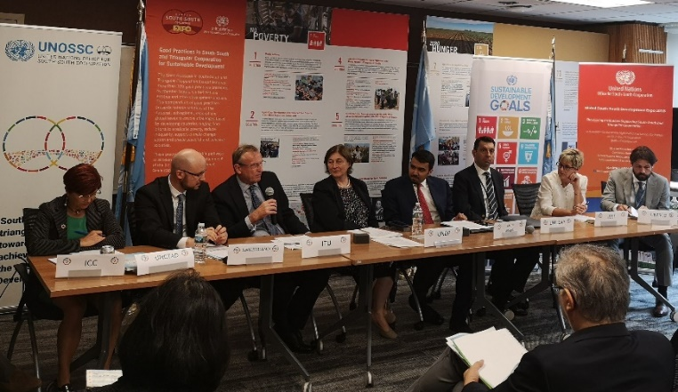
- More than 75 participants from across the UN system and beyond joined experts, representatives of governments, and stakeholders from across sectors. Panelists involved WSIS stakeholders, who spoke on the wide range of efforts that advance the SDGs as well as raised key priorities for action. Many underlined the need to develop policies and strategies that leverage digital transformation to propel progress, update regulations to fit the new digital landscape across sectors and economies, as well as increase investments in digital development particularly in countries that are lagging behind.

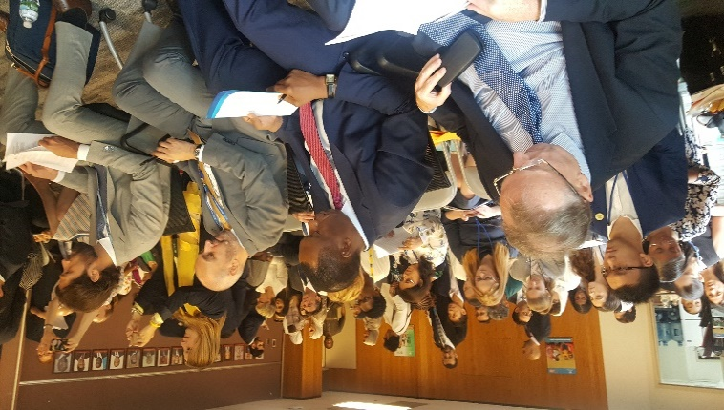
- Panelists representing stakeholders also pointed out the importance of regional-level cooperation, citing how the implementation of WSIS outcomes in Asia-Pacific and Africa (as shared by UNESCAP and UNECA) are advancing the SDGs. Many raised case studies and examples underway across countries, which show how ICTs are integrated in development efforts; the significant need to mobilize digital solutions and engage the digital community to help finance the SDGs; the growing importance of digital finance, digital trade and e-commerce in the inclusive growth of economies; and the need to tackle issues related to youth, gender, ageing and persons with disabilities, establishing stakeholders not only as beneficiaries of efforts but as drivers and co-designers of solutions to their unique needs.
- The event was hosted by Saudi Arabia and UNOSSC and organized by ITU and UNDP as co-chairs of UNGIS. It was designed to welcome and enable engagement among stakeholders, and was opened by a lunch hosted by Saudi Arabia.
Photographs of the event are available at: https://www.flickr.com/photos/itupictures/albums/72157709671333027

UNGIS Technical level meeting:

- ITU and UNDP chaired this special edition of the Technical UNGIS meeting as the UNGIS co-chairs.

- The members spoke about rebranding the group to include “digital transformation” in the name. It was agreed that a tag line of “UNGIS for Digital Transformation” will be added to the UNGIS activities and website.

- It was decided that the UNGIS website will be upgraded and will be designed to be more interactive by ITU and the co-chairs will collect all the information on projects by UNGIS members on Digital Transformation.

- Efforts to reduce duplication of work were discussed.

- It was decided that a permanent section on the WSIS Flash newsletter will be reserved for UNGIS members to make their monthly announcements.

- Participants agreed the UNGIS members should analyse SGs report on Digital Cooperation and identify the tasks and roles of UNGIS could play.

- It was agreed that UNGIS should hold high-level meetings in September during the SDG Summit and the 2nd committee of the UNGA in December.

Creation of a Repository of the activities of UNGIS Members in the area of Digital Transformation to Achieve the SDGs:

- The UNGIS website is currently being redesigned to make it more interactive and also to add new feature, such as the repository of projects by UNGIS members on Digital Transformation. This would serve as a reference guide and repository of UN Agencies on different initiatives implemented by them on ICTs for development/digital transformation.

Current Co-Chairs of UNGIS: ITU and UNDP
Vice Chairs: UNESCO, UNCTAD and UNESCAP

