Council Working Group on WSIS&SDG
34th meeting – Geneva, 25 September 2019
Document CWG-WSIS&SDG-34/007-E
Revision 1
20 August 2019
English only

World Summit on the Information Society (WSIS) Prizes (2019 and 2020)

During the WSIS Forum 2019 (8-12 April, Geneva), the International Telecommunication Union (ITU) announced the top 90 winning ICT-related projects and initiatives recognized for implementing the WSIS Action Lines, competing for the prestigious WSIS Prizes 2019. With participants emerging from across the globe, 72 champions were honoured and 18 winners awarded for each of the 18 categories in line with the WSIS Action lines and their impact on the Sustainable Development Goals (SDGs). Since 2012, WSIS Prizes has been recognising remarkable efforts made by entities and organisations from around the globe that focus on accelerating socio-economic progress of the whole world as a community. See Annex 1 for list of WSIS Prizes 2019 Winners and Champions.

The submission phase which began from 2 July 2018 to 12 December 2018 received a record number of 1,141 project submissions, out of which 1,062 exceptional projects were nominated for WSIS Prizes 2019. More than two million online votes were cast from 21 December 2018 till 10 February 2019 for these projects and following a comprehensive review by the Expert Group lead to the selection of 90 extraordinary ICT initiatives for the eight edition of the WSIS Prize contest. For a full list of this year's WSIS Prizes Awardees, click here. WSIS Prizes 2019 Winners project descriptions were published in the publication WSIS Stocktaking: Success Stories 2019.

Due to the increased interest from the previous WSIS Prizes winners and champions, alongside with the existing policy of the WSIS Prizes process to continuously promote their achievements and track the further development of the awarded projects, WSIS Team has held a special session at the WSIS Forum 2019 with the objective to bring together the winners and champions (2012-2019). As a result of this meeting, former WSIS Prizes awardees have proposed to establish a WSIS Prizes Network, which form a key part of our global and grassroots community, with an objective to be engaged in online and community advocacy, while providing input related to the future progress of the contest and promotion of ICTs for SDGs.

For the eight year in a row, the WSIS Prizes 2020 will be recognizing outstanding success stories from around the world for their part in building an inclusive information society. Our common objective is to inspire and advance sustainable development through the effective use of ICTs. Building upon the outcomes of the United Nations General Assembly Overall Review on WSIS as well as the 2030 Agenda for Sustainable Development, the WSIS Prizes 2018 seek to reflect close linkages with achieving the Sustainable Development Goals (SDGs).

ECOSOC resolution 2018/28 also reiterates the importance of recognizing excellence in the implementation of the projects and initiatives that further the WSIS goals, and encourages all stakeholders to nominate their ICT-related projects for the annual WSIS Prizes contest as an integral part of the WSIS Stocktaking process (www.wsis.org/stocktaking).

In order to process the submission, stakeholders are requested to complete the submission form for WSIS Prize 2020 online at www.wsis.org/prizes by 22 November 2019. All stakeholders are urged to encourage their networks to join the WSIS Prizes process. The contest is organized in five phases with Nomination phase starting from 23 November and resulting with 360 nominated projects (20 projects will be nominated in each WSIS Action Line Category) for the Online Voting phase planned to start on 20 December 2019 and ending on 4 February 2020.

Based on constructive recommendations and input received from the ITU Membership and the WSIS stakeholders, we are introducing innovations to further improve the contest highlighting social, economic and environmental impact of the submitted projects. In the Submission phase, we are introducing an updated submission form in order to better guide project owners when submitting entries using more detailed questionnaire and ensuring that Rules and Guidelines are respected.

Due to a large number of nominations in 2019 (1.062) we have received an input to limit this number to a reasonable level in order for the voters to be able to review all projects and cast their votes based on social , economic and environmental impact of the projects. In this respect, the Expert Group, professionals working on the implementation of WSIS outcomes, will review the submitted projects in the Nomination Phase referring to the rules for project submission and nomination criteria and the outcome will be a list of nominated projects (twenty projects per category) that will be announced to the public on 21 December 2019.

Finally, following the deadline for the online voting, 24 January 2020, the voting process, will result in identifying five projects with the highest number of appreciations/votes given for project descriptions by WSIS stakeholders. The voters are encouraged to vote keeping in mind the social, economic and environmental impact of the projects. During the Selection Phase, 25 January – 7 February 2020, the Expert Group will make in-depth analyses of five most voted projects per category and will select one winning project per category, taking into account scale and impact of the project on the implementation of the WSIS outcomes and its contribution to the sustainable development. The outcome of the Expert Group’s work will be the list of eighteen winning projects that will be publicly announced during the WSIS Forum 2020 only.

Should you have any questions or need for assistance with WSIS Prizes 2020 contest, please do not hesitate to contact the WSIS Team at wsis-prizes@itu.int.
_______________

Annex 1
An Integral Part of the WSIS Stocktaking
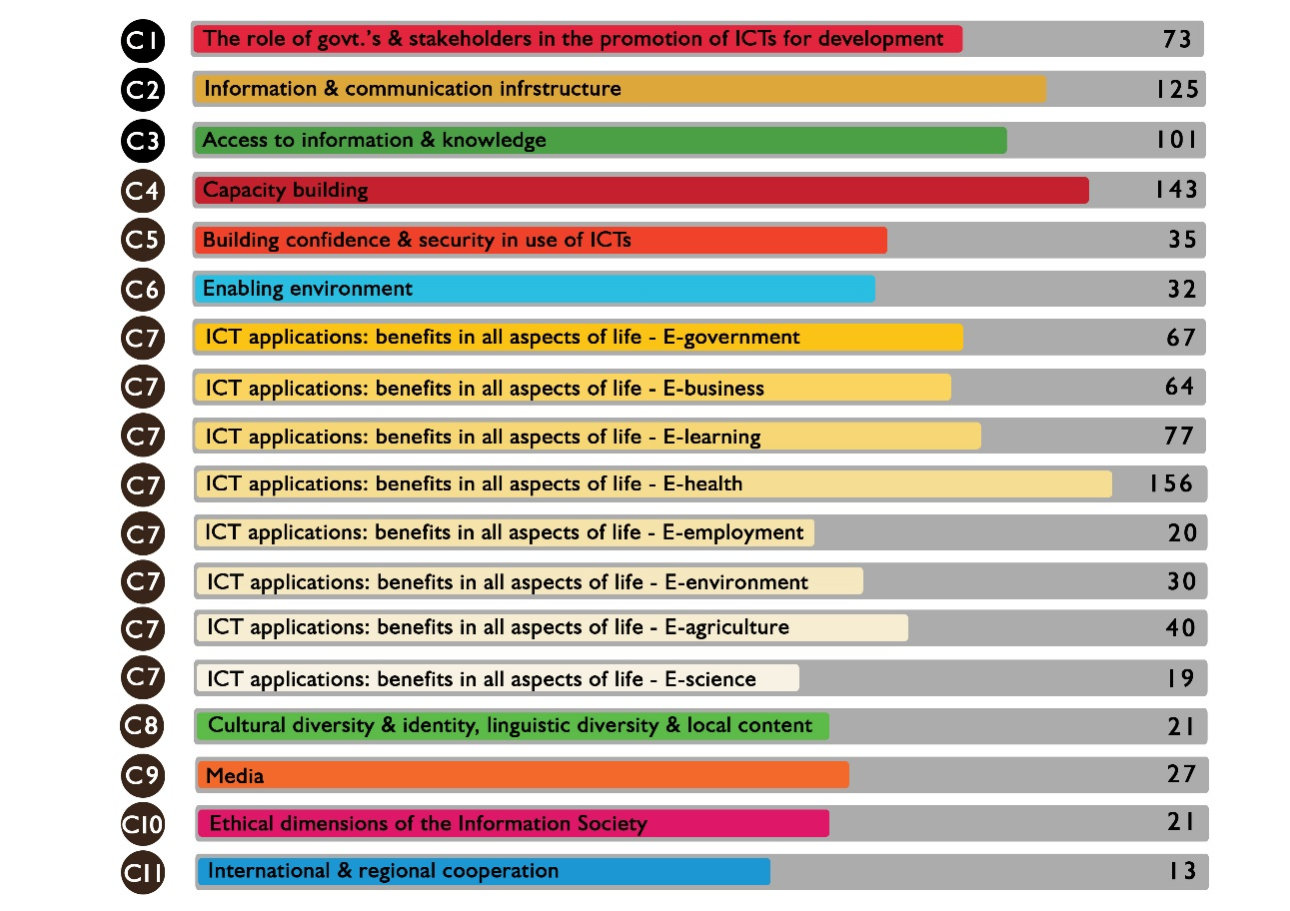
Most globally recognized contest awarding best ICT practices for SDGs
Category 1 : Role of governments and all stakeholders in promotion of ICTs
The e-payment of social security contributions | National Social Insurance Fund (CNAS) | Algeria | Government | WINNER
Empowering Women through Technology | United for Hope | India | International Organization | CHAMPION
Citizen’s portal in Pinar del Río | Computer Applications Company, DESOFT | Cuba | Civil Society | CHAMPION
ICT for Girls Program | Universal Service Fund | Pakistan | Government | CHAMPION
EyeBorg | Hand Eyes | Ecuador | Civil Society | CHAMPION

Category 2 : Information and Communication Infrastructure
The Village Broadband Internet Project | Ministry of Digital Economy and Society | Thailand | Government | WINNER
Development of National ICT Infra-network (Info-Sarker) project | Bangladesh Computer Council | Bangladesh | Government | CHAMPION
Digital Assistant takes your work to new heights (myhome 3.0) | Saudi Aramco | Saudi Arabia | Private Sector | CHAMPION
Rural Communities into Gigabit Society | Digital Poland Project Centre | Poland | Government | CHAMPION
Technology for Education | Fundación Sergio Paiz | Guatemala | Civil Society | CHAMPION
Category 3 : Access to Information and Knowledge
United libraries portal - free knowledge for all | St. Petersburg State Unitary Enterprise "St. Petersburg Information and Analytical Centre" | Russian Federation | Government | WINNER
Public Security Video Surveillance Cloud Platform | China Communications Technology Co., Ltd. | China | Private Sector | CHAMPION
Smart Police Mobile Application | CENTRAL INFORMATICS BUREAU | Mauritius | Government | CHAMPION
DBD Business Data Warehouse | Department of Business Development | Thailand | Government | CHAMPION
Presidential Communication Center | Presidency Of the Republic Of Turkey Directorate of Communications | Turkey | Government | CHAMPION
Category 4 : Capacity Building
Capacity Building through end-to-end ICT enabled “Utkarsh Bangla” programme | Paschim Banga Society for Skill Development, Dept of Technical Education, Training & Skill Development, Govt. of West Bengal | India | Government | WINNER
Mark Robots | Mark Robots | Uruguay | Civil Society | CHAMPION
ICT Public Training Administration & Service Center for Hi-skilled Workers | China Communications Technology Co., Ltd. | China | Private Sector | CHAMPION
RURALTIC | Computadores para Educar | Colombia | Government | CHAMPION
Innovation Summer Camp | Telecommunications Regulatory Authority | United Arab Emirates | Government | CHAMPION

Category 5 : Building confidence and use of ICTs
Data Encryption Leak-proof and Tamper-resistant Network System Based on Quantum Communication Trunk Line | China United Telecommunications Co., Ltd. |  | China |  | Private Sector | WINNER
The Computer emergency response team in financial sphere | The Central Bank of the Russian Federation (Bank of Russia) |  | Russian Federation |  | Government | CHAMPION
Artificial Intelligence (AI) based spam messages and calls prevention solution | China Mobile Communications Corporation |  | China |  | Private Sector | CHAMPION
Online Sexual Harassment-and-Blackmail Awareness for Palestinian Schoolgirls (iSHA) | Palestine Chapter of the Internet Society |  | United States of America |  | International Organization | CHAMPION
Identity Digital Watermarking | Saudi Aramco |  | Saudi Arabia |  | Private Sector | CHAMPION
Category 6 : Enabling Environment
Establishment of Bangladesh National Digital Architecture (BNDA) and e-Government Interoperability Framework (e-GIF) | Bangladesh Computer Council | Bangladesh |  |  | Government | WINNER
My PY Portal | Common First Year – King Saud University | Saudi Arabia |  |  | Government | CHAMPION
Speaking Library | Data Processing Center | Azerbaijan |  |  | Government | CHAMPION
Digital accessibility for all | Office of Electronic Communications | Poland |  |  | Government | CHAMPION
Women In Tech Africa | Women In Tech Africa | Kenya |  |  | International Organization | CHAMPION
Category 7 : eGovernment
Licenses Portal | Ministry of Environment Water & Agriculture |  | Saudi Arabia |  | Government | WINNER
Sabooj Sathi Online 2.0 - wheels of change | BACKWARD CLASSES WELFARE DEPARTMENT |  | India |  | Government | CHAMPION
Midterm and Final e-Exam Booking System | Majmaah University |  | Saudi Arabia |  | Government | CHAMPION
The Public Service Centers «My Documents» | Ministry of Economic Development of the Russian Federation |  | Russian Federation |  | Government | CHAMPION
E-Police in your Mobile | Ministry of Interior |  | United Arab Emirates |  | Government | CHAMPION
Category 8 : eBusiness
BnC Bot | BnC Bot (Bot Bán Hàng as Vietnamese name) |  | Viet Nam | Private Sector |  | WINNER
Nuara E2 - Effective and Efficient | Nuara Group |  | Brunei Darussalam | Private Sector |  | CHAMPION
BaktikuPadaPetani | PT. Telekomunikasi Seluler Indonesia |  | Indonesia | Private Sector |  | CHAMPION
Dataforest | Dataforest |  | Azerbaijan | Private Sector |  | CHAMPION
Mobile Money Platform | Huawei Technologies Co., Ltd |  | China | Private Sector |  | CHAMPION
Category 9 : eLearning
Generative Schools | University of La Punta |  | Argentina |  | Academia | WINNER
Data Bojonegoro | ICT volunteers Bojonegoro |  | Indonesia |  | Civil Society | CHAMPION
Teachers’ Portal | Access to Information |  | Bangladesh |  | Government | CHAMPION
The System of Road Traffic Safety Awareness “Salik” | Majmaah University |  | Saudi Arabia |  | Government | CHAMPION
Sustainable ICT model for educational Institutions | Arpuda App Private limited |  | India |  | Private Sector | CHAMPION
Category 10 : eHealth
E-Health Mato Grosso (Telessaude Mato Grosso | Ministry of Health |  | Brazil |  | Government | WINNER
Automated and Computerized Protein Determination in Latex Glove | Multimedia University |  | Malaysia |  | Academia | CHAMPION
Protect My Environment | Ministry of Environment Water & Agriculture |  | Saudi Arabia |  | Government | CHAMPION
Blood Donation Application | Majmaah University |  | Saudi Arabia |  | Government | CHAMPION
SMART HOME | COMSATS University Islamabad |  | Pakistan |  | Academia | CHAMPION
Category 11 : eEmployment
Digital Jobs Africa | The Rockefeller Foundation |  | United States of America |  | International Organization | WINNER
Work Wizard the digital platform for disability | Advanced Info Service |  | Thailand |  | Private Sector | CHAMPION
Women Power - A sustainable Rural Development initative | Women Power International Foundation |  | India |  | International Organization | CHAMPION
Connected Women | Connected Women |  | Philippines |  | Private Sector | CHAMPION
I-recruitment | Ministry of Human Resources and Emiratisation |  | United Arab Emirates |  | Government | CHAMPION
Category 12 : eEnvironment
A less intrusive rhinos conservation, a hope for endangered species | Sigfox Foundation |  | France |  | Private Sector | WINNER
Caribbean Climate Innovation Center | Caribbean Climate Innovation Center |  | Jamaica |  | Private Sector | CHAMPION
E- Climate justice and resilience through Community Radio at coastal areas of the Bay of Bengal in Bangladesh | Bangladesh NGOs Network for Radio and Communication |  | Bangladesh |  | Civil Society | CHAMPION
e-License Program | Federal Authority for Nuclear Regulation |  | United Arab Emirates |  | Government | CHAMPION
Smart Mobile Apps Project - Emergency Alert App | Central Informatics Bureau |  | Mauritius |  | Government | CHAMPION
Category 13 : eAgriculture
Swift Vee (Livestock) | mLab Southern Africa |  | South Africa |  | Civil Society | WINNER
Geo data to control late blight fungal disease in potato in Bangladesh | mPower Social Enterprise Ltd. |  | Bangladesh |  | Private Sector | CHAMPION
e-Agriculture ,, Partnership for Community Development and SDGs Achievement | Gedaref Digital City Organization Sudan GDCO |  | Sudan |  | Civil Society | CHAMPION
Baktiku Negeriku | PT. Telekomunikasi Seluler Indonesia |  | Indonesia |  | Private Sector | CHAMPION
COMBATTING FOOD INSECURITY THROUGH REMOTE SENSING TECHNOLOGY | AgroGeoBW |  | Botswana |  | Private Sector | CHAMPION
Category 14 : eScience
IRAN National Research and Education Network | IRAN National Research and Education Network |  | Iran (Islamic Republic of) |  | Private Sector | WINNER
Scientists 3.0: children and adolescents | San Luis government |  | Argentina |  | Government | CHAMPION
National Research information system | Ministry of Education and Science |  | Latvia |  | Government | CHAMPION
Smart Meter | Services Industriels de Genève |  | Switzerland |  | Private Sector | CHAMPION
Digital Humanities and the Arabic-Islamic corpus | The Netherlands eScience Center |  | Netherlands |  | Academia | CHAMPION
Category 15 : Cultural Diversity and Identity, Linguistic Diversity, and Local Content
Uganda Computer Aid | Musabe Foundation |  | Uganda |  | Civil Society | WINNER
IT For The Differently Able | Bridge Foundation |  | Bangladesh |  | Civil Society | CHAMPION
Social Intelligence | Information Age Consulting |  | Kuwait |  | Private Sector | CHAMPION
Together | Association Wlad Elblad |  | Morocco |  | Civil Society | CHAMPION
Information Platform for Indigenous Communities and Peoples | Instituto Federal de Telecomunicaciones |  | Mexico |  | Government | CHAMPION
Category 16 : Media
Working in ICT is cool | Chamber of Information and Communication Technologies (Cámara de Tecnologías de Información y Comunicación) |  | Costa Rica |  | Private Sector | WINNER
Creating Awareness on E- Right to Information (E-RTI) through Community Radio | Bangladesh NGOs Network for Radio and Communication |  | Bangladesh |  | Civil Society | CHAMPION
Girls Speak Out | Girls Speak Out |  | Zimbabwe |  | Civil Society | CHAMPION
Internet Hotline | NATIONAL MEDIA AND INFOCOMMUNICATIONS AUTHORITY |  | Hungary |  | Private Sector | CHAMPION
Bridge the gap between science and society using interesting content on website and social media | Saintif |  | Indonesia |  | Private Sector | CHAMPION
Category 17 : Ethical Dimensions of the Information Society
Artificial Intelligence (AI) Governance and Ethics Initiatives in Singapore | Personal Data Protection Commission, Infocomm Media Development Authority | Singapore | Government | WINNER
“Mobile Based Age Verification before Marriage Registration to Stop Child Marriage” | Access to Information | Bangladesh | Government | CHAMPION
Why do I exist? | Kuki Ndiho Rwanda Orphans Support Project | United States of America | International Organization | CHAMPION
DataSense | Cognigo Inc. | United States of America | Private Sector | CHAMPION
Women / Research / Data | Women Research Data | Kenya | Private Sector | CHAMPION
Category 18 : International and Regional Cooperation
UAE Space Agency Global Efforts in Partnership Sustainable Development | UAE Space Agency | United Arab Emirates | Government | WINNER
Rlabs | Rlabs | South Africa | Private Sector | CHAMPION
Technology Innovation Hubs | Indigo Trust | United Kingdom | International Organization | CHAMPION
Information Society Innovation Fund | Information Society Innovation Fund | Australia | Civil Society | CHAMPION
CodeBus Africa | Aalto Global Impact | Finland | Private Sector | CHAMPION

