|  |  |
| --- | --- |
| **Council Working Group on Financial and Human Resources Ninth meeting - Geneva, 29-30 January 2019** |  |
|  |  |
|  |  |
|  | **Document CWG-FHR 9/11** |
| **21 January 2019** |
| **English only** |

**Human Resources Strategic Plan (HRSP) Process**

|  |
| --- |
| **Summary**  Resolution 48 (Rev. Dubai, 2018) instructs the Secretary-General to prepare and implement, with the assistance of the Coordination Committee, and in collaboration with the Regional Offices, a four (4)-year Human Resources Strategic Plan (HRSP) aligned with the ITU strategic and financial plans, to respond to the needs of the Union, its membership and its staff  **Action required**  The ITU Secretariat will present to the 2019 Council session the HRSP for approval.  References  *Plenipotentiary Resolutions* *48* |

# 1 Background

The Plenipotentiary Conference of the International Telecommunication Union (Dubai, 2018) instructed the ITU Secretary General to prepare and implement, with the assistance of the Coordination Committee, and in collaboration with the Regional Offices, a four (4)-year Human Resources Strategic Plan (HRSP) aligned with the ITU strategic and financial plans, to respond to the needs of the Union, its membership and its staff.

As a result, the Human Resources Management Department (HRMD) has taken the lead in advising the ITU Secretary General on the HRSP’s format, design and implementation so as to address the issues reflected in Res. 48 (Rev. Dubai, 2018), particularly in Annex 1; and based on priorities being identified for supporting the ITU Strategic Plan as well as in alignment with the ITU Financial Plan 2020-2023.

The first step towards establishing the HRSP is the development of an **ITU People Strategy**, ***representing the foundation of the process***. The ITU People Strategy has been developed:

1. making reference to existing United Nations Common (UN) System[1], Plenipotentiary (PP)[2], Council[3], Management Coordination Group (MCG) documentation; recommendations from internal and external audits[4]; International Civil Service Committee’s Framework[5] as well as benchmarking with Human Resources (HR) Strategies of other international Organizations[6];.
2. taking into consideration the internal and external environment influencing (input) human resources management which is composed of three (3) mains sectors of influence: External Governance, ITU Governance & Internal Factors and External Factors, as shown in the visual below.

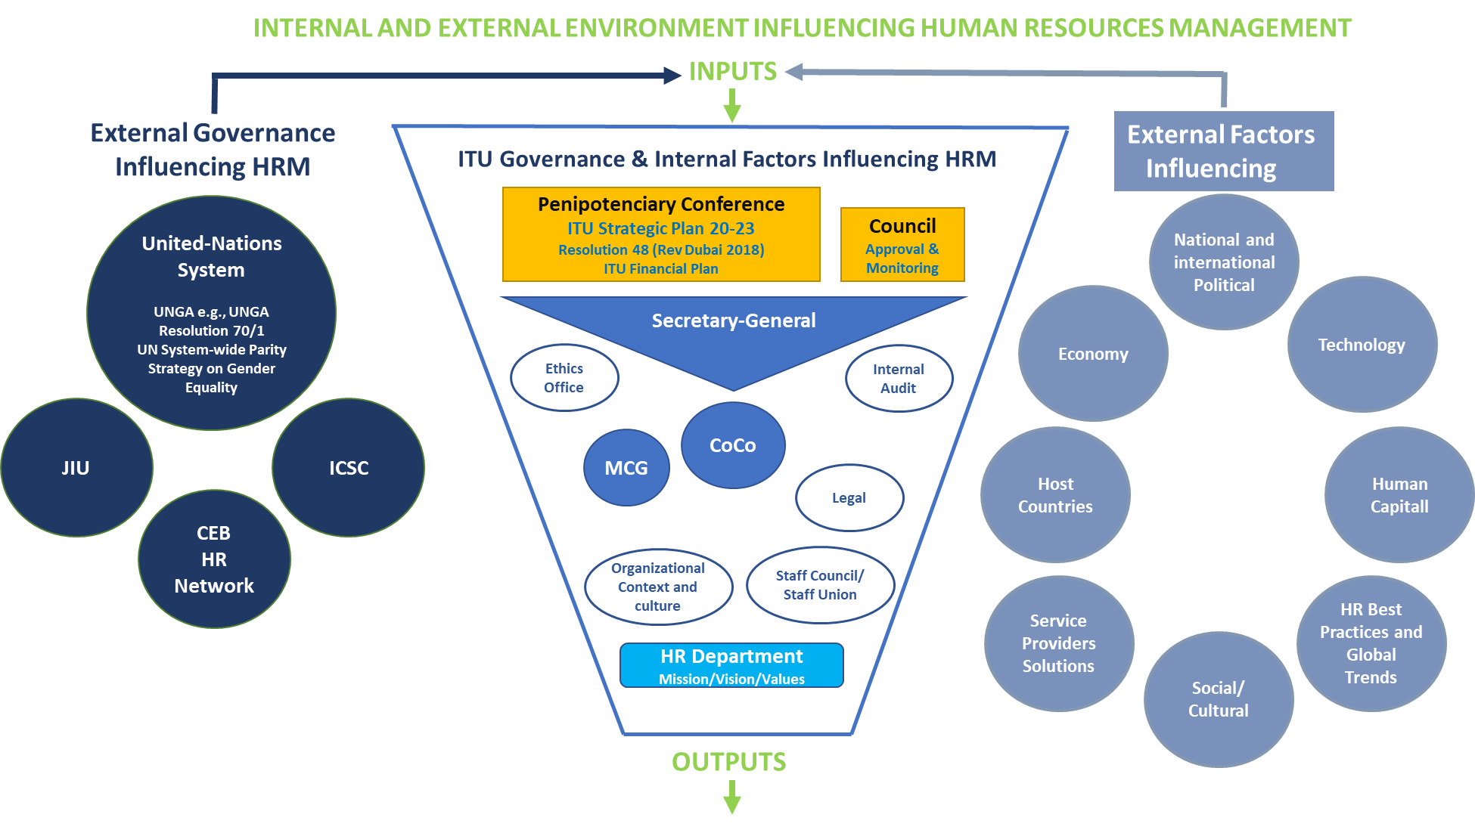

The ITU People Strategy is forward-looking and balances the need of the current operating climate at ITU with long-term priorities. ITU will strive to create a culture where people feel safe, heard and respected and where excellence and professionalism are expected.

Building on the ITU People Strategy, HRMD will conduct a consultation with the sectors in order to translate the priorities and goals of the ITU People Strategy (Pillar 1, 2, 3 and 4 as described in Section 5 of the Annexed ITU People Strategy 20-23) into an HRSP driven by the specific needs of the Sectors and in line with the overall ITU priorities and goals. This process will result in **HRMD Operational Plans, *ensuring a successful HRPS implementation***. Process and Timeframe are illustrated below:

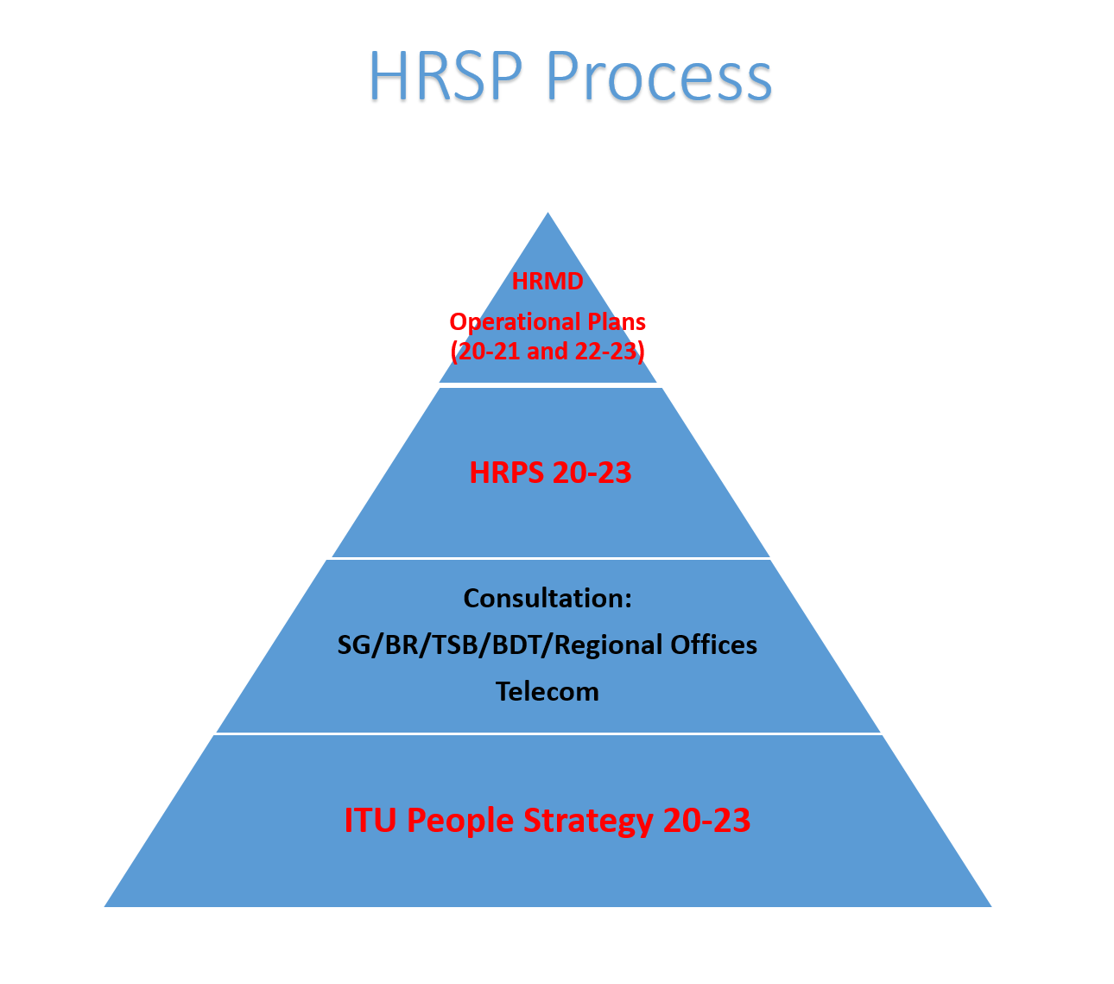

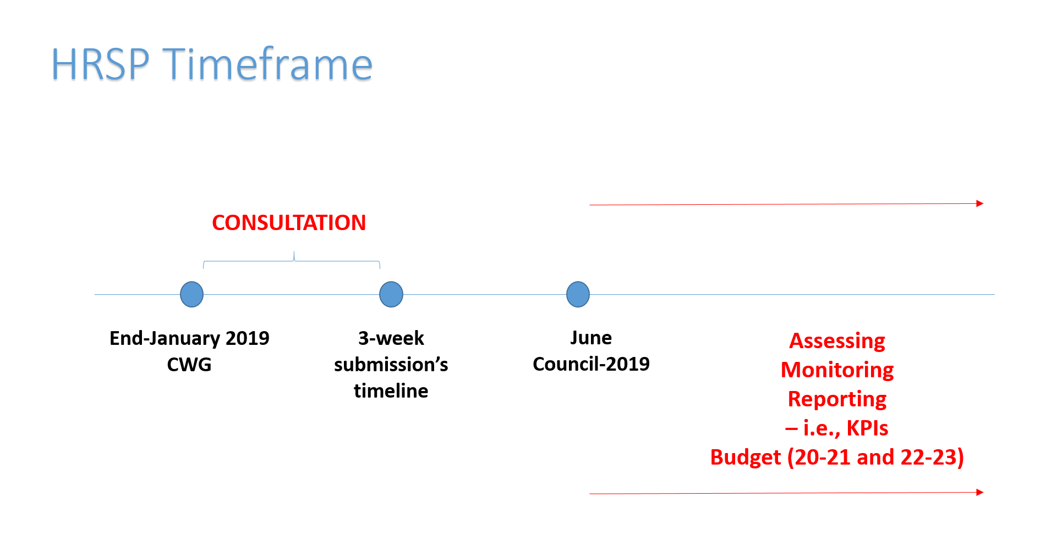

**Annex 1.** ITU People Strategy2020-2023

**Annex 2.** HRSP Consultation Template

**Annex 3.** HRPS Format





**Annex 1. ITU People Strategy 2020-2023**

# Strategic Context: People at the Center of the ITU Strategic Plan 2020-2023

# All UN Organizations are responsible to reporting to a large number of Member States, which decide on their missions and mandates. They are guided by the values set out in the *Charter of the United Nations, in particular Article 101,* referring to “the highest standards of efficiency, competence, and integrity” and in the various legal instruments that govern each organization.

# The ITU Strategic Plan 2020-2023 puts people at the center of its value-system. It states that ITU should be people-centered, service-oriented and results-based: being *people-centered*, ITU is focused on people in order to deliver results that matter to each and every individual. Being *service-oriented*, ITU is committed to further delivering high-quality services and maximizing the satisfaction of beneficiaries and stakeholders. Being *results-based*, ITU aims for tangible results and to maximize the impact of its work.

The ITU People Strategy aims to *attract, recruit and retain* the ablest staff across all sectors and to maintain and enhance ITU’s world leading reputation. *The increasing competition in a global market means we must continue to strive to be world leading in our approach to managing and developing our talented staff.* Collaboration between Human Resources and Business Organizational Units are crucial to the development of staff and the organization as a whole.

*ITU will implement the strategic goals of the Union for 2020-2023 through a number of objectives* to be attained in this period. The activities and support services of the General Secretariat and the Bureaus provide the *Enablers* to the work of the overall Union. *Human Resources Management represents an essential Enabler* to ensure the success of the Union.

# ITU Challenges: Global and ITU Change Management Context

*The ITU People Strategy supports the mission and values of ITU as they are described in the ITU Strategic Plan (2020-2023).* The ITU HR strategy is being conceived against a backdrop of challenges for the ITU, which calls for changes to its ways of working. Challenges such as the fact that the Information and Communication Technology sector is entering a period that will be characterized by transformation. The need for the ITU sectors to work towards a coordinated operational planning, avoiding redundancies and duplication and maximizing synergies across the sectors and Bureaux and the General Secretariat, determination to reach gender parity as an operational imperative across all grades by 2027 and the anticipated move to a new Headquarters Building and UN System-wide Reform. The 2015 United Nations staff well-being survey, answered by over 17 000 UN staff, showed that higher levels of perceived incivility and occupational conflict in the workplace and a lower level of job satisfaction were strongly associated with higher levels of reported mental health problems resulting in short and long term sick leave. To deliver successfully in this environment, ITU staff need to be fully engaged, not only in helping to shape the Strategy but also throughout the implementation of initiatives that will help improve the organization, create trust-based relationships and work harmony within the organization.

ITU need a culture change – to one that increases support for trust and collaboration. This will require leaders to adopt enabling leadership behavior, continuous feedback in order to unleash the talent and require staff to possess self-leadership skills: to take responsibility and ownership for common objectives.

The ITU People Strategy aims at ensuring that the ITU is an employer of choice, whilst providing a stimulating and rewarding environment for its people. It also aims at creating a new human resources management paradigm leading towards an *accountability, results-based and evidence based culture*[7].

When addressing organizational development and change initiatives, a majority of change management programmes fail because of a lack of attention to management behavior and employee resistance. Adequate awareness is to concentrate efforts on initiatives that will generate the greatest benefits, i.e. priority setting and specific timelines are important.

# HR Mandate: HR as an Enabler of the Strategic Goals of the Union

# As part of the General Secretariat, the Human Resources Management Department (HRMD) represents an enabler of the ITU Strategic Plan 2020-2023 and the ITU in general. The Enablers support the overall objectives and strategic goals of the Union. The activities and support services of the General Secretariat and the Bureaux provide these Enablers to the work of the Sectors and the whole Union. As a result, HRMD’s mandate is to manage the administration of staff services; develop, harmonize and streamline policies, regulations and rules, develop and implement talent management strategies to create a workforce with high standards of competence, efficiency, and integrity through a performance management and staff development framework that fosters a culture of responsibility, accountability and motivation. The mandate is also about promoting wellbeing, a healthy and safe working environment as well as providing data reports and statistical analysis.

# HR Mission: HR contribution to the ITU Strategic Plan 20-23 Outcomes and Results

# *Effective HR Management is essential for the successful achievement of ITU’s strategic goals.* *The ITU Strategic Plan 2020-2023 identifies the following Objectives, activities, contributions and results concerning human resources*:

|  |  |  |
| --- | --- | --- |
| General Secretariat Activities | Contribution to the Outcomes | Results |

|  |  |  |
| --- | --- | --- |
| Human resources management services (including payroll, staff administration, staff well-being, organization design and recruitment, planning and development) | - Ensuring efficient use of human resources, in a work-conducive environment | - Develop and implement the HR framework fostering sustainable and satisfied workforce, including the elements of career development and training  - Workforce adapted to the evolving environment and the evolving needs of the organization  - Expeditious recruitment processes  - Gender parity among ITU employees / gender parity in ITU statutory committees |

As a result, HRMD has defined its mission towards the contribution to the ITU Strategic Plan and Results as to providing a modern, trusted, creative and proactive HR Management Services that add value to the Union.

The set of values guiding HR management drive HR priorities and provide the basis for decision making are in line with ITU values: *1. Efficiency, 2. Transparency and Accountability, 3. Openness, 4. Universality and Neutrality, 5. People-Centered, Service-Oriented and Results-Based.* While HRMD has a key strategic enabling role for the Union since its responsibility is to accompany staff and the organization towards its utmost development through the delivery of quality services, ITU staff members remain responsible for taking ownership of their own performance and development as well as the performance and development of the Organization.

# HR Goals and Objectives: 4 Pillars

In order to address the challenges described in Section 3, the importance of HRMD being an enabler mentioned in Section 4, and based on the principles listed in Section 5, the following HR goals have emerged as reflected in *four (4) main pillars*:

|  |
| --- |
| **Pillar 1. Enhanced workforce diversity and agility  (aligning ITU workforce to the ITU goals)** |
| * **Balanced and diversified workforce** when it comes to staff in Professional and higher *versus* General Service categories; age, gender parity at all levels and geographical distribution * **A Fit-for-purpose workforce**, including identification of duplication or overlap of work * **Alignment between the Union's strategic priorities and staff functions and posts**   + - * **Strengthened, simplified and shortened recruitment model** to determine highly qualified candidates, from young talents (intern- and youth programmes, JPOs, etc.) to highly skilled talents for senior roles * **Balanced recruitment model** between external and internal recruitment * **Enhance ITU brand** through a strategic outreach in attracting highly qualified and *diverse* candidates as well as a strengthened partnership with the Member States and National Governments. |

|  |
| --- |
| **Pillar 2. Engaged employees** |
| * **Strategic and operational alignment between staff performance and ITU goals** based on an effective performance management and development system which includes opportunities for success, growth and recognition of accomplishments * **Effective and conducive Leadership Model** that promotes continuous feedback to staff through informal, real-time constructive conversations – in order to move beyond managing performance to improving performance * **A common basis for required competencies and skills** based on analysis and gap assessments (designing skills and competency profiles), so as to ensure the right people in the right positions, also through mobility and functional rotations * **Learning and Development** as an essential means to ensure *continuous development of ITU staff towards the organizational goals*, including a *leadership development framework, on-the-job learning* so as to increase organizational and staff responsiveness * **Staff orientation, induction, mentoring and training** from the on-boarding stage as well as the preservation of institutional memory through a streamlined and comprehensive exit process * **An organizational rewards programme** which supports and promotes an organizational culture that recognizes individual ITU staff members and teams who have made an outstanding contribution to advancing the ITU’s mandate, goals and values * **Succession Planning** as a means to streamline planning and earlier identification of needs * **Change management and engagement strategies and plans** to respond quickly and more strategically to change, recognizing emerging challenges in the world of work and the need for new skills, mindset and behaviors to address them. |

|  |
| --- |
| **Pillar 3. Excellence driven HR Services** |
| * **A business partnering and results-based HR model** aligning with the institutional strategy, focusing on the people implications, acting with accountability in response to clients, modernizing working methods, processes etc. * **HRM Department as a trusted and accountable partner** that adds value, is pro-active, continuously deliver high quality HR services, service minded, and ensure organizational equity * **Connecting with internal customers** with curiosity, purpose and impact * **Streamlined and holistic HR services** (simplify workflows and processes, promote a paperless work environment and build business plans and programmes oriented to clients) * **Innovative, rationalized and integrated ERPs** which will progressively support all types of HR processes and provide a range of new functionalities that will enhance the efficiency of these operations * **An effective use of HR data and analytics,** which can be turned into meaningful information, and linked to related HR actions and in the context of a global digitalization of HR functions * **A strengthened and corporate internal communication** * **Reviewed and update HR and administrative regulatory framework**, including Service Orders and ITU Staff Regulations and Staff Rules * **Capacity building and sectors’ empowerment** to ensure success in HR service delivery and decision making. |

|  |
| --- |
| **Pillar 4. Enabling work environment** |
| * **Healthy workplace** resulting in staff well-being through the necessary duty of care as it relates to medical services, psychological support and occupational health * **Respectful and ethical workplace** with clear mechanisms preventing discrimination, harassment as well as integrating diversity and disability as a social and organizational value * **A work-environment that is inclusive** and takes into account headquarters and field staff and organizational needs * **A work environment that enables a healthy work–life balance** through flexible work arrangements in order to balance personal and professional commitments * **Supportive workplace** in which all employees are given an equal opportunity to advance their careers * **Moving people decisions closer to people,** ensuring effective delegation of authority as well as accountability model in line with the Organizational Governance as well as Administrative and Legal Framework * **Regular staff surveys** to identify internal factors and develop action plans influencing the organizational climate and culture of ITU, including incentives and support for the adoption of healthier habits, reducing stress and strengthening resilience * **A culture of accountability, results and evidence-based,** at all levels, including the enforceability to support the delivery of ITU objectives * **A culture of dialogue and understanding** of the Organizational and Staff needs, minimizing or resolving conflicts also by making effective use of mediation and conflict management framework. |

# Next steps

The objectives listed in Section 5 will be translated into an HR Strategic Plan (HRSP) to be implemented in 2020-2023 and for which HRMD is accountable through Operational Plans for regularly reporting to Member States on its level of progress. HR will introduce impact oriented reporting; progress towards the achievements of HR strategic goals shall be clearly reported, focusing on the impact on ITU Staff.

**Reference Documents**

* **C09/56 – E** Draft Human Resources Strategic Plan
* **C09/104-E** Report by the Chairman of the Standing Committee on Administration and Management
* **C09/121**-E Summary Record of the Tenth and Final Plenary Meeting
* **C09/25-E** – Report by the Chairman of the Tripartite on Human Resources Management
* **SG/SGO/IA/15**-16-17 – Internal Audit Reports
* **C18-40-E** – External Audit Report
* **JIU/REP/2016/1**, Review of Management and Administration in the International Telecommunication Union (ITU)
* **C17/45-E**, Efficiency Measures
* **C18/39-E**, 2018 JIU Progress Status report
* **C18/24-E,** Progress Report on the Implementation of the Human Resources Strategic Plan and of Resolution 48 (Rev. Busan, 2014)
* **A/72/682/Add.2** Review of Efficiency of the Administrative and Financial Functioning of the United Nations
* **A/RES/72/266** Resolution Adopted by the General Assembly on 24 December 2017 – Shifting the Management Paradigm in the United Nations
* **A/72/492** Shifting the Management Paradigm in the United Nations: ensuring a better future for all
* **United Nations General Assembly (UNGA) Resolution 70/1**

**Annex 2. HRSP Consultation Template**

**Date: …………………………**

**​Sector: ………………………..**

**​ITU Staff Members present: ………………………………………….………………………………………….**

| **Sector** | **General Feedback on ITU People Strategy priorities and goals**  **i.e., Pillar 1, 2, 3, 4** | **Specific Feedback on Sector’s HR needs, priorities, goals etc.** | **Strategic and Operational HRMD response** | **Other notes** |
| --- | --- | --- | --- | --- |
| **GS\*** |  | **e.g.,** *staff engagement, flexible work arrangements, enhancing ITU brand etc.* |  |  |
| **BR** |  | **e.g.,** *career development, organizational design, talent acquisition and workforce agility, contractual framework etc.* |  |  |
| **TSB** |  | **e.g.,** *skills gap analysis, talent acquisition and retention etc.* |  |  |
| **BDT** |  | **e.g.,** *mobility (long and short-term), regulatory framework etc.* |  |  |
| **Regional Offices** |  | **In line with BDT and on additional specific issues,** *e.g., training, staff development, career framework etc.* |  |  |
| **Telecom** |  | **e.g.,** *learning plans,**performance goals alignment between units/staff and ITU etc.* |  |  |

|  |  |  |  |  |
| --- | --- | --- | --- | --- |
| **Key Partners** | **General Feedback on ITU People Strategy priorities and goals**  **i.e., Pillar 1, 2, 3, 4** | **Specific Feedback on Partners’ HR needs, priorities, goals etc.** | **Strategic and Operational HRMD response** | **Other notes** |
| **Staff Council** |  | **e.g.,** *staff engagement, flexible work arrangements etc.* |  |  |

**\*to be further broken down in Departments as needed.**

**Annex 3. Human Resources Strategic Plan[8]**

|  |  |  |  |  |  |  |  |
| --- | --- | --- | --- | --- | --- | --- | --- |
|  | **Pillar 1.**  **Enhanced workforce diversity and agility (aligning ITU workforce to the ITU goals)** | **Title and specific activities** | **Key Performance Indicators** | **HRMD Organizational Unit**  **&**  **Partners** | **Timeframe** | **Resources and Constraints** | **ASSESSING MONITORING REPORTING**  **(Status)** |
| 1.1 | **Balanced and diversified workforce** |  |  |  |  |  |  |
| 1.2 | **A Fit-for-purpose workforce** |  |  |  |  |  |  |
| 1.3 | **Alignment between the Union's strategic priorities and staff functions and posts** |  |  |  |  |  |  |
|  | **Pillar 2.  Engaged employees** |  |  |  |  |  |  |
| 1.1 |  |  |  |  |  |  |  |
| 1.2 |  |  |  |  |  |  |  |
| 1.3 |  |  |  |  |  |  |  |
|  | **Pillar 3.  Excellence driven HR Services** |  |  |  |  |  |  |
| 1.1 |  |  |  |  |  |  |  |
| 1.2 |  |  |  |  |  |  |  |
| 1.3 |  |  |  |  |  |  |  |
|  | **Pillar 4.  Enabling work environment** |  |  |  |  |  |  |
| 1.1 |  |  |  |  |  |  |  |
| 1.2 |  |  |  |  |  |  |  |
| 1.3 |  |  |  |  |  |  |  |

**____________________**

1. The United Nations General Assembly resolution 72/266 B “Shifting the management paradigm in the United Nations: implementing a new management architecture for improved effectiveness and strengthened accountability”.
2. Revised Resolution 48 (Rev. Dubai, 2018).
3. A draft HR Strategic Plan was presented to Council 09 in doc C09/56. The Tripartite Group on Human Resources Management had comments – ref. doc C09/25. The Standing Committee on Administration and Management made some comments and recommended approving the Strategy - ref. doc C09/104 (para 17). The plenary approved the Standing Committee’s recommendation – see doc C09/121 (para 3.23) towards the establishment of the HR Strategic Plan 2015-2018. The HR Strategic Plan 2015-2018 document elaborated a series of principles guiding HR services based on the following values: *transparency of policies, processes and practices; competency based; performance-oriented; respect for staff dignity and rights such as confidentiality*. The same document indicates *that ITU’s human resources strategies should emphasize the continued importance of maintaining a well-trained, geographically equitable and gender-balanced workforce while recognizing budget constraints.* 
4. Ref. JIU/REP/2016/1.
5. Ref. ICSC Human Resources Management Framework ([http://commonsystem.org/hrframework/)](http://commonsystem.org/hrframework/).
6. E-g., Deloitte, PWC, WEF, UNFPA etc.
7. A/72/492 Shifting the Management Paradigm in the United Nations: ensuring a better future for all.
8. HRMD Services and staff members’ workplans will be drawn from HRSP so as to ensure effective HRM accountability framework.