|  |  |
| --- | --- |
| **Council 2019 Geneva, 10-20 June 2019** |  |
|  |  |
|  |  |
|  | **Document C19/INF/11-E** |
| **6 May 2019** |
| **English only** |
| Report by the Secretary-General | |
| Information on fellowships awarded by ITU in 2018 | |

|  |
| --- |
| Summary  This document provides information on fellowships awarded by ITU during 2018.  Action required  This document is submitted to Council **for information**.  ____________  References  [*PP Resolution 213 (Dubai, 2018)*](https://www.itu.int/en/council/Documents/basic-texts/RES-213-E.pdf)*,* [*Document C19/25*](https://www.itu.int/md/S19-CL-C-0025/en)*;* [*Document C19/INF/7*](https://www.itu.int/md/S19-CL-INF-0007/en)*;* [*Document C18/INF/16*](https://www.itu.int/md/S18-CL-INF-0016/en) |

1. The purpose of this document is to provide additional information on the number of fellowships awarded by ITU in 2018 under its regular budget. New Resolution 213 (Dubai, 2018) of the Plenipotentiary Conference instructed ITU management to report annually to the Council on fellowships which includes information on ITU Sectors; number of fellowships; region and country; gender; and expenses, among others.

2. As at year-end 2018, 509 fellowships had been awarded, with the following regional distribution: Africa (266); Americas (12); Arab States (134); Asia and the Pacific (70); and the Commonwealth of Independent States (27). **Annex 1** provides an overview of this distribution, with the number of fellowships awarded to participants by region shown in the column “beneficiary region”. The number of activities and events hosted in the regions are shown in the column “hosted by the region”. More detailed statistics on fellowships awarded in 2018 are given in **Annex 2**. Table 1 shows fellowships awarded by region, Table 2 by Sector, Table 3 by gender and Table 4 by country and region.

**Annex 1**

Overview of fellowships awarded in 2018

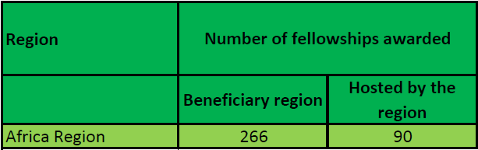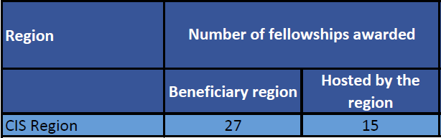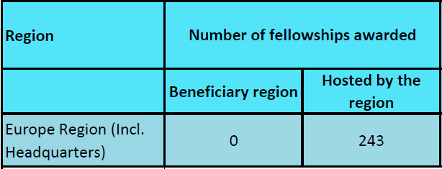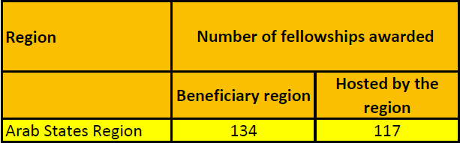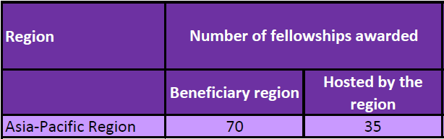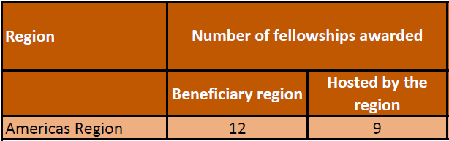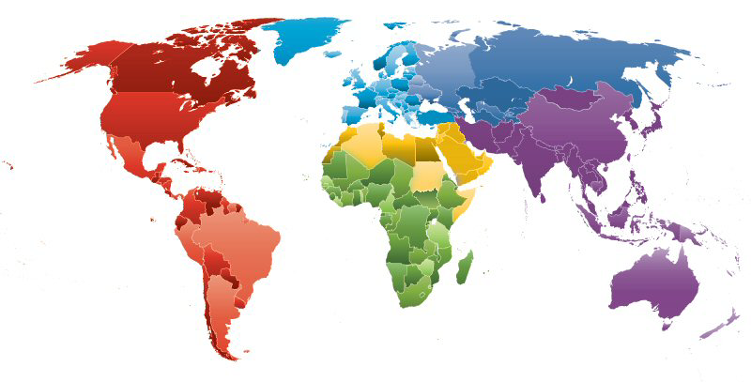

**Annex 2**

Statistics on fellowships awarded in 2018

**Table 1 - Fellowships awarded by region**

|  |  |
| --- | --- |
| **ITU-D regions** | **2018**  **Number of fellowships** |
| Africa | 266 |
| Americas | 12 |
| Arab States | 134 |
| Asia-Pacific | 70 |
| CIS | 27 |
| Europe | - |
| **Total** | **509** |

**Table 2 - Fellowships awarded by Sector**

|  |  |  |
| --- | --- | --- |
| **2018**  **Number and expenses of fellowships awarded[1] by Sector** | | |
| ITU-D | 241 | CHF 417,000 |
| ITU-R | 38 | CHF 83,000 |
| ITU-T | 230 | CHF 423,000 |
| **Total** | **509** | **CHF 924,000** |

**Table 3 - Fellowships awarded by gender**

|  |  |
| --- | --- |
| **2018**  **Gender** | |
| Male | 398 |
| Female | 111 |

**Table 4 - Fellowships awarded to participants by country and region**

| **2018**  **Number of fellowships by country and region** | |
| --- | --- |
| **Africa** | **266** |
| Angola | 1 |
| Benin | 11 |
| Burkina Faso | 16 |
| Burundi | 12 |
| Cameroon | 4 |
| Central African Rep. | 19 |
| Chad | 6 |
| Congo (Rep. of the) | 5 |
| Côte d'Ivoire | 3 |
| Dem. Rep. of the Congo | 20 |
| Ethiopia | 3 |
| Gambia | 19 |
| Ghana | 3 |
| Guinea | 15 |
| Guinea Bissau | 1 |
| Kenya | 2 |
| Lesotho | 4 |
| Liberia | 4 |
| Madagascar | 13 |
| Malawi | 3 |
| Mali | 8 |
| Mozambique | 2 |
| Niger | 14 |
| Rwanda (Republic of) | 11 |
| Sao Tome and Principe | 7 |
| Senegal | 16 |
| Sierra Leone | 4 |
| South Sudan | 7 |
| Togo | 9 |
| Uganda | 10 |
| Zambia | 9 |
| Zimbabwe | 5 |

| **2018**  **Number of fellowships by country and region** | |
| --- | --- |
| **Americas** | **12** |
| Cuba | 1 |
| Haiti | 11 |

| **2018**  **Number of fellowships by country and region** | |
| --- | --- |
| **Arab States**1 | **134** |
| Comoros (Union of the) | 19 |
| Djibouti | 7 |
| Egypt | 2 |
| Mauritania | 23 |
| Somalia | 7 |
| Sudan | 27 |
| Syrian Arab Republic | 18 |
| Yemen | 5 |

| **2018**  **Number of fellowships by country and region** | |
| --- | --- |
| **Asia and the Pacific** | **70** |
| Afghanistan | 14 |
| Bangladesh | 17 |
| Bhutan | 10 |
| Cambodia | 2 |
| India | 2 |
| Kiribati | 2 |
| Lao P.D.R. | 4 |
| Mongolia | 3 |
| Myanmar | 4 |
| Nepal (Republic of) | 4 |
| Pakistan | 2 |
| Solomon Islands | 1 |
| Timor Leste | 2 |
| Vanuatu | 3 |

| **2018**  **Number of fellowships by country and region** | |
| --- | --- |
| **Commonwealth of Independent States (CIS)** | **27** |
| Kyrgyzstan | 22 |
| Tajikistan | 5 |

1 State of Palestine, Resolution 99 (Rev. Dubai, 2018), received 26 fellowships in 2018.

_______________

1. Out of the 509 fellowships awarded, 15% of the beneficiaries cancelled their participation or did no-showed up.