Council 2019
Geneva, 10-20 June 2019
Agenda item: PL 2.10 | Document C19/55-E
 | 18 April 2019
 | Original: English
Report by the Secretary-General
VENUE OF THE 2022 PLENIPOTENTIARY CONFERENCE

Summary
Pursuant to No. 2 of the Convention, the Council will be invited to fix the precise place and exact dates of the next plenipotentiary conference with the concurrence of the majority of the Member States.
This document informs Councillors of the invitation received from the Government of Romania to hold the next plenipotentiary conference in Bucharest.

Action required
The Council is invited to decide on the place for the holding of the next plenipotentiary conference with the understanding that the decision on the dates will be taken at the next Council session and will be followed by the consultation of all Member States on the dates and place.
The Council is also invited to adopt the draft decision contained in Annex B to this document.
____________

References
CV 2; Res. 77 (Rev. Dubai, 2018)

1 Background
1.1 In its resolves 4.6, Resolution 77 (Rev. Dubai, 2018) provides that the next plenipotentiary conference (PP) shall be held in the last quarter of 2022.
1.2 Pursuant to No. 2 of the Convention, in the event that the precise place and exact dates of a PP have not been set by the preceding PP, they shall be fixed by the Council with the concurrence of the majority of the Member States.
1.3 On 8 April 2019, the Ministry of Communications and Information Society of Romania, together with the National Authority for Management and Regulation in Communications of Romania (ANCOM) officially informed the Secretary-General that Romania would like to host the next PP to be held in 2022 in Bucharest (see Annex A).

2 Proposal
2.1 The Council is invited to consider the invitation of Romania to hold PP-22 in Bucharest and to decide on the precise place for holding PP-22 by adopting the draft decision contained in Annex B.
2.2 The secretariat will undertake a mission to Romania to assess various venues in Bucharest for the conference and report to the next Council session.
2.3 The Council will decide on the exact dates at it next session and revise the decision accordingly.
2.4 A consultation of ITU Member States will then be launched to secure their concurrence regarding the venue and the exact dates in accordance with No. 2 of the ITU Convention.

ANNEX A
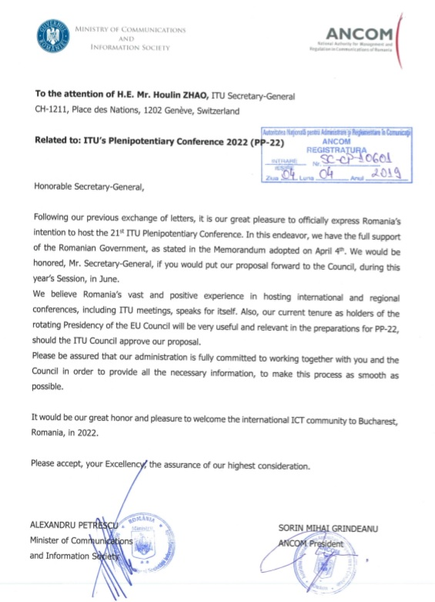

ANNEX B
DRAFT DECISION
Convening of the next ordinary plenipotentiary conference

The Council,
noting
that this conference is included in the schedule of future conferences, assemblies and forums of the Union (2019-2023) as adopted in Resolution 77 (Rev. Dubai, 2018),
decides
that, subject to the concurrence of the majority of the Member States of the Union, the next ordinary plenipotentiary conference will take place in Bucharest (Romania) in 2022;
that the decision on the exact dates should be taken at the 2020 session of the Council,
instructs the Secretary-General
to undertake a site visit and report to the 2020 session of the Council.

________________

