Council 2019
Geneva, 10-20 June 2019
Agenda item: ADM 5 | Document C19/47-E
 | 18 April 2019
 | Original: English
Report by the Secretary-General
Status report on implementation of
Council Decisions 600 and 601 (UIFN, IIN)

Summary
Following the approval of Decisions 600 and 601 at the Council 2017 session, ITU has been in the process of implementing these Decisions. This report summarizes the status of the implementation and the consultations with Member States.

Action required
The Council is invited to endorse the proposal on Universal International Freephone Numbers (UIFNs) and Issuer Identifier Numbers (IINs) provided in section 5.
____________

References
Document C17/133; C17/134; C18/100; CWG-FHR 9/14; CWG-FHR 9/15.

1 Background
1.1 Following the approval of Decisions 600 (C17/133) and 601 (C17/134) at the Council 2017 session, the ITU secretariat has been in the process of implementing these Decisions.
1.2 TSB presented document C18/100 to Council 2018, which provides updates of the status of implementation of Council Decisions 600 and 601, including the status of the contacts for UIFN service providers and IIN assignees. It reproduces the first proposal presented to CWG-FHR in January 2018 and modifies the second proposal following the recommendation by CWG-FHR. The Council was invited to take note of the first proposal and endorse the revised second proposal.
1.3 Council 2018 took note of the first proposal in Document C18/100:
National Administrations/regulators are invited to provide a focal point for providing or investigating up-to-date contacts for UIFN service providers (RoAs) and the assignees of IINs.
1.4 Council 2018 approved the revised second proposal in Document C18/100:
For Entities for which national Administrations/regulators have lost contact and for which no contacts could be found by the end of Council 2019, all records relevant to these entities will be removed from the ITU database based on confirmations/notifications from national Administrations/regulators.
1.5 Council 2018 also instructed the secretariat, “as an interim step, to undertake consultations with national administrations in order to submit a report on the status of those consultations to CWG-FHR.”
1.6 The ITU secretariat gave a status report on the implementation (CWG-FHR 9/14) to the ninth CWG-FHR meeting (29-30 January 2019), including the status of consultations with national Administrations/regulators or authorized agencies, as instructed by Council 2018. The Report (CWG-FHR 9/15) by the Chair summarized the discussion.
1.7 The secretariat also reminded that at the end of a year, according to IPSAS rules, provision will be made for any unpaid invoices. If the invoices remain unpaid for an extended period, the secretariat will seek assistance from Member States to recover the debt. Finally, if this is not successful, it would fall to the Council to decide whether to write off the debt.

2 Status of implementation of Decisions 600 and 601
2.1 The upgraded UIFN and IIN assignment and registration systems went live on 16 January 2018.
2.2 In 2018, 505 new UIFNs have been reserved or assigned following the new fee structure approved in Council Decision 600, and 35 new IINs have been registered following the new fee structure approved in Council Decision 601. Both a one-time fee and an annual maintenance fee were paid by non ITU-T and ITU-R Sector Members. Among the 505 new UIFNs, 95 (18%) were assigned to non ITU-T and ITU-R Sector Members. Among the 35 new IINs, 25 (70%) were registered for non ITU-T and ITU-R Sector Members.
2.3 For the UIFN annual maintenance fee for 2018, invoices representing CHF 752 700 were sent out in January 2018. Applying the principle of pro rata fee for newly joined Sector Members in 2018, the total amount to be paid was CHF 562 067. As of 10 April 2019, CHF 104 900 (18%) has been paid. It is important to note, however, that 60% percent of the unpaid CHF 457 167 is due by only five UIFN service providers.
2.4 ITU-T SG2, in its meeting of 19 to 28 February 2019, approved revisions to Recommendation ITU-T E.169.1 “Application of Recommendation E.164 numbering plan for universal international freephone numbers for international freephone service” and ITU-T E.118 “The international telecommunication charge card” to reflect Council Decision 600 and 601.
2.5 The list of invoices for IIN annual maintenance fee for 2018 and 2019 has not been generated yet as the secretariat continues to seek confirmation of contacts from national Administrations/regulators or authorized agencies for IIN assignees.

3 Status of the contacts for UIFN service providers and IIN assignees
3.1 In 2017, TSB initiated the process to notify 166 service providers of UIFN (Universal International Freephone Number) and 787 assignees of IIN (Issuer Identifier Number). Over 3000 emails were sent out to assignees, to regulators, and to answer queries in 2017.
3.2 Since Council 2018, and up to 10 April 2019, TSB contacted 134 national Administrations/regulators or authorized agencies regarding 573 IINs. Fifty-one (38%) national regulators have responded and provided assistance for 186 IINs (32%).
3.3 As of 10 April 2019, the contact information status of 798 IINs kept in ITU database is shown in the figure below.

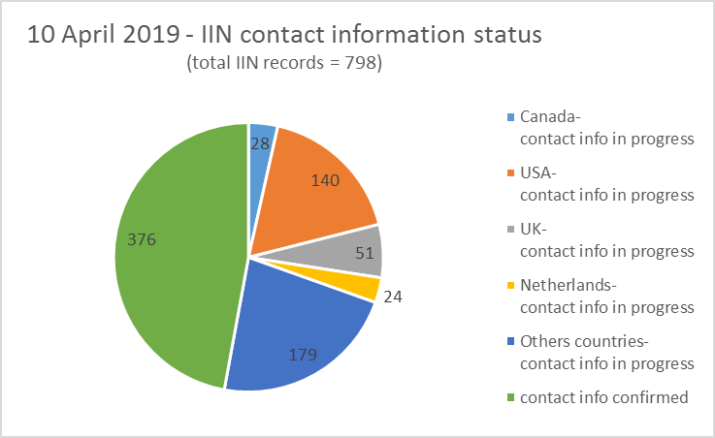
Note: the number of IIN records for the countries listed in the above figure include geographic areas under their Administrations.
3.4 Consultation on the up-to-date contact information of 33 service providers for 204 UIFNs is still ongoing. The list of UIFN service providers is provided in Annex C.
4 Observations
4.1 Reclamation of UIFNs
Between 23 June 2017 to 10 April 2019, 1021 UIFNs were returned, in contrast to an average year, for example for 2016, where 268 UIFNs were returned. Council Decisions 600 and 601 encouraged operators to update their list of active UIFNs and return the unused UIFNs to ITU.
4.2 IIN updates
Based on notifications and responses received from national Administrations/regulators or authorized agencies, the number of IIN record updates per year since 2014 is provided in the table below:

Year | New | Deletion | Update | Total/year
2014 | 22 | 3 | 12 | 37
2015 | 24 | 1 | 6 | 30
2016 | 22 | 1 | 14 | 37
2017 | 22 | 7 | 83 | 112
2018 | 35 | 29 | 154 | 218
10 April 2019 | 4 | 5 | 33 | 42

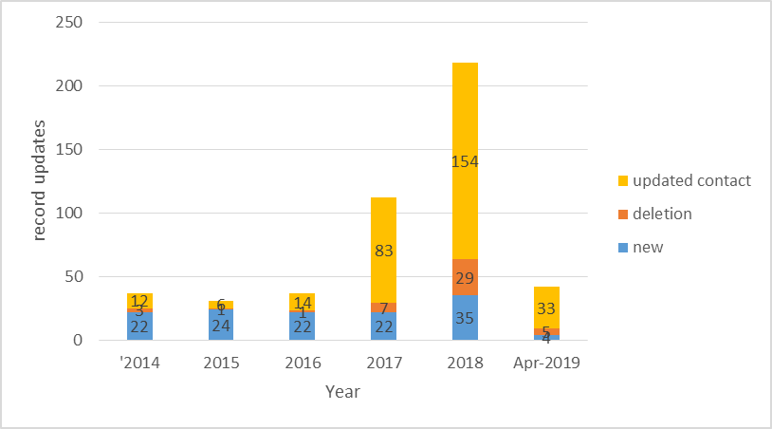
It shows a sharp increase in the number of IIN record updates per year following the approval of Council Decision 601. This process improves the precision of the IIN records kept in the ITU database.

5 Proposal
5.1 The list of UIFN service providers in Annex A to this document will be marked as “not reachable” in the ITU database. The records for these UIFN service providers are subject to removal from the ITU database and the UIFNs assigned to them are subject for reclamation based on confirmations/notifications from national Administrations/regulators as recommended by Council 2018. Among these UIFN service providers, for the ones to whom invoices for the maintenance fee for 2018 have been sent, it would fall to the Council to decide whether to write off the debt.
5.2 The list of UIFN service providers in Annex B have been contacted and they have received the invoices for the 2018 maintenance fee. Payment for the invoices are still under their consideration. If the invoices remain unpaid for an extended period, the secretariat will seek assistance from Member States to recover the debt.
5.3 The list of UIFN service providers requiring further information is provided in Annex C. National Administrations/regulators or authorized agencies are encouraged to provide assistance in identifying the up-to-date contact or status of these entities (e.g., if they are no longer in business).
5.4 The list of IINs for which contact information is pending will be published on ITU website as IINs with the status “assignee not reachable” and will be announced in the ITU Operational Bulletin. National Administrations/regulators or authorized agencies are encouraged to provide assistance in identifying their up-to-date status and/or contact information.
5.5 For the UIFNs and IINs which are still under consultation with national Administrations/regulators or authorized agencies, their status should be confirmed before 31 October 2019. If no objection is received from national Administrations/regulators or authorized agencies, the corresponding UIFNs and IINs will be considered as no longer active and removed from ITU databases.
5.6 UIFN service providers or IIN assignees with the status of ADMIN RELATED are not subject to the annual maintenance fee.

Annex A - List of UIFN service providers subject for removal
Amount | currency | UIFN quantity  1/1/2018 | Company's name | Country/Geographic Area | note
147,400.00 | CHF | 1474 | USA Global Link | United States | No longer active
5,000.00 | CHF | 50 | RSL Com USA, Inc. | United States | No longer active
3,300.00 | CHF | 33 | Executive Telecard | United States | No longer active
100.00 | CHF | 1 | Carrier1 International GmbH | Switzerland | No longer active
- | - | 3 | Cable and Wireless plc, Bermuda | Bermuda | No longer active
- | - | 399 | Global Telesystems (Europe) Limited (formerly Esprit Telecom) | United Kingdom | No longer active
- | - | 50 | RSL Communications Ltd | United Kingdom | No longer active
- | - | 2 | Axicom Communications Group Inc. | United States | No longer active
- | - | 10 | WorldXchange Communications | United States | No longer active
Note: “-” indicates no invoice was sent and further information was required at the time of billing.
Annex B - List of UIFN service providers pending payment for 2018
Amount | currency | UIFN quantity  1/1/2018 |  | Company's name | country/Geographic Area | note
55,700.00 | CHF | 557 | Eircom |  | Ireland
46,300.00 | CHF | 463 | Singtel Telecommunications Limited |  | Singapore
25,800.00 | CHF | 258 | Orange Business Services(ex Equant) |  | France
14,000.00 | CHF | 140 | Bezeq International |  | Israel
3,700.00 | CHF | 37 | Magyar Telekom |  | Hungary
1,000.00 | CHF | 10 | Eutelia S.p.A. |  | Italy | partially purchased by CloudItalia with no UIFN responsibility, however,  3 UIFNs are reachable
500.00 | CHF | 5 | Kingston communications/Affiniti |  | United Kingdom
400.00 | CHF | 4 | Qupra Wholesale (EX-MTTM Partners B.V) |  | Netherlands

Annex C - List of UIFN service providers requiring further information
Amount | currency | UIFN quantity  1/1/2018 | Company's name | country/Geographic Area | note
6,800.00 | CHF | 68 | Smile Telecom 012 | Israel
5,600.00 | CHF | 56 | International Telcom Ltd. | United States
900.00 | CHF | 9 | Tele 2 AB | Sweden
700.00 | CHF | 7 | Cable & Wireless Panamá S.A. | Panama
500.00 | CHF | 5 | Colombia Telecomunicaciones S.A. ESP - Telecom Colombia | Colombia
400.00 | CHF | 4 | PLANinterNET VoIP-GmbH | Germany
400.00 | CHF | 4 | WTT HK Limited | Hong Kong, China
300.00 | CHF | 3 | Telefonica del Peru | Peru
300.00 | CHF | 3 | PRIMUS Telecommunications Ltd. | United Kingdom
200.00 | CHF | 2 | Telefónica de Argentina S.A | Argentina
200.00 | CHF | 2 | Elion Ettevõtted AS | Estonia
200.00 | CHF | 2 | Télécom Développement | France
200.00 | CHF | 2 | Teléfonos de México S.A.B. de C.V. | Mexico
100.00 | CHF | 1 | Bahrain Telecommunications Co - Batelco | Bahrain
100.00 | CHF | 1 | Telecom Itália Móbile S.p.A. (TIM)  (ex-INTELIG Telecomunicações Ltda.) | Brazil
100.00 | CHF | 1 | TelePassport AG | Germany
100.00 | CHF | 1 | Empresa Hondureña de Telecommunicaciones (HONDUTEL) | Honduras
100.00 | CHF | 1 | SIA LATTELEKOM | Latvia
100.00 | CHF | 1 | Vodafone New Zealand | New Zealand
100.00 | CHF | 1 | Telecable de Asturias SA | Spain
100.00 | CHF | 1 | Unisource NV | Sweden
100.00 | CHF | 1 | TeleForwarding USA Inc. | United States
- | - | 3 | IT-Austria GmbH | Austria
- | - | 1 | Interoute Belgium NV | Belgium
- | - | 1 | AES Comunicaciónes Bolivia S.A. | Bolivia
- | - | 2 | BellSouth Chile | Chile
- | - | 1 | Compañia de Telecomunicaciones de El Salvador, S.A. de C.V. | El Salvador
- | - | 1 | HanseNet Telekommunikation GmbH | Germany
- | - | 2 | Netzquadrat GmbH | Germany
- | - | 2 | Infostrada S.p.A. | Italy
- | - | 4 | GTS Nextra (now SWAN) | Slovakia | Pending confirmation from SWAN on UIFNs  All 4 UIFNs work.
- | - | 9 | Inclarity PLC (ex ABS Telecom plc) | United Kingdom
Note: “-” indicates no invoice was sent and further information was required at the time of billing.
_______________

