|  |  |
| --- | --- |
| **Council 2019 Geneva, 10-20 June 2019** |  |
|  |  |
|  |  |
| **Agenda item: PL 2.11** | **Document C19/24-E** |
| **4 June 2019** |
| **Original: English** |
| Report by the Secretary-General | |
| PREPARATIONS FOR THE  WORLD TELECOMMUNICATION Standardization Assembly 2020 | |

|  |
| --- |
| Summary  Pursuant to No. 42 of the Convention, Council will be invited to fix the precise place and exact dates of the next World Telecommunication Standardization Assembly (WTSA-20) with the concurrence of the majority of the Member States.  This document informs the Council of the invitation received from the Government of India to hold WTSA-20 in India at New Delhi or at Hyderabad, and the proposed dates from 16 to 27 November 2020 (see Annex 1).  Action required  The Council is invited to **decide** on the host country, preferred venue and dates of WTSA-20. The decision will then be subject to the concurrence of the majority of the Member States of the Union by consultation.  The Council is also invited to **adopt** the draft decision contained in Annex 2 to this document.  ____________  References  [*No. 114 of the ITU Constitution*](https://www.itu.int/en/council/Documents/basic-texts/Constitution-E.pdf)*,* [*Nos. 23, 24, and 42 of the ITU Convention*](https://www.itu.int/en/council/Documents/basic-texts/Convention-E.pdf)*,* [*Chapter I of the General Rules of Conferences, Assemblies and Meetings of the Union*](https://www.itu.int/en/council/Documents/basic-texts/General-Rules-E.pdf) *and* [*Resolution 77 (Rev. Dubai, 2018)*](https://www.itu.int/en/council/Documents/basic-texts/RES-077-E.pdf) *and* [*Resolution 111 (Rev. Busan, 2014)*](https://www.itu.int/en/council/Documents/basic-texts/RES-111-E.pdf) |

**1. Background**

1.1 No. 114 of the ITU Constitution stipulates that a World Telecommunication Standardization Conference (WTSA) shall be convened every four years; and Nos. 23 and 24 of the ITU Convention stipulate that a World Telecommunication Standardization Conference (WTSA) shall be convened within the period between two plenipotentiary conferences.

1.2 Resolution 77 (Rev. Dubai, 2018) of the Plenipotentiary Conference resolves that WTSA shall be held in the last quarter of 2020.

1.3 Resolution 111 (Rev. Busan, 2014) calls on the Union and its Member States to make every effort, as far as practicable, to ensure that the planned period of any ITU conference does not conflict with what may be considered a major religious period by a Member State.

1.4 No. 42 of the ITU Convention and Chapter I of the General Rules of Conferences, Assemblies and Meetings of the Union require, respectively, that, in the absence of a decision by the Plenipotentiary Conference, the precise place and the exact dates of a WTSA be approved by the Council with the concurrence of a majority of the Member States.

1.5 The ITU Secretary-General has received an invitation from the Government of India for the hosting of WTSA-20 in India with the proposed dates from 16 to 27 November 2020, with possible venues either at New Delhi or at Hyderabad (see **Annex 1**). Consultations are under way in order to agree on the requirements for holding this conference outside Geneva.

**2. Proposal**

2.1 The Council is invited to consider the invitation of the Government of India to hold WTSA-20 in India from 16 to 27 November 2020 and to decide on the host country, venue and exact dates of WTSA-20 by adopting the draft decision contained in **Annex 2**.

2.2 Should the Council preferred venue be Delhi, the secretariat will undertake a mission to assess the venue for the conference in New Delhi and when completed circulate the report before a final decision is taken by correspondence. Should the preferred venue be Hyderabad, since it would be the same venue as WTDC-10, a final decision can be taken at this Council.

2.3 A consultation of ITU Member States will then be launched to secure their concurrence regarding the precise place and the exact dates in accordance with No. 42 of the ITU Convention.

ANNEX 1 **Invitation from the Government of India   
to host WTSA-20**

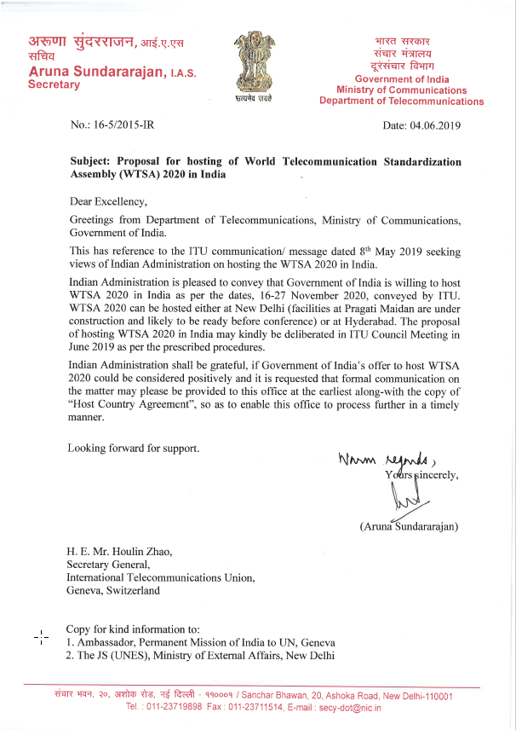

ANNEX 2

DRAFT DECISION

Convening of the next World Telecommunication Standardization Assembly (WTSA-20)

The Council,

noting

that WTSA-20 is scheduled to be held in the last quarter of 2020 in accordance with Resolution 77 (Rev. Dubai, 2018) (Scheduling and Duration of future conferences, forums, assemblies and Council sessions of the Union (2019-2023),

decides

that, subject to the concurrence of the majority of the Member States of the Union, the next World Telecommunication Standardization Assembly (WTSA-20) will take place in [Hyderabad] India, from 16 to 27 November 2020,

instructs the Secretary-General

[to undertake a site visit and report to the Council Member States for a decision by correspondence on the precise place, which will be followed by] [to carry out] a consultation with all Member States on the exact dates and precise place of WTSA-20

______________