Council working group on WSIS
32nd meeting, Geneva, 24-25 January 2018
Document WG-WSIS-32/17-E
18 January 2018
English only

Note by the Chairman
ICT for SDGs strategy of respective regions, including on the linkages between WSIS Action Lines and SDGs

At the 31st meeting of CWG-WSIS, vice-chairs of the group were invited to inform the next meeting of the WG-WSIS on the ICT for SDGs strategy of their respective regions, including on the linkages between WSIS Action Lines and SDGs.

Input received to date from Mr Ghislain de Salins, Vice-Chairman of Region B (Western Europe), can be found below.

Abstract
In Europe, many initiatives have been undertaken to implement the World summit on information society (WSIS) outcomes and meet the Sustainable development goals (SDGs), both at the national and regional level. At the latter, a significant initiative is the European Digital Single Market (DSM). The DSM Strategy aims at boosting the growth of the digital economy in Europe through harmonizing rules and lowering barriers for businesses and consumers so that they can operate more easily across Europe. While the DSM Strategy is designed by the European Commission and the 28 Member States of the European Union (EU), its impact will probably go beyond and affect many other European countries.
Launched in May 2015, the DSM Strategy relies on three pillars: a better access for consumers and businesses to digital goods and services across Europe; creating the right conditions and a level playing field for digital networks and innovative services to flourish; maximizing the growth potential of the digital economy. For instance, the DSM Strategy has proposed to remove roaming charges and geo-blocking in order to facilitate access to online content across the EU.
Achieving a Digital Single Market will help European stakeholders to further implement the WSIS outcomes, especially regarding Action Lines C1 (The role of governments and all stakeholders in the promotion of ICTs for development), C2 (Information and communication infrastructure), C3 (Access to information and knowledge), C5 (building confidence and security in the use of ICT), C6 (enabling environment), C7 (access to ICT applications), C8 (cultural diversity) and C11 (international and regional cooperation).
- Introduction
There is a wide range of initiatives that have been undertaken in Europe in order to implement the WSIS outcomes. While many involve mostly local and national stakeholders, some of them are also developed at the regional level. In this contribution, we have chosen to focus on the Digital Single Market (DSM) of the European Union (EU), as one of the most significant initiatives recently launched in Europe to implement the WSIS outcomes. While the DSM is developed by the European Commission and the 28 Member States of the European Union, it will also have an impact on many other European countries.

- Overview
In 2014, the EU Commission and Members States identified the fragmentation of the European market as one of the main impediments to developing the full potential of the digital economy in Europe. With more than 28 different regulatory frameworks, it was difficult for businesses to grow and thrive regionally and for consumers to benefit from a wider choice of products and services. Therefore, the European Commission and Members States adopted in May 2015 a Strategy towards achieving a digital single market. The European Commission has identified the completion of the Digital Single Market (DSM) as one of its 10 political priorities - Vice-President Andrus Ansip of the European Commission leads the project team "A Connected Digital Single Market". Ongoing Digital Single Market Public consultations help to define the objectives for the implementation. In May 2017, the Commission published a mid-term review of the Digital Single Market Strategy, which evaluates the progress in implementing the Strategy since 2015 and identifies areas where further actions are needed.
A Digital Single Market is one in which the free movement of persons, services and capital is ensured and where the individuals and businesses can seamlessly access and exercise online activities under conditions of fair competition and under a harmonized regulatory and legal environment, including a high level of consumer and personal data protection, irrespective of their nationality or place of residence. The rationale for achieving a Single Regional Market is that the resulting increase of consumer choice and competition will boost the development of the digital economy in the region and help to achieve the objectives of the WSIS outcomes. When the DSM Strategy was first launched, a number of regulatory barriers preventing consumers and businesses to operate across Europe were identified (for instance, roaming charges and geo-blocking for copyrighted content). Therefore, most initiatives that are part of the DSM focus on removing those barriers and allowing for more interactions across the region.
The Digital Single Market Strategy is built on three pillars:
- Access: better access for consumers and businesses to digital goods and services across Europe;
- Environment: creating the right conditions and a level playing field for digital networks and innovative services to flourish;
- Economy & Society: maximizing the growth potential of the digital economy.

- The Digital Single Market's achievements so far
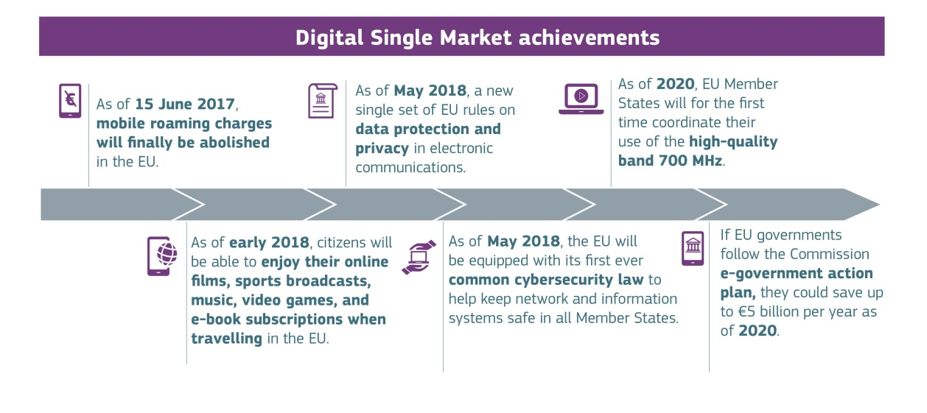
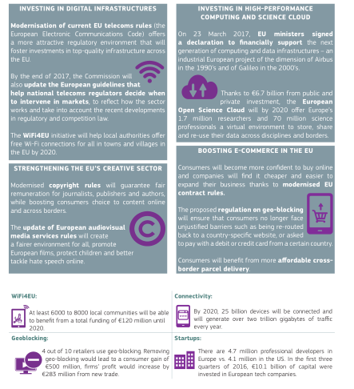

- The mid-term review of the Digital Single Market Strategy
The Digital Single Market strategy has delivered the main legislative proposals set as priority, specifically in the topics of e-commerce, copyright, audiovisual and media services, telecoms review, e-Privacy, harmonization of digital rights, affordable parcel delivery, harmonized VAT rules (Cf. part 3).
However, in order to further ensure a fair, open and secure digital environment, the mid-term review of the DSM has identified three new emerging challenges:
  - Ensuring that online platforms continue to bring benefits to our economy and society, especially through:
    - addressing the issues of unfair contractual clauses and trading practices in platform-to-business relationships ;
    - improving the coordination with online platforms regarding the mechanisms and technical solutions for the removal of illegal content ;
  - Developing the European Data Economy to its full potential, including through adopting a regulation on the free flow of non-personal data in the EU ;
  - Protecting European assets by tackling cybersecurity challenges.
In addition, the review explores a number of important policy areas critical for unlocking the true value of the data economy:
  - Digital skills ;
  - Digitizing industry and services (e.g. connected cars, FinTech) ;
  - High Performance Computing ;
  - Artificial intelligence ;
  - Modernizing public services and e-goverment ;
  - Health and care.
The mid-term review focuses also on the investments needed in digital infrastructures and services, not forgetting the global dimension of the European Digital Single Market.

- Expected outcomes.
A Digital Single Market creates opportunities for new startups and allows existing companies in a market of over 500 million people. According to the EU Commission analysis, achieving a Digital Single Market can contribute EUR 415 billion per year to Europe's economy, create jobs and deeply transform our public services. Also, it offers new opportunities for citizens, provided they are equipped with the right skills: enhanced use of digital technologies improves citizens' access to information and culture, improve their job opportunities and supports modern open government initiatives.

- Linking the DSM achievements with the WSIS action lines

Achieving a Digital Single Market in Europe will help States and other stakeholders to further implement the WSIS outcomes. More specifically, the DSM Strategy has had an impact on the following action lines:
  - C1 - The role of governments and all stakeholders in the promotion of ICTs for development): the DSM Strategy was developed and implemented at the regional level by governments in cooperation with many stakeholders through regular public consultations organized throughout the implementation (Cf. Mid-term review).
  - C2 - Information and communication infrastructure: the Wifi4EU initiative will help local authorities to offer free Wi-Fi connections in all towns and villages across the EU by 2020. Modernization of telecom rules with a new European code for electronic communications will offer a new attractive enabling environment to foster investment in top quality infrastructure.
  - C3 - Access to information and knowledge: ending roaming charges, modernizing copyrights rules and removing geo-blocking will boost consumer choice to access content across the EU.
  - C5 - Building Confidence and Security in the use of ICT: in 2018, the EU will be equipped with its first ever common cybersecurity law.
  - C6 - Enabling Environment: modernizing the telecom rules with a new European code for electronic communications will offer a new attractive enabling environment to foster investment in top quality infrastructure.
  - C7 - Access to ICT applications: ending roaming charges, modernizing copyrights rules and removing geo-blocking will boost consumer choice to access content across the EU.
  - C8 - Cultural Diversity: ending roaming charges, modernizing copyrights rules and removing geo-blocking will boost consumer choice to access content across the EU.
  - C11 - International and Regional Cooperation: the DSM Strategy was developed and implemented at the regional level by governments in cooperation with many stakeholders through regular public consultations organized throughout the implementation (Cf. Mid-term review).

The Council of Europe, for example, which is made up of 47 European countries, has developed programs on digital citizenship education, children and the digital environment, safety of journalists, gender and media and human rights online.
There are 28 Members States of the European Union: Austria, Belgium, Bulgaria, Croatia, Cyprus, Czech Republic, Denmark, Estonia, Finland, France, Germany, Greece, Hungary, Ireland, Italy, Latvia, Lithuania, Luxembourg, Malta, Netherlands, Poland, Portugal, Romania, Slovakia, Slovenia, Spain, Sweden, and the United Kingdom. In addition to those 28 members, 3 countries are members of the European Economic Area (EEA) while not being members of the EU: Norway, Iceland and Lichtenstein.
There are 48 countries in the CEPT, including the 28 Members of the UE and the three additional members of the EEA.

