Council Working Group on the
World Summit on the Information Society
32nd meeting – Geneva, 24-25 January 2018
Document CWG-WSIS-32/09-E
11 December 2017
English only

WSIS Action lines and SDGs (WSIS– SDGs Matrix)
Linking WSIS Action Lines with Sustainable Development Goals

With the objective of strengthening the alignment of the WSIS with the SDGs, the overall theme for WSIS Forum 2018 (www.wsis.org/forum) is Leveraging ICTs to Build Information and Knowledge Societies for Achieving the Sustainable Development Goals (SDGs). The WSIS Forum 2018 Agenda will be searchable by WSIS Action Lines and SDGs making it convenient for the Stakeholders to identify the connection of the sessions with SDGs. In addition a mapping tool will be made available to emphasize the linkages between the Action Lines and the SDGs identified by WSIS Stakeholders in their respective sessions and workshops. Please see example from WSIS Forum 2017 http://www.itu.int/net4/wsis/forum/2017/Agenda/#heatmap .
Moreover, the outcomes of all the workshops that will be held at the WSIS Forum 2018 clearly indicate the linkages of the respective workshops between the WSIS Action lines and SDGs resulting in a WSIS Forum 2018 Matrix Flyer and Document.
In response to the call by the UN General Assembly within the framework of the ten year review of the WSIS (Res. A/70/125) calling for a close alignment between the WSIS process and the 2030 Agenda for Sustainable Development, the WSIS Stocktaking process (www.wsis.org/stocktaking) continues collecting information on actions, projects, programmes, initiatives implemented by all Stakeholders related to WSIS and SDGs, while providing concrete proof of impact of particular WSIS Action Lines on SDGs, transforming the meeting of the WSIS-SDG Matrix into evidence based policy guide for all WSIS Stakeholders.
The WSIS Prize 2017 contest also aligned its rules to highlight the linkage between the WSIS Action Lines and SDGs (www.wsis.org/prizes). This was well appreciated by the WSIS Stakeholders. For the seventh year in a row, the WSIS Prizes 2018 will be recognizing outstanding success stories from around the world for their part in building an inclusive information society. Our common objective is to inspire and advance sustainable development through the effective use of ICTs. Building upon the outcomes of the United Nations General Assembly Overall Review on WSIS as well as the 2030 Agenda for Sustainable Development, the WSIS Prizes 2018 seek to reflect close linkages with achieving the Sustainable Development Goals (SDGs).
Background:
At the WSIS Forum 2015, ITU coordinated the WSIS Action Lines and SDG Matrix, a new tool developed by a number of United Nations agencies to map how ICTs may contribute to the implementation of the new SDGs. The Matrix serves as an easy reference for stakeholders engaged in shaping the future of both, the SDGs and the WSIS processes beyond 2015 and the 2030 Agenda for Sustainable Development. The Matrix is also considered as a valuable conceptual framework by the UN Regional Commissions that are utilizing the Matrix as a tool to plan their implementation work at the regional level.
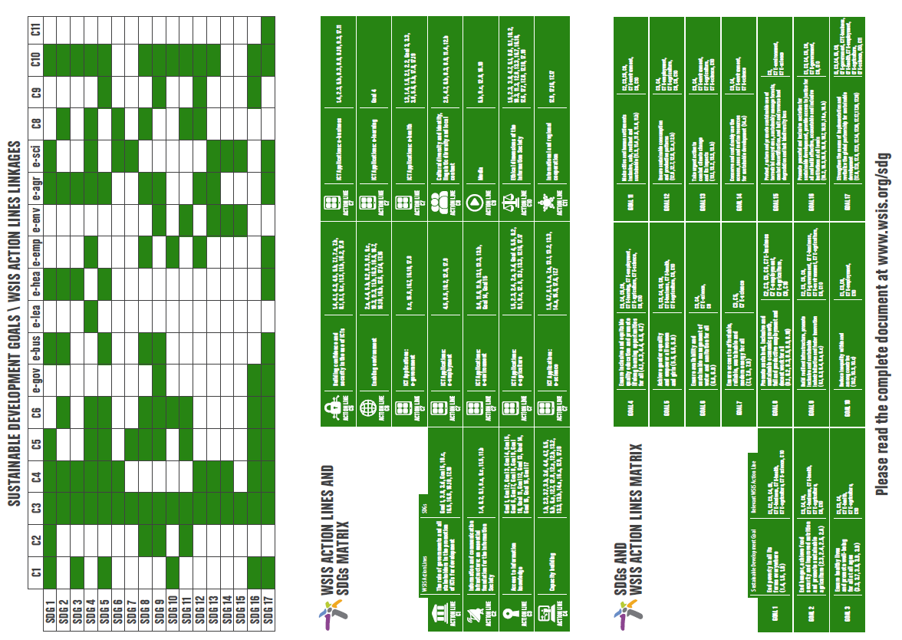
The mapping exercise draws direct linkages of the WSIS Action Lines with the proposed SDGs to continue strengthening the impact of Information and Communication Technologies (ICTs) for sustainable development. Each UN Action Line Facilitator has analyzed the connections and relations of their respective Action Line with the proposed SDGs and their targets. This is a living document and changes can be introduced by Action Line Facilitators, if needed.
The goal is to create a clear and direct link and an explicit connection between the key aim of the WSIS, that of harnessing the potential of ICTs to promote and realize the development goals, and the post 2015 development agenda, so as to contribute to the realisation of the latter.
The WSIS Forum continues to evolve and adapt, by strengthening the synergies between the WSIS Action Lines and SDGs, and taking into account the outcomes of the UNGA Overall Review.

