Plenipotentiary Conference (PP-18)  Dubai, 29 October – 16 November 2018 | 
PLENARY MEETING | Revision 2 to  Document 39-E
 | 18 September 2018
 | Original: French
Note by the Secretary-General
candidacy for the post of director of the
telecommunication development bureau (BDT)

Further to the information contained in Document 3, I have pleasure in transmitting to the
conference, in annex, the candidacy of:
Mr Jean Philémon KISSANGOU (Republic of the Congo)
for the post of Director of the Telecommunication Development Bureau (BDT) of the International
Telecommunication Union.
Houlin ZHAO
Secretary-General

Annex: 1

Republic of the Congo
Brazzaville, 24 May 2018
To: Mr Houlin Zhao, ITU Secretary-General
From: Ministry of Posts, Telecommunications and the Digital Economy
Reference: 0517/MPTEN-CAB/18
Subject: Candidacy of Mr Jean Philémon KISSANGOU for the post of Director of the ITU Telecommunication Development Bureau (BDT)
Dear Sir,
I have the honour, on behalf of the Congolese Government, pursuant to your letter CL-17/42 of 23 October 2017, to transmit to you the candidacy of Mr Jean Philémon Kissangou for the post of Director of the ITU Telecommunication Development Bureau, elections for which will be held during the next plenipotentiary conference from 29 October to 16 November 2018 in Dubai (United Arab Emirates).
Mr Kissangou holds master's degrees in ICT regulation and policy and in information and telecommunications, and a degree in telecommunication regulation. He also has 15 years of experience, first as technical director of an ISP and subsequently as a manager responsible for universal access with the local regulator in the digital communications sector. Since 2009, Mr Kissangou has concentrated on research and is the author of two books in the field of telecommunications.
Beyond this, Mr Kissangou's candidacy is motivated by a vision and strategy for global telecommunication development, which he wishes to implement with all his managerial skill and professional rigour.
Congo reaffirms its wish to contribute to the dynamic ongoing work of the International Telecommunication Union in seeking the greatest possible happiness of the world's citizens though telecommunications.
Please accept, Sir, the assurances of my highest consideration.

Yours faithfully,
(signed)
Léon Juste IBOMBO
Minister
[Official stamp]

Attachments:
– Candidate's vision
– Candidate's CV
– A photo of the candidate

KISSANGOU Jean Philémon  Candidate for the post of Director of the Telecommunication Development Bureau (ITU), PP-18  www.kissangou.name | 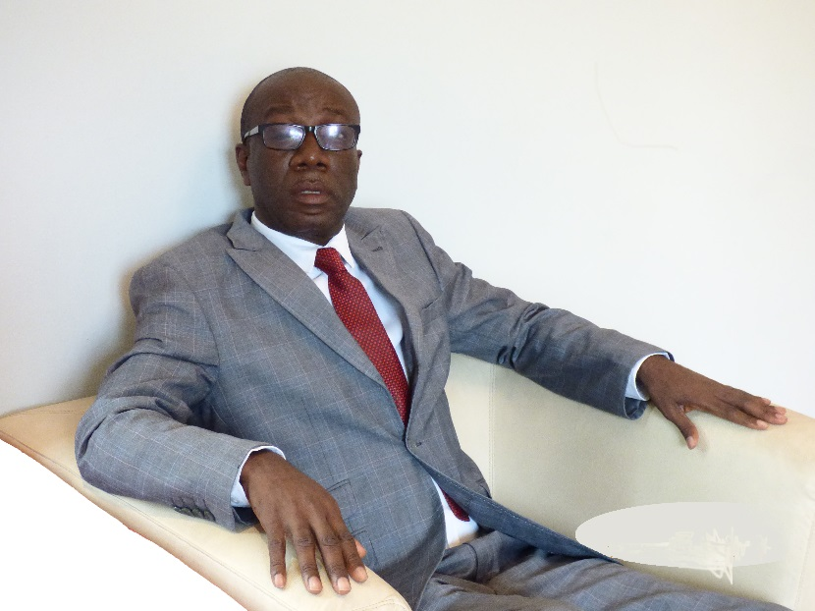

My vision
To ensure that by 2030, one-fifth of the world's unconnected will acquire broadband access without discrimination in order to obtain information, participate in the economy and develop as individuals.

Seven strategic pillars

Pillar 1: Telecommunication sector reform
Reform of the telecom sector in the 1980s led to mixed outcomes. Our activities will focus on countries and subregions where reform did not produce the desired results. The ultimate goal is to implement the reform in the telecom/ICT sector wherever it is needed. In specific terms, provided that countries sign up, we will support them in liberalizing the sector, totally or partially privatizing incumbent operators, and establishing a genuinely independent regulatory authority. For sub-Saharan Africa and Latin America, the HIPSSA and ICAR projects will be renegotiated with the partner (EU) and the implementation strategy will be reviewed. Furthermore, the Telecommunication Development Bureau (BDT) will support the cooperation and harmonization initiative in the telecom sector launched by the countries of the Commonwealth of Independent States (CIS), by providing them with the means and support needed. In general terms, anywhere in the world, appropriate responses will be sought in the areas of policy and regulation in order to ensure a real impact with regard to markets, competition and effective management, which should result in considerable improvement to the relevant development indicators and have a positive impact on the well-being of populations worldwide.

Pillar 2: Broadband access
Telecommunications in the twenty-first century are based on broadband networks, which alone can stimulate the economy, develop businesses, create jobs, improve quality of life and boost innovation. Development of broadband networks and services will, among other things, increase penetration of mobile broadband, which is currently only 8 per cent in Africa and 5 per cent in the Arab States. Our goal in extending the global network will be to connect one-fifth of the 3.9 billion people in the world (ITU, 2016) who are still unconnected. We will provide support, training and follow-up for States and regional groupings for development and for implementation of realistic and appropriate broadband policies. We will work on stimulating demand by training and improving the range of services offered, so that users, once connected, make real use of the digital services available to them.

Pillar 3: Consumer protection
Faced with increasingly complex telecommunication services (broadband networks, smartphones, OTT, SMS and MMS, social networks, and so on), consumers are vulnerable to all kinds of abuses with implications in terms of potential infringements of their liberty and negative impacts on their social well-being. It is thus essential that consumers be protected from possible abuses, especially by operators. Our strategy in this will involve training consumers to be autonomous, by involving the media and specialist associations. Monitoring will be set up to ensure that rules and regulations are put in place, function properly and are reinforced locally.
In addition to protecting consumers from poor information, we will work to reduce the carbon footprint of the ICT/telecom sector (currently estimated at 24 per cent). An initiative will be launched as an example to encourage efforts, through partnership and innovation, to find alternative energy sources to the thousands of petrol generators installed at telecom facilities. In Africa, for example, many of these generators operate 24 hours a day, seven days a week.

Pillar 4: Investment
In the IT sector, a total of 1.085 billion in foreign investment is expected in 2008 (UNICTAD, 2017), and an increase in global expenditure which should reach 2.8 billion in 2019 (GSMAi, 2016).
We will reinforce these trends by helping countries and communities to develop investment-friendly policies and regulation. Depending on whether the country is developed, developing or in transition, the strategy applied to promote investment in the telecom/ICT sector will differ. We will discuss with the private sector ways of setting up a permanent framework for exchanges and action in order to encourage innovative and efficient investment. In addition, artificial intelligence, which is already revolutionizing the telecommunication sector, will grow from 39 million euros in 2016 to 59.7 million in 2025. BDT will work to ensure that the telecommunication/ICT investment curve grows further to support global growth, for the sake of a better world.

Pillar 5: Innovation
Different forms of support for innovation and research in the ICT sector will be a major article of faith in our activities. This will mean monitoring and support measures in favour of technological innovation. Innovation is a source of growth and job creation. Thanks to innovation based on diversified partnerships, new systems and new applications are created in all areas of human activity (education, health, agriculture, industry, administration, energy, government, IoT). These new measures will contribute to building a better world. BDT, with the help of its partners, will create a framework conducive to the development of national and regional community policy to ensure that ICTs support and stimulate innovation. A special innovation monitoring unit will be created within BDT.
In the case of North America, Europe and Asia, given the maturity of the prevailing environment in those areas (growth, lengthy experience, large markets), the Bureau will support partnerships among different agencies, including partnerships with the private sector.

Pillar 6: Quality assurance in BDT
Once in post, we will progressively launch a study and implementation initiative within the Bureau to establish a quality assurance system based on international quality standards, the aim being to ensure that the Bureau meets established requirements and justifies the confidence of its partners (internal and external). The ultimate goal for the Bureau is to facilitate procedures and bring about constant improvements in governance and performance. BDT's structure will be reviewed in line with the need for greater efficiency, better governance and more effective action.

Pillar 7: Adapting to the needs of a dynamic and complex market
With the advent of broadband mobile Internet, the development of the next-generation mobile technologies (3-, 4- and 5G) and the unexpected rise of OTT services, the telecommunication market has changed, but BDT has not fundamentally adapted telecommunications management in response to the threat represented by OTTs for telecommunication operators, although as a result of the changing market, regulators and operators have lost ground in the face of the difficulty of keeping pace with the increasingly complex, dynamic and unpredictable packages of services on offer. BDT will seek a better understanding of the new requirements of the market resulting from the rise of OTTs and to offer appropriate responses, especially in terms of cost control and calculation of tariffs, as well as enhancing consumer welfare. Gearing BDT action to the new market challenges will mean that the market is better protected, competition promoted, and the formation of monopolies – which are still all too prevalent – discouraged. Regulators and operators will embrace the new market requirements rather than just passively submitting to them. Operators, already suffering a dramatic decline in revenues from voice and SMS as a result in a huge increase in traffic, are struggling to maintain investment in their infrastructure. This is an important issue, and BDT will reflect on it as a matter of urgency. Beyond this, we will consider very quickly to what extent operators might participate in the work of BDT.

THE CANDIDATE'S CV
Name: Kissangou Jean Philémon
Country: Congo-Brazzaville
Family status: Married, three children
kissangou@kissangou.name
www.kissangou.name

EDUCATION
Master's in Telecommunications/IT 2003
Ecole Multinationale de Télécommunication (ESMT), Dakar
Master's in ICT policy and regulation (in progress) 2018
University of Witherland, Johannesburg, South Africa
Diploma in Telecommunication Regulation 2009
West Indian University, St Augustine, Trinidad and Tobago
Certificate in Internet Governance 2003
Diplofoundation, Geneva
Certificate in Project Management 2003
Innovit, Dakar

OVERALL EXPERIENCE
Fifteen years in Internet and telecommunication network management, analysis and development of telecommunication/ICT policy and regulations.

PROFESSIONAL EXPERIENCE
Head of Universal Service Management Department, Economy and 2010-2018
Market Division Postal and Communications Regulatory Department (ARPCE),
Brazzaville, Congo
Consultant, Department for New Technologies, 2004-2007
Ministry of Telecommunications, Brazzaville, Congo
Lecturer in NICTs, 2005-2015
Polytechnique, Université Marien NGOUABI, Brazzaville, Congo
Technical Director of DRTVnet (Internet access provider) 2006-2009

INTERNSHIPS
Internet Governance Bureau, United Nations headquarters, Geneva, Switzerland 2005
Telecommunication Development Bureau (BDT), ITU, Geneva, Switzerland 2012

CIVIC ACTIVITIES
– President of the Congolese chapter of the Internet Society (ISOC)
– African coordinator of the NGO CACSUP 2004-2014
– Director on Board of AFRINIC 2008-2011
– Member of AFNIC International College. 2018

LANGUAGES
– French (official language)
– English (language of studies)
– Portuguese

PUBLICATIONS
Books:
1. Accès et services universels en télécoms/TIC dans les pays en développement: Planification, financement et contrôle. Edilivre 2015, Paris, France
2. Protection des consommateurs dans le secteur des télécommunications: Enjeux, arnaques, et défis. Edilivre 2016, Paris, France
3. Un village en émoi (Roman), published by CACSUP
4. In progress (book): L'Intelligence Artificielle: Que-peuvent les pays en développement ?
5. In progress: Analyzing the telecoms sector in G7 countries.

AWARDS AND HONOURS
– Afrinic Board member award (2008-2011)

EXPECTED REFORMS AND ROADMAP
The implementation of my programme, as Director of BDT, will require several reforms to facilitate the realization of our vision and the attainment of our goals. The reforms will be discussed first within BDT in order better to formulate and, where need be, adapt them.
For illustration, below is a list of reforms to be conducted under our mandate. The list will evolve throughout the election process as we gather fresh input from telecommunication sector stakeholders around the world.

1 Reform of BDT management
Regarding functioning and internal management in the strict sense of the terms, we shall establish management KPIs with carefully selected metrics to track the performance of BDT officials. This will be done both in ITU’s Geneva offices and in its 15 regional and subregional offices.

2 Organizational reform of BDT
Currently, BDT comprises three main bodies: the Telecommunication Development Advisory Group (TDAG), the working parties, and the secretariat. These will be restructured to become more efficient, open to external expertise and geared towards action.

3 Reform of the "measuring the information society" activity
The annual "measuring the information society" activity must be reviewed in depth, particularly with regard to the content of the basket used to calculate the ICT development index (IDI). The new index would, rather, assess the level of digital inclusion and take into account other factors as pertinent as the two already chosen (access and policies). For example, data linked to competition, regulation, pricing and consumer protection, or to the implementation of ITU-T, ITU-R and ITU-D Recommendations, also bear witness to the level of digital inclusion. In this regard, certain new factors might be increasingly taken into account in the calculation of the new "Digital Inclusion Index", making country classification more relevant.

4 Reform of projects and their governance
Regarding the projects, we shall build on the success stories and strive not to repeat past mistakes. Reflection, action, results – this will be our motto.

5 Consumer involvement reform
We will help to ensure that consumers are empowered and more involved in telecommunication issues. This will require awareness-raising and training, and will involve consumer associations, governments, regulators and the press.

6 Preparation of map of those offline
A dynamic geographical map will be produced, showing the location – regions, settlements – of the 3.9 billion people still offline. This means we will have before us the real distribution of those we have to connect, and this will help us in project prioritization.

7 Global universal access
This will involve introducing a mechanism for the collective implementation of the “Connecting the World” project. Once we know where the 3.9 billion people offline are located, their respective characteristics and what to work on to ensure their digital inclusion (policies, regulations, regulation), we will have to work to produce a mechanism that identifies and directs funding towards those countries most in need.

8 New relationship between BDT and researchers
BDT will build a stronger relationship with researchers and research centres, to produce relevant studies the results of which will help focus the Bureau’s action.

9 Dynamization of working relations between BDT and the ITU Council.
We will propose that the capacities of Council members be strengthened in terms of understanding the challenges involved in telecommunications and ITU’s mission. The Council should be better equipped in regard to supervision, assessment and surveys regarding BDT’s activities. Thus together we will ensure that BDT and ITU enjoy greater success not least in the implementation of projects that contribute to connecting those still offline.
Together, we will regularly assess how much ITU is really connecting the world.

Conclusion

Reasons for my candidacy
1) Telecommunications are facing challenges around the world: 3.9 billion people are currently excluded from telecommunication/ICT opportunities for a number of reasons. I am convinced in all humility that I have something to offer in improving this situation.
2) I think that I have the right profile and sufficient experience.
3) Coming from outside ITU, I am convinced me that I am more familiar with the problems facing the telecommunication sector and that I have a different perspective on the challenge of developing telecommunications around the world.
4) I come from a developing country.
5) I am immersed in a good part of the telecommunication sector literature and studies, to which I have also contributed.
6) Since 2009, I have engaged and, where possible, visited the different stakeholders in the telecommunication sector.
7) Within the framework of classes and lectures I have given at the university and elsewhere, I have engaged people in discussions on telecommunications.
8) My personal character is beyond reproach.
9) I will be a director who takes a grassroots interest and listens to people.
10) I will be a director who is geared towards action.
11) I will be a director who feels fully accountable for his decisions.
12) I will be a director who fights bureaucracy, trickery, the "establishment", settling of scores, intrigues, and other such negative activity.
13) I will be a director who promotes change, competence and the free circulation of people and ideas.

______________

