Plenipotentiary Conference (PP-18)
Dubai, 29 October – 16 November 2018
PLENARY MEETING | Document 22-E
 | 19 March 2018
 | Original: English
Note by the Secretary-General
CANDIDACY FOR THE POST OF MEMBER OF
THE RADIO REGULATIONS BOARD (RRB)
Further to the information published in Document 3, I have pleasure in transmitting to the Conference, in annex, the candidacy of:
Mr Luis Fernando Borjón Figueroa (Mexico)
for the post of member of the Radio Regulations Board.

Houlin ZHAO
Secretary-General

Annex: 1

ANNEX
PERMANENT MISSION OF MEXICO
OGE01075
The Permanent Mission of Mexico to the United Nations and other international organizations based in Geneva presents its compliments to the International Telecommunication Union (ITU) and is pleased to inform you that the Government of Mexico has decided to present the candidacy of Mr Fernando Borjón Figueroa for membership of the ITU Radio Regulations Board (RRB) for the period 2019-2022, in the elections that are due to be held during the ITU Plenipotentiary Conference in Dubai, from 29 October to 16 November 2018.
The Permanent Mission would like to draw particular attention to Mr Borjón Figueroa’s extensive experience in the field of telecommunications at both the national and international levels. He is currently Director-General of Mexico’s Promotional Body for Investment in Telecommunications, and since 2016 has been Chairman of the Expert Group on the International Telecommunication Regulations (EG-ITRs) in ITU.
The Permanent Mission of Mexico to the United Nations and other international organizations based in Geneva avails itself of this opportunity to assure the International Telecommunication Union of its highest consideration.

(Official seal of the Permanent Mission of Mexico)
Geneva, 19 March 2018
To: International Telecommunication Union (ITU), Geneva

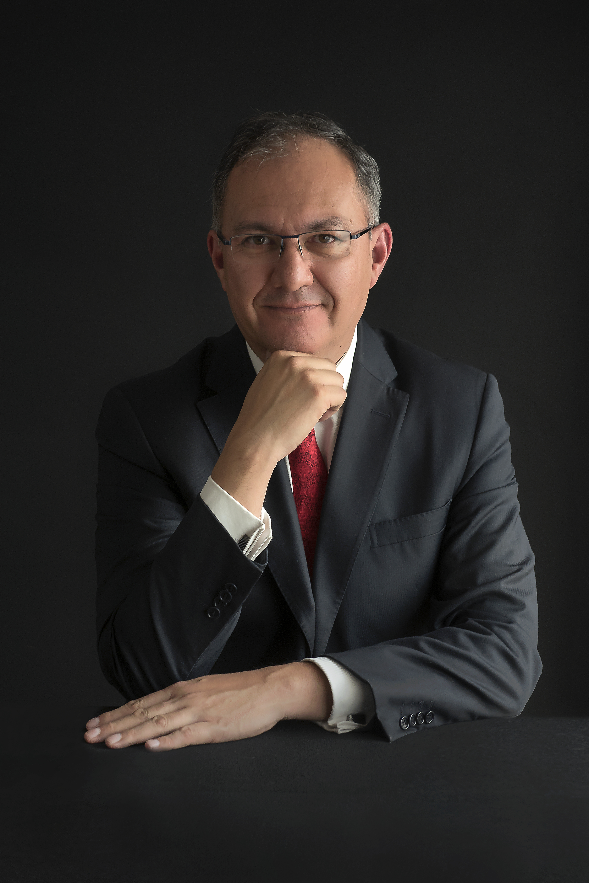 | Luis Fernando Borjón Figueroa  Expert in telecommunications and broadcasting  Government and regulation sector  Higher education  Massachusetts Institute of Technology, Sloan School of Management, Cambridge, MA, United States  2015 Certificate in Administration and Leadership, Certificate in Strategy and Innovation  Brunel University, London, United Kingdom  1991 Master’s degree in Industrial Measurement Systems Prize for best Master’s dissertation in Great Britain awarded by the Institute of Measurement and Control of the United Kingdom  Universidad Iberoamericana, Mexico City  1987 Bachelor’s degree in Biomedical Engineering  Nationality/status: Mexican, married  Date of birth: 20 May, 1962  Languages: Spanish, English and French

Professional experience
Telecommunications and broadcasting, regulation, technological development, government and academia

Promotional Body for Investment in Telecommunications (PROMTEL)
March 2016 - present: Director-General of Mexico’s Promotional Body for Investment in Telecommunications (Organismo Promotor de Inversiones en Telecomunicaciones, PROMTEL).
On 11 March 2016 Fernando Borjón was appointed Director-General by President Enrique Peña Nieto, who founded PROMTEL by decree on that date. This body has been established in the sector coordinated by the Secretariat of Communications and Transport (SCT), the purpose of which is to adopt measures promoting the deployment of the Shared Public Telecommunication Network (Shared Network) and other such networks for the purpose of providing public telecommunication services by themselves, through third parties or in public-private partnerships (PPPs), and ultimately ensuring effective access for the general population to broadband communications and public telecommunication services. It is also responsible for promoting development and investment projects for the deployment of telecommunication infrastructure and, where appropriate, broadcasting, using available public assets in accordance with SCT policies and guidelines.

Federal Institute of Telecommunications
September 2013 - February 2016. Commissioned and appointed by the President of the Republic and confirmed by the Senate. Chairman of the Committee on Portability. Establishment and setting up of the Institute, implementation of activities to comply with constitutional and legislative targets ensuing from the 2013 Constitutional Reform in the field of telecommunications. Tendering processes for TV channels, promulgation of “asymmetric” regulation for dominant radio and TV operators; Must Carry/Must Offer; transition to digital terrestrial TV and freeing up of the 700 MHz band; annual programme of frequency bands; tenders for spectrum in the 1.7/2.1 GHz band (AWS); resolution of problems pertaining to competition in the area of telecommunications and broadcasting, including sanctions and mergers; publication of guidelines and regulations on telecommunications, broadcasting and competition; representing the Institute at various international forums.

Federal Telecommunications Commission
January 2011 - September 2013. Head of the Radio and TV Systems Unit.
Regulation of broadcasting and related public policy. Digital terrestrial radio policy. Revision of policy on digital terrestrial TV. Responsible for dealing with different areas of broadcasting, licensing, inspections, supervision and sanctions regarding broadcasting concessions and licences. Technical Secretary of the Advisory Board on Digital Technologies for Broadcasting. Radio and broadcasting tenders.

Secretariat of Communications and Transport
Subsecretariat of Communications
August 2008 - January 2011. Coordinator for Technological Development
Leader of the Digital TV Project. Public policies relating to the use of radio spectrum and satellites. Regulatory aspects of broadcasting and telecommunications; technological aspects in international spectrum negotiations.
September 2010 - June 2012. Executive Secretary of the Inter-Secretariat Commission for Digital Transition.
September 2007 - July 2008. Coordinator of Technical-Regulatory Projects (by competition).
January - August 2007. Adviser on Follow-up and Logistics.
January 1998 - January 2007. Director of TV and Director of Radio (1999).
Broadcasting industry regulation. Coordination and negotiation of agreements and official Mexican broadcasting standards. Policy for transition to DTTV (2004). From May 2006, seat on the Federal Telecommunications Commission.
Member of the Advisory Board on Digital Technologies for Broadcasting 1999-2007.

International experience
Chairman of the ITU Council, October 2010 – July 2012
Chairman of the ITU Plenipotentiary Conference (PP-10) Guadalajara, Mexico, from 4 to 22 October 2010, receiving ITU silver medal in recognition of his work. Vice-Chairman of the ITU Council (2010).
Participation in meetings in ITU and the Inter-American Telecommunication Commission (CITEL).
Negotiation of broadcasting and telecommunications agreements between Mexico and the United States, with special emphasis on digital terrestrial TV, sharing of the 700 MHz band, and the 1.7/2.1 GHz, 2.3 GHz, 800 MHz bands, and Satellite Digital Sound Broadcasting, among other topics.
Participation in international forums including the Mobile World Congress of GSMA in Barcelona and the World Radiocommunication Conference, 2015.
2016-2018. Chairman of the Expert Group on the International Telecommunication Regulations (EG-ITRs). In accordance with the international commitments made by Mexico, Fernando Borjón is leading this group, which is responsible for revising the ITRs.

Academic experience

Universidad Iberoamericana
Department of Science and Engineering
Assistant to the Director of the Department
Projects for technology research and development in instrumentation, automation and telecommunications, accreditation of engineering programmes and improvements to the curriculum.
Professor 4 (1995) Biomedical Engineering, Electronics and Communications Engineering and Chemical Engineering.
1989-1990 Coordinator for Biomedical Engineering
2000 Course professor (Category A). Electronics and Communications Engineering.

Recent courses
Massachusetts Institute of Technology, Sloan School of Management, Cambridge, MA, United States
2015 Executive Degree Programs: Intelligent Organizations: Collaboration and the Future of Work; Platform Strategy: Building and Thriving in a Vibrant Ecosystem; Understanding Global Markets: Macroeconomics for Executives; Managing Technical Professionals and Organizations; Strategies for Sustainable Business; Understanding and Solving Complex Business Problems.

Languages
Spanish (native speaker)
English 95%
French 80%

Vision statement
The Radio Regulations Board (RRB) plays an important role in interpreting and applying the ITU’s Radio Regulations and in approving the Rules of Procedure used by the Radiocommunication Bureau. In its role as conciliator, the RRB is deeply involved in the rapid and far-reaching developments in radiocommunication technologies, as well as ICTs and broadband services, which are characterized by the convergence of traditional services such as telephony, broadcasting, radiolocation and others, prompting a review of the allocations, allotments and assignments of specific frequency bands in order to promote the social and economic development of societies through more efficient use of the radio spectrum.
Based on my professional experience, I believe that efficient use of the radio spectrum is an important catalyst for the evolution of telecommunications and broadcasting. A case in point is the transition to digital terrestrial TV, a process completed by Mexico at the end of 2015, which resulted in the first digital dividend which was then used to build the “Shared Network” (Red Compartida). This is a national broadband network intended to provide wholesale telecommunication services and ultimately to bridge the country’s digital divide.
In addition, from my experience in the Mexican regulatory authority, I believe that a collegial decision-making process, along the lines of the one in the RRB, enables us to build agreements that are strengthened by a diversity of views which all are directed towards the common good, as well as facilitating the impartial resolution of disputes.
Against this background, what I have to offer, if I can count on the support of ITU’s Member States in seeking election to the RRB, is to share and make good use of my experience in technical fields, in planning, conciliation, and in international negotiations, in order to tackle the priority RRB issues including frequency assignments, the resolution of interference issues between countries, and in analysing issues not dealt with in the Radio Regulations.
I am convinced that my experience and knowledge in the telecommunications field, and in radiocommunications in particular, will enable me to contribute and to reinvigorate and modernize the key role and activities of RRB.

______________

