|  |  |
| --- | --- |
| **Plenipotentiary Conference (PP-18) Dubai, 29 October – 16 November 2018** |  |
|  |  |
|  |  |
| PLENARY MEETING | **Document 5-E** |
|  | **10 November 2017** |
|  | **Original: English** |
|  | |
| Note by the Secretary-General | |
| CANDIDACY FOR THE POST OF MEMBER OF  THE RADIO REGULATIONS BOARD (RRB) | |
|  | |

Further to the information published in Document 3, I have pleasure in transmitting to the Conference, in annex, the candidacy of:

**Ms Chantal Beaumier (Canada)**

for the post of member of the Radio Regulations Board.

Houlin ZHAO  
 Secretary-General

**Annex:** 1

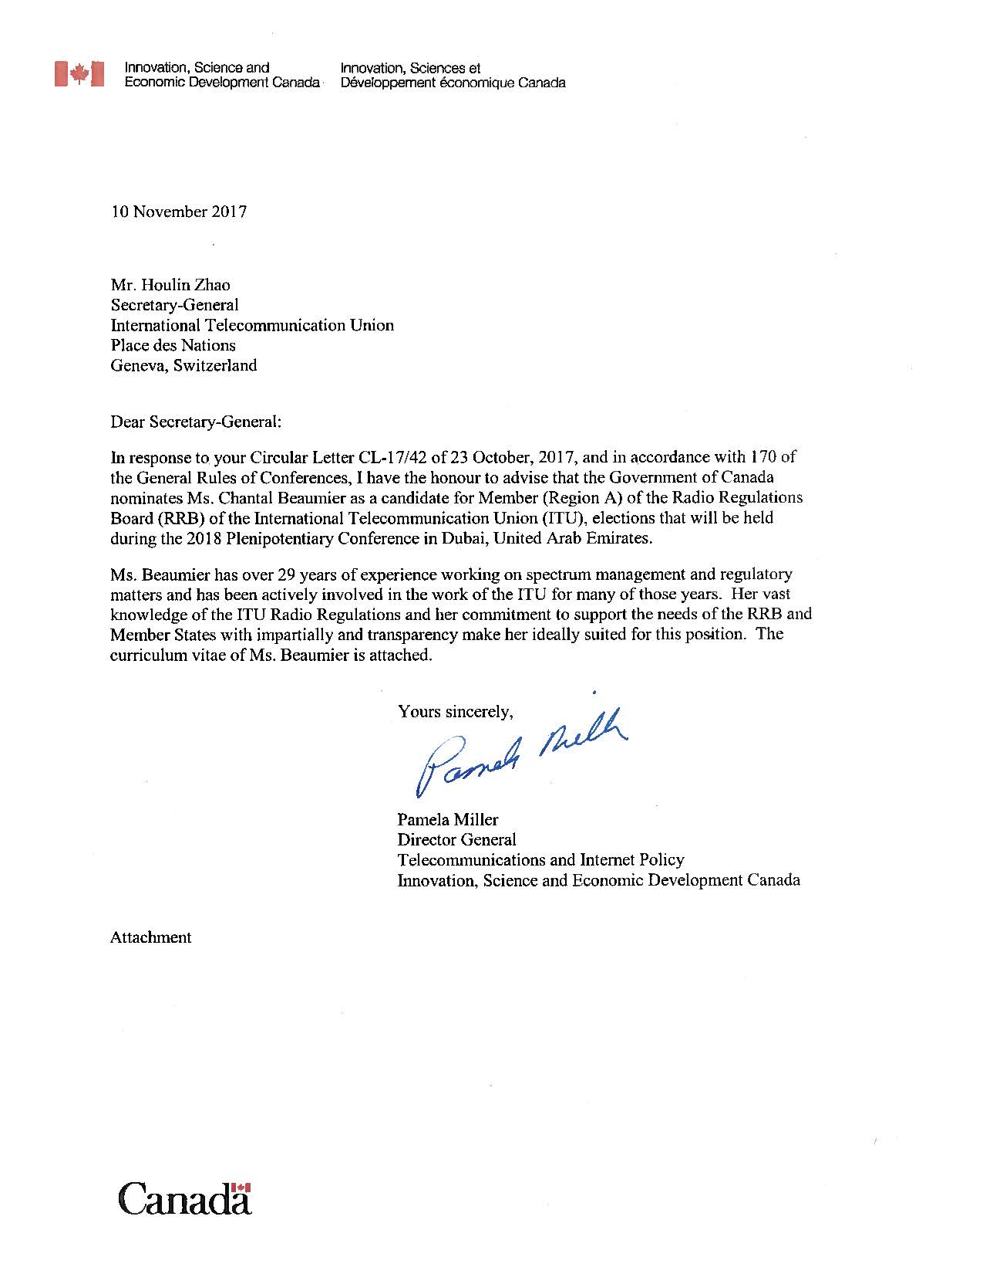

|  |  |
| --- | --- |
| **Plenipotentiary Conference 2018**  **CURRICULUM VITAE**  **CHANTAL BEAUMIER**  **Candidate of Canada for the post of Member**  **of the Radio Regulations Board (Region A**) | **C:\Users\beaumiec\rrb picture.jpg** |

**PERSONAL INFORMATION**

**Date of birth** 12 August 1965

**Nationality** Canadian

**Languages** English, French

**Civil Status** Married, one daughter

**Contact** Tel: +1 (343) 291-1920, +1 (613) 251-0152

Email: chantal.[beaumier@canada.ca](mailto:beaumier@canada.ca)

**EDUCATION**

**1988** Bachelor of Applied Sciences (Electrical Engineering), University of Sherbrooke, Quebec, Canada

**PROFESSIONAL EXPERIENCE**

**2017 - present** Director, Space Services Planning, Innovation, Science and Economic Development Canada

**2016 - 2017** Acting Senior Director, Spectrum Planning and Engineering,

Innovation, Science and Economic Development Canada

**2009 - 2016** Director, Space Services Planning, Industry Canada

**2000 - 2009** Director, Space and International Regulatory Activities, Industry Canada

**1998** Senior Policy Advisor, Intergovernmental Satellite Organizations,

Industry Canada

**1993 - 2000** Manager, Space Services Authorization, Industry Canada   
**1988 - 1993** Terrestrial Services Engineer, Spectrum Management Operations,

Industry Canada

**INTERNATIONAL ACTIVITIES**

Ms Beaumier has extensive experience with the development and application of the international Radio Regulations. She has led Canadian delegations to WRC-15, CPM-15, Special Committee and related bilateral meetings. She also led preparations of Canadian positions and proposals. She has acted as principal spokesperson on satellite, space science and regulatory issues since 2000 within the ITU-R and the Inter-American Telecommunication Commission (CITEL).

She oversees Canadian participation in ITU-R activities related to space services (SG 4, SG 7, CPM and WRCs). She directs the review of Rules of Procedures and the preparation of submissions to the Radio Regulations Board. She provides expert advice and positions on satellite related issues considered at Plenipotentiary Conferences and Council meetings.

In addition, she directed for several years the Canadian international coordination and notification activities for space and terrestrial services. She has led bilateral and multilateral satellite frequency coordination meetings with several operators and administrations; negotiated and concluded various coordination agreements.

**ITU and CITEL Participation**

**2017-present** CITEL, Vice-Chair WRC-19 WG 3 on Satellite and Regulatory Issues

**2015-present** ITU CPM-19, Vice-Chair

**2015** ITU WRC-15, Head of delegation

**2015** ITU CPM-15, Head of delegation

**2013-2015** ITU Inter-regional Workshop on WRC-15 preparations, CITEL representative

**2012-2014** ITU Special Committee and its Working Party, Head of delegation

**2012-2015** CITEL, Vice-Chair WRC-15 WG 4 on FSS and Satellite Regulatory Issues

**2012** ITU WP 4A Efficient orbit/spectrum utilization for FSS and BSS

**2012** ITU WRC-12, Principal Spokesperson, Committee 5 dealing with science, satellite and regulatory issues

**2011** ITU Inter-regional Workshop on WRC-12 preparations, CITEL representative

**2011** ITU CPM-11, Principal Spokesperson, Chapter 5 on Satellite issues

**2009** ITU BR Workshop on the efficient use of the spectrum/orbit

**2009** ITU WP 4A Efficient orbit/spectrum utilization for FSS and BSS

**2008-2012** CITEL, Chair WRC-12 Sub WG 3 on Science and Satellite Issues

**2007-2012** ITU Special Committee and its Working Party, Head of delegation

**2007** ITU WRC-07, Principal Spokesperson, WG 4B dealing with Procedures and Regulatory Provisions

**2007** ITU CPM-07, Principal Spokesperson, Chapter 6 on Regulatory procedures and associated technical criteria applicable to satellite networks

**2004-2007** CITEL WRC-07 Working Group, Coordinator for agenda items 1.12 (satellite regulatory procedures and 7.1 (report of the Director)

**2003** ITU WRC-03, Principal Spokesperson, Committee 4 dealing with regulatory and procedural matters

**2002** ITU CPM-02, Principal Spokesperson, Chapter 5 dealing with Maritime mobile, amateur and amateur-satellite, broadcasting in MF and HF bands

**2002** ITU Special Committee, Deputy Head of delegation

**2001-2003** CITEL WRC-03 Working Group

**2001-2003** ITU Satellite Backlog Action Group (SAT-BAG)

**2001** ITU WP 8D All mobile satellite services and radiodetermination satellite service

**2000** ITU WRC-2000, Spokesperson for agenda items 1.3 (Earth station coordination – Review of Appendix 7) and 1.8 (Earth stations on board vessels)

**1999** ITU CPM-99, Spokesperson for agenda items 1.3 (Earth station coordination – Review of Appendix 7) and 1.8 (Earth stations on board vessels)

**1999** Task Group 1/6 Development of method(s) for the determination of the coordination area around an earth station

**1994** ITU Radiocommunication Seminar on Spectrum Management

**1994** ITU WP 4/9S Frequency sharing between the fixed-satellite service and the fixed service

**NATIONAL ACTIVITIES**

Ms Beaumier is responsible for the development and implementation of strategies, policies and technical regulations governing spectrum/orbital resources allocation and utilization. She provides strategic and expert advice to Canadian government and industry executives on complex satellite policy, technical, licensing and regulatory matters. She has led the development of negotiation strategies to resolve contentious frequency coordination and WRC issues. She has also directed the processing of applications for space related spectrum licences and the development of licensing frameworks, procedures and processes.

**SUMMARY**

Ms. Chantal Beaumier has more than 29 years of experience in spectrum management and regulatory activities in the federal government (Department of Innovation, Science and Economic Development, formerly Industry Canada) where she has worked on domestic and international telecommunications matters. She is a recognized regulatory expert with strong leadership competencies, problem-solving skills and a vast knowledge of wireless technologies, ITU radio regulations and procedures.

Her in-depth expertise is wide-ranging, and includes development and implementation of strategies, policies and technical regulations governing spectrum/orbital resources use. She has managed spectrum planning, engineering, frequency coordination and licensing programs that provide access to spectrum for new radio services and address coexistence issues amongst all radio services. Ms. Beaumier has also served as head of delegation and principal spokesperson to numerous international conferences and meetings, such as WRC, CPM, ITU-R Study Group/Working Party, CITEL and satellite coordination meetings.

