|  |  |
| --- | --- |
| **Plenipotentiary Conference (PP-18) Dubai, 29 October – 16 November 2018** |  |
|  |  |
|  |  |
| PLENARY MEETING | **Revision 1 to Document 4-E** |
|  | **23 February 2017** |
|  | **Original: English** |
|  | |
| Note by the Secretary-General | |
| CANDIDACY FOR THE POST OF DIRECTOR OF THE RADIOCOMMUNICATION BUREAu (BR) | |
|  | |

Further to the information published in Document 3, I have pleasure in transmitting to the Conference, in annex, the candidacy of:

**Dr Mindaugas ŽILINSKAS (Republic of Lithuania)**

for the post of Director of the Radiocommunication Bureau of the International Telecommunication Union.

Houlin ZHAO  
 Secretary-General

**Annex:** 1

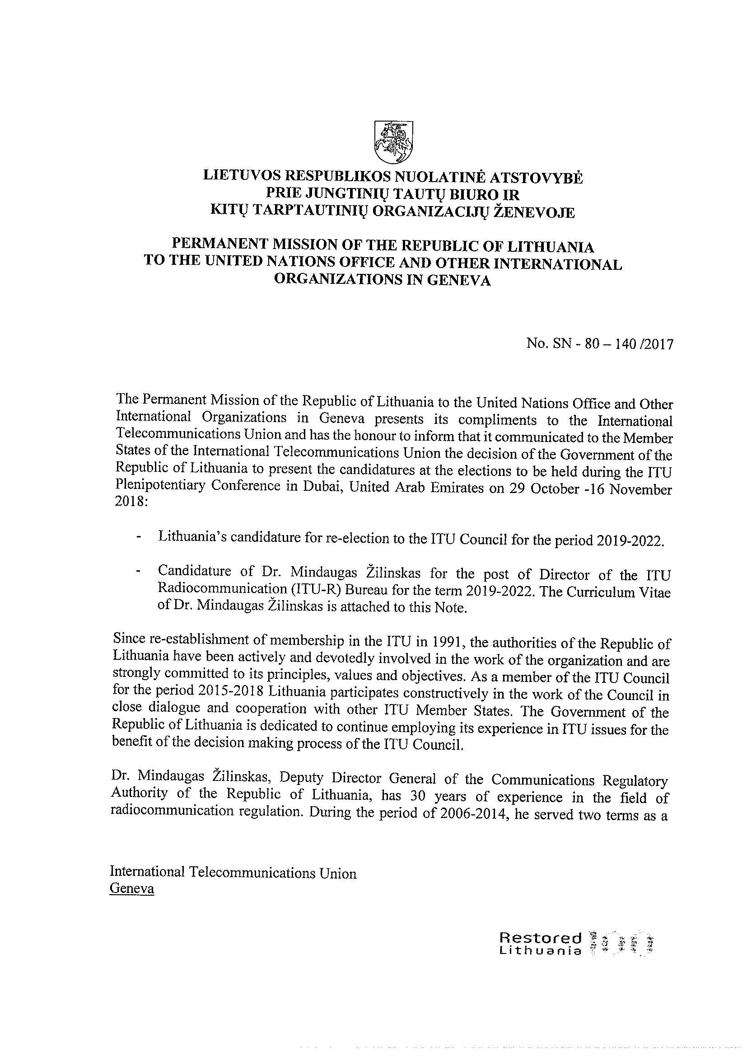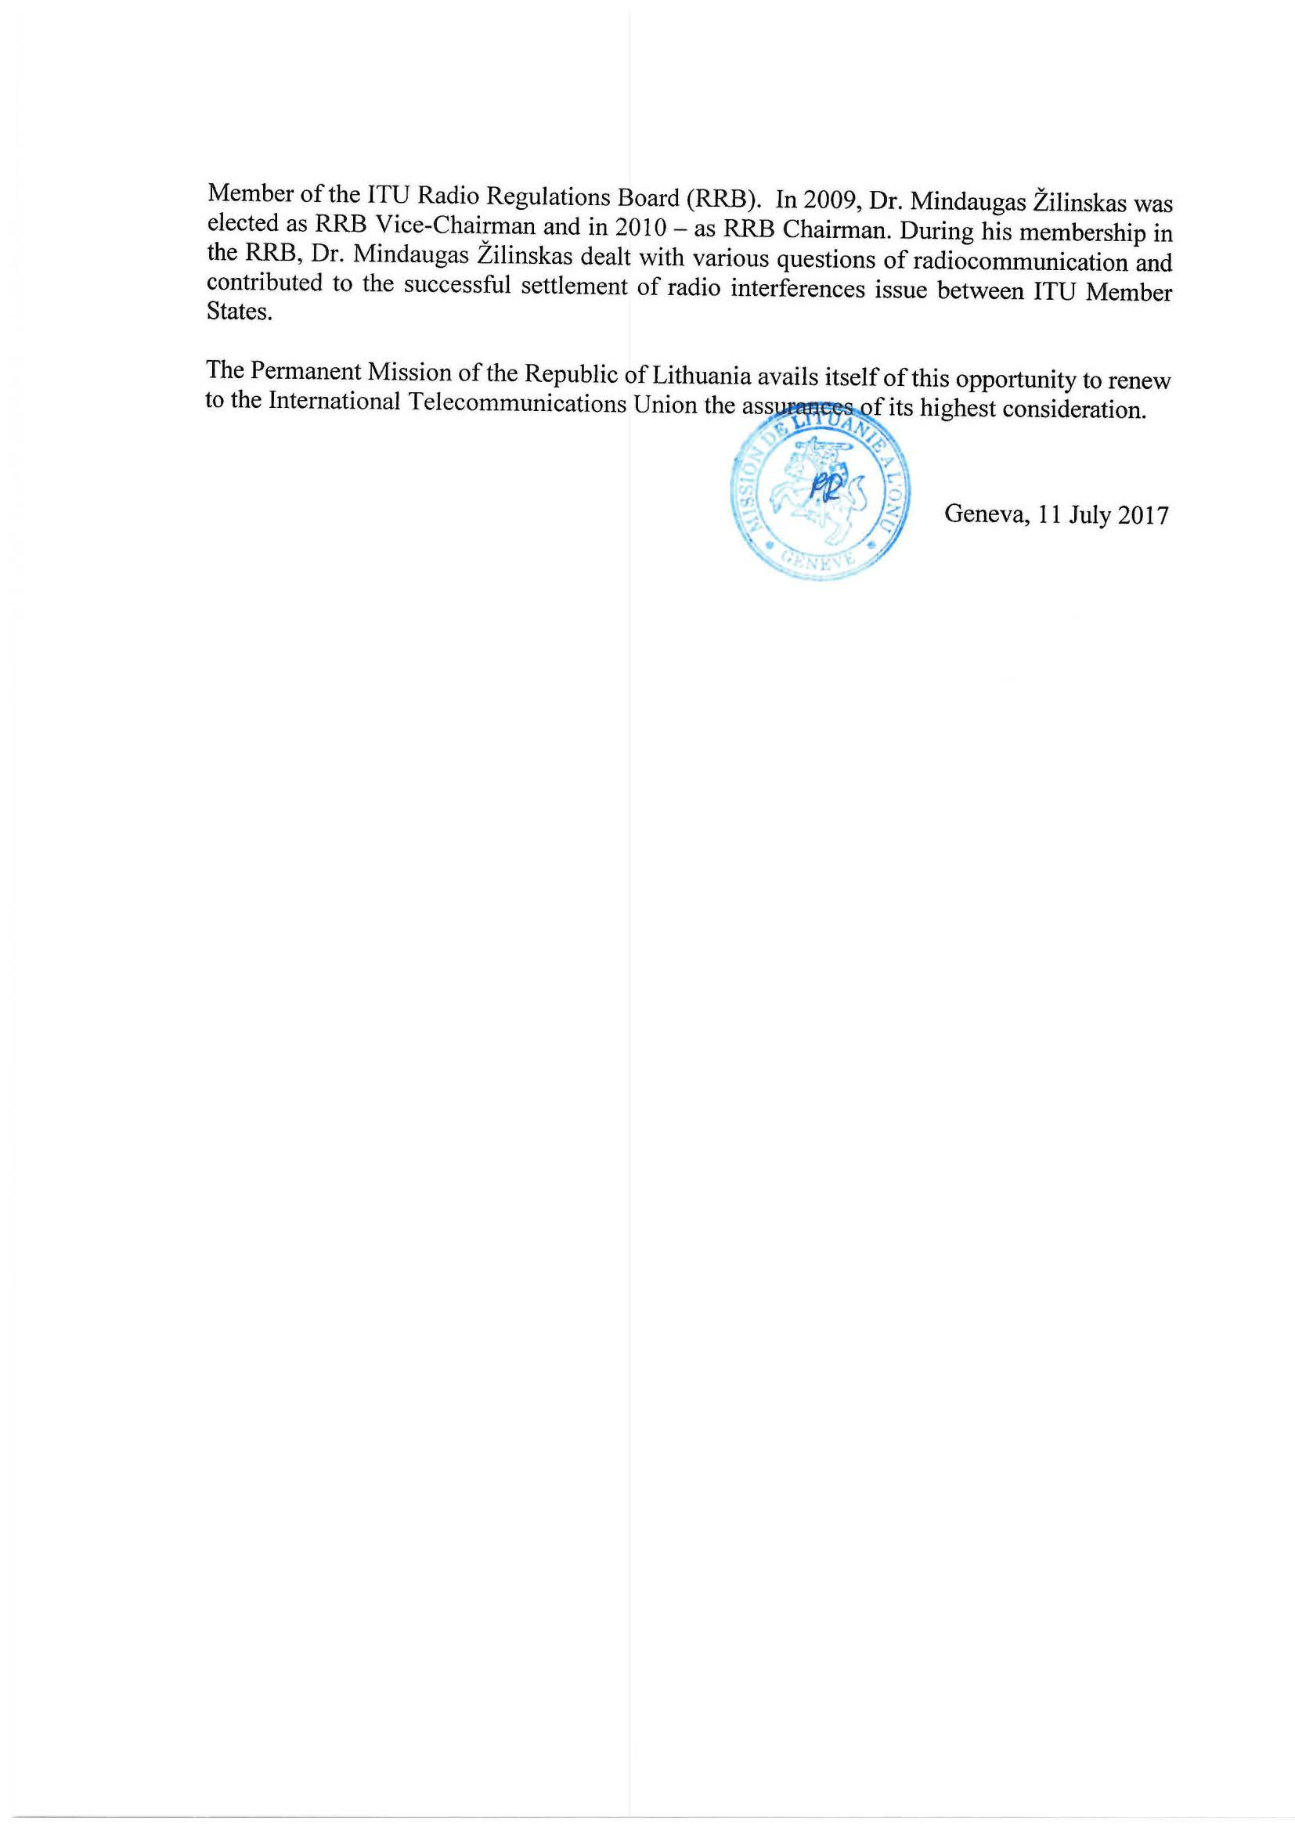



|  |  |  |  |
| --- | --- | --- | --- |
| **CANDIDATE FOR THE POST**  **OF DIRECTOR OF THE ITU-R BUREAU**   |  |  | | --- | --- | | cid:image001.png@01D2EAAB.6C11D1A0 | **2019-2022**  **Dr. MINDAUGAS ŽILINSKAS** | | |
| **GENERAL INFORMATION** | |
| Date of Birth | 26 February, 1956 |
| Nationality | Lithuanian |
| Marital Status | Married, has a daughter and a son |
| Languages | Lithuanian (mother tongue), English, Russian |
|  |  |
| **EDUCATION** | |
|  |  |
| 2003 | Courses at the United States Telecommunications Training Institute, “Spectrum Management in the Civil Sector”, Washington D.C. |
| 1989 | Doctor’s degree in science (PhD) from Vilnius University  Thesis “Analysis of electromagnetic convertors of information by using method of singular integral equations” |
| 1974-1979 | Master’s degree in Physics from Vilnius University |
| **PROFESSIONAL EXPERIENCE/CAREER HIGHLIGHTS** | |
| 2015-Present | Deputy Director General  Communications Regulatory Authority of the Republic of Lithuania ([www.rrt.lt](http://www.rrt.lt))   * Fulfils the functions related to management, organization and co-ordination of the work at the Authority * Leads work teams of over 70 of staff * Supervises activities of the Authority related to radio communication regulations and policy implementation |
| 2001-2015 | Director of Radio Communication Department  Communications Regulatory Authority of the Republic of Lithuania   * Involved in management of work of radio communication team consisting of 24 experts * Directly responsible for spectrum allocation and designation for radio communication services and stations, ensuring interference-free environment * Led bilateral and multilateral negotiations on radio spectrum * Organized and led bilateral or multilateral frequency coordination’s negotiations for 3G, 4G technologies for mobile broadband communications including multipoint multimedia distributions systems (MMDS) * Actively participated in development of broadcasting satellite services (BSS) and fixed satellite plans for Lithuania * Responsible for development and implementation of the regional (European) decisions for electronic communications into the national law |
| 2000-2001 | Director of Radio Communication Department  State Radio Frequency Service (was reorganized into the Communications Regulatory Authority of the Republic of Lithuania)   * Led team of 24 experts * Directly responsible for spectrum allocation and designation for radio communication services and stations, ensuring interference-free environment * Development of the national plans for analogue and digital television and for analogue FM radio * Coordination of the above-mentioned plans with the neighboring administrations, including bilateral or multilateral negotiations |
| 1998-2000 | Head of Electromagnetic Compatibility and Information Technologies Division  State Radio Frequency Service   * Responsible for design of software for electromagnetic compatibility of various telecommunications systems, e.g. radio, television, mobile communication, radio relay lines, providing electromagnetic compatibility calculations for television and radio stations ensuring their conformity with international agreements * Development of national plans and their coordination with the neighboring administrations, including organization and leading of bilateral or multilateral negotiations |
| 1993-1998 | Engineer of Radio Planning Division  State Radio Frequency Service |
| **SCIENTIFIC WORK**   |  |  | | --- | --- | | 2004-Present | Associated Professor  Faculty of Physics, Vilnius University  Lectures and practices of Applied Electrodynamics | |  | Publications  **Author or co-author of more than 70 articles and reports in scientific journals and conferences** |   **PERSONAL SKILLS** | |
| Communication skills | * Communication skills gained through work experience and participation as an expert in international projects, negotiations and co-operation activities |
| Organizational/ managerial skills | * Leads work teams (over 70 of staff) from different departments within the Authority * Head of Lithuanian delegation in radio frequency coordination and negotiations with neighboring countries on fixed and mobile, broadcasting services |
| Job-related skills | * In-depth knowledge of spectrum management due to academic work, long-term experience in international and national practical work * Vast experience in management and organizing of work groups related to spectrum auctions, negotiations, etc. * Involvement in regulatory issues including experience in drafting of national legislation implementing EU and CEPT legal acts |
| **REGIONAL AND INTERNATIONAL EXPERIENCE** | |
| Regional (European) experience | * Co-chairman of Good Office Group of RSPG, since 2015 * Member of Radio Spectrum Committee of the EC, 2005-2014 * Member of Radio Spectrum Policy Group (RSPG), since 2014 * Member of ECC and CPG committees (CEPT ECC, CPG), since 2005 |
| International (ITU) experience | * Member of ITU Radio Regulation Board (RRB), 2007-2014 * Chairman of RRB of ITU, 2010 * Vice-chairman of RRB of ITU, 2009 and 2014 * Deputy Head of Lithuanian delegation in WRC-15 * Member of Lithuanian delegation in Regional Conference for Digital Television 2004 and 2006 |
| Projects | * Implementation of the First digital dividend (as ITU expert),Kirgizstan, Bishkek, 2010 |
| **MOTIVATION** | |
| Lithuania has been an active member of regional and international organizations, including ITU. We honestly believe in strong leadership and expertise of ITU officials. With its commitment to put candidature of Dr. Mindaugas Žilinskas, the Government of Lithuania ensures that the candidate is devoted to offer to ITU community the best of his leadership and expertise. Scientific experience and practical knowledge in the field of radio communication that Dr. M. Žilinskas has acquired over the 30 years ensures candidates’ capability of fostering:   * Leadership and expertise to support needs of ITU and its members; * Culture of collaboration and cooperation, sharing of knowledge and leadership; * Management of ITU-R sector impartially and transparently. | |
| **VISION STATEMENT**  “**Access to Wireless Broadband for Everyone”** | |
| Bearing in mind that ICT plays the significant role in economics of every country, ITU performs as the main body in ensuring equal rights to all countries irrespective of their size to get equitable access to the limited natural resources – radio spectrum and satellite orbits through its instruments. Having this task together with the requirement of effective and rational use of spectrum, the Radiocommunication Bureau shall:   * maintain the high professionality and efficiency of its work ensuring transparency of all Bureau’s decisions; * strengthen the role of Radiocommunication Bureau in ITU structure, striving to prepare the solutions and proposals to WRC in ITU-R study groups or committees for all issues related to allocation and use of radio spectrum and orbital resources; * in cooperation with the Radio Regulations Board, increase the Radiocommunication Bureau’s involvement in solving the disputes on harmful interferences between the countries; * trying to reduce cases of harmful interferences, strengthen the Radiocommunication Bureau’s activities in frequency management consultations through: seminars, workshops, deeper cooperation with regional ITU offices, development of corresponding software; * provide assistance to individual countries if necessary; * strengthen relations with academia in the work of ITU-R study groups. | |

_________