Council Working Group for  Strategic and Financial Plans 2020-2023  Fourth meeting – Geneva, 16 April 2018 | 
 | Document CWG-SFP-4/INF/2-E
 | 27 March 2018
 | English only

Chairman of the Council Working Group for
Strategic and Financial Plans 2020-2023 (CWG-SFP)

Introduction to the second Public Consultation on ITU’s Strategic Plan for 2020-2023
The ITU Council Working Group for Strategic and Financial Plans (CWG SFP) is mandated to develop a draft Strategic Plan for the Union for 2020-2023 to be reviewed by Council 2018 and forwarded to PP-18 for adoption. To this end, the CWG SFP agreed during its third meeting in Geneva (15-16 January 2018) on conducting a Public Consultation on the revised draft Annex 1 to Res.71 (the draft ITU Strategic Plan 2020-2023), including the texts in square brackets.
The Public Consultation was held from January 30 to March 16, 2018. An online platform was launched for this purpose, and all contributions, including the ones received via e-mail to strategy@itu.int, are available online.
In total, 18 contributions were submitted by: a regional organization (African Telecommunication Union – ATU); four Member States and regulatory authorities (Russian Federation, Japan, Mexico and Colombia); five civil society and international/national associations/organizations (GSMA, EMEA Satellite Operator’s Association (ESOA), Association for Progressive Communications (APC), Global Partners Digital, Mujeres en Política y al Poder); three private sector organizations (Ericsson, Intel, AVtobvS llc); and five individuals. Section 3 below presents a full list of contributions.
This document introduces the contributions per section of the Strategic Plan, indicating the contribution presenting the proposal [number of the contribution in square brackets], as per the full list presented in Table 1 of Section 3.
This document reflects solely the views of the authors and organizations who participated in the consultation.

Inputs

Vision and Mission
Overall, the proposed Vision and Mission statements have received a wide support from contributions. Specific proposals for change range from adding to the Mission a reference to “promoting development of communication and information technologies” [contribution no. 3] to explicitly specifying that ITU should focus on core its Mission [contr. no. 17]. Regarding the Vision statement, it is proposed to add: a) “smart” to the “information society” [11]; b) “next generation” before "telecommunication/information and communication technology networks", and c) “high-speed and high-quality” before “services” [11].

Values
There were several contributions focusing on the values. Proposals range from adding new Values, such as “Forward looking” [3], “Inclusiveness” [17], “Efficacy and efficiency”, “Accountability”, “Professionalism”, “Innovation” [18] and “Human Rights” ([13], [17]), to deleting explanatory text from Values “Excellence” and “Universality and Neutrality” [5]. It was also proposed to add reference to other standardization organizations in the Value “Openness” [11]; and to add the word “credibility” to “confidence” and to “trust” [7]. It was also mentioned that “Excellence” implies to look for ways to minimize the introduction of duplicative work, particularly by undertaking more rigorous research before adopting new work items [11].

Strategic Goals
All contributions but two support the current 5 Goals, with very few changes. One contribution proposes to merge back Goals 4 and 5 [7] and another one to create a new Goal on security [3].
Proposals of changes to Goal 1 range from including a reference to people-centered in the explanatory text [17], and referring to promoting policies that foster a mix of technologies [13], to replacing “digital economy and society” by “information society” [7]. A contribution pointed out to the need to build agreements allowing the participation of both governments and citizens and that the role of civil society organizations should be helping to raise awareness of what ICT-related international organizations are doing [16]. Another contribution proposes to add “conditions to” before “access to”, and add “affordable good quality” before “telecommunication/ICT” [18].
Regarding Goal 2, it is proposed to replace the words “people with different income levels” by “people from lower socio-economic groups” [8]. Another contribution proposes to add “internationally agreed level of quality” before “broadband” [18].
On Goal 3, it is proposed to change “as well as safety and security” to “as well as building confidence and security” and to put “in close collaboration with all stakeholders” after the sentence of “in the use of telecommunications/ICTs” [10]. A contribution also pointed out to the natural resilience of satellite systems which make them “naturally protected from natural or man-made disasters” [13]. A contribution proposes to delete from this Goal the sentence “the Union will work towards minimizing the negative impact of undesired collaterals, such as cybersecurity threats, including potential harm to the most vulnerable parts of society, in particular children, and negative effects on the environment, including e-waste” [13]. Another contribution highlights e-waste and pollution as one of the main challenges [15].
For Goal 4, a proposal was to add “new business models and” before “advances in new technologies” [17].
Regarding Goal 5, a contributor emphasizes that ITU should continue to encourage public/private partnerships to provide a platform where governments and other stakeholders can collaborate on a set of common challenges to bridge the digital divide [17].

Strategic Targets
One of the proposals [5] suggested establishing an interdependence, where it is appropriate, between the relevant targets by 2023 and the targets established by the Broadband Commission to support the initiative “Connect the Other Half”, presented at the joint meeting of the BBComm and the World Economic Forum.
Some contributions requested more information on how some targets were set ([7], [17]) or on how they will be measured [10]. Other requested clarification for the definition of some of the terms (e.g. “households”, “using the Internet” or “Individuals” [17].
Other proposed new targets, including a new target “2.9: By 2020-2023 the number of collaborative frameworks concluded to be progressed at 30%) [7], or new targets 1.10: by 2023, 40% of population should be using digital health services, new target 2.11: by 2023, 30% of world population covered by 5G services, new target 2.13: by 2023, in the developing world, 60% of schools, health units and telecenters should have access to high speed broadband, and 2.14: by 2023, 50% of developing countries should have a strategy on Artificial Intelligence [11]. It was also proposed to add a new target on equitable and reliable access to affordable spectrum (and international connectivity) under Goal 3: Sustainability [17].

Objectives and Outcomes
Inputs received on the sector and inter-sectoral Objectives and Outcomes included:
- ITU-R: New R.4: (High Speed Mobile Broadband): Foster the deployment of IMT-2020 (5G) and start to develop new IMT standardization process beyond IMT-2020 (5G) [11].
- ITU-T: In T.1 and T.2, a proposal to change “non-discriminatory” by “voluntary, consensus-based” [11]; and another proposal to keep the term “non-discriminatory” [18]. Another contribution noted that the term “Non-Discriminatory Standards” is an ambiguous term that may have unintended consequences [9]. In T.5, a proposal to change “regional telecommunication organizations” by “industry fora to avoid duplication and overlap of work” [11]. Regarding T.2, Process and procedures, a participant would like to see a return to adherence to documented ITU process and procedures, particularly in relation to document introduction, consensus determination, pre-determined outcomes and accurate meeting reporting, especially in ITU-T Study Groups. The ITU Secretariat should remain neutral [12]. A participant proposed to add 3 Outcomes on increased collaboration with other SDOs [18].
- ITU-D: From Objective D.1, a proposal was made to delete the words “and agreement” and from D.3 delete the words “policy and regulatory” [8]. A proposal was also made to add to D.2 “next generation” before “infrastructure” and “high speed, high quality broadband” before “services”; and add to D.4 “affordable next generation” before “telecommunications/ICTs”, and “services” before “and applications” [11].
- Inter-sectoral: A proposal to remove the square brackets in I.4-d was submitted ([8], [18]). In I.1-d, an “enhanced support to tech SMEs should be materialized by the possibility to join the ITU as an associate or sector member with a discounted rate” [14].

Outputs and Enablers
A contribution proposes to add 2 new Outputs under Objective D.4: “D.4-5: Participation and compromise by citizens and administrations thanks to telecommunications-oriented strategies for public policies and D.4-6: Norms and regulations encouraging companies to invest in infrastructure to benefit social, cultural and environmental programs” [16].

Strategic Risk management
Overall, comments on this section mainly refer to the mitigation measures in the corresponding risks. For example, “in an effort to chase new issues like Artificial Intelligence and Blockchain, for example, necessary updates to the SS7 specification have not happened” [12]. The risks of “Spreading too thin” and “Mission dilution and losing sight of the organization core mandate” can be avoided by prioritizing use of available funding/resources towards activities that are part of the ITU’s core mandate [17]. The risk of “Failure to respond quickly to emerging needs and innovate sufficiently while still providing high quality deliverables” can be avoided by partnering with other actors already working on emerging needs [17]. Risks related to “Concerns regarding trust and confidence” and “ Risk of rising concerns related to trust by membership and stakeholders” can be avoided by investing in increased transparency in decision-making and being consistently inclusive [17]. The risk of “Insufficient funding” can be avoided by the Union sticking to its core mandate and thereby avoiding escalation in costs [17]. A contribution proposed to delete the text “It should be emphasized that the strategic risks are not meant to represent deficiencies of ITU's operations. They represent forward-looking uncertainties that may affect efforts to fulfil the mission of the Union during the period of the strategic plan” [18].

Linkage with SDGs and WSIS ALs
A contribution proposes to specify what kind of activities have been made to promote C2, C5 and C6 by ITU as sole facilitator and, in addition, how much progress has been made as a result of ITU activities [10].

Implementation and evaluation of the Strategic Plan
A contribution proposes to incorporate a set of implementation criteria, as the current plan does [8].

Contributions
Figure 1: Contributions to the Public Consultation on the Draft ITU Strategic Plan 2020-2023
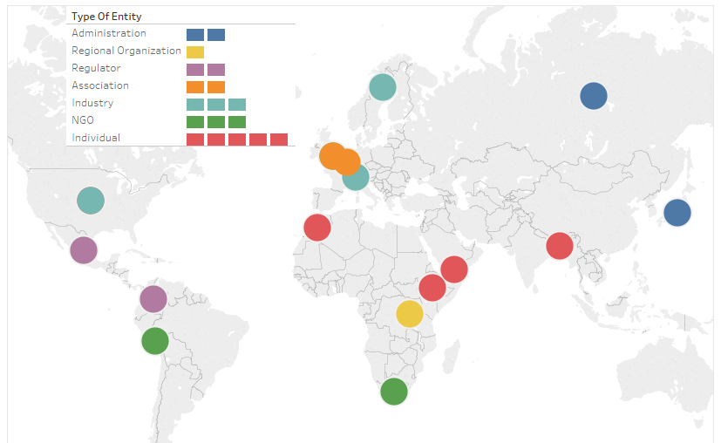
11 4
13
8 12
14
15
16
17
18
10
7
6
9
5
3
2
1
* numbers correspond to the numbers in the list of the contributions in Table 1 below

The list of contributions received to the Public Consultation to the Draft ITU Strategic Plan 2020-2023 is presented in the Table below.
Full contributions are available in the online platform.

Table 1: List of Contributions
No. | Date | Entity (or individual) / Country | Focal Point
[1] | 18.02 | Mohanata, Sukumar / Bangladesh | MOHANATA, Sukumar
[2] | 27.02 | Mansoor, Magdi / Yemen | MANSOOR, Magdi
[3] | 01.03 | Aregawi, Aynalem / Ethiopia | AREGAWI, Aynalem
[4] | 04.03 | Reavill, Sheila / USA | REAVILL, Sheila
[5] | 12.03 | Ministry of Telecom and Mass Communications / Russian Federation | YUZHAKOV, Anton
[6] | 14.03 | Sellam, Achraf / Morocco | SELLAM, Achraf
[7] | 15.03 | On behalf of the African Telecommunication Union (ATU) / Rwanda | MUPENZI, Jackline
[8] | 15.03 | Global Partners Digital / UK | WINGFIELD, Richard
[9] | 15.03 | Ericsson / Sweden | OVESEN, Hans
[10] | 15.03 | Ministry of Internal Affairs and Communications / Japan | GOTO, Akira
[11] | 15.03 | Intel / USA | MULUK, Turhan
[12] | 15.03 | GSMA / UK | DAWES, Lauren
[13] | 16.03 | EMEA Satellite Operators Association (ESOA) / Belgium | VICENTE, Natalia
[14] | 16.03 | AVtobvS llc / Switzerland | KOVAC, Stiepan
[15] | 16.03 | Agencia Nacional del Espectro / Colombia | SOSA LEGUIZAMÓN, Carol
[16] | 16.03 | Mujeres en Política y al Poder / Peru | PUKALUK, Michał
[17] | 16.03 | Association for Progressive Communications (APC) / South Africa | WAY NAUPAY, Silvia
[18] | 20.03 | Federal Telecommunications Institute (Mexico) / Mexico | HERNÁNDEZ, Juan Carlos

