Council 2018  Dubai, 27 October 2018 | 
 | Document C18/INF/19-E
 | 19 October 2018
 | French/English
Note by the Secretary-General
itu new hq Project

Summary
This report gives additional information on the building design and functionality.

Action required
This report is transmitted to the Council for information.

The new building, designed by the Christian Dupraz bureau, winner of the international competition held by the International Telecommunication Union in 2017, offers ITU a headquarters building that is emblematic and functional, iconic but discreet, visible without being ostentatious, in the form of a workplace that gives the Union the architectural revival it is seeking.
The new ITU building is to be built on the site of the former Varembé building. It will be trapezoidal, with the same width as the Montbrillant building on the Place des Nations side, tapering slightly along the rue de Varembé.

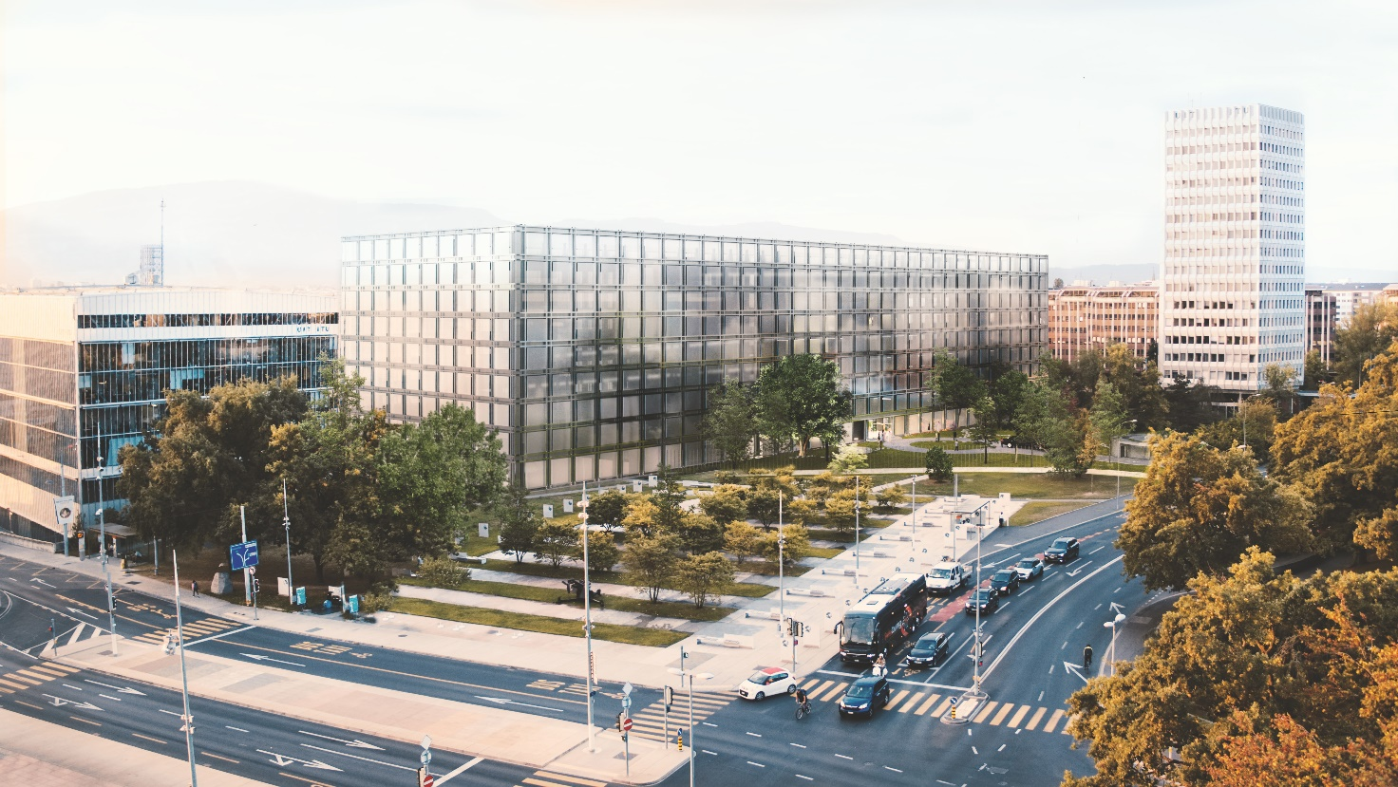

Although its length will ensure that the new building’s presence is felt, its height too will provide a characteristic presence. Over thirty metres high, it will readily find its place in the Nations area, standing taller than the Montbrillant building without dwarfing it.

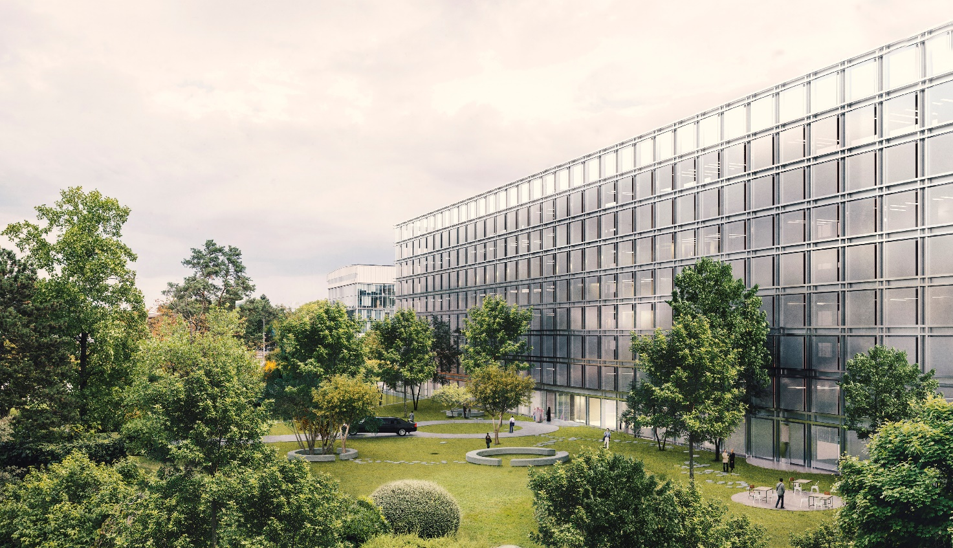

The building’s uniqueness nevertheless resides within. Although compact when viewed from outside, its interior volume is largely hollow, leaving room for a beautiful indoor garden barely visible through the glazed façades.
The main entrance is from the park on the Giuseppe Motta side, via a mezzanine artfully crafted to provide the structure of the entire lobby.

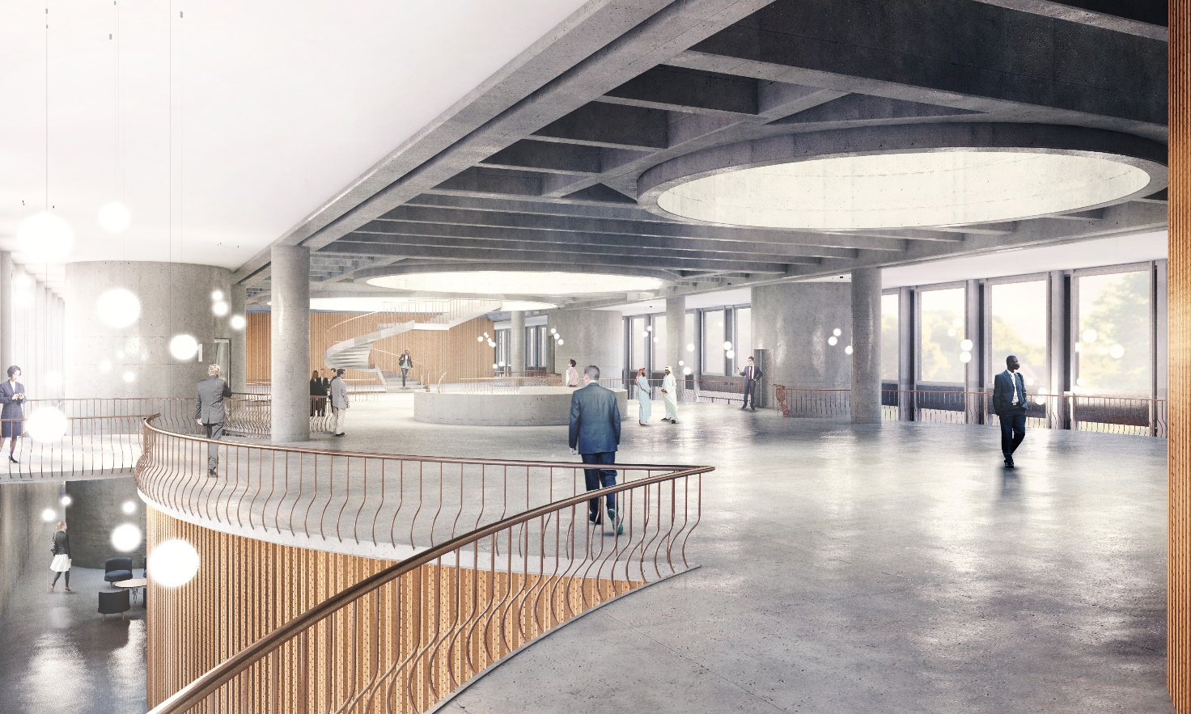

The lobby houses ITU’s conference rooms, on three different levels: one seating 100 people on the upper ground floor (mezzanine on the Giuseppe Motta park side); another seating 500 on the lower ground floor (rue de Varembé level); and a third seating 234 in the basement. These rooms have the appearance of large cylinders, cleverly placed so that the lobby’s other activities gravitate around them: salon, café, meeting areas.
The lobby is home to a world full of connections created to echo the very nature of the organization. Opening on to the park and on to the rue de Varembé, the space is bathed in light and can be used to hold large-scale events. The three meeting rooms in close proximity, the large multifunctional spaces and smaller meeting rooms, a cybercafé, all allowing ITU to gather its members and visitors together in a single area.
The impressive garden paving, perforated by three circles, also brings light into the heart of the building and provides connection with the upper reaches of the building via a large stairway traversing the equivalent of an entire floor of technical support functions. Although closed toward the centre of the building, this floor is completely open toward the outside. It is home not only to the control centre and rooms used for ITU’s clubs, but also to the entire reprography section, kitchen stores and production areas.
For most ITU users, however, this floor remains invisible. They pass through it either by lift, in circular cores ascending the entire height of the building, or via the large stairway majestically connecting the lobby directly with the garden level.
This raised garden offers the ITU staff a world of its own. Three tall glass cylinders connected to the crown of offices enclosing the garden with a multitude of walkways make the garden a place of unexpected and iconic design.
Public activities common to all ITU users and staff are conducted around the building’s lush green centre. The restaurant occupies the east (Montbrillant) end, opening on three sides on to the green terrace. A new media centre, cultural spaces, sports facilities, along with the infirmary and training rooms, all take advantage of this amazing outdoor area to facilitate interaction between colleagues and maximize the opportunity for people to meet in the new headquarters building.

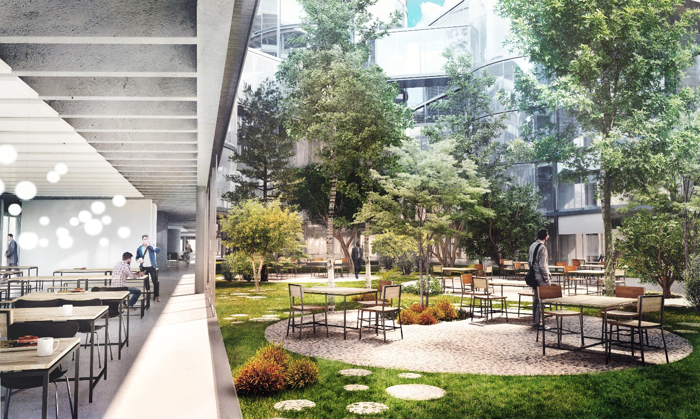

The offices – designed as open space at the organization’s request – are located around this green heart, enjoying constant double exposure.
In the centre, the three rising cylinders offer different areas, linked by walkways spanning open space and providing staff with meeting rooms and rooms for collaboration purposes essential to the smooth functioning of the office areas. The smallest tower is a terrace tower, with each level offering exceptional outside space. The two others house meeting rooms for 16, 20, 30 or 40 people.
With the intermediate spaces – stairwells, areas for collaboration, etc. – the volumes are visually segmented, allowing the different services to organize themselves mutually without having to partition themselves off. Department heads each have a separate office, but purposely positioned at the heart of the entire service, in the centre of the open-plan offices.

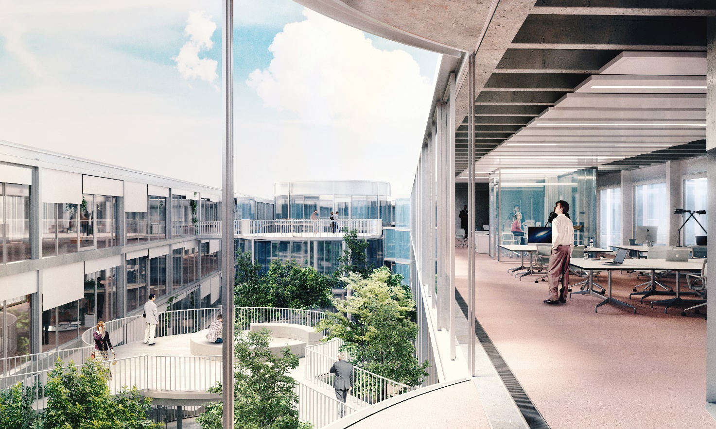

Vis-à-vis the exterior, the building’s thermic envelope entirely made of glass has a double skin cladding the whole. A network of metal frames integrates the solar protection essential to a glass building like this, but also gives the staff visual protection from the outside world. The transparent façade ensures that the international organization it accommodates is visible, and offers the International Telecommunication Union the headquarters building that best reflects its commitment to setting its sights firmly on the future.

A few figures:
Surface area: 27 926 m2 + 759 m² = 28 685 m² (building and security lodge)
Workplaces: 723
Number of floors: 10: one basement, one technical floor, three floors with public access and five floors of offices
Conference rooms: 3, one seating 500 people, divisible into two, one seating 234 people, divisible into two, and one seating 100 people
Meeting rooms: 27 rooms of different sizes, spread over all floors
Collaborative spaces: garden terraces, kitchenettes, consultation areas, hotspots for visitors, on all levels
Cultural spaces: for use by staff, on the same floor as the indoor garden and on upper floors

________________

