|  |  |
| --- | --- |
| **Council 2018 Geneva, 17-27 April 2018** |  |
|  |  |
|  |  |
|  | **Document C18/INF/13-E** |
| **3 April 2018** |
| **English only** |
| Note by the Secretary-General | |
| information document from GREECE  The hellenic rural broadband project: Fostering the Information Society in Territorial cohesion to support the implementation of Agenda 2030 | |

I have the honour to transmit to the Member States of the Council an information document submitted by **Greece**.

Houlin ZHAO  
 Secretary-General

INFORMATION DOCUMENT FROM GREECE

**The Hellenic Rural Broadband Project: Fostering the Information Society in Territorial Cohesion to Support the Implementation of Agenda 2030**

The core vision of the Ministry of Digital Policy, Telecommunications and Media in Greece, is to “**Ensure that no one is left behind**”, hence we are strongly committed to bridge the digital divide and promote the digital cohesion, by assuring and/or improving connectivity across the country and offering broadband services to rural areas, thus supporting the Sustainable Development Goals (SDGs) in the UN Agenda 2030.

The General Secretariat is the competent National Authority for the preparation and implementation of the **National Broadband Plan,** that encompass various activities/projects that reflect to this vision, financed by national resources and by European Structural and Investment Funds (ESIF).

The Rural Broadband Project was awarded in the framework of **European Broadband Awards 2017,** in Category 3: “Territorial cohesion in rural and remote areas”.

The **Rural Broadband** is a national-wide, large scale project, supported by ESIF and implemented via a Public-Private–Partnership scheme. It provides broadband infrastructure coverage and affordable connectivity services to the citizens of remote, disadvantageous areas of Greece - previously deprived of the full benefits of broadband. With this project, high-capacity networks reached remote areas where private players would not invest due to its low commercial value. A mix of technologies (i.e. fibre and Wireless Backhauling, Wireless and VDSL Access) has been used to provide broadband infrastructure availability to NGA-white areas all over the country. The geographical span of the infrastructures covers almost **45% of the Greek territory** (geographically) and provide broadband connectivity to 5 077 villages/settlements and 525 287 inhabitants of rural and insular areas of the country.

**Challenges**

**Rural connectivity is a major challenge** for our country, due to the particular geomorphology and inhomogeneous population distribution. In particular, Greece is primarily a mountainous country, with more than 300 larger and smaller mountains extending across the mainland, which covers 80% of the total territory. The rest of 20% corresponds to approximately 6,000 islands, islets and rocky islets. Only 117 of them are inhabited, while there are only 79 having a population of over 100 inhabitants and only 53 having a population of over 1,000 inhabitants. Besides of the geographical morphology issues that needed to be encountered during the design of the project, other challenges that we also encountered were:

a) The difficulty to develop the broadband infrastructure, due to certain technical, socio-economic and market-related reasons, related directly to rural areas’ profile in Greece;   
b) The innovative financing scheme combining two EU funds - namely ERDF and EAFRD - under a Public Private Partnership (PPP) scheme, was also cumbersome. This scheme allowed to build a public-owned network while distributing and partially lowering the risks of the involvement of private partners. The applied business model is DBOT (Design, Build, Operate and Transfer).

**Financing**

**TYPE OF SOURCES / INSTRUMENTS**

The total budget of the project exceeds 160M€, co-financed by public funds (both EU and National) and private partner funds. EU funds have been used through the European Structural and Investment Funds (PP 2007-2013) and more specifically from the European Regional Development Fund (ERDF) and the European Agricultural Fund for Rural Development (EAFRD). For the Phase B (Operation) of the project, funds have been used from ERDF and EAFRD (PP 2014-2020) as well as Greek national funds, with a ratio of 80%-20%.

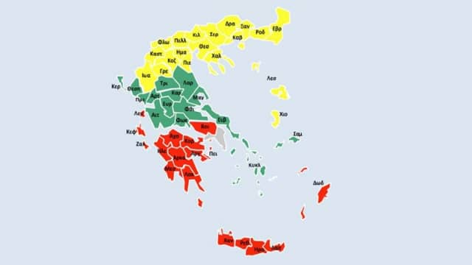

Figure 1

**The owner of the RURAL** project is the General Secretariat of Telecommunications and Post (**GSTP**) of the Ministry of Digital Policy, Telecommunications and Media and the Contracting Authority is the Information Society S.A. that is representing the public sector in the PPP scheme. The country was split into 3 segments (LOTs). Figure 1 illustrates the geographical span of each LOT. The bidders were Legal Entities (Special Purpose Vehicles-SPVs) that participated in the contract awarding process for each LOT. For LOT 1 (North) and 3 (South), the project was assigned to OTE Rural North (<https://www.oteruralnorth.gr>) and OTE Rural South (<https://www.oteruralsouth.gr>) respectively, whereas LOT 2 was assigned to RURAL CONNECT.

**TECHNICAL POTENTIAL FOR EXPANSION**

The project focused on the implementation of a broadband network capable of connecting NGA-white rural areas (project’s domain) with predefined regional concentration points. The project included the development of broadband network infrastructure (passive & active elements), in order to provide the full bundle of wholesale access and services (described in detail in a subsequent paragraph). In order to ensure a future-proof, scalable solution the project selected Fibre and Wireless Backhauling, Wireless and VDSL Access technologies. The service-level of 30 Mbps or higher in some of the areas will gradually expand to all areas, provided that re-investment takes place in subsequent years of operational period (claw-back mechanism). The network deployment option selected was a step by step, beginning from a mixed Class B–Class A and gradually evolving to a pure Class A. Coverage of the project's domain set to ~95%. Infrastructure and wholesale services are offered for use to all third party operators, the internet service providers, following an open access model. Consequently, the overall network comprises:  
• Access networks in NGA-white rural areas;  
• Backhauling networks that connect local access networks with regional concentration points;  
• Concentration/termination points in locations where multiple network operators (retail ISPs) have already established their presence. Under the scope of the project, concentration points are called RIX (Rural Internet Exchanges);  
• A Network’s Operation Centre (NoC) that monitors and controls network operations.

**National Broadband Policy for Rural Areas**

Bearing in mind the peculiarities of the rural areas, all over the country and the fact that the citizens face digital exclusion, we plan the deployment of telecommunications/ICTs for these areas that will improve the quality of life, the environment and bridge the digital divide with urban areas by eliminating the digital isolation of rural and remote areas. Further steps that reflect to this strategy, is the recent National Broadband Plan intervention we made to enhance our ability to offer high quality broadband services across the country, including urban areas, rural areas and the islands. The updated broadband plan outlines coverage, target values of service and policies for implementing the plan.