|  |  |
| --- | --- |
| **Council 2018 Geneva, 17-27 April 2018** |  |
|  |  |
|  |  |
|  | **Document C18/INF/6-E** |
| **8 February 2018** |
| **English only** |
| Report by the Secretary-General | |
| STRENGTHENING THE REGIONAL PRESENCE | |

|  |
| --- |
| Summary  This information document contains the six annexes to [Document C18/25](https://www.itu.int/md/S18-CL-C-0025/en).  Action required  This document is submitted to the Council **for information**.  ____________  References  [*Document C17/25*](http://www.itu.int/md/S17-CL-C-0025/en) |

1. The purpose of this document is to provide additional information on the strengthening of the regional presence. It contains the following annexes:

**Annex 1****:** Summary of the 2017 operational plan and projects implementation level and summary of the 2017 Regional and Area offices expenditure

**Annex 2****:** 2017 operational plan implementation level by region and objective

**Annex 3****:** Breakdown of the 2017 regional and area offices expenditure by category of expenditure

**Annex 4****:** 2017 Fellowships awarded and recruited experts

**Annex 5****:** Summary of staffing level by Regional and Area offices

**Annex 6****:** Breakdown of staffing level by Regional and Area offices

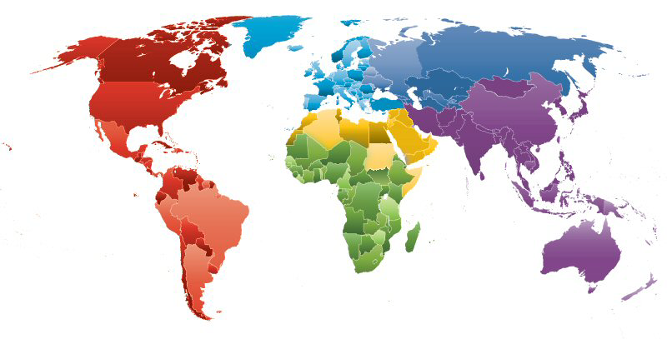h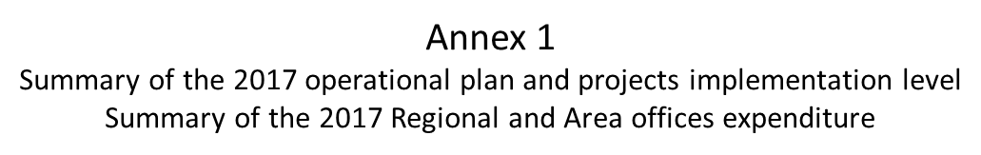











Annex 3

Breakdown of the 2017 regional and area offices expenditures

by category of expenditure



Annex 4

2017 Fellowships awarded and Recruited experts





Annex 5

Summary of staffing level by Regional and Area offices

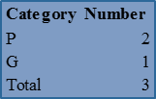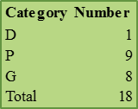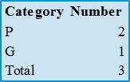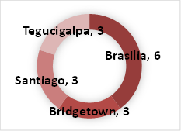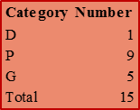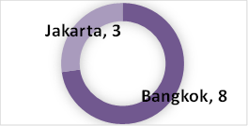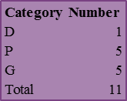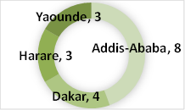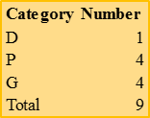

Annex 6

Breakdown of staffing level by Regional and Area offices

