Council Working Group on the
World Summit on the Information Society
31st meeting – Geneva, 19-20 September 2017
Document WG-WSIS-31/10-E
10 August 2017
English only

World Summit on the Information Society (WSIS) Stocktaking (2017/2018)

WSIS Stocktaking Process -2017

ITU remains committed to the WSIS process, and to implementation of the WSIS goals towards 2025. ITU recognizes and highly appreciates the extremely valuable contributions made by stakeholders to enable the continuation of WSIS monitoring and reporting. There can be no doubt whatsoever that, in today’s fast-moving world, innovation and efficiency are vital to success. Accordingly, the WSIS Stocktaking process continues to progress in reaching out to new stakeholders, collecting record numbers of submissions in 2017, and introduces new products, such as newly introduced WSIS Photo Contest, that helps evolve understanding of the enhancing role of ICTs in advancing SDGs.
The principal role of the WSIS Stocktaking exercise is to leverage the activities of stakeholders working on the implementation of WSIS outcomes and share knowledge and experience of projects by replicating successful models designed to achieve SDGs. The WSIS Stocktaking process was initiated in October 2004 during the Tunis phase of WSIS, and in the years since then it has come to comprise the database of:
- exchanges of information on projects,
- sharing of best practices of certain regions,
- initiatives related to the implementation of the 11 WSIS action lines
- linkages between the 11 action lines and the Sustainable Development Goals (SDGs) - a linkage that became an essential guideline of the WSIS Stocktaking process.
The WSIS Stocktaking process provides a register of activities, including, projects, programmes, training initiatives, conferences, websites, guidelines, tool-kits, etc., carried out by governments, international organizations, the private sector, civil society and other entities. To that end, in accordance with of the Tunis Agenda for the Information Society (TAIS) adopted by WSIS, ITU has been maintaining the WSIS Stocktaking Database as a publicly accessible system providing information on ICT-related initiatives and projects with reference to the 11 WSIS action lines (Geneva Plan of Action) and 17 SDGs.
As in 2015, the UN General Assembly within the framework of the ten year review of the WSIS (Res.A/70/125) called for a close alignment between the WSIS process and the 2030 Agenda for Sustainable Development (Res.A/70/1). The WSIS Stocktaking process responded by highlighting the contribution of 11 WSIS Action Lines to the achievement of 17 Sustainable Development Goals (SDGs).
The direct linkages between the WSIS action lines and the SDGs set out below are crucial to continuing to strengthen the impact of ICTs for sustainable development. Each UN action line facilitator has analyzed the connections and relations between their respective action lines and the proposed SDGs and their targets to create a clear and direct linkage and an explicit connection between the key aim of WSIS - that of harnessing the potential of ICTs to promote and realize the development goals – and the post-2015 development agenda, so as to contribute to realization of the latter.
At the WSIS Forum 2015, the SDG matrix was extremely well received by the WSIS community, offering as it does a better explanation of the potential of ICTs as enablers for sustainable development. A new component was introduced in the WSIS Stocktaking process in the form of reporting ICT success stories to best showcase the possible achievement of SDGs through the implementation of WSIS action line-related projects. The majority of the collected submissions in 2017 clearly showcase the linkage between their related action lines and the various SDGs and targets.
WSIS Stocktaking Platform was introduced in 2010, providing a repository of best practices for stakeholders seeking updated information on progress in the implementation of WSIS outcomes (§ 28.e of the Geneva Plan of Action), continues to foster implementation of the WSIS outcomes and to facilitate exchange of information among its community of 300.000 WSIS Stakeholders representing governments, the private sector, international organizations, civil society, and others. We continue to maintain and improve the WSIS Stocktaking Database, which contains around 10.000 entries so far. This encouraging outcome reinforces stakeholders’ belief in and commitment to the WSIS Stocktaking process and their desire to share best practices.
New WSIS Stocktaking products were introduced in 2017 with positive feedback from the WSIS stakeholders who showed much interest in using them. One such products has been designed in a form of an interactive matrix that is to be used as a graphical representation of WSIS and SDG data collected through the implementation of the WSIS Stocktaking process, where the individual values contained in a matrix are represented colorfully:
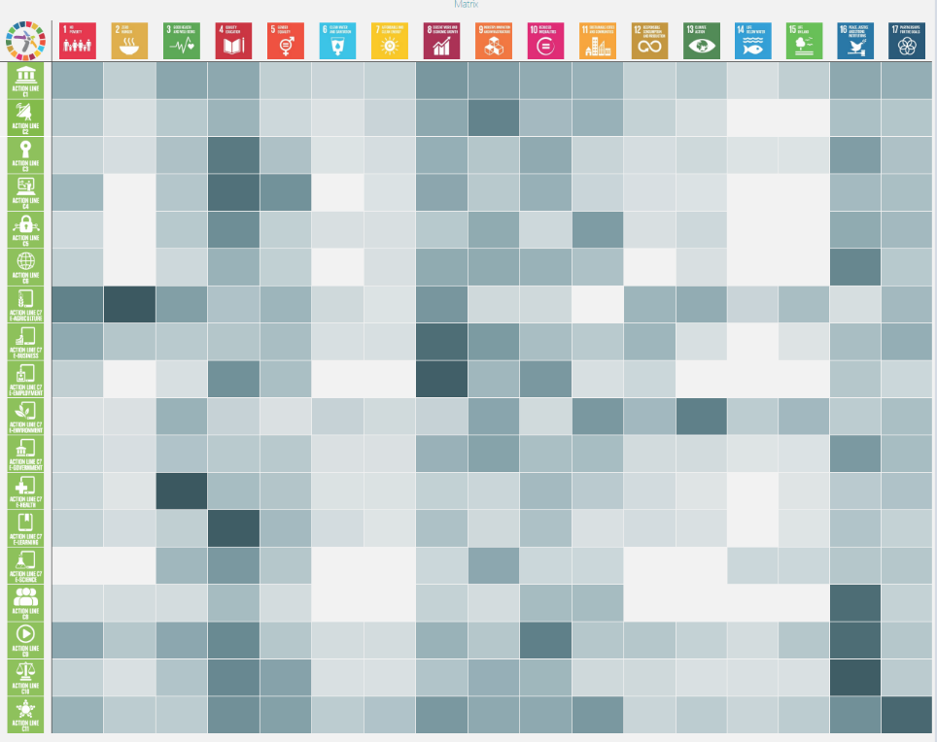
Shifting from theory to practice and impact, using the data from the WSIS Stocktaking platform, including projects submitted for the WSIS Prizes in past two years (when we have started to reflect on SDGs), the objective of this product is to draw conclusions from the automated matrix providing strength of proposed links between WSIS Action Lines and SDGs, and the analysis of connections and relations between the respective Action Line with the proposed SDGs and their targets, as proposed by each Action Line Facilitator.
Furthermore, using the data provided for the WSIS Stocktaking process in 2016 and 2017, in cooperation with the WSIS Prizes 2016 Champion, AgriNeTT from the University of West Indies, Trinidad and Tobago, the WSIS team has been developing a mobile application aiming to provide information on the linkages between WSIS Action Lines and SDGs. The launch of this application took place during the World Café on WSIS Stocktaking at the WSIS Forum 2017, providing a quick access to relevant information on WSIS Action Lines and SDGs to WSIS Stakeholders community at the Forum and beyond It portrays the WSIS-SDG Matrix, developed at WSIS Forum 2015 together with the UN Action Line Facilitators, with detailed information on each WSIS Action Line and SDG. New edition of the application is soon to be released showing the linkages on the ground by listing the projects submitted for the WSIS Stocktaking in past two years, since we started monitoring SDG process within the WSIS Stocktaking. This application was much appreciated and welcomed by the community at the WSIS Forum 2017 with a vibrant discussion on how to best use it, while new features were proposed to be considered in the future editions.
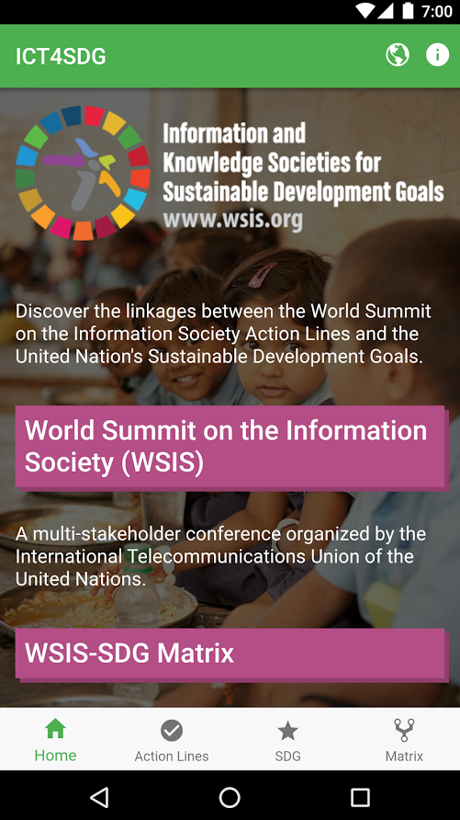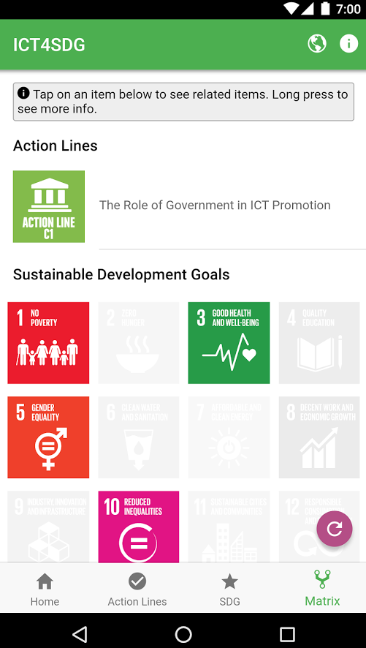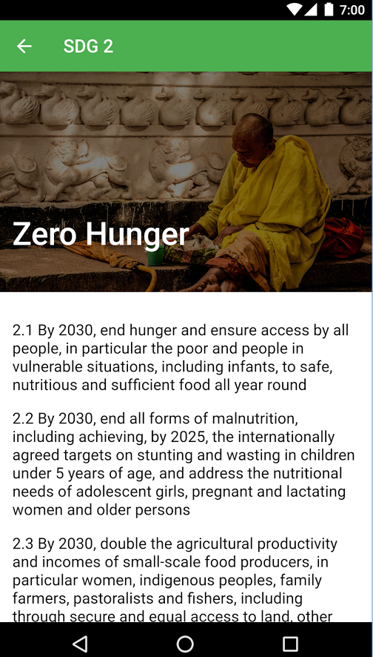
Finally, last year we have developed a WSIS Stocktaking embeddable interface, product that has much potential in expending the WSIS Stocktaking process through the WSIS multistakeholder community by uploading the WSIS Stocktaking platform in a form of an iFrame on portraying it on their websites and platforms. Visitors will be able to view live entries (live results are customizable upon a particular WSIS Action Line or SDG or region or other data focus relevant to the user), search the WSIS stocktaking database within partners’ websites environment, and to submit ICT-related projects from the embeddable WSIS Stocktaking interface for the WSIS Prizes contests or for the WSIS Stocktaking reports. We invite all stakeholders to take part in this unique opportunity towards evidence based policy making and promote it within different communities and networks. The WSIS Team will provide the necessary information, sufficient to test and run the interface, upon request.

WSIS Forum Photo Competition 2017
The World Summit on Information Society (WSIS) Forum launched in 2017 its first-ever photo contest – asking WSIS stakeholders community to picture a more sustainable world, with the theme: Information and Knowledge Societies for Achieving the Sustainable Development Goals.
WSIS Forum invited the community to picture how Information and Communication Technologies (ICTs) are playing an enabling role in achieving the Sustainable Development Goals (SDGs). 251 photos were submitted and more than 53 were selected as finalists and participated in building a collage of ICTs for SDGs photographs from around the world.
Photos of projects, people, and organizations that are leveraging the power of ICTs to make difference were collected in the contest that ran from 2 March to 22 May 2017.
The three winning entries in the WSIS photo contest were presented at the WSIS Forum 2017 12-16 June 2017 in Geneva, Switzerland. In addition the winners were invited join ITU’s #ICT4SDG campaign. A dedicated Photo Exhibition was set up at the WSIS Forum 2017 attracting many visitors and positive feedback, and it continues to be exposed in the ITU HQ. All photos are also reflected in the WSIS Stocktaking Report 2017.
WSIS Forum Photo Contest 2017 Winners:
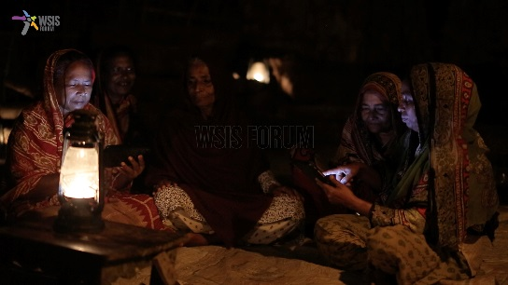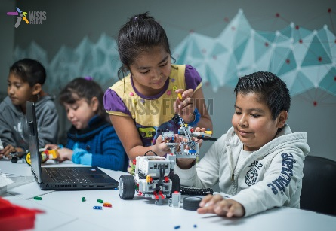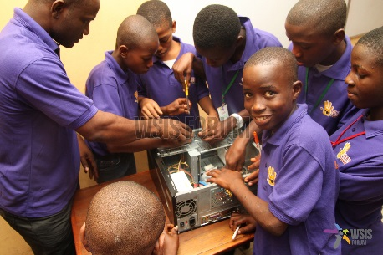
WSIS Stocktaking Process in 2018
Regular reporting on WSIS Stocktaking is the outcome of the Tunis phase of the Summit, launched to serve as a valuable tool for assisting with the WSIS follow-up. Since 2005, regular reporting has been a key tool for monitoring the progress of ICT initiatives and projects worldwide. WSIS Stocktaking has played a crucial role over many years, and this role takes on even greater significance this year in the light of the WSIS 2015-2025 review process on the implementation of WSIS outcomes.
ITU announces an official call for updates and new entries and urges these stakeholders, along with all Member States, international organizations, the private sector, and civil society, to continue submitting such contributions in the future as WSIS pursues the ongoing stocktaking process.
The new call for update and new entries 2017-2018 will be launched August 2017 and we invite you to submit entries online at www.wsis.org/stocktaking. Submitted activities will be reflected in various forms in the WSIS Stocktaking 2018 (reports, exhibitions, videos etc.) which will be released at WSIS Forum 2018. We look forward to receiving your responses to this call. Timeline of this process will soon be announced. Should you have any questions or need for assistance, please do not hesitate to contact the WSIS Team at wsis-stocktaking@itu.int.
All stakeholders benefit from the sharing of interesting case studies, by the undoubtedly facilitation of the transfer of knowledge, experiences, and models for project implementation. The WSIS Stocktaking platform helps to create partnerships, provide greater visibility, and add value to ICT projects all around the world. The many and varied stakeholders who have implemented innovative projects and contributed to the success of the WSIS Stocktaking process deserve our sincere gratitude.
In coordination with the Telecommunication Standardization Bureau (TSB) (TSB), the WSIS team is currently preparing an additional track within the WSIS Stocktaking platform for collecting international best practices of the artificial intelligence (AI) for development, striving to provide tangible overview of projects and initiatives in this emerging field. Although customized for the needs of the AI for Good Global Summit and TSB objectives, the inputs will also be reflecting the essential components of the WSIS Stocktaking, namely all inputs will reflect projects’ implementation of the WSIS Action Lines and how ICTs are advancing sustainable development around the world using innovative technologies.
We trust that in 2018, the WSIS Stocktaking will gather even more submissions from traditional WSIS Stakeholders community and will attract new stakeholders by providing all a wider range of opportunities for promotion of various ICT success stories in advancing development, including sustainable development, and help create partnerships among the prospective stakeholders and thus participate in the construction of a broader and more inclusive information society for all.

