Council Working Group on the
World Summit on the Information Society
31st meeting – Geneva, 19-20 September 2017
Document WG-WSIS-31/04-E
10 August 2017
English only

WSIS Action lines and SDGs (WSIS– SDGs Matrix)
Linking WSIS Action Lines with Sustainable Development Goals

At the WSIS Forum 2015, ITU coordinated the WSIS Action Lines and SDG Matrix, a new tool developed by a number of United Nations agencies to map how ICTs may contribute to the implementation of the new SDGs. The Matrix serves as an easy reference for stakeholders engaged in shaping the future of both, the SDGs and the WSIS processes beyond 2015 and the 2030 Agenda for Sustainable Development. The Matrix is also considered as a valuable conceptual framework by the UN Regional Commissions that are utilizing the Matrix as a tool to plan their implementation work at the regional level.
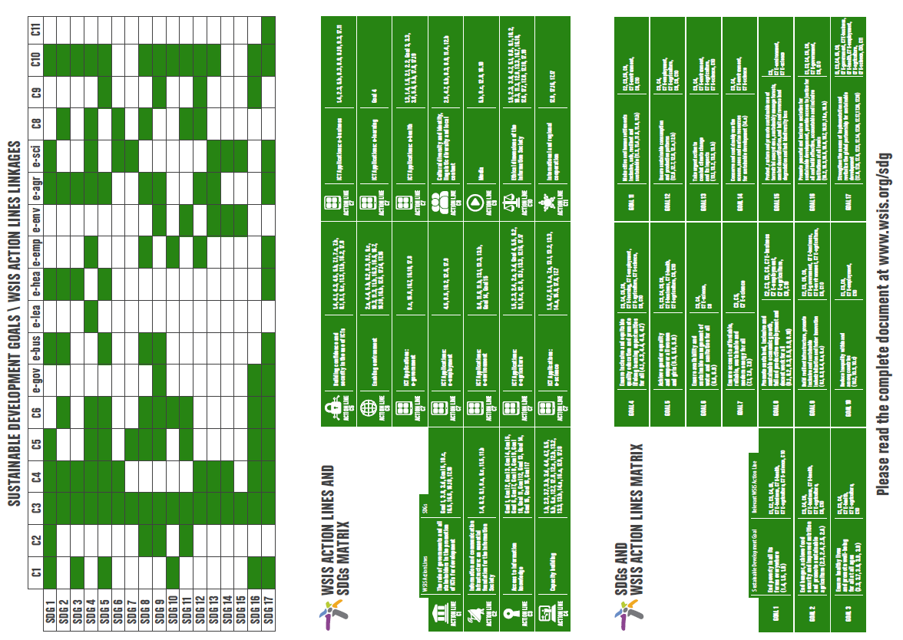
The mapping exercise draws direct linkages of the WSIS Action Lines with the proposed SDGs to continue strengthening the impact of Information and Communication Technologies (ICTs) for sustainable development. Each UN Action Line Facilitator has analyzed the connections and relations of their respective Action Line with the proposed SDGs and their targets. This is a living document and changes can be introduced by Action Line Facilitators, if needed.
The goal is to create a clear and direct link and an explicit connection between the key aim of the WSIS, that of harnessing the potential of ICTs to promote and realize the development goals, and the post 2015 development agenda, so as to contribute to the realisation of the latter.
The WSIS Forum continues to evolve and adapt, by strengthening the synergies between the WSIS Action Lines and SDGs, and taking into account the outcomes of the UNGA Overall Review.
With the objective of strengthening the alignment of the WSIS with the SDGs, the overall theme for WSIS Forum 2017 (www.wsis.org/forum) was Information and Knowledge Societies for SDGs. In order to highlight the contribution of the WSIS Action Lines in accelerating the achievement of the SDGs, the ITU coordinated, with the UN Action Line Facilitators, UNDESA, UNESCO, UNCTAD, ITU, UPU, WHO, ILO, WMO,UNEP a document that focuses on the impact of the respective Action Lines on the HLPF 2017 theme “Eradicating poverty and promoting prosperity in a changing world”. It further seeks to encourage and promote effective multistakeholder cooperation in implementation of WSIS action lines and the SDGs. The report is available here: http://www.itu.int/net4/wsis/forum/2017/#outcomes
The WSIS Forum 2017 Agenda was searchable by WSIS Action Lines and SDGs making it convenient for the Stakeholders to identify the connection of the sessions with SDGs. In addition a mapping tool was made available to emphasize the linkages between the Action Lines and the SDGs identified by WSIS Stakeholders in their respective sessions and workshops. http://www.itu.int/net4/wsis/forum/2017/Agenda/#heatmap .
Moreover, the outcomes of all the workshops held at the WSIS Forum 2017 clearly indicate the linkages of the respective workshops between the WSIS Action lines and SDGs.
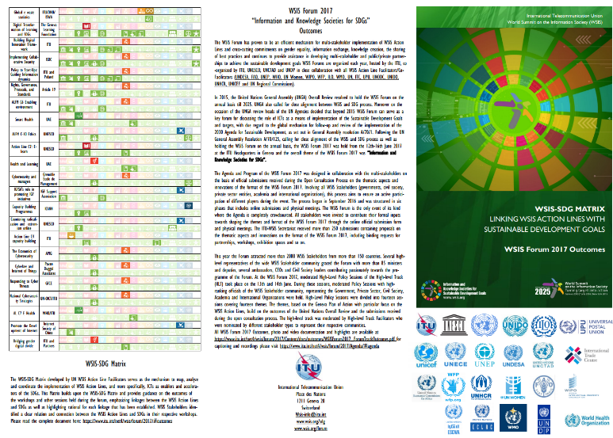
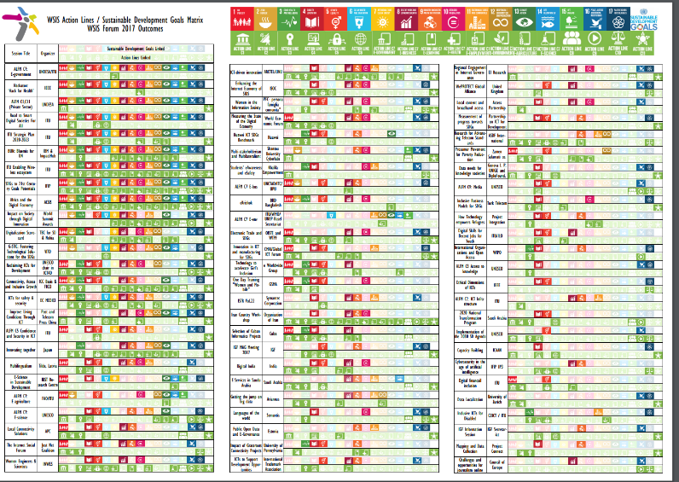
The WSIS Forum 2017 Matrix Flyer and Document linking WSIS Action Lines and SDGs are available here: http://www.itu.int/net4/wsis/forum/2017/#outcomes
In response to the call by the UN General Assembly within the framework of the ten year review of the WSIS (Res. A/70/125) calling for a close alignment between the WSIS process and the 2030 Agenda for Sustainable Development, the WSIS Stocktaking process (www.wsis.org/stocktaking) continues collecting information on actions, projects, programmes, initiatives implemented by all Stakeholders related to WSIS and SDGs, while providing concrete proof of impact of particular WSIS Action Lines on SDGs, transforming the meeting of the WSIS-SDG Matrix into evidence based policy guide for all WSIS Stakeholders.
The WSIS Prize 2017 contest also aligned its rules to highlight the linkage between the WSIS Action Lines and SDGs (www.wsis.org/prizes). This was well appreciated by the WSIS Stakeholders.

