Council Working Group on the
World Summit on the Information Society
31st meeting – Geneva, 19-20 September 2017
Document WG-WSIS-31/03-E
10 August 2017
English only

WSIS Stocktaking 2017 Report

More than 600 ICT-related projects from around the world were submitted for the WSIS Stocktaking Report 2017 by the WSIS Stakeholder community. The ninth edition of the WSIS Stocktaking set a new record of global multistakeholder engagement in implementation of WSIS Action Lines for SDGs. The Report will be presented during the WSIS Forum 2017, 12-16 June 2017 in Geneva, Switzerland. At the same occasion, an interactive session will be dedicated to presentation of the results of this year’s WSIS Stocktaking and to listen to the voices of the WSIS stakeholders community on how to improve the process in the future.

The 2017 edition of the WSIS Stocktaking Report is the continuation of the WSIS Stocktaking Report series. This ninth edition in the series reflects around 427 activities utilizing ICTs for development, submitted to the WSIS Stocktaking Platform for the period January 2016 - March 2017, each one highlighting the efforts deployed by stakeholders involved in implementation of the SDGs. The report is based on the multi-stakeholder approach, including input from stakeholders from all over the world responding to ITU’s official call in 2016 for stocktaking updates and new entries. The inputs from WSIS action line facilitators and co-facilitators also contributed to the present report.

The WSIS Stocktaking database (www.wsis.org/stocktaking) was introduced in 2010 and currently has 10.000+ entries and a growing community of 300.000 stakeholders. It is a unique global tool for collecting information and regular reporting on information and communication technology related initiatives and projects, carried out by governments, international organizations, the business sector, civil society, academia and other entities, in the context of 11 WSIS Action Lines. The WSIS Stocktaking process has been maintained by ITU since 2004 as requested by the WSIS Outcomes (TAIS, Para 120).

Since the WSIS Stocktaking Process was established, eight editions of global WSIS Stocktaking Reports have been published, providing an overall picture of progress and an insight into latest WSIS-related activities. Following the 2016 Report, the ninth report also focuses on contributions by stakeholders worldwide to WSIS and Sustainable Development Goals. This Report seeks to provide key findings on emerging trends in the development of the information society, and references major activities being implemented in the eighteen areas covered by the eleven WSIS action lines and seventeen SDGs.

The United Nations Economic and Social Council (ECOSOC) resolution 2016/22 on "Assessment of the progress made in the implementation of and follow‐up to the outcomes of the World Summit on the Information Society" reiterates the importance of sharing best practices at the global level, and, while recognizing excellence in the implementation of the projects and initiatives that further the WSIS goals, encourages all stakeholders to submit ICT‐related projects and initiatives to the WSIS Stocktaking platform.

The same Resolution also reiterates the importance of recognizing excellence in the implementation of the projects and initiatives that further the goals of the World Summit on the Information Society process, and encourages all stakeholders to nominate their ICT-related projects for the annual WSIS Prizes contest as an integral part of the WSIS Stocktaking process.
With the year-round ongoing call for updates and new entries, all stakeholders are invited to continue sharing best practices on the WSIS Stocktaking Platform and emphasize how ICT-related initiatives and projects are enabling SDGs.

All WSIS-related publications, including the WSIS Stocktaking reports, are available to download at the ITU Bookshop.

(control+click to open)
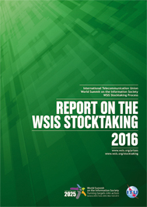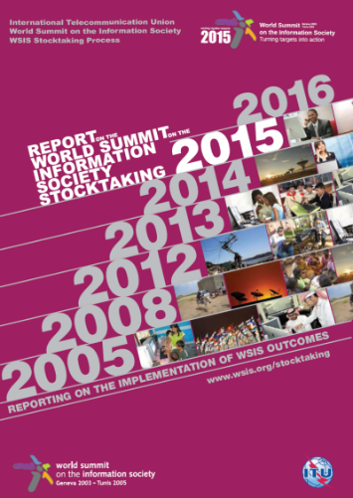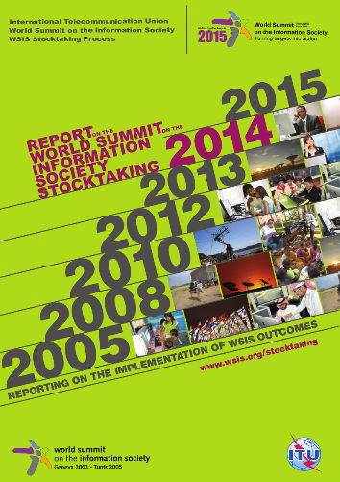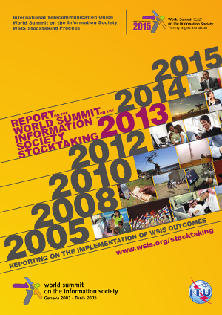
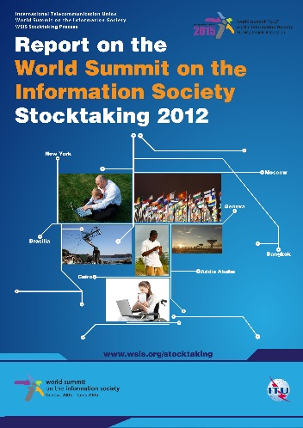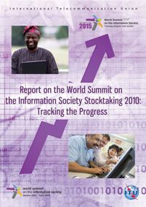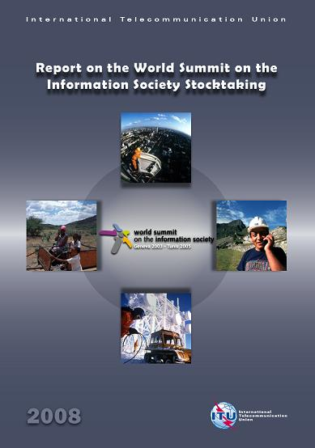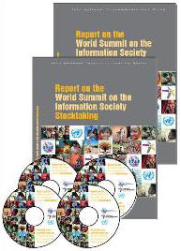

Attached: Annex 1: WSIS Stocktaking 2017 Report
Annex 1: WSIS Stocktaking 2017 Report (control+click to open)

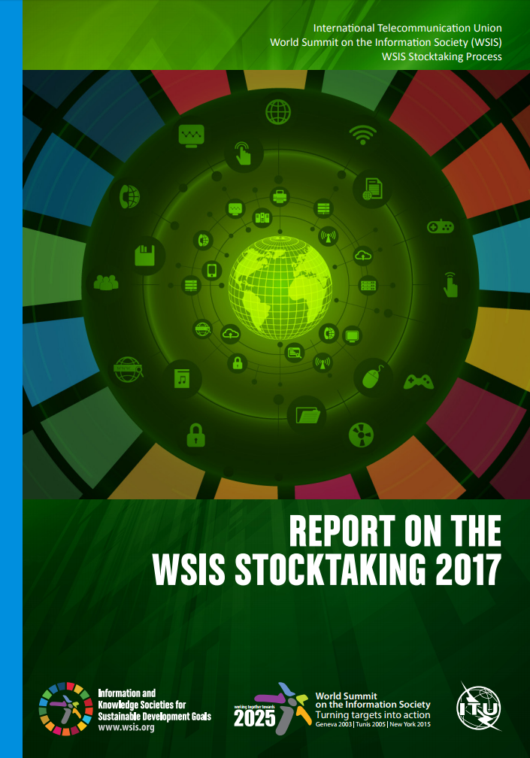

See the complete WSIS Stocktaking Report series available at http://www.itu.int/en/publications/gs/Pages/publications.aspx?parent=S-POL-WSIS, with the previous editions of the report dated 2005, 2008, 2010, 2012, 2013, 2014, 2015 and 2016.

