Expert Group on  International Telecommunication Regulations  Second meeting – Geneva, 13-15 September 2017 | 
 | Document EG-ITRs-2/11-E
 | 30 August 2017
 | Original: English
Contribution from Japan
Japan’s VIEWS ON the review of the international telecommunication regulations

1 Introduction
In Japan, the domestic and international telecommunication market was liberalized in 1985. Many new carriers entered the telecommunications markets based on the principle of competition, and that competition among carriers could drive down the prices for telecommunication services and create diversified services in telecommunication markets. These could increase the use of ICT, and as a result, the ICT industry is developing in a virtuous cycle in Japan.
As shown in the figure below, in the almost 30 years since the telecommunications liberalization, Japan’s telecommunication and ICT industry has grown dramatically. The ICT industry has also been a consistent contributor to our economic growth.
Figure 1: Sales by telecoms (total sales in the domestic market and international market)
Sales by Japanese telecommunications carriers have increased about 4 times in 28 years.
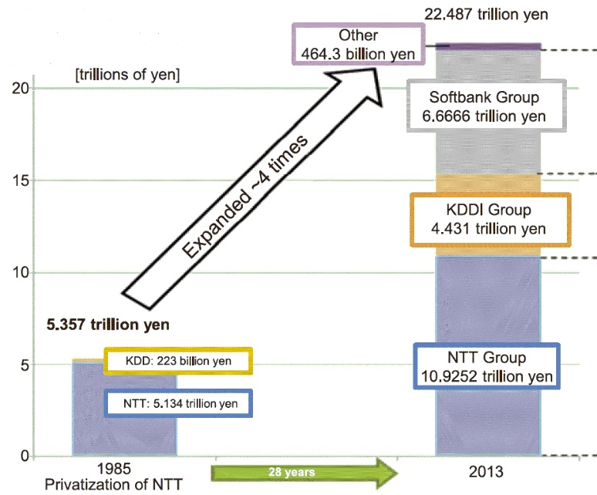
(Source: White paper 2015 Information and Communications in Japan, MIC Japan)
Figure 2: Size of the ICT industry’s market in Japan
The ICT industry’s market has expanded by about 2.4 times in 28 years.
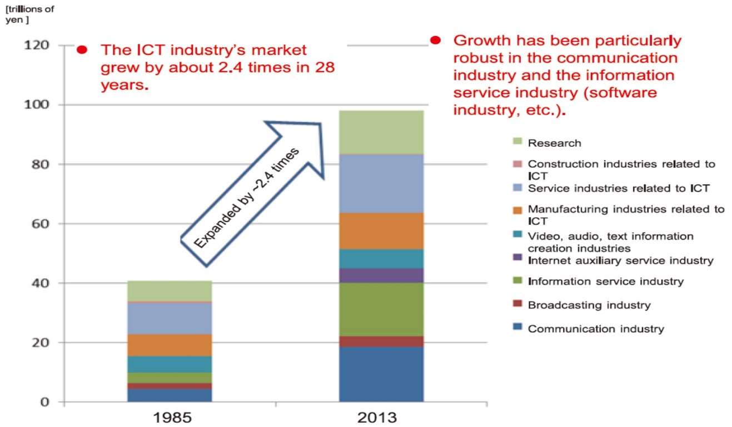
(Source: White paper 2015 Information and Communications in Japan, MIC Japan)

Under such a liberalized and competitive market, Japan did not sign the 2012 ITRs at the 2012 World Conference on International Telecommunications and continue to be bound by the 1988 ITRs.
As shown in the following results of the survey on the ITRs conducted in Japan, Japanese operators have not faced any conflicts or problems in the business activities related to international telecommunication services when there exist the 1988 ITRs and the 2012 ITRs.
2 Results of the survey on the ITRs
Japan conducted this questionnaire survey on the ITRs to our operators authorized as Recognized Operating Agencies and Accounting Authorities by Ministry of Internal Affairs and Communications, JAPAN. The questionnaire is based on Terms of Reference set out in Resolution 1379 adopted at the Council 2016. Here are the results of our survey on the ITRs.

Results of the questionnaire survey on the ITRs by MIC, Japan
Number and attribute of respondents: 12 operators (4 Recognized Operating Agencies, 8 Accounting Authorities)
Survey period: 24 July 2017 to 4 August 2017

Q1) Do you usually use the ITRs for your international business?
Yes: 0
No: 12

  - If yes, to which ITRs are you bound to? N/A
  - If yes, please tell us which provisions and/or articles you usually use. N/A
  - If no, please describe the reason in as much detail as applicable.
- Because we use our own commercial agreements. (12 all operators)
- Sometimes refer to Recommendation D.90, too. (3 AAs)

Q2) Please identify the provision(s) of the 2012 ITRs you consider essential for the provisions of international telecommunications services in today’s international telecommunications environment based on your experience. Please cite examples of the essentiality.

- No provisions since we don’t use the ITRs but use commercial agreements. (7 operators)
- The provisions to define “Accounting Authority” as a reasonable explanation of our operation. (1 AA)
- No comments since Japan has not acceded to the 2012 ITRs. (1 ROA, 1 AA)
Q3) Have you faced any obstacles that did arise from the implementation of the 2012 ITRs? (Question related to 1 of ToR)
Yes: 0
No: 12

3-1. If yes, please describe the obstacles and the involved specific provision(s). N/A
3-2. If no, please share your view on any reasons why obstacles did not arise.

- Because we don’t use the ITRs (1988 and 2012) and commercial agreements fulfil the key role instead of the ITRs. (5 operators)
- As far as we know, after the 2012 ITRs entered into force in 2015, signatory countries to the 2012 ITRs also have not referred to the 2012 ITRs. (1 ROA)
Q4) Have you experienced or do you foresee any (potential) conflicts between the obligations stemming from implementations of the 2012 ITRs and those from the 1988 ITRs? (Question related to 2c of ToR)
Yes: 0
No: 12

4-1. If yes, please describe the problems and the involved specific provision(s). N/A
4-2. If no, please share your view on the reasons why conflicts did not occur or are not foreseen.
- Because we don’t use the ITRs. (7 operators)
- Because Appendix 2 which defines Accounting Authority is mostly unchanged. (2 AAs)
Q5) What is your opinion regarding whether the 2012 ITRs can fulfil a substantial role in contributing to a rapidly evolving international telecommunication environment, taking into account technology, services and existing multilateral and international legal obligations as well as changes in the scope of domestic regulatory regimes? (Question related to 2a of ToR)

- ITRs are not relevant anymore to our business which is based on commercial agreements. (7 operators)
Q6) any comments.

- We see no need for revising the 2012 ITRs. (1 AA)
- We have a serious concern about insecurity caused by the revision of the ITRs because we cannot foresee how a new ITRs would affect our business. (2 ROAs)
- Flexibility is indispensable for developing competitive business and promoting innovation in this rapidly changing international communications market. (3 ROAs)
- Detailed rules should not be set at the treaty level. (2 ROAs)
- Setting additional limitations on commercial activities is not appropriate for developing various business activity. (1 ROA)
- The ITRs should not obstruct the flexibility and business of each carrier. (1 ROA)
3 Japan’s views on the ITRs
Based on the results of our survey as described above, we present our views on the review of the ITRs.
3.1 Obstacles by the implementation of the 2012 ITRs
As shown in the answer to Q3, no obstacles, issues, problems or challenges by the implementation of the 2012 ITRs in Japan. This is because Japanese operators do not use the ITRs, whether the 2012 ITRs or the 1988 ITRs, for their business activities nowadays, but they use commercial agreements which fulfil the key role instead of the ITRs for the provision and operation of international telecommunication services.
3.2 Potential conflict between the 1988 and the 2012 ITRs
As shown in the answer to Q4, Japanese operators have not experienced or do not foresee any potential or actual conflicts between the obligations stemming from implementations of the 2012 ITRs and those from the 1988 ITRs.
3.3 Applicability of the 2012 ITRs
As shown in the answer to Q1 and Q5, Japanese operators do not use the ITRs but use commercial agreements. This means that the ITRs are not relevant to today’s international telecommunication services provided by Japanese operators. Taking into account the Japanese fundamental business principle of competition, we believe Japanese operators will continue to use commercial agreements and will not use the ITRs in the future.
3.4 Japan’s position on the ITRs
As described above in “1 Introduction”, today’s international telecommunication markets in Japan and where Japanese operators do business are liberalized and pro-competitive. In such competitive markets, as shown in the answer to Q1, Japanese operators have no need for using the ITRs, whether the 2012 ITRs or the 1988 ITRs, but they use commercial agreements which stipulate every detail required for the provision and operation of international telecommunication services. From this point of view, we think the substantial value of the ITRs is impaired in today’s competitive telecommunications markets in Japan and where Japanese operators do business.
However, we also recognize some member states consider that the ITRs is necessary in their markets as expressed at 1st EG-ITR in February in 2017.
Along with the rapid development of technologies, international telecommunication markets and operators’ providing services which respond to markets’ need are also ever-changing. In order to accommodate this rapidly evolving international telecommunication environment, we believe the ITRs should be flexible and future-proof which could be applied in the future, as shown in the answer to Q6.
As described in Resolution 4 of the 2012 ITRs, “the ITRs consist of high-level guiding principles that should not require frequent amendment”, Japan is of the view that the ITRs should be “high-level guiding principles” as stable regulation and should not stipulate details as below. These should be excluded from the ITRs and delegated to operators, or would be defined in non-binding documents such as recommendation or guideline only when it is absolutely necessary and agreed among ITU members. Operators have the same view as shown in the answer to Q6.
- Detailed operational matters
- Matters which need to be updated frequently
- Matters which impose undue and unnecessary burden on operators
- Matters which blanket obligations cannot be imposed on every operators and member states since each country has unique circumstances
- etc.
We believe the ITRs should not be revised frequently. As shown in the answer to Q6, if the ITRs were ever revised, operators would feel deeply insecure until a new ITRs reaches consensus and is completed. This insecurity will interfere, directly or indirectly, with operators in making investments and long-term business plans or expanding their business because they cannot foresee the impact caused by an unseen new ITRs.
In addition, the ITRs should not hinder operator’s business activity and we should remove undue and unnecessary regulatory burden from operators and build enabling environment for accelerating operators’ business activity. This could create new services, markets, and innovation and contribute to economic growth.
4 Conclusion
After telecommunications liberalization, the telecommunication markets which surrounds Japan and other countries are pro-competitive. Japanese operators do not use the ITRs and commercial agreements fulfil the key role for their business activities. Non-use of the ITRs or existence of 2 sets of the ITRs have not arisen any problems affecting the provision and operation of international telecommunication services provided by Japanese operators.
In order to accommodate the rapidly evolving international telecommunication environment, we believe the ITRs should be flexible and high-level guiding principles without stipulating details, and the ITRs should not be revised frequently because operators will feel deeply insecure until a new ITRs reaches completion, and this insecurity will interfere, directly or indirectly, with operators in making investments and long-term business plans or expanding their business. This will have an adverse effect on global economic growth and development of international telecommunication.

