|  |  |
| --- | --- |
| **Council Working Group for Strategic and Financial Plans 2020-2023**  **Second meeting – Geneva, 11-12 September 2017** |  |
|  |  |
|  | **Document CWG-SFP-2/INF/1-E** |
| **4 August 2017** |
| **English only** |

**Chairman of the Council Working Group for Strategic and Financial Plans 2020-2023**

**REPORT OF THE CWG-SFP   
1ST PUBLIC CONSULTATION ON THE ITU 2020-2023 STRATEGY**

# The CWG-SFP Public Consultation on the ITU 2020-2023 Strategy

The 2017 Session of the ITU Council initiated the process for the elaboration of the draft Strategic plan for the Union for 2020-2023, by establishing the Council Working Group for Strategic and Financial plans for 2020-2023 (CWG-SFP). The group held its inaugural meeting on 23 May 2017, at the ITU Headquarters in Geneva, Switzerland, and decided to hold a first public and open consultation on the strategic priorities of the Union.

The Public Consultation was held from June 1 to July 7, 2017. The ITU web-based platform ([www.itu.int/PublicConsultations](http://www.itu.int/PublicConsultations)) was used for this purpose, and all contributions, including the ones received via e-mail to [strategy@itu.int](mailto:strategy@itu.int), have been published on this platform.

The public consultation received 23 contributions from 4 administrations, 2 regional organizations, 5 regulatory authorities, 5 associations, 3 industry entities, 2 non-governmental organizations (NGOs) and 2 individuals.

This document highlights key trends of the consultation and suggestions received with regards to the ITU strategic priorities for 2020-2023. The report reflects solely the views of the authors and organizations who participated in the consultation. The main findings of the Consultation and overall suggestions for the 2020-2023 ITU Strategy are summarized below.

# Findings of the public consultation

## Key strategic priorities for ITU for 2020-2023 / taking into account the SDGs

Strategic priorities for 2020-2023

Building on the continuity of the current Strategic Plan, contributions suggest key strategic priorities for the Union, taking into consideration key developments, such as the adoption of the 2030 Agenda for Sustainable Development.

(Russian Federation) “Retaining the succession of the Strategic Plans and thus, the common vision for systematic approach to elaboration of the balanced ITU strategic plan, as indicated in Resolution 71 (Busan, 2014) supposing to shape the ITU goals and targets for 2020-2023 in such a way that, on the one hand, to complete those goals that had been partially implemented in the previous planning period, and, on the other hand, consider new realities both in ICTs and other areas of human living activities which were outlined in the UNGA Resolution "The 2030 Agenda for Sustainable Development".

The majority of the contributions in the public consultation suggest that the key strategic priority for ITU should be bridging the digital divide and focusing on fostering universal and affordable access to ICTs (Africa Region, CEPT, Russian Federation, ICTA/BTK, Solomon Islands, ESOA/GVF).

Bridging the digital divide is also highlighted in view of the 2030 Agenda and the SDGs:

(CEPT) Bridging the digital divide, or as indicated in “Goal 2 - Inclusiveness – Bridge the digital divide and provide broadband for all” should continue to be a key priority for ITU in the 2020-2023 period, particularly taking into consideration the UN 2030 Agenda for Sustainable Development and the Sustainable Development Goals (“SDGs”).

Particular emphasis is given to the gender divide by several contributions (Africa Region, Russian Federation, UNESCO Chair in ICT4D).

Another strategic priority is for ITU to promote closer international cooperation among governments, with other international agencies and organisations and the private sector (ICTA/BTK, UNESCO ICT4D, Solomon Islands. ESOA/GVF).

Other proposals highlight the need to further improve internal strategies –in working as One ITU, defining ITU’s added value and strengthening internal structures:

(Federal Office of Communications OFCOM – Switzerland): “Consistency (“United in action” & “One ITU”) (…) For its own benefit, ITU must not content itself with an elementary strategy of coordination and internal cooperation aimed at avoiding overlaps in activities and optimizing the use of resources between the three Sectors. A real spirit of unity must be created within the organization, reflected by values and goals shared by all colleagues (within the three Sectors as well the General Secretariat)”.

(Ericsson Canada) “(…) for ITU to ensure that its programs and activities meet the needs and expectations of its diverse membership, and for the Union, a) to focus on the delivery of its core competencies in the most efficient and effective manner possible, and b) to develop strategies which clearly define ITU’s value-added in an increasingly complex global ICT ecosystem”.

(Article 19) “As the mandate of the ITU has grown over time to address issues of global Internet infrastructure, its strategic plan moving forward must focus more on strengthening and refining its internal structures to facilitate more resilient decision-making”

The need to maintain the essential role within the ITU’s traditional areas of strength and expertise is also highlighted, along with the need to allocate its resources to those core activities:

(CEPT) “ITU should be amongst the forefront of international telecoms/ ICT standardization and the management of radio spectrum including satellite filings”.

(OFCOM – Switzerland) “Remain the leading forum for matters relating to radio spectrum management and harmonization at global level”.

(International Chamber of Commerce) “ITU should allocate resources to those activities that are core to its mission and unique role”.

Openness and transparency are also identified as a priority area for the organization (CEPT, Switzerland, GSMA, ASIET, Ericsson Canada, ESOA/GVF, Article 19):

(OFCOM – Switzerland) “ITU must associate the representatives of civil society, the private sector and the worlds of science and politics closely with the action it takes in regard to the 2030 Agenda and WSIS processes. Collaboration between state and non-state actors will be essential in achieving the global goals. The rules of the game, policies and responsibilities will be defined within the framework of a new global partnership for sustainable development, and ITU has a major role to play in creating a conducive international environment and in following-up and reporting on achievement of the goals of these processes”.

(GSMA) “Enhance transparency: The ITU will benefit from allowing Sector Members to participate in all key discussions and meetings”.

The need for ITU to manage emerging risks and challenges due to the increased use of ICTs was also suggested:

(Russian Federation) “Manage the challenges resulting from telecommunication/ICT development, including security. To promote the beneficial use of telecommunication/ICTs for sustainable development goals, the Union recognizes the need to manage challenges that emerge from research and development achievements in ICTs and the rapid growth of telecommunication/ICTs and have a certain impact not only on the economy, but also on human’s personal abilities, psychological state, behavior in the information environment and world view.”

(ICTA/BTK) “ITU should focus on newly emerged risks and challenges related to increased use of ICTs, especially about dangers mostly effecting young people such as internet addiction, exposure to harmful content and privacy violations, cyberbullying and internet abuse”.

The need for ITU to ensure it is seen as a ‘trustful’ organization has been identified:

(UNESCO Chair in ICT4D) “Ensuring that the ITU is indeed seen as an organization that can be trusted”

Challenges for potential duplication of work with other organizations have been identified:

(GSMA) “We find that many of the topics that are being introduced in these [ITU] meetings are duplicative of work already under way, either in other parts of the ITU or in other organisations and institutions”.

The ITU and its contribution to the Sustainable Development Goals (SDGs)

Several contributions highlight the role of ITU with regards to the implementation of the 2030 Agenda and the SDGs, suggesting focusing on specific SDGs (Russia, Oman, Switzerland, CRC-Colombia, EBU, Article 19).

Contributions from the industry also make a similar point:

(Ericsson AB) “ITU has significant opportunities as we are moving into IMT 2020 to address Government and other Nations state bodies to promote programs to support deeper deployment of networks as well as focused programs to increase literacy and poverty eradication, well supporting the UN Sustainability Development Goals”.

Several contributions highlight the key and enabling role of ICTs in the 2030 Agenda and the role that ITU has to play in the process:

(OFCOM – Switzerland) “It is essential for ITU to strengthen the interaction between the process designed to achieve the 2030 Agenda sustainable development goals (SDGs) and the process designed to implement the goals of WSIS in order to ensure that the efforts made by the United Systems as a whole are consistent, concerted and coordinated to thus have maximum and sustainable impact. (…) Information and communication technologies (ICTs) will play a key role as catalysts for sustainable development. The transformation potential of ICTs must be used to accelerate the progress of humanity, by synchronizing ICT policies with national development plans and programmes in a way that promotes implementation of the 2030 Agenda”.

(Russian Federation) “(…) [ITU] to contribute to the development of ICT environment that is sufficiently conducive to innovation, where advances in new technologies and strategic partnership become one of the most essential components of the 2030 Agenda for Sustainable Development. The Union recognizes the need to expand participation and cooperation with other entities and organizations to pursue a development-oriented policy (diversification, technical upgrade and innovation) that promotes productive activity and increases communications/ICTs efficiency”.

The figure below summarizes the references to the various SDGs (showing contributions making a reference to a specific SDG). Most of the SDG are being referenced by the contributions, while *SDG 9: Build resilient infrastructure, promote inclusive and sustainable industrialization and foster innovation* is being referenced in most of the contributions.

**Figure 1: Reference to specific SDGs (results of the public consultation)**

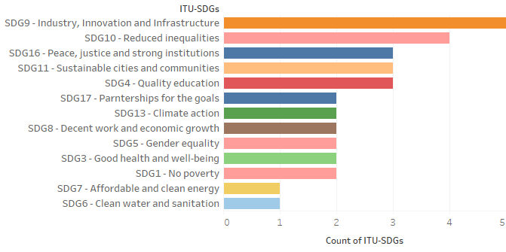

## Key technological trends to consider

The following technological trends have been identified in the consultation as those that ITU should consider the most while planning its strategy:

* 5G and IMT-2020 (in 50% of the contributions);
* Internet of Things (in more than 35% of contributions);
* Artificial Intelligence (in more than 25%);
* Big Data (around 20%); and
* Development of standards (around 15% of contributions).

A more detailed list of the trends identified is presented in the figure below.

**Figure 2: List of key technological trends identified in the consultation (and their frequency of reference)**

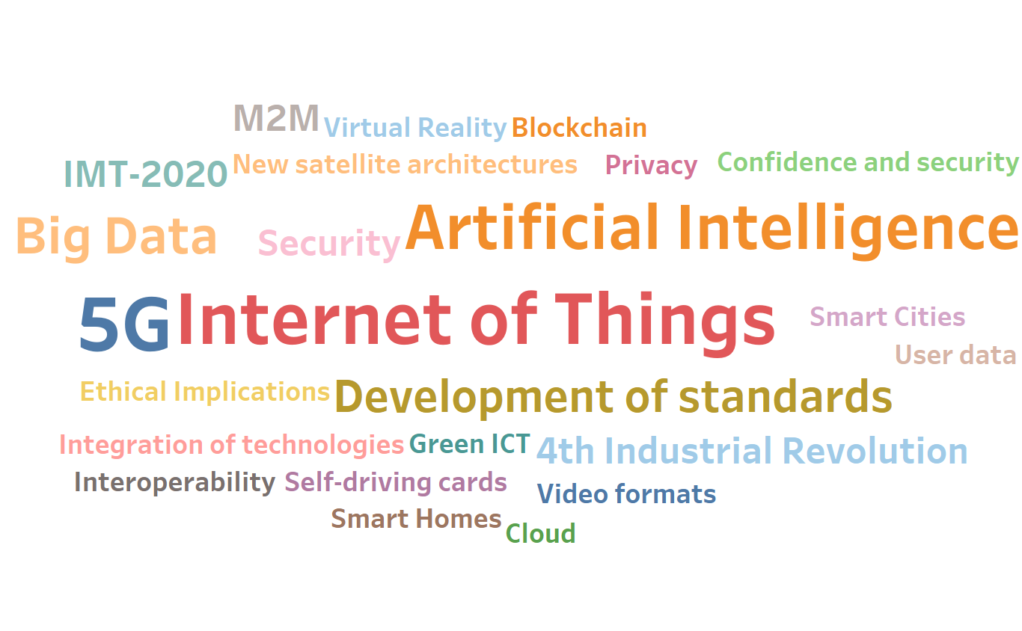

## Key challenges for ITU in the 2020-2023 timeframe

The figure below identifies the key challenges identified by various contributions in the consultation. Among the top challenges identified were the following:

* Digital Divide and Global Connectivity (Africa Region, Russia, Switzerland, ICTA/BTK, CRC-Colombia, Oman Telecommunications Regulatory Authority, Solomon Islands);
* Cyber-security, data protection and privacy (Africa Region, Russia, CITCC, ICTA/BTK);
* Effectiveness of the organization (Russia, CEPT, ICTA/BTK).

A more detailed list is presented in the figure below.

**Figure 3: List of key challenges identified (and their frequency of reference)**

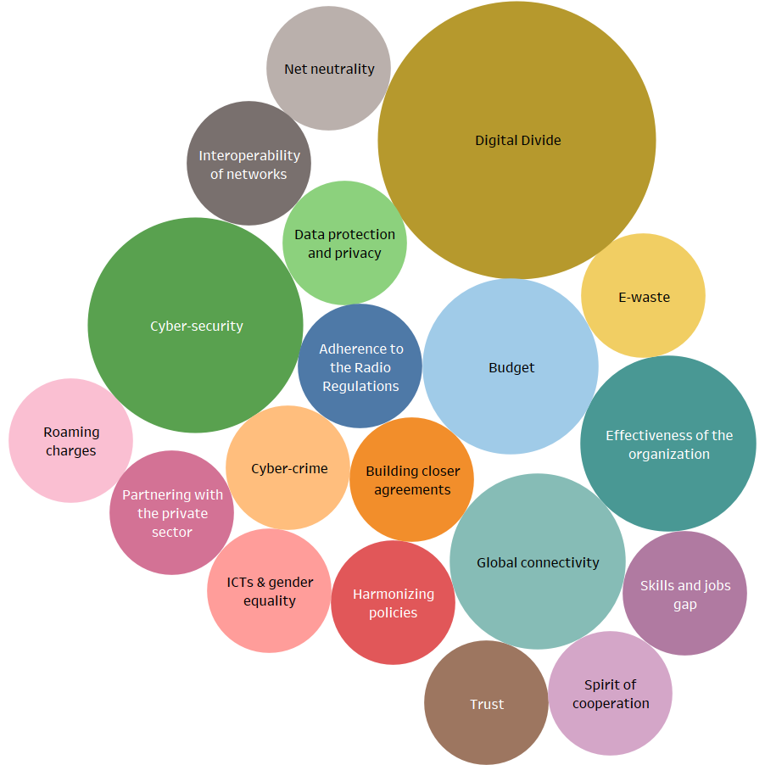

## Key achievements for ITU to accomplish in the 2020-2023 timeframe

The contributors would like to see ITU achieving following top achievements in the 2020-2023 timeframe:

* Foster universal access to ICTs (Africa Region, ICTA/BTK, Oman Telecommunications Regulatory Authority, Solomon Islands, Agence Ivoirienne de Gestion des Fréquences Radioélectriques);
* Ensure safe and secure ICT infrastructures (ICTA/BTK, Oman Telecommunications Regulatory Authority, Solomon Islands);
* Increased participation of the private sector and industry experts (Africa Region, GSMA, ASIET, ESOA/GVF):

(GSMA) “Industry expertise, information and data should form a central part of ITU discussions alongside input from Member States. This will help root decisions in the reality of operating communications services in today’s liberalized markets and will strengthen the robustness of ITU Recommendations and other outputs”.

## Other proposals

The creation of a committee to consistently follow-up and advice on strategic issues for ITU is proposed:

(Africa Region) “ITU is recommended to have in place a coordination and implementation of the strategic and financial plan Committee that will consistently follow up and advice on the gaps / challenges faced during the implementation process to ensure proper linkage of activities and results”

Recognizing the role of the industry and of market-based approaches:

(GSMA) “ITU should recognise the importance of all stakeholders, including industry service providers, in developing and investing in current and future technology for connectivity. Market-based approaches to the development of technologies should be embraced by the ITU”.

A proposal related to personal data and consumer protection:

(Oman Telecommunications Regulatory Authority) “Consumer protection in respect of personal data and unsolicited intrusion are emerging as significant concerns in the ever connected world; codes of practice and self-regulation measures should be encouraged and facilitated to avoid over-use of digital economy”.

An observation on the number of ITU events:

(Solomon Islands): “ITU is organizing too many events which LDCs cannot afford to attend and therefore lag behind in terms of knowledge, skills and technology”.

A proposal for ITU to promote an interconnected and integrated global submarine and land fiber optical communication network was also submitted:

(CITCC) “[ITU] to promote and develop a globally interconnected fibre-optic network with the integration of terrestrial and submarine cable”.

# List of Contributions

The contributions received for the CWG-SFP Public Consultation on the ITU strategic priorities for 2020-2023 are listed below. Links to the full text of all the contributions is available online at [www.itu.int/PublicConsultations](http://www.itu.int/PublicConsultations) and in [document CWG-SFP-2/INF-5](https://www.itu.int/md/S17-CLCWGSPF2-INF-0005/en).

**Figure 4[1]: Contributions to the CWG-SFP Public Consultation on the ITU 2020-2023 strategy**

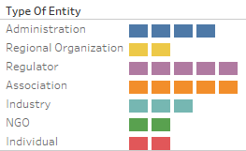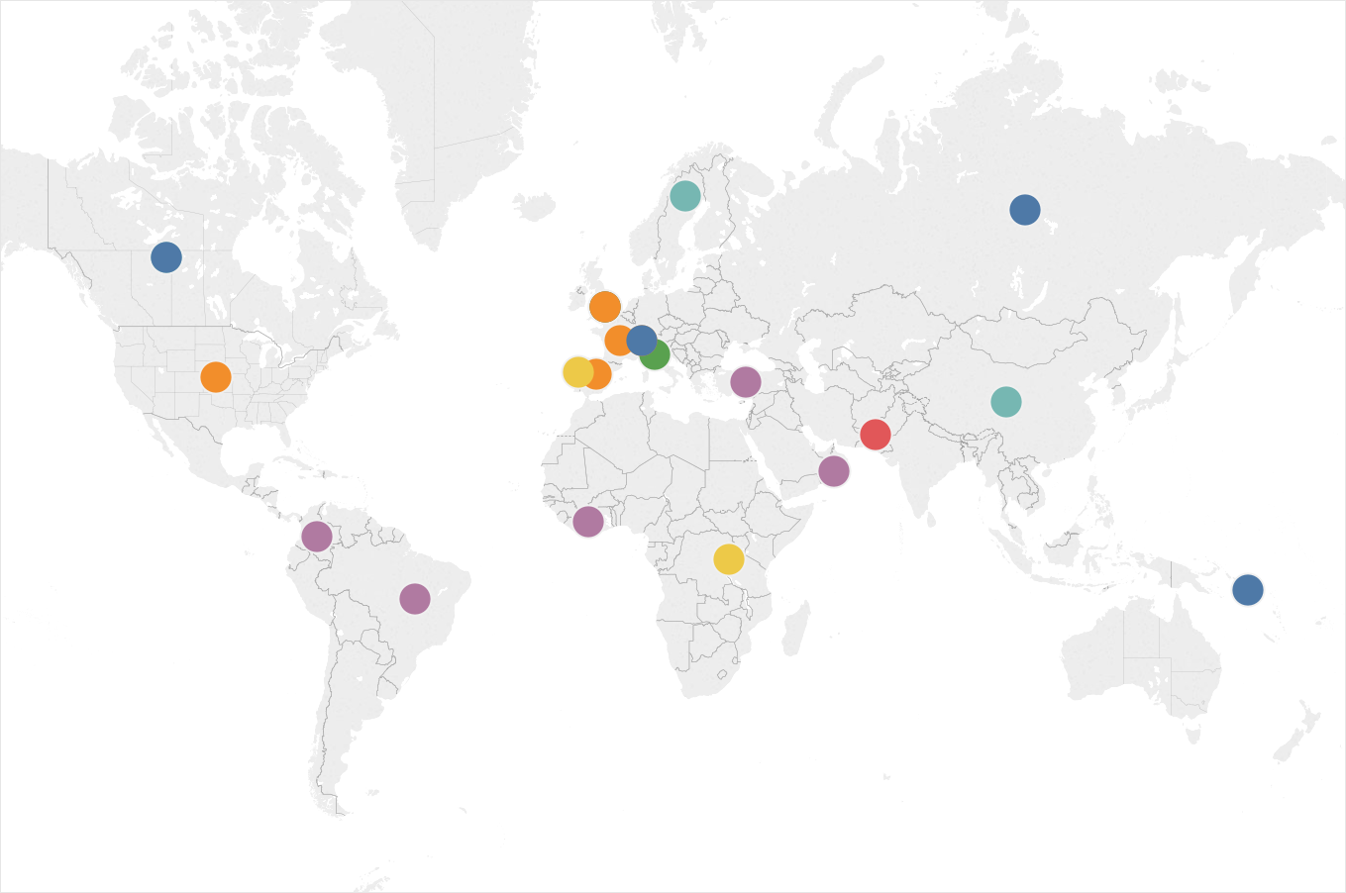

|  |  |  |  |  |
| --- | --- | --- | --- | --- |
|  | Date | Entity | Country | Focal Point |
| 1 | 22 Jun | Royal Holloway, University of London / UNESCO Chair in ICT4D | UK | Tim UNWIN |
| 2 | 23 Jun | Department of Innovation, Science and Economic Development (ISED) | Canada | Santiago REYES-BORDA |
| 3 | 4 Jul | Rwanda Utilities Regulatory Authority / Africa Region | Rwanda | Jackline MUPENZI |
| 4 | 4 Jul | CITCC - China International Telecommunication Construction Corporation | China | Wei Zhao |
| 5 | 6 Jul | GSMA | UK | Dominique LAZANSKI |
| 6 | 6 Jul | Oman Telecommunications Regulatory Authority | Oman | Muna AL BALUSHI |
| 7 | 6 Jul | Ericsson AB | Sweden | Jan FÄRJH |
| 8 | 6 Jul | Ministry of Telecom and Mass Communications of the Russian Federation | Russia | Anton YUZHAKOV |
| 9 | 7 Jul | Information and Communication Technologies Authority (ICTA/BTK) (Turkey) | Turkey | Handan CANTEKINLER |
| 10 | 7 Jul | CSFP (Commonwealth Scholarship and Fellowship Plan) | Pakistan | Muhammad Imran MAJID |
| 11 | 7 Jul | Ericsson Canada | Canada | Bruce GRACIE |
| 12 | 7 Jul | CEPT (European Conference of Postal and Telecommunications Administrations) | Portugal | Manuel DA COSTA CABRAL |
| 13 | 7 Jul | Ministry of Information & Communications (Solomon Islands) | Solomon Islands | Sonam P HUNTSHO |
| 14 | 7 Jul | International Chamber of Commerce (ICC) | France | Sophie TOMLINSON |
| 15 | 7 Jul | Interamerican Association of telecommunications Companies (ASIET) | Spain | Lorenzo SASTRE |
| 16 | 7 Jul | National Telecommunications Agency - Anatel (Brazil) | Brazil | Amélia ALVES |
| 17 | 7 Jul | ARTICLE 19 | UK | Mehwish ANSARI |
| 18 | 7 Jul | PFC - person family community | Italy | Maurizio INCERPI |
| 19 | 7 Jul | European Broadcasting Union (EBU) | Switzerland | Simon Fell / Giacomo Mazzone |
| 20 | 7 Jul | EMEA Satellite Operators Association (ESOA) and the Global VSAT Forum (GVF) | USA | Ruth Pritchard-Kelly |
| 21 | 11 Jul | Comisión de Regulación de Comunicaciones (CRC) (Colombia) | Colombia | Mariana SARMIENTO |
| 22 | 11 Jul | Federal Office of Communications OFCOM (Switzerland) | Switzerland | Dirk-Oliver VON DER EMDEN |
| 23 | 12 Jul | Agence Ivoirienne de Gestion des Fréquences Radioélectriques | Côte d'Ivoire | Francine LOGBO |

1. The designations employed and the presentation of material on this map do not imply the expression of any opinion on the part of the ITU secretariat concerning the legal status of any country, territory, area, city or area or of its authorities, or concerning the delimitation of its frontiers or boundaries. The term “country” as used in this Material also refers, as appropriate, to territories or areas. The depiction and use of boundaries, geographic names and related data shown on the map are not warranted to be error free nor do they necessarily imply official endorsement or acceptance by the ITU or its member organizations.