Council 2017  Geneva, 15-25 May 2017 | 
 | Document C17/INF/12-E
 | 10 April 2017
 | Original: English
Report by the Secretary-General
RESULTS OF THE SURVEY OF SATISFACTION WITH ITU’S REGIONAL PRESENCE

Summary
This information document presents the preliminary results of the survey of satisfaction with ITU’s regional presence.

Action required
This document is submitted to the Council for information.
____________

References
Document C17/25, Resolution 25 (Rev. Busan, 2014) and its annex

- Background
  - The purpose of this document is to present the results of the survey of satisfaction with ITU’s regional presence.
  - Resolution 25 (Rev. Busan, 2014) states inter alia:
“Instructs the Secretary-General
to conduct, once every four years, within the existing financial resources, a survey of the level of satisfaction of Member States, Sector Members and regional telecommunication organizations with ITU’s regional presence, and to present the results in a report to the session of Council prior to each plenipotentiary conference”.
Furthermore, the annex to Resolution 25 (Rev. Busan, 2014) sets the framework within which this survey should be undertaken and contains the elements for evaluation of the ITU regional presence.
  - In this context, in order to continue providing a high standard of service to membership through its regional and area offices, the International Telecommunication Union has undertaken a survey of satisfaction with ITU’s regional presence.
- Implementation of the survey
  - The main objective of this survey is to evaluate the effectiveness of the ITU regional presence on the basis of Resolution 25 (Rev. Busan, 2014) and its annex. This involves an assessment of the level and quality of the services provided, the effectiveness of the network of ITU regional and area offices including their activities and services to the membership, as well as their collaboration with regional telecommunications organizations.
  - The survey was undertaken in 2016 and the preliminary results and report are presented to Council at its 2017 session. As instructed by Resolution 25 (Rev. Busan, 2014), an updated version will be presented to the Council 2018. The objective of undertaking the survey in 2016 is to allow ITU to take any action required based on the results of this survey.
- Overall results of the survey
  - The survey was sent to all Member States, Sector Members, Associates, Academia, Regional Telecommunication Organizations, United Nations, Specialized agencies, and IAEA. ITU received 129 responses to the survey, 88 from Member States and 41 from Sector Members, Associates, Academia, Regional Organizations, and International Organizations, broken down as presented in tables 1 and 2 below:
 | Developed country | Transition countries | Developing country | Least developed country
% | 9.52% | 16.67% | 60.32% | 13.49%
Table 1

Table 2
Regional Distribution
Region | %
Africa | 14.29%
The Americas | 38.88%
Arab States | 14.29%
Asia & Pacific | 8.73%
Europe | 7.94%
CIS countries | 18.87%

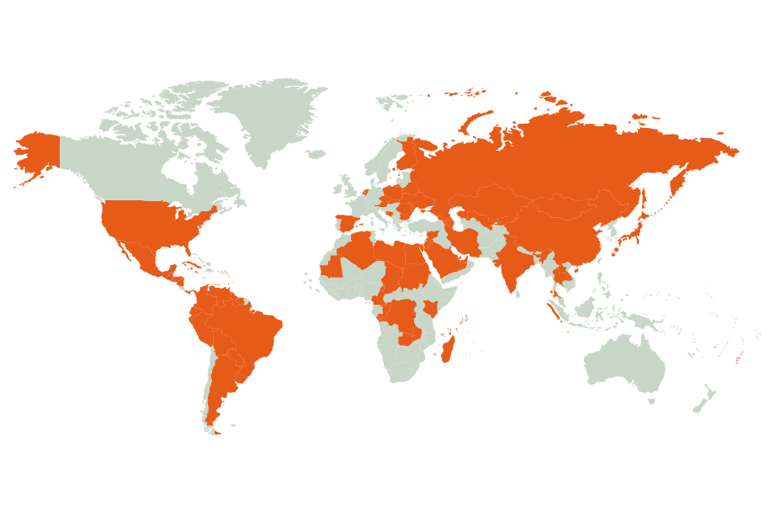
  - The geographical distribution of the participation to the survey of satisfaction with ITU’s regional presence stands as follows:
  - The overall results are generally satisfactory for all the aspects of this survey. The results of the survey are presented in detail further in this document.
- Specific results
  - Location of Regional/Area offices and quality of service provided
The vast majority of the participants to the survey have indicated that the location of Regional and Area offices are appropriate, and that they were familiar with the activities of the ITU including at the regional level. The majority of the participants to the survey have also indicated that they were considering the staffing level of the Regional and Area offices appropriate. The charts on next pages set forth details on the results of the survey for the aspect relating to the location of Regional / Area offices and the quality of service provided:

Question 1: Are you familiar with the activities of ITU?
Yes | No
126 | 3
Number of answers to this question: 129/129 (100.00%)
Chart 1

Question 2: Are you aware of the regional activities of ITU?
Yes | No
121 | 8
Number of answers to this question: 129/129 (100.00%)
Chart 2

Comments:
- Some issues were raised by some countries with regards to the opportunity for change of region.
Question 3: Do you consider the location of the regional / area offices optimal?
Yes | Partially | No
102 | 22 | 4
Number of answers to this question: 128/129 (99.22%)
Chart 3

Yes | Partially | No
94 | 21 | 11
Question 4: Do you consider the staffing level of the regional / area offices appropriate?
Number of answers to this question: 109/129 (84.49%)
Chart 4

Comments:
- In the light of the increased number of activities, the staffing level should be increased to cope with the very high demand.
- Staff redeployment from headquarter to field offices might be considered to better respond to Membership requirements.

Question 5: How would you rate the quality of service provided by regional / area offices?
Consistent high quality | Generally good | Satisfactory | Quality varies depending on the request | Poor quality
46 | 60 | 14 | 5 | 1

Number of answers to this question: 126/129 (97.67%)
Chart 5

Question 6: Are your questions / queries answered within a reasonable time-frame?
Yes | Partially | No
109 | 15 | 2
Number of answers to this question: 126/129 (97.67%)
Chart 6

Comments:
- In some rare cases, there were no answers or very delayed answers.

  - Specific result: Regularity of contact and quality of reception/facilities
The vast majority of the participants to the survey have indicated that they have regular contact with ITU, at least several times a month or more. The quality of the responses to queries is generally considered over higher quality. Contact points are mostly with headquarter for some 2/3 of the participants to the survey. Regional offices come second in terms of contact points.
A majority of the participants to the survey has indicated that the information received from Regional/Area offices was over higher quality.
The 3 most interesting domains of activity as per this survey are:
- Technology and network development;
- ITU events;
- Cybersecurity.
Question 7: How often do you contact ITU?
Frequently | Several times a month | Several times a year | Never
50 | 26 | 48 | 3
Number of answers to this question: 126/129 (97.67%)
Chart 7

Question 8: How would you rate the quality of our responses to your inquiries?
Consistent high quality | Generally good | Satisfactory | Quality varies depending on the request
59 | 51 | 10 | 7
Number of answers to this question: 126/129 (97.67%)
Chart 8

Question 9: Where are your contact points in ITU?
Headquarters | Regional office | Area office
83 | 71 | 43
Number of answers to this question: 126/129 (97.67%)
Chart 9

Question 10: Do you receive information from ITU Regional / Area offices?
Frequently | Several times a month | Several times a year | Never
54 | 38 | 30 | 6
Number of answers to this question: 126/129 (97.67%)
Chart 10

Question 11: How would you rate the quality of information received from Regional / Area Offices?
Consistent high quality | Generally good | Satisfactory | Quality varies depending on the request | Poor quality
50 | 52 | 16 | 5 | 2
Number of answers to this question: 126/129 (97.67%)
Chart 11

Question 12: How often do you meet ITU representatives from Regional / Area Offices?
Frequently | Several times a month | Several times a year | Never
11 | 13 | 87 | 15
Number of answers to this question: 126/129 (97.67%)
Chart 12

Question 13: What area(s) of activity are you mainly interested in?
Chart 13

Comments:
- Other domains of interest were mentioned such as: other Sectors’ events (PP, WRC, ITU-T study Groups, WSIS), IoT, Smart city and e-Development, Telehealth, etc.
  - Pertinence of activities or future requirements
Most participants consider that the activities of the regional / area offices are pertinent and that there is no duplication with the activities undertaken by other international / national organizations. The majority of participants consider that the regional initiatives are properly addressed by the regional / area offices and that they positively contribute to the fulfillment of the objectives and outcomes of the strategic plan. A significant portion of the participants consider that the regional / area offices do not properly represent all the sectors of the Union.
Quetsion 14: How would you rate the pertinence of regional / area offices activities?
Pertinent | Partially pertinent | Not pertinent
93 | 28 | 3
Number of answers to this question: 124/129 (96.12%)
Chart 14

Comments:
- Some participants have expressed reservations concerning the pertinence of the activities and the adequacy of the linkage between activities and regional initiatives.
- Many comments commended the regional / area offices for the quality of their activities.

Question 15: Do you consider that there is duplication in the services provided by the ITU regional/area offices with other international/national organizations?
Yes | Partially | No
9 | 39 | 77
Number of answers to this question: 125/129 (96.89%)
Chart 15

Comments:
- Many comments indicating that participants consider there is no overlap.
Question 16: Do you consider that ITU regional initiatives properly address regional needs?
Yes | Partially | No
83 | 38 | 4
Number of answers to this question: 125/129 (96.89%)
Chart 16

Comments:
- The importance of annual review of the implementation of the regional initiatives was highlighted.
Question 17: Are there any other activities you would like the ITU regional/area offices to undertake?
Yes | No
62 | 59
Number of answers to this question: 121/129 (93.79%)
Chart 17

Comments:
- The main following fields of activity were identified:
  - Capacity building;
  - Standardization activities;
  - Big data, cloud computing;
  - Terrestrial Digital Television;
  - IPv6;
  - Activities of the other sectors;
  - Broadband;
  - Frequency coordination;
  - Policy and regulatory activities for market development.

Question 18: Do you consider that the regional/area offices contribute to the fulfillment of the objectives and outcomes of the ITU strategic plan?
Yes | Partially | No
97 | 24 | 4
Number of answers to this question: 126/129 (97.67%)
Chart 18

Comments:
- Most comments were positive and participants considered that the regional initiatives contribute significantly to the fulfillment of the objectives and outcomes of the ITU strategic plan.
Question 19: Do you consider that regional/area offices properly represent all Sectors/activities of the ITU?
Yes | Partially | no
65 | 46 | 13
Number of answers to this question: 125/129 (96.89%)
Chart 19

Comments:
- Many participants indicated that efforts should be made to better reflect the work of the R and T Sectors.

  - Communication and accessibility/pertinence of information
Only half of the participants to the survey are familiar with the ITU website for Regional Offices information and consider that the quality and pertinence of the information on ITU regional presence provided on the ITU website are over higher quality.
The majority of the participants to the survey considered that the ITU website should have specific regional focus for news and events in the relevant language. Only half of the participants to the survey considered that the communications and media activities provide sufficient visibility of the work of ITU.
Yes | Partially | No
73 | 42 | 13
Question 20: Are you familiar with the ITU website for Regional Offices information?

Number of answers to this question: 128/129 (99.22%)
Chart 20

Comments:
- Many participants indicated that efforts should be made to improve the ITU website for Regional Offices and indicated that the website was not easy to find.
- Other participants indicated that the main channel of information was through the Head of the regional office.

Question 21: How would you rate the quality/pertinence of the information on ITU regional presence provided on the ITU website?
Consistent high quality | Generally good | Satisfactory | Quality varies depending on the request | Poor quality
25 | 55 | 36 | 7 | 2
Number of answers to this question: 125/129 (96.89%)
Chart 21

Comments:
- Some comments were made regarding the quality and availability of the information and websites.

Question 22: Do you think that the ITU website should have specific regional focus for news and events in the relevant language?
Yes | Partially | No
88 | 21 | 15
Number of answers to this question: 124/129 (96.12%)
Chart 22

Comments:
- Many participants indicated that there is a need to provide more information in the relevant language as compared to the prevailing situation.
Question 23: Are the communications and media activities providing sufficient visibility of the work of ITU?
Yes | Partially | No
65 | 51 | 10
Number of answers to this question: 126/129 (97.67%)
Chart 23

Comments:
- Some participants indicated that there is still room for improvement in order to provide sufficient visibility of the work of ITU.
__________

