|  |  |
| --- | --- |
| **Council 2017 Geneva, 15-25 May 2017** |  |
|  |  |
|  |  |
| **Agenda item: PL 1.19** | **Document C17/72-E** |
| **21 April 2017** |
| **Original: English** |
| Report by the Secretary-General | |
| EFFECTIVENESS OF REGIONAL GROUPS FOR BRIDGING THE STANDARDIZATION GAP | |

|  |
| --- |
| Summary  The purpose of this document is to report on the effectiveness of Regional Groups as per *instructs* of Resolution 44 (WTSA-16).  Action required  The Council is invited to **note** this report.  ____________  References  [WTSA Resolution 44 (Rev. Hammamet, 2016)](https://www.itu.int/pub/T-RES-T.44-2016) |

# 1 Background

1.1 PP-14 revised Resolution 123 on *Bridging the Standardization Gap between Developing and Developed Countries*, recognizing that the implementation of Recommendations of the ITU Radiocommunication Sector (ITU-R) and the ITU Telecommunication Standardization Sector (ITU-T) is a basic step towards bridging the standardization gap between developed and developing countries. It further instructs the Secretary-General and the Directors of the three Bureaux to work closely with each other on the follow-up and implementation of this Resolution and related resolutions, and in pursuing initiatives intended to enhance efforts to bridge the standardization gap between developing and developed countries.

1.2 Resolution 1353 of the Council recognizes that telecommunications and ICT are essential components for developed and developing countries for achieving sustainable development, and instructs the Secretary-General, in collaboration with the Directors of the Bureaux, to identify new activities to be undertaken by ITU to support the developing countries to achieve sustainable development through telecommunications and ICTs.

1.3 WTSA-16 revised Resolution 54 on the Creation of, and assistance to, regional groups, and *resolves* to support the creation of regional groups in Study Groups.

1.4 WTSA-16 revised Resolution 44 and its Action Plan to further address the disparity in standardization between developed and developing countries, including least developed countries, Small Island developing States and countries with economies in transition.

1.5 This report sets forth information on the effectiveness of regional groups as instructed by WTSA-16 Resolution 44.

1.6 Finally, this document is supplemented by Information Document [C17/INF/9](https://www.itu.int/md/S17-CL-INF-0009/en) that contains a presentation on ITU-T regional groups.

# 2 History of Regional groups and upcoming 50-year anniversary

Next year, in 2018, ITU will celebrate 50 years of the existence of regional groups. SG3 Regional groups were first established in 1968 for four different regions, namely for the African region, Europe and Mediterranean region, Latin America and Caribbean region, and the Asia and Oceania region. The figure below illustrates the history of the establishment of ITU-T regional groups from 1968 to the present.

Figure : History of Regional groups 1968-2016

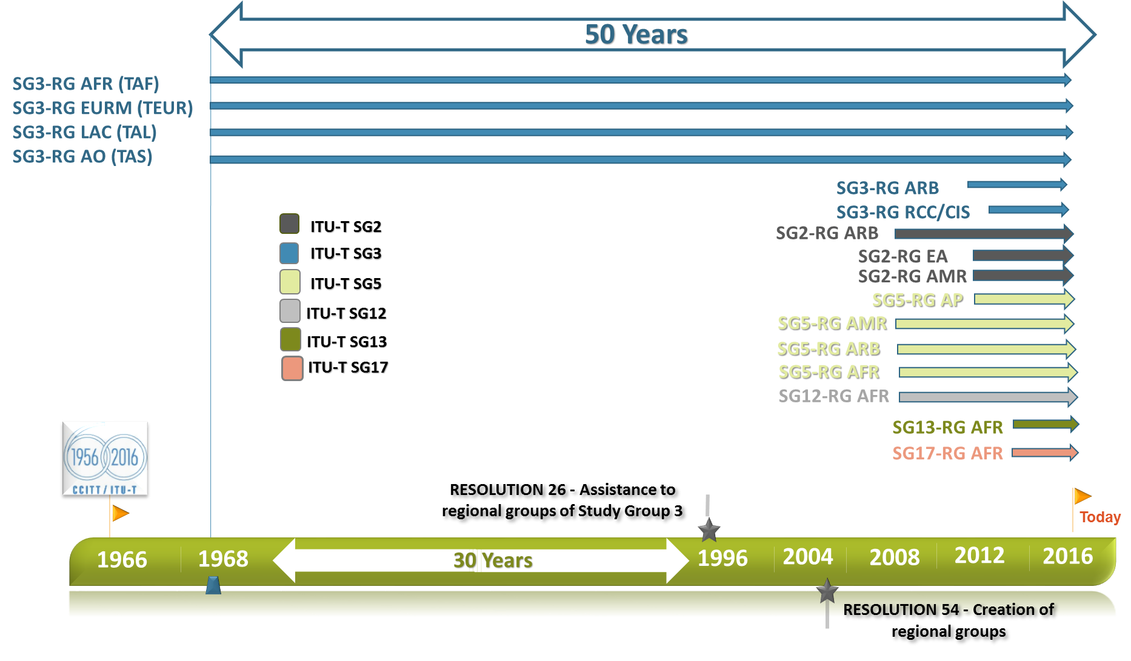

Figure 2: Evolution of the number of Regional groups 1968-March 2017. The year indicated refers to the entire study period, e.g. ITU-T SG2, SG3 and SG12 were created in the study period 2004-2008 etc.

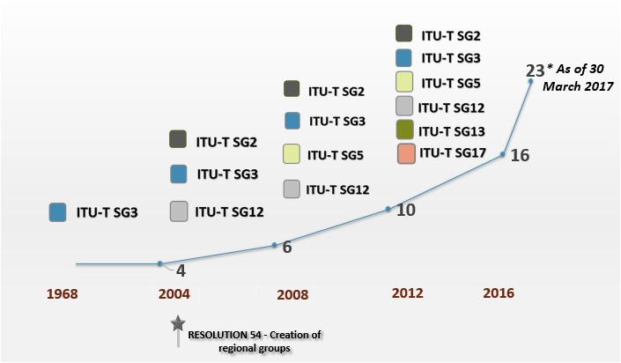

# 3 Regional groups up to 30 March 2017 and regional group meetings 2013 – 2016

As at 1 March 2017, ITU-T had 18 regional groups: seven for Africa (Study Groups 2, 3, 5, 11, 12, 13, and 17), three for the Americas (Study Groups 2, 3, and 5), three for the Arab region (Study Groups 2, 3, and 5), two for Asia and the Pacific (Study Groups 3 and 5), one (Study Group 3) for the Regional Commonwealth in the field of Communications and the CIS region (RCC/CIS), one (Study Group 11) for RCC, and one (Study Group 3) for Europe and the Mediterranean Basin. Five new regional groups were set up in March 2017, bringing the total to 23 regional groups – four by ITU-T SG20: [Regional Group for Latin America (RG-LATAM)](http://www.itu.int/en/ITU-T/studygroups/2017-2020/20/sg20rglatam/Pages/default.aspx); [Regional Group for the African Region](http://www.itu.int/en/ITU-T/studygroups/2017-2020/20/sg20rgafr/Pages/default.aspx) (RG-AFR); [Regional Group for the Arab Region](http://www.itu.int/en/ITU-T/studygroups/2017-2020/20/sg20rgarb/Pages/default.aspx) (RG-ARB); [Regional Group for Eastern Europe, Central Asia and Transcaucasia](http://www.itu.int/en/ITU-T/studygroups/2017-2020/20/sg20rgeecat/Pages/default.aspx) (RG-EECAT); and one by ITU-T SG17 for the Arab region (RG-ARB).

Regional Groups for ITU-T Study Groups have proven effective mechanisms to assist in bridging the standardization gap by stimulating effective participation in ITU-T Study Groups and increasing the number and quality of contributions from developing countries that could eventually lead to standards.

Key figures and statistics on Regional Groups and meetings are set out in the figures below.

Figure 3 : Study group Regional group meetings: Total number, duration and participation, 2013-2016

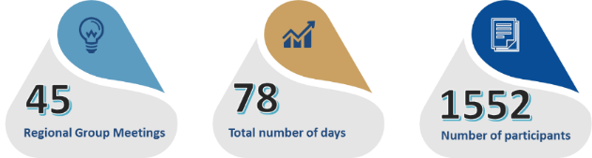

Figure 4 : Study Group Regional Group Meetings: Location, number and participation, 2013-2016

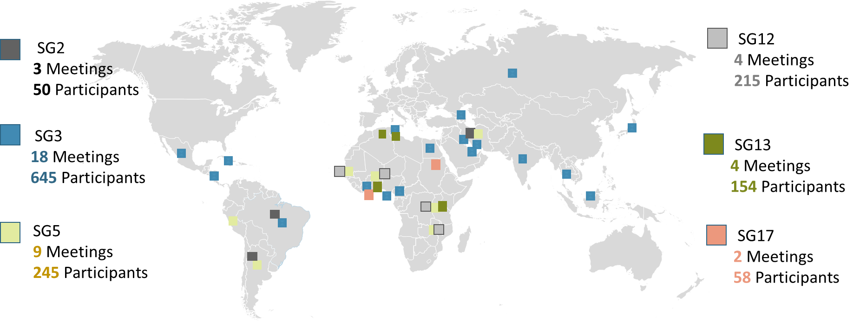

Figure 5: Study Group Regional Group Meetings: Location and dates, 2013-2016

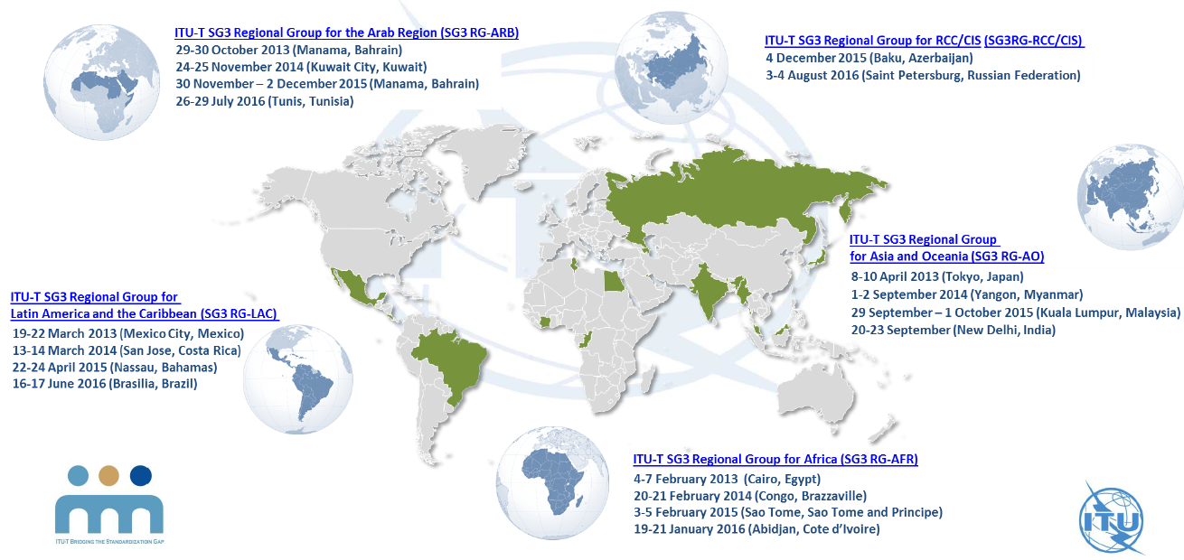

# 4 Forums held in association with Regional group meetings (2013-2016)

4.1 BDT and TSB have been jointly organizing Regional Economic and Financial Forums that are held back-to-back with SG3 Regional Groups, since the 1990s. Every year, four such joint meetings were being held in the four regions of Africa, Asia-Oceania, Arab States, and Latin America and the Caribbean. Based on requests from regional membership on adapting the content of the Regional Forums to their standardization needs, with a view to building greater cohesion in the progression of technology and policy, Regional Standardization Forums (RSFs) are being held back-to-back with SG3 Regional Groups in Asia-Oceania, Arab States, and Latin America and the Caribbean in collaboration with ITU Regional offices.

4.2 There were 12 Regional Standardization Forums (figure below) held for, or in, developing countries during the past study period (2013-2016), covering a wide range of themes, including Human exposure to EMF, Quality of Service, Smart Water Management, International Mobile Roaming, Mobile financial services, digital identify and big data, etc., as well as tutorials on the ITU-T working methods.

Figure 6: ITU-T REGIONAL STANDARDIZATION FORUMS FOR BSG

Meetings and Participants by Region (2013- 2016)

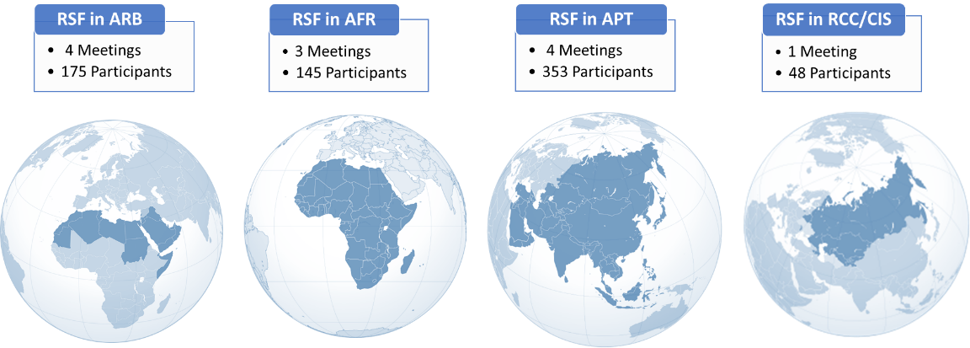

# 5 Capacity building in standardization

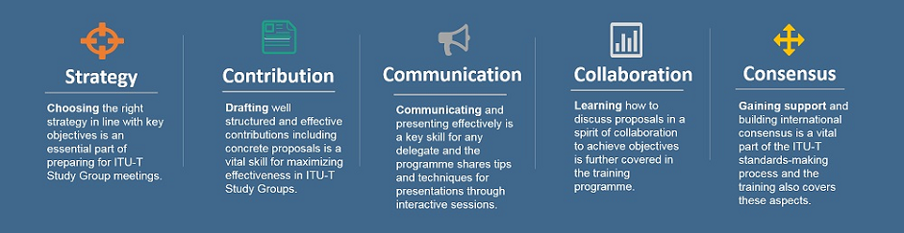The successful hands-on capacity-building and effectiveness sessions conducted by ITU‑T SG3 since early 2014 has now been extended to other study groups and their regional groups. These BSG Hands-On sessions are geared towards assisting developing countries in acquiring the right skills and capabilities for international standards-making and to draft contributions for submission to Study Group meetings. The sessions focus on the development of practical skills to maximize the effectiveness of developing countries’ participation in the ITU-T standardization process, covering topics such as strategies for participation in Study Groups, drafting contributions, presenting proposals, gaining support, and building consensus. The content of these sessions is outlined in the five key areas in the figure above.

Figure 7: KEY ASPECTS OF BSG HANDS-ON SESSIONS

*For more information about the Bridging the Standardization Gap (BSG) Programme, please see Section 16 of the Director’s report to WTSA-16 available here:* [*https://www.itu.int/md/T13-WTSA.16-C-0028/en*](https://www.itu.int/md/T13-WTSA.16-C-0028/en)

_________________