|  |  |
| --- | --- |
| **Plenipotentiary Conference (PP-14) Busan, 20 October – 7 November 2014** |  |
|  |  |
|  |  |
| **PLENARY MEETING** | **Document 41-E** |
| **14 April 2014** |
| **Original: English** |
| Note by the Secretary-General | |
| CANDIDACY FOR THE POST OF MEMBER OF THE RADIO REGULATIONS BOARD | |
|  | |
|  | |

Further to the information published in Document 3, I have pleasure in transmitting to the Conference, in annex, the candidacy of:

**Dr Ievgen KHAIROV (Ukraine)**

for the post of member of the Radio Regulations Board.

Dr Hamadoun I. TOURÉ  
 Secretary-General

**Annex**: 1

ANNEX

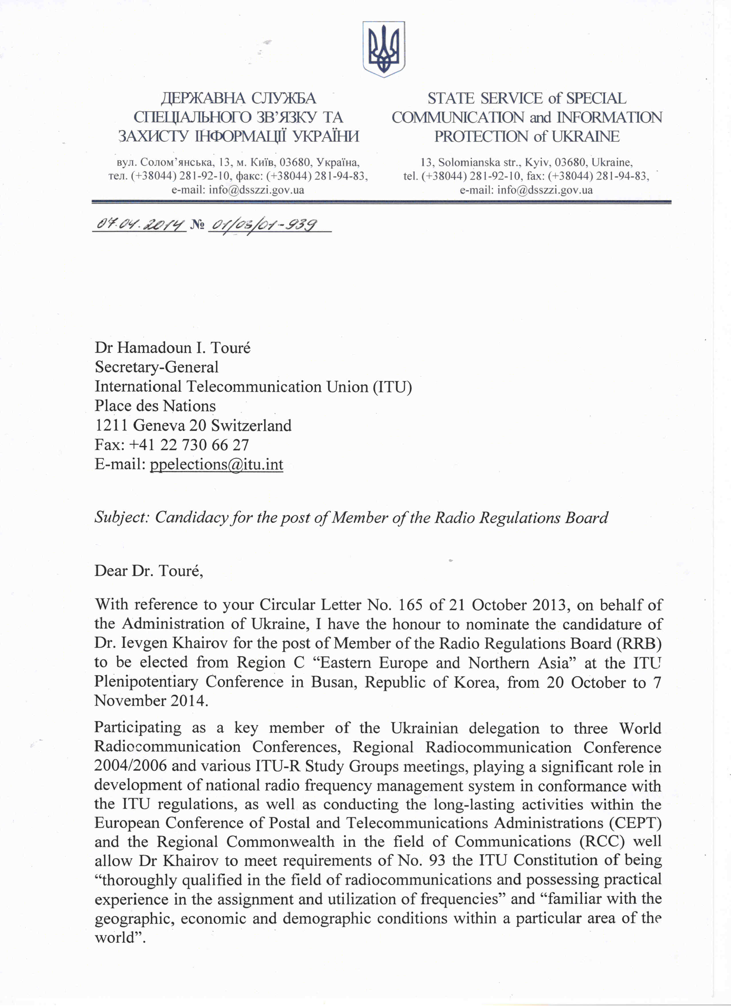

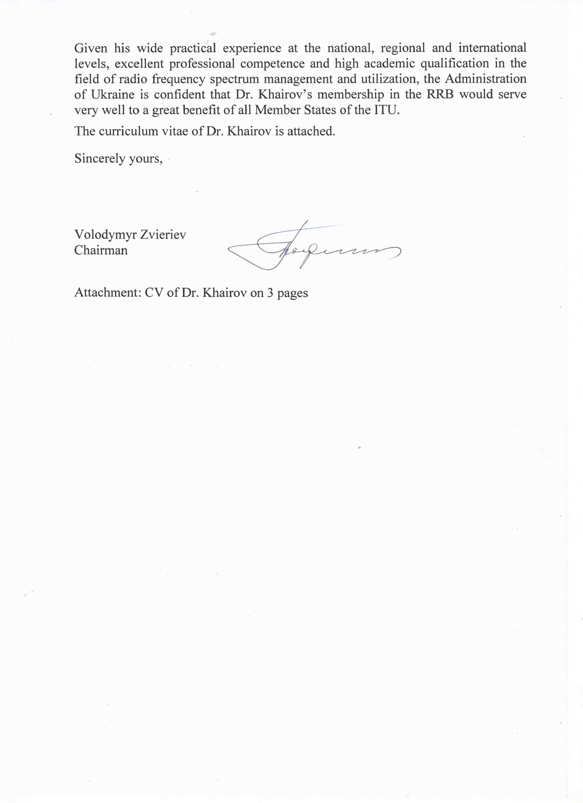

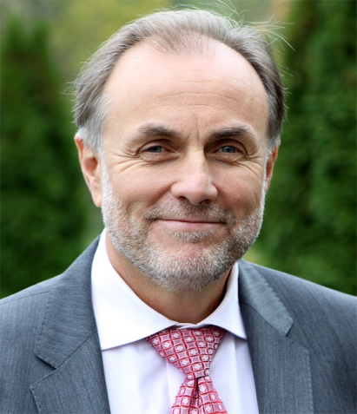**Plenipotentiary Conference   
of the International Telecommunication Union**

Busan, Republic of Korea, 20 October – 7 November 2014

**Curriculum Vitae**

**Dr IEVGEN KHAIROV**

**Candidate of Ukraine for the post of member  
of the Radio Regulations Board (Region C)**

**PERSONAL INFORMATION**

**Name** Ievgen KHAIROV  
**Current position** First Deputy Head of the Ukrainian State Centre of Radio Frequencies

**Born** 24 October 1959, Makyivka, Ukraine  
**Citizenship** Ukraine  
**Marital status** Married, has a daughter  
**Languages** English, Russian, German, Ukrainian  
**Contact** Tel: + 380 444228103, Fax: + 380 44 4228181  
 E-mail: [kew@ucrf.gov.ua](mailto:kew@ucrf.gov.ua)

**PROFESSIONAL EXPERIENCE**

**2006 – present** First Deputy Head of the Ukrainian State Centre of Radio Frequencies (UCRF)

**2002 – 2006** UCRF Deputy Head on Radio Frequency Assignments

**2001 – 2002** UCRF Deputy Head– Head of General Radio Frequency Assignments Service

**1976 – 2001** Military Forces of Ukraine and the USSR, Colonel in the reserve.

Served as an engineer, academic lecturer, researcher, head of laboratory, head of department, Deputy Head of Scientific-Research Directorate and Deputy Head of Scientific Center for Communications, Reconnaissance and Electronic Warfare under the Ministry of Defense of Ukraine.

Honored Service Industries Worker of Ukraine (Decree of the President of Ukraine #640/2012 of 16.11.2012), Honored Worker of Communication Industry of Ukraine (2006).

**INTERNATIONAL ACTIVITIES**

Having 33-year experience of technical, academic, research, scientific and administrative experience, last 12 years Dr Khairov has actively participated in the work of the ITU, as well as RCC and CEPT on regional level, on spectrum management and radio regulatory issues. He was deeply involved in preparation and work of three WRCs, RRC04/06 and other high-level conferences and meetings, by leading the frequency management expert group within the Ukrainian delegation, and he took an active part in numerous ITU seminars/workshops, as listed below. He coordinates UCRF’s activity under its membership in the ITU Radiocommunication Sector (since 2008) and in relation to work with the RCC and CEPT working groups.

**International Telecommunication Union (ITU)**

**2013** ITU Seminar for the CIS/Europe “Radio frequency spectrum management. Radio monitoring as an effective tool for RF spectrum management”

**2012, 2007, 2003** World Radiocommunication Conferences

**2012** ITU-R Joint Task Group 4-5-6-7 on WRC-15 agenda items 1.1 and 1.2

**2011** Conference Preparatory Meeting for WRC-12

**2011** Global Symposium for Regulators

**2010, 2006** World Radiocommunication Seminars of the Radiocommunication Bureau

**2010** ITU Workshop “Radiomonitoring and enhancement of spectrum usage efficiency”

**2009** ITU-R/SG1Working Party 1B on Spectrum management methodologies and economic strategies

**2009** ITU-R/SG5 Working Party 5A on Land mobile service above 30 MHz, excluding IMT; amateur and amateur-satellite services

**2008** ITU Workshop “Spectrum monitoring today and tomorrow. Tasks, problems and solutions”

**2007 World Telecommunication Standardization Assembly**

**2006, 2004** Regional Radiocommunication Conference for planning of the digital terrestrial broadcasting service in parts of Regions 1 and 3, in the frequency bands 174-230 MHz and 470-862 MHz (1st and 2nd sessions)

**2006** ITU Seminar "Trends in Development of National Spectrum Monitoring"

**2005** Intersessional Planning Group (RRC-04/06)

**2005** ITU Workshop “Automation of the Spectrum Management”

**2004** Working Party of the Special Committee on Regulatory/Procedural Matters

**2004** ITU Workshop "Monitoring of Radio Frequency Spectrum"

**2002** World Telecommunication Development Conference

**2002** ITU-R/SG8 Working Party 8F on IMT-2000 and systems beyond IMT-2000

**Regional Commonwealth in the field of Communications (RCC)**

**2011 – present** Deputy Chairman of the RCC Commission on regulation of radio frequency spectrum and satellite orbits usage

**2012 – present** Chairman of the Working Group on Radio Frequency Spectrum Management

**2010, 2011** Joint CEPT-RCC meetings on preparation to the WRC-12

**2008 – 2011** Deputy Chairman of the RCC Commission on satellite communication, television and sound broadcasting

**2005 – 2009** Chairman of the Working Group on studying the need to develop the Common Table of Frequency Allocation for CIS countries

**2002 – 2008** Deputy Chairman of the RCC Commission on regulation of radio frequency spectrum and EMC of radio-electronic facilities

**2004 – 2006** Participation in the RCC Coordination Group on preparation to RRC-06

**European Conference of Postal and Telecommunications Administrations (CEPT)**

**2002 – 2009** ECC's Working Group on Frequency Management (WG FM)

**2002 – 2007** ECC's Conference Preparatory Group (CPG)

**2005** ECC's Working Group on Regional Radio Conference 2006 (WG RRC-06)

**2003** ECC’s Working Group Spectrum Engineering (WG SE)

**2003** CEPT Conference

**2003** WG FM’s Project Team 22 on Monitoring and Enforcement

**2002** CEPT Multilateral meeting on the Special Arrangement on use of the band 1452–1479.5 MHz for T-DAB (Maastricht), Head of Ukrainian delegation

**NATIONAL ACTIVITIES**

Dr Khairov has played a key role in developing the up-to-date radio spectrum management system in Ukraine in accordance with the ITU regulations. At the national frequency management authority he is responsible for the activities, including international ones, related to radio frequency spectrum assignment, allocation, planning, sharing, coordination and notification both for terrestrial and space services.

The major activities, implemented under his leadership, include:

* participation in creating the legislative background for national radio frequency spectrum management, including Law of Ukraine “On radio frequency resource”, National Table of Radio Frequency Bands Allocation of Ukraine, Plan of Radio Frequency Resource Usage of Ukraine, Amateur Radiocommunication Regulations of Ukraine and many others,
* automation of frequency assignment process (application handling, EMC calculations, creation of unified assignment database, authorization, etc.),
* frequency sharing studies for different radiocommunication services(e.g. CDMA vs E-GSM, radiolocation vs TV, broadband access stations, CDMA-450, DVB-T2, etc.),
* DVB-T planning (for the year 2011 Ukraine deployed the biggest DVB-T2 network in the world, including 4 multiplexes and 664 frequency assignment and ensuring the simultaneous operation of analogue and digital TV broadcasting),
* implementation of measuring the quality of service and quality of coverage,
* frequency planning and assignment for the final part of the European football championship EURO-2012 in Ukraine.

Dr Khairov headed numerous Ukrainian delegations to bilateral and multilateral cross-border frequency planning and coordination meetings.

**EDUCATION AND ACADEMIC ACHIEVEMENTS**

**1988** Candidate of Engineering Sciences (equal to Ph.D. (eng))

**1986 – 1989** Academic lecturer at the Stavropol Higher Military Educational Institution of Communications

**1983 – 1986** Postgraduate studies at the Kharkiv Higher Military Educational Institution named after the USSR Marshal M. Krylov

**1976 – 1981** Kharkiv Higher Military Educational Institution named after the USSR Marshal M. Krylov, speciality – Management and Communications Systems, qualification – Radio Engineering

**PUBLICATIONS**

Dr Khairov is an author and co-author of about 40 academic and scientific publications on different technical subjects in the field of communications, including spectrum management and monitoring, frequency utilization and automation techniques.

**SUMMARY**

Dr Khairov is a recognized expert with excellent professional competence, high academic qualification, and proven practical experience in radio frequency spectrum management and utilization at the national, regional, and international levels.

Dr Khairov was a key member of the Ukrainian delegation to three World Radiocommunication Conferences, Regional Radiocommunication Conference 2004/2006 and numerous ITU-R meetings and workshops. Besides, he conducted the long-lasting activities within the Regional Commonwealth in the field of Communications (RCC) as a deputy chairman of the profile RCC commissions and chair of working groups addressing spectrum management and utilization, and actively participated in the major working groups of the European Conference of Postal and Telecommunications Administrations (CEPT).

He has been playing a significant role in development of national radio frequency management system and legislative background in conformance with the ITU regulations. He has specialized experience in a wide variety of technical, regulatory, and policy issues pertaining to the frequency assignment, allocation, planning, sharing, coordination and application of the Radio Regulations.

___________________