Plenipotentiary Conference (PP-14)
Busan, 20 October – 7 November 2014
PLENARY MEETING | Document 37-E
 | 20 March 2014
 | Original: English/Arabic
Note by the Secretary-General
CANDIDACY FOR THE POST OF MEMBER OF
THE RADIO REGULATIONS BOARD
Further to the information published in Document 3, I have pleasure in transmitting to the Conference, in annex, the candidacy of:
Mr Nasser BIN HAMMAD (United Arab Emirates)
for the post of member of the Radio Regulations Board.

Dr Hamadoun I. TOURÉ
Secretary-General

Annex: 1

ANNEX

PERMANENT MISSION OF THE UNITED ARAB EMIRATES, GENEVA

Ref.: 1/5/73-241
Date: 24 March 2014 AD, corresponding to 23 Jumada I, 1435 H
To: H.E. Deputy Minister for International Organizations Affairs, Ministry of Foreign Affairs, Abu Dhabi
Subject: UAE candidatures for membership of the ITU Council and the Radio Regulations Board

Dear Sir,
With reference to your letter Ref. MD/1/5/73-704, dated 24 March 2014, concerning UAE's candidatures for renewal of its membership of the Council of the International Telecommunication Union (ITU) and membership of the Radio Regulations Board for the period 2015-2018, I hereby inform you that the Mission has taken the necessary steps, the said candidatures having been delivered by hand to the Office of the ITU Secretary-General, Dr Hamadoun Touré. The candidature with the official stamp and acknowledgement of receipt by the Office of the Secretary-General is attached.
Yours faithfully,

(signed)
Obaid Salem Al Zaabi
Ambassador, Permanent Representative

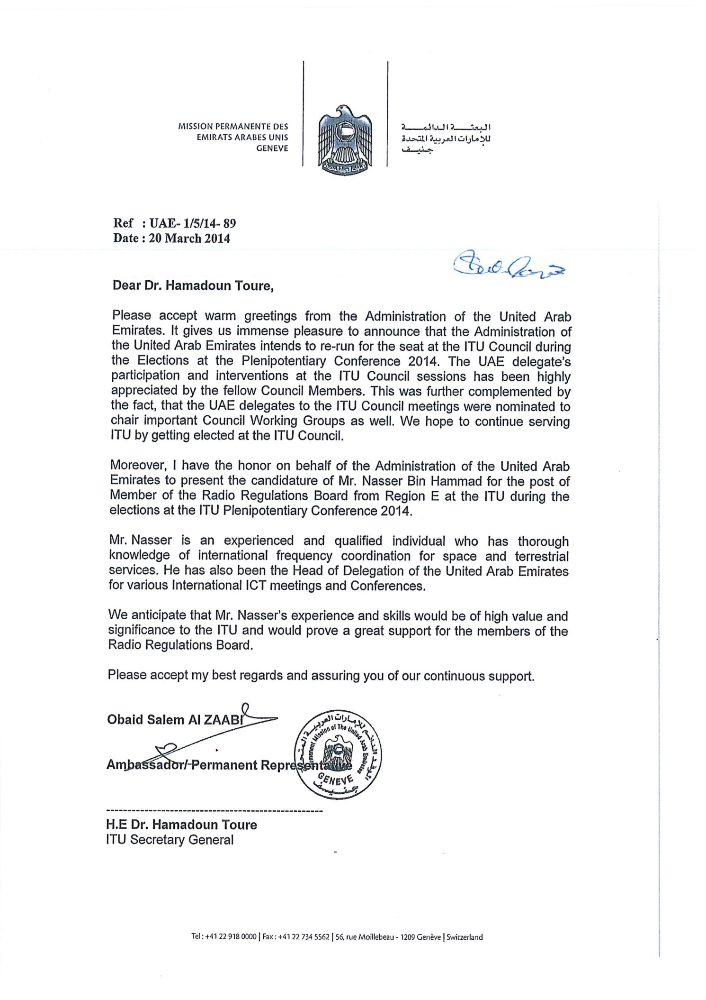
Nasser A. Bin Hammad  Vice-Chairman of Special Committee (ITU-R)  Candidate for Radio Regulation Board | 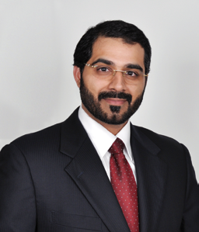
Nationality: United Arab Emirates
Languages: English, Arabic, French (basic)
Education: Bachelor of Science (BS) in Telecommunications Engineering with Distinction, (First Class Honors).
Khalifa University of Science, Technology & Research, (Earlier Etisalat College of Engineering), UAE.
Master of Art in Diplomacy and International Affairs from Zayed University-UAE (Expected 2015).
Family Status: Married, Four Children
E-mail: nasser.binhammad@tra.gov.ae
Summary Profile
Nasser is an experienced International Telecommunications Policy and Regulatory Affairs professional and expert and Telecommunications Engineer and has been actively participating in the activities of the International Telecommunication Union (ITU) for the past 14 years. He has a considerable amount of experiences in International Cooperation and Policy including but not limited to Arab Countries Affairs, Gulf Cooperation Council (GCC) Affairs, ITU Affairs, other UN Organizations including UN Office of Outer Space Affairs as well as Arab Regulators Network activities, International frequency coordination (space and terrestrial), allocation, and interference analysis of Radio, Wireless and Space services. He was candidate for the RRB from (Region E – Asia & Australia) at the Plenipotentiary Conference held in Mexico in 2010 with 69 votes and short of 7 votes. He has been the Head of Delegation and Deputy Head of UAE delegation and official spokesperson of the UAE Administration at many Regional and International conferences, meetings, forum and meetings expressing and defending UAE positions and interests in Telecom sector.
He has chaired several meetings at the GCC and Arab Leagues and ITU as well such as but not limited to chairing the WRC-07 Working Group 5A in 2007, and before that he was assigned to be the Chapter three Rapporteur (2003 – 2007) in ITU for some of the Agenda Items of WRC-2003. In addition to his membership in the Advisory Committee for Telecom Exhibitions, he is the main focal point in TRA and UAE for matters related to the ITU, national Coordination of UAE Space Services and other industrial Groups for ITU conferences preparations in the capacity of the UAE Administration. He chaired for several times the Arab ICT Permanent Committee meetings which are reporting to the Ministerial ICT Council. He also chaired and contributed actively on behalf of UAE in all GCC working groups and committees and also chaired the GCC Regulation and legislation committee. In 2012 in Geneva he chaired one of the important committees on finance and budgets during the World Radiocommunication Conference WRC-12. He is currently leading a team of technical, policy and international experts for advising the UAE Government on the policy issues related to the telecom and ITU, International Radiocommunication, and Spectrum Management and the negotiations at the UN international conferences and meetings such as the World Telecommunication Standardization Assembly, World Radiocommunication Conference, ITU Council, ITU Plenipotentiary Conference, World Development Conference, World Conference for International Telecommunications, World Telecommunications Policy Forum, ITU Telecom and the World Summit on Information Society. He has been involved and was the main focal national coordinator from the TRA for the successful hosting of three major ITU conferences and events in 2012 hosted in Dubai for the first time and in the Middle East. The three ITU events hosted in UAE in 2012 are; the ITU Telecom 2012 (Exhibition and conference), the World Telecommunications Standardization Assembly 2012, and the World Conference on International Telecommunication Regulations which all were chaired by UAE as well. In 2008, he has initiated the idea for UAE to become the sole founder of a State of Art ICT Museum (later called ICT Discovery) by an agreement signed between ITU and UAE Administration officially in November 2009. The UAE based on this agreement is considered to be the sole founder of this Museum in Geneva and the inauguration was officially under the patronage of President of UAE His Highness Sheikh Khalifa Bin Zayed Al Nahyan in 2012. He has excellent team building skills, in depth knowledge and experience of telecom policy matters particularly those dealing with ITU, Arab and GCC Affairs. He has been selected to be the chairman of the GCC and Arab preparatory group for PP-14 conference and for the WTDC- GCC preparatory group.
Major International achievements
- Chaired Working Group 5A (responsible for five Agenda Items) at the last World Radio Conference (WRC-07).
- Selected as the Chapter Rapporteur for the Chapter 3 on Fixed, Mobile and Broadcasting issues (responsible for five Agenda Items) at the ITU-R during the period 2003 – 2007.
- Currently he is Vice Chairman of the Special committee in ITU-R responsible for Regulatory and procedural aspects of the WRC agenda items for (2012-2015).
- Member of the ITU Telecom Forum Advisory Committee since 2008 and actively participated in drafting the program of ITU Telecom World 2009 and ITU Telecom Africa 2008 as well as the Telecom 2012 which was hosted in Dubai.
- Deputy Head of Delegation for the UAE on Ministerial Committees of the GCC and the Arab Information & Communications Technology (ICT) Ministerial Council.
- Chaired the 5th Multilateral meeting for the Regions 1 and 3 GSO/MSS (Geo Stationary Satellite Orbit/Mobile Satellite Services) 1.6/1.5 Band Memorandum of Understanding (MLM /MoU) in 2008.
- Arab Group Representative on various WRC agenda items during World Radio Conference 2003 and World Radio Conference 2007 and chaired the Budget and finance committee during the Radiocommunication Assembly in 2012 in Geneva.
- Head of UAE Delegation during Several Satellite Coordination Meetings held between the UAE Administration with other Administrations.
- Head of UAE delegation for several GCC and Arab Meetings in GCC and Arab Leagues respectively.
- Chaired the Arab ICT Permanent Committee meetings several times that are responsible to raise recommendations on ICT policy matters to the Arab Ministerial Council meeting.
- Selected to be the focal point in the National Supreme committee for hosting the ITU Mega events in 2012.
- Focal point from the Administrations of UAE responsible for hosting the GCC Ministerial Meeting in UAE (June 2011).
- Focal point and coordinator for hosting the annual event of Global Symposium of Regulator (GSR) in Dubai in 2007 in Dubai.
- He has been selected after the successful decision of Council session 2013 to be the Chairman for the committee that will be mandated to work on the preparations for ITU Anniversary celebrations for 150 Years Age of the Union.
- Deputy Head of Delegation for the United Arab Emirates Administration at:
- Radiocommunication Assemblies and World Radio Conferences 2003, 2007 and 2012.
- World Telecommunication Standardization Assemblies 2008 and 2012.
- ITU Council Meetings 2008, 2009, 2010, 2011 and 2012.
- Plenipotentiary Conferences 2006 and 2010.
- GCC and Arab Technical and Regulatory Committees since 2001 till date.
- Arab Regulators Network (AREGNET) meetings since 2003 till date.
- Coordination Meetings between the GCC and the concerned Entities since 2001 till date.
- He is leading the team who has worked hard and led the successful winning of hosting in 2012 the ITU Telecom 12, WTSA 12 and WCIT 12 for the first time in Middle East.
Major National and International Activities
- ITU Plenipotentiary Conference 2006 in Turkey and 2010 in Mexico. (UAE selected as a Member to ITU Council in 2006 and reelected in 2010)
- ITU Plenipotentiary Conference 2010. (He was UAE candidate for the post of RRB in Region-E).
- Radiocommunication Assembly and World Radio Conference in 2003 and 2007 and 2012.
- Regional Radiocommunication Conference (2006)
- Conference Preparatory Meetings (2003, 2007 and 2012)
- Radiocommunication Advisory Group since 2002 till date.
- ITU-R Study Group and Working Party Meetings (Satellite and Terrestrial) since 2001
- ITU-T and ITU-D Study Groups since 2001.
- ITU Council and associated Council Working Group meetings since 2006.
- Arab Spectrum Management Group since 2001.
- GCC Technical and WRC preparatory Committees since 2001.
- Head of UAE National Committee for WRC Preparations since 2002.
- Member of the Electrical Engineering Department Advisory Board of the Ajman University and Technology and American University in Dubai
- Multilateral Satellite Coordination Meetings.
- Bilateral satellite frequency coordination meetings with other Administrations
- World Telecommunication Standardization Assembly 2008 in South Africa and 2012 in Dubai.
- World Telecommunication Development Conference 2006 in Qatar and 2010 in India.
- World Summit on Information Society (WSIS since 2009).
- Arab Regulators Network.
- ITU Telecom 2006 in China, 2009 in Geneva and 2012 in Dubai.
- Actively Participated in concluding agreement between the ITU and the Administration of the UAE for the design and construction of ICT Exploratorium at the ITU which was signed during November 2009.

HONORS
- Certificate of Appreciation by UAE Minister of Government Sector Development for achieving outstanding performance at the World Radiocommunication Conference 2007;
- Certificate of Appreciation by UAE Minister of Government Sector Development for promoting and protecting Honors national interests at the Plenipotentiary Conference 2006;
- Certificates of Appreciation for outstanding performance and achievements by TRA and Etisalat.
- Certificates of Appreciation for outstanding performance and achievements during the ITU-PP 10 in Mexico.
- Certificates of Appreciation for outstanding performance and achievements in the TRA for 2010.
- Certificates of Appreciation and received official Appreciation message from ITU Secretary-General Dr. Hamadoun Touré for successful coordination during the Telecom 2011 in Geneva.
- Certificates of Appreciation from the Air Force and Air Defense for active coordination for hosting in UAE the Search and Rescue Forum in 2011
- Certificates of Appreciation from the TRA Chairman for active participation in the national committee for Telecom Emergency established in 2007
- Certificates of Appreciation from the TRA Chairman for active participation in the hosting of ITU Mega events in 2012.
- Certificates of Appreciation and received official appreciation message from ITU Secretary-General Dr. Hamadoun Touré for successful hosting of ITU Mega events in 2012.

