|  |  |
| --- | --- |
| **Plenipotentiary Conference (PP-14) Busan, 20 October – 7 November 2014** |  |
|  |  |
|  |  |
| **PLENARY MEETING** | **Document 23-E** |
| **8 January 2014** |
| **Original: English** |
| Note by the Secretary-General | |
| CANDIDACY FOR THE POST OF MEMBER OF THE RADIO REGULATIONS BOARD | |
|  | |
|  | |

Further to the information published in Document 3, I have pleasure in transmitting to the Conference, in annex, the candidacy of:

**Dr Ing. Alfredo MAGENTA (Italy)**

for the post of member of the Radio Regulations Board.

Dr Hamadoun I. TOURÉ  
 Secretary-General

**Annex**: 1

ANNEX 1

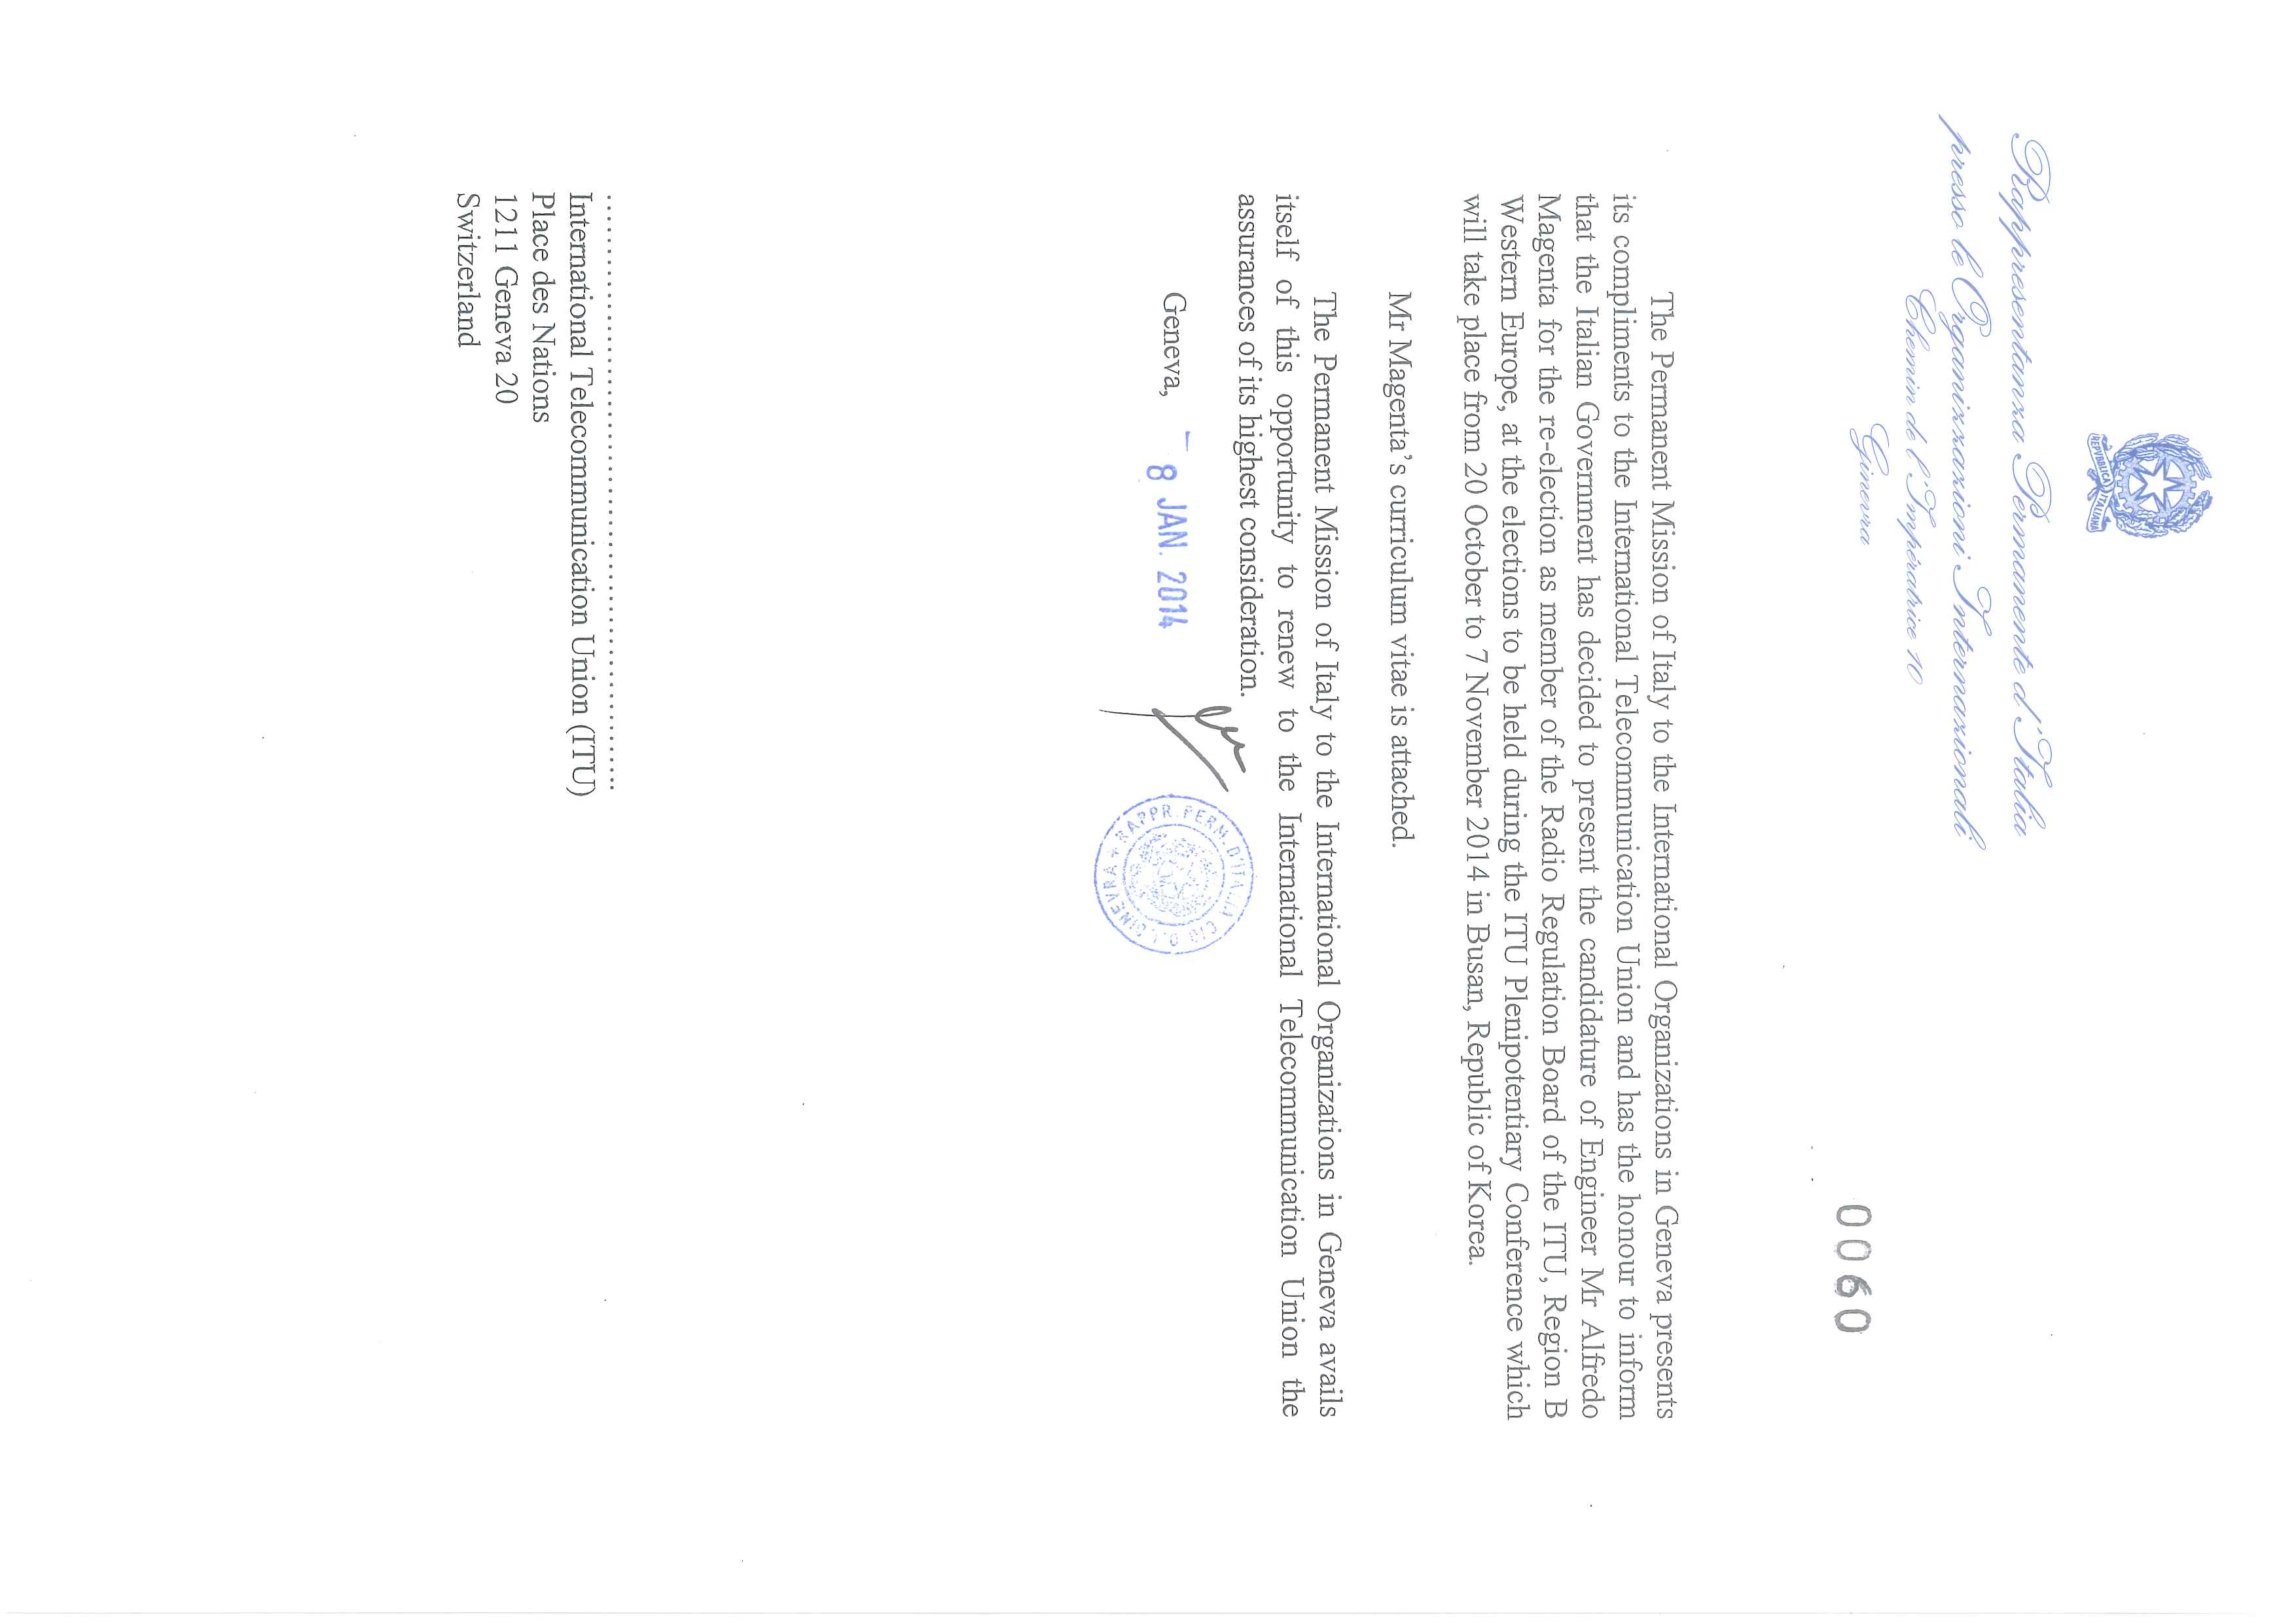

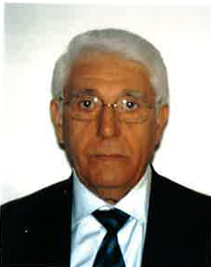 **CURRICULUM VITAE**

**NAME:**

Dr. Ing. **Alfredo MAGENTA**

Born in Giovinazzo (Bari), Italy, on July, 16, 1939

*Nationality*: Italian

*Address:* Via Prato della Signora,15, 00199 Rome, Italy

**STUDIES:**

|  |  |
| --- | --- |
| **1958:** | Graduated at the High School for classical studies "Matteo Spinelli" in Giovinazzo. |
| **1963:** | Degree in Electronic Engineering at "Politecnico" in Turin. |
|  | Title of the thesis: "Equalizers for telephone lines". |

**COURSES AND SPECIALIZATIONS:**

|  |  |
| --- | --- |
| **1968:** | Honeywell Course on "BASIC" programming |
| **1969:** | Honeywell Course on "FORTRAN" programming |
| **1972:** | IFAP (Institute for education of state-owned company managers) Course on "Personnel management |
| **1973:** | IFAP Course on "Teams and relations in company organization"; |
| **1974:** | IFAP Course on "New electronic technologies"; |
| **1976:** | "International Seminar on Safety of electrical equipment"; |
| **1977:** | IFAP Course on "Integrated management training"; |
| **1978:** | "Seminar on the techniques of personnel selection"; |
| **1980:** | "World Conference of Amateur radio operators (EDX)"; |
| **1983:** | "Third Conference on antennas and propagation - ICAP 83-" organized by IEEE and URSI; |
| **1986:** | IFAP Course on "Negotiation"; |
| **1993:** | Course at "Residence di Ripetta", Rome, on "Creativeness"; |
| **1994:** | Course at "Reiss Romoli", L'Aquila, on "Cost accounting". |

**Languages:**

|  |  |
| --- | --- |
| **French:** | Excellent |
| **English:** | very good |
| **Spanish:** | very good |
| **Italian:** | mother tongue |

**Experience:**

|  |  |
| --- | --- |
| **1964:** | joined the RAI |
| **1964-65:** | scholarship holder at the Engineering Department in Turin - Building Division. |
| **1966-71:** | Engineering Department in Turin: Employed as Chief Engineer of the Design, Installation and Testing Division for Medium and Long Waves transmitters, remote signalling, remote controls and automation of equipment for Medium Waves, Feeders, Dog Houses, Self-radiating Antennas for Medium Waves. |
| **1971-87:** | RAI Engineering Department in Rome: Chief Engineer of the Short Wave Division, charged with the Maintenance and Design of the technical upgrading of the Short Wave transmitting station. |
| **1979:** | Appointed responsible for the Short Wave transmitting station. |
| **1987-91:** | RAI Engineering Department in Rome, International Technical Relations Division: responsible for: International Technical Procedures and Standardizations. |
| **1992-1998:**  **1999-2012:**  **2009- …:** | appointed Head of the "International Technical Relations" Division.  Consultant to RAI  Member of “Accademia delle Scienze” of the‘Repubblica di San Marino’ |

**Didactic Activities:**

|  |  |
| --- | --- |
| **1973-77:** | Charged to hold courses on "MF-HF Antennas and Propagation" to engineers of RAI's transmitting centres. |
| **1978:** | Charged to hold sessions on "Radio Engineering" to engineers attending post-degree courses at "Instituto Superiore delle Poste e Telecomunicazioni" of the Italian Administration |

**International activities:**

|  |  |
| --- | --- |
| **1979-…:** | RAI's representative to the EBU in the field of international broadcasting.  Delegate of the Italian Administration to the ITU Plenipotentiary Conference.  Delegate of the Italian Administration to the ITU World Radiocommunication Conference.  Delegate of the Italian Administration to ITU-R. |

**Special tasks:**

* Member, in his quality of broadcasting expert, of the Italian Delegation, headed by Mr Palleschi, Under-Secretary of State, charged to ascertain the feasibility of the TV network in Somalia (1982).
* Coordinator of the RAI technical delegation in Somalia (1983).
* Member of ISPELS Working Group charged to fix the dosimeter methods and the exposure standards for the prevention against risks and damages of electromagnetic fields on personnel (1985).
* Vice Chairman of ITU-R National Study Group 3 (1986-1989).
* Member of CEI (Comitato Elettrotecnico Italiano) Board of Directors (1989-1992).
* Convenor of CEPT ECP (European Common Proposal) on the allotment of frequency bands to the HF broadcasting service at the ITU World Administrative Radiocommunication Conference in Malaga-Torremolinos (WARC-92).
* Delegate of the Italian Administration to the ITU-R Radio Assemblies (RA) and the ITU World Radiocommunication Conferences in 1984 (HFBC/1), 1987 (HFBC/2), 1988 (ORB-88), 1992 (WARC-92), 1993 (WRC-93) 1997 (WRC-97), 2000 (WRC-00), 2003 (WRC-03).
* Delegate of the Italian Administration to the ITU-R Radio Assembly (RA) in all RA from 1991 to 2007.
* Delegate of the Italian Administration to the ITU Plenipotentiary Conferences in 1989, 1992, 1994 and 2008.
* Coordinator on “Workshop and Seminars on Multimedia Convergence“ of ITU-T and speaker on “Interactivity in Multimedia” (12 March 2002).
* Promoter and Coordinator of ITU-R “High-Definition Progress Report and Demonstration” in Geneva, (5 October 2005).
* Deputy Head of Italian Delegation to ITU-R RA-2007
* Delegate of RRB at ITU World Radiocommunication Conferences (WRC-2012)

**ITU-R Chairmanships**

* Chairman of Sub-Working Party 3A-2 charged with the revision of Recommendation 240 "Protection ratios" (1985)
* Chairman of Sub-Working Party 10A-1 charged with the revision of Report 80 on the Antennas (1987)
* Chairman of Sub-Working Party 6N-6 charged with the revision of Resolution 63 "Computer-aided ionospheric prediction" (1988)
* Vice-Chairman of Working Party 10A "Sound broadcasting of frequencies below 30 MHz and sound broadcasting in the Tropical Zone” (1991-1994)
* Chairman of Working Party 10D "Transmitting and receiving antennas for sound broadcasting" (1994)
* Chairman of Study Group 10 "Broadcasting Service (Sound)" (1995-2000)
* Chairman of Study Group 6 “Broadcasting Service” (2000-2003) and (2003-2007).
* Vice-Chairman of Radio Advisory Group (RAG) (2007-2011)
* Member of Radio Regulations Board (RRB) (2011-2015)

Registered in the rolls of freelance journalists on 26 January 1987.

**PUBLISHED WORKS**

"Determinazione di volumi endoventricolari mediante una nuova metodica ecocardiografica", excerpt from the XXXVIII Congresso della Società Italiana di cardiologia (June 1977)

"Contributo alla valutazione ecocardiografica dei volumi endoventricolari sinistri con l'applicazione della geometria sferica", excerpt from the XXXIX Congresso della Società Italiana di cardiologia (October 1978)

"Radiodiffusione ad Onde Corte - stazioni a terra o satelliti?", Poste e Telecomunicazioni nello sviluppo della Società No 1/1980

"Esercitazioni di Radiotecnica", text used at the "Istituto Superiore di Specializzazione in Telecomunicazioni", published by the Italian Administration (June 1982)

"E MUF, E Layer cut-off frequency, F MUF, E-mode and F-mode fieldstrenght calculation using a programmable pocket calculator", Proceedings of the ITU IWP 6/12 (September 1982)

"Onde Corte: Problemi tecnico-organizzativi all'esame della CAMR 84", Poste e Telecomunicazioni nello sviluppo della Società No 1/1984

"Onda Corta: Conferenza Mondiale", Poste e Telecomunicazioni nello sviluppo della Società No 6/1984

"Measured radiations patterns of mono and multiband antennas", Proceedings of the ITU IWP/10/1 (June 1985)

"Diagrammi di Antenne", Poste e Telecomunicazioni nello sviluppo della Società No 5/1985

"Cos'è la televisione ad alta definizione”, DOMANI Elettronica, Informatica, Automazione, Telecomunicazione (No 9/ September 1986)

"Diagrammi di irradiazione di antenne per Onde Medie - Verifica e misure con elicottero", Poste e Telecomunicazioni nello sviluppo della Società No 4/1987

"Le Telecomunicazioni e i loro riflessi sociali", Poste e Telecomunicazioni nello sviluppo della Società No 1/1989.

“Exposure to E.M. Fields of the Medium Waves Broadcasting”, La COMUNICAZIONE 2005-Volume LIV.

“The Transition from Analogue to Digital Television”, ITU News Commemorative Edition N° 3 April 2006

“La migrazione da Analogico a Digitale”, Nuova Armonia N° 4 – Ottobre 2007

“Telecommunications and Broadcasting in Medium Waves with DRM”, La Comunicazione - Numero Unico –Anno 2012 - Volume LVIII

“The future of digital Radio with the DRM+ broadcasting System”, ITU NEWS N° 5 June – July 2013

Regularly contributes to the column "ATTIVITA' INTERNAZIONALE nell'ambito della Diffusione Radiotelevisiva", published in the review ELETTRONICA E TELECOMUNICAZIONI.

Writes for local newspapers and for GLOBAL PRESS news agency.

Technical editor of the quarterly review "Speciale Telecomunicazioni".

Wrote the texts of his didactic activity, still used by the Italian Administration for training.

Ge. 27/10/2013

______________________