Plenipotentiary Conference (PP-14)
Busan, 20 October – 7 November 2014
PLENARY MEETING | Document 17-E
 | 28 November 2013
 | Original: English
Note by the Secretary-General
CANDIDACY FOR THE POST OF MEMBER OF
THE RADIO REGULATIONS BOARD
Further to the information published in Document 3, I have pleasure in transmitting to the Conference, in annex, the candidacy of:
Mr Ilham AFANDIYEV (Republic of Azerbaijan)
for the post of member of the Radio Regulations Board.

Dr Hamadoun I. TOURÉ
Secretary-General

Annex: 1

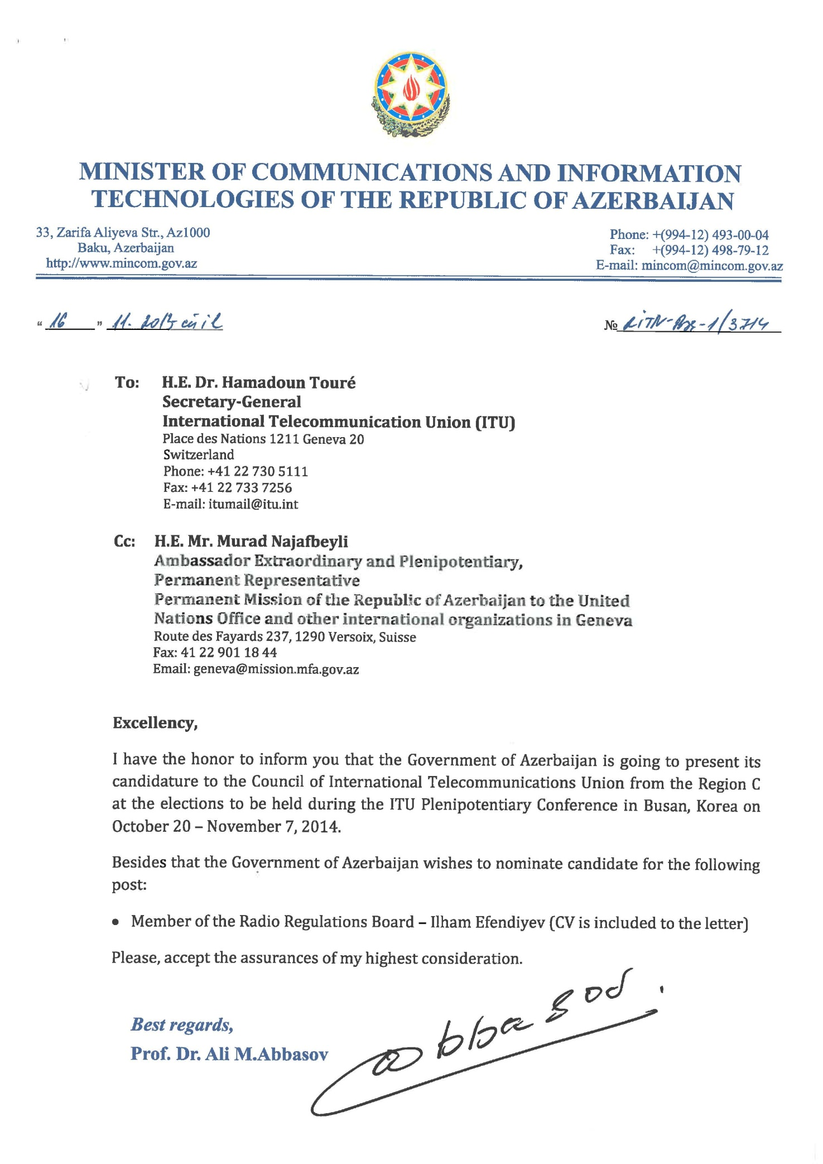

CURRICULUM VITAE
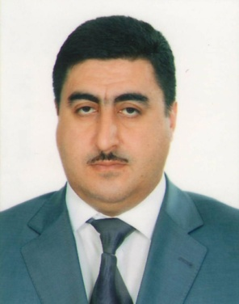
Personal Information:
Name, Surname: Ilham Afandiyev
Date of birth: April 10, 1973
Place of birth: Qutqashen (Qabala), Azerbaijan
Nationality: Azerbaijan
Marital status: Married
Address: 29 Q, U.Akbarov Str., Baku, Azerbaijan
Telephone: +994 12 4987949; +994 50 2114431
Fax: +994 12 598 4843
E-mail: ilham@dri.az
ilham.afandiyev@gmail.com (PE)
Education:
1990-1995: The Faculty of Radio Technique of the Azerbaijan Technical University of Azerbaijan Republic
Military service:
1993-1995 Lieutenant
Work experience:
2006 - Present: Technical Director of State Management of Radiofrequencies
2004-2006: Head of the Technical Department of Teleradio Production Union.
2000-2004: Engineer of Technical Department of Teleradio Production Union.
1998-2000: The 11th grade engineer at the Radio broadcasting enterprise of Teleradio Production Union.
1995-1998: Head of laboratory of the Radio Technical Department of the Technical University of Azerbaijan
Seminars and Workshops:
October 2003 Islamic Republic of Iran – Radio-TV broadcasting coordination meeting
2003 Turkey – Introducing with the Radio control systems in the Aselsan Company
2005 Islamic Republic of Iran – Radio-TV broadcasting coordination meeting
June 2005 Italy – receiving test of Radio-TV transmitters in the “Elettronika” Plant
May 2006 Geneva – WRC -06 DVB-T plan
November 2006 Republic of Korea – Digital Broadcasting Course
June 2007 China – Radio and television management seminar
September 2007 Ukraine – seminar for the mobile operators
2007 Georgia – Radio-TV coordination meeting
2008 Georgia – GSM coordination meeting
2008 Germany – Introducing with the Radiocontrol Systems in the Rohde& Schwarz
December 2008 Geneva – World Radiocommunication Conference
December 2008 Geneva – Participation in the 2008 World Radiocommunication Seminar
June 2009 Iran – GSM network coordination meeting
September 2009 Russia – GSM network coordination meeting
August 2009 Estonia – Dream-On-Demand Seminar of DVB-T
2009 Kazakhstan – meeting related with the coordination of satellite networks
2010 Ukraine – meeting related with the coordination of satellite networks
2010 Georgia – Radio-TV coordination meeting
2011 Switzerland – Second Session of the 2011 Conference Preparatory meeting
2012 Switzerland – in the ITU meeting on the frequency assignment for LTE technology
2012 Switzerland – the ITU Joint Task Group 4-5-6-7
2013 USA – TCI Spectrum Management Factory Acceptance
2013 Switzerland – JTG Group meeting
Computer skills:
Windows 97 - 2007, ATDI(ICS), SR-4, Visual GSO and other special software
Spoken Language(s):
English - good
Russian - fluent
Azerbaijani – native
Awards and achievements:
Master of the Azerbaijan State National Aviation Academy.
Author of several scientific articles and the teaching book named – “The measurements in the Radio-television broadcasting”.
Candidate of a degree of Azerbaijan Technical University.
In 2007 he was awarded the name of “Rabita Ustasi”.
Honored engineer since 2011 of the Republic of Azerbaijan.

