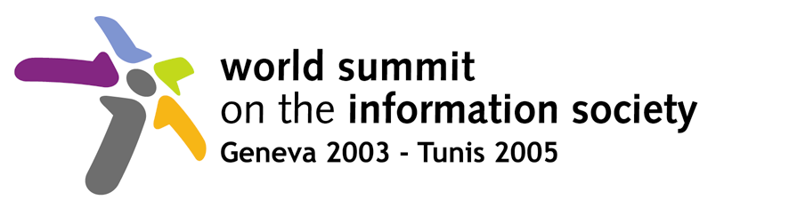 | 

Document WSIS/PC-2/CONTR/119-E
19 February 2003
English only
United Nations Industrial Development Organization (UNIDO)


UNITED NATIONS INDUSTRIAL DEVELOPMENT ORGANIZATION (UNIDO)

Contribution to the World Summit on the Information Society (WSIS)

UNIDO wishes to draw attention to the needs of a part of the information society, i.e. small and medium-sized enterprises or SMEs, whose growth may determine the success of efforts to support other parts of that society.

In this respect, UNIDO feels that an important outcome of the WSIS should be some concrete and practical ways that the Millennium Development Goals can be achieved through the use of information and communication technologies (ICTs). Of particular interest to UNIDO in the context of this Summit are ways to achieve real long-term sustainable poverty reduction.

At the outset, it is important to realize that the only way to reduce poverty in a sustainable way is to promote economic growth, through wealth and employment creation. In developing countries, SMEs are the major source of income, a breeding ground for entrepreneurs and a provider of employment. In order for SMEs to prosper, grow and be competitive, they require a supportive environment that provides easy unencumbered access to capital, information, technology, knowledge and skills. The adoption and adaptation of information and communication technologies (ICTs) can have a profound effect on the delivery of these resources.

The same logic can be applied to enterprises of all sizes in rural areas and the use of multipurpose rural telecentres. By providing fee-based information and communication services through the telecentres to rural enterprises, it is possible to subsidize, and thus sustain, their use for other purposes such as for schools, local communities and medical centres. UNIDO’s work in the field of renewable energy application in remote grid-disconnected rural communities may also be helpful in providing energy sources that could be used to power telecentres on a renewable basis.

A large area of the work of UNIDO is devoted to removing the many constraints that SMEs face in developing countries and particularly in the least-developed countries. In this respect, UNIDO has a number of programmes and initiatives underway that directly or indirectly are concerned with the use and diffusion of ICTs for development. These are typically in the area of providing support to the growth and competitiveness of SMEs in the emerging global economy. Examples are: clustering or networking of SMEs; provision of business support services; building up national capacities to meet the information and support service needs of SMEs in a sustainable way; linking SMEs into e-business relationships in national and global supply chains, including the provision of necessary e-services for e-security and e-trust; building up national SME support services, such as investment promotion services; promoting the use of ICT in SMEs; and training in the use of ICTs for business. With particular reference to international supply chains, the needs of transnational corporations (TNCs) need to be taken into account. TNCs now select their suppliers not only according to price and quality but also include social and environmental criteria in their supply chain standards or codes of conduct. The challenge is to improve social and environmental performance of suppliers in developing countries without increasing their costs.

UNIDO’s focus is thus on building up local capacities of industry to identify, adopt and use applications of ICT to make their work more effective and efficient. As important, is the recognition that the benefit of ICT is really the benefit of the information or knowledge (i.e. content) that is made available via ICT. In other words, development outcomes will be more determined by knowledge and learning capacity than by investment in physical capital alone.

UNIDO has thus already amassed a large body of practical experience in developing countries of what is required to make such interventions work. As part of our global forum work, we are also researching into the effect of ICTs in the creation of manufacturing value.
UNIDO is also promoting the use of Technology Foresight as an important policy-making instrument to determine the medium and long-term development objectives that might have an impact for a country’s prosperity and progress. Technology Foresight enables governments to set in place effective mechanisms for the continuous assessment and monitoring of technology development and application. These mechanisms are crucial, both for the formulation of national strategic development policies as well as for the identification of competitive and innovative initiatives for the role of the indigenous industries and organizations.
For these reasons, UNIDO believes that the Summit should:

- Recommend that Governments promote an enabling ICT environment for SMEs, including access to e-services to support digital certification of e-business
- Recommend that Governments start e-procurement programmes for their own procurement activities with a specific focus on national SMEs
- Recommend that TNCs actively pursue supply chains for SMEs in developing countries and join in the efforts of international organizations to provide support programmes to assist SMEs
- Recommend that TNCs develop a framework for Small Business Responsibility that takes account of the specific characteristics of SMEs in developing countries in their Corporate Social Responsibility
- Recommend that SMEs in developing countries be encouraged to take advantage of opportunities provided by ICTs, including the use of ICTs at firm level activity and by becoming e-ready for e-business.

