 | 
Document WSIS/PC-2/CONTR/55-E
Paris, December XX, 2002
20 December 2002
English only
The GLOBAL e-SUSTAINABILITY INITIATIVE (GeSI)
Business, UNEP and the ITU working in Partnership
and WWF

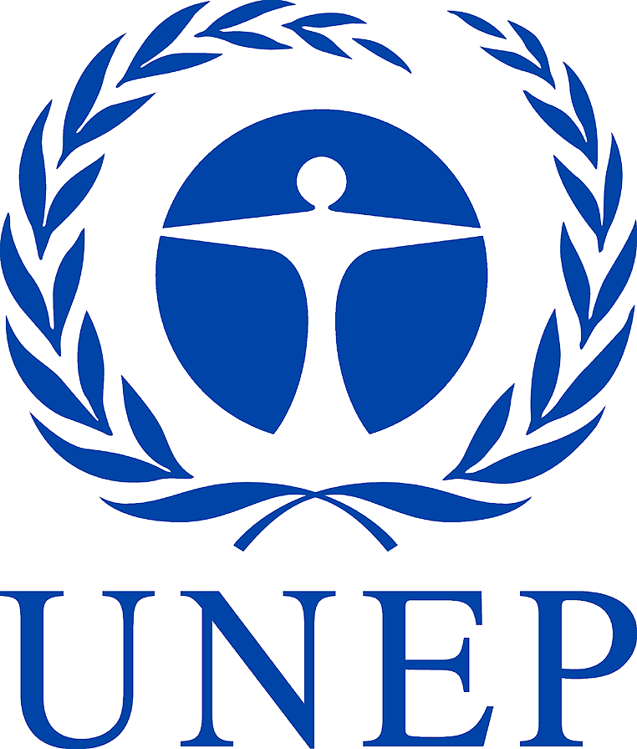 | 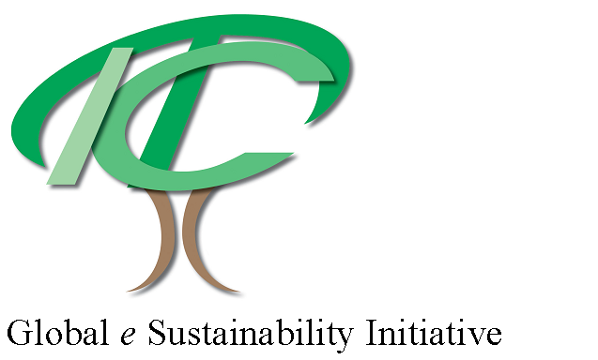 |  | 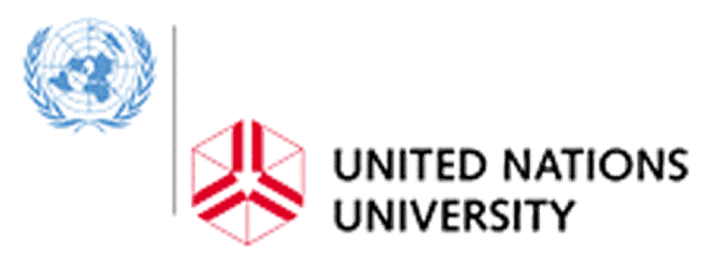 | 

Executive Summary

The Global e-Sustainability Initiative (GeSI) is an Initiative of information and communications technology (ICT) companies to improve the global environment and support sustainable development by promoting business practices and technologies that save energy, minimise waste and help bridge the Digital Divide. GeSI is supported by the United Nations Environment Programme (UNEP) and the International Telecommunications Union (ITU).

WWF is an international and independent conservation organisation. WWF s mission is to stop the degradation of the planet's natural environment and to build a future in which humans live in harmony with nature, by:
- Conserving the world's biological diversity.
- Ensuring that the use of renewable natural resources is sustainable.
- Promoting the reduction of pollution and wasteful consumption.

This contribution puts forward a series of issues that should be reflected in the WSIS summit Declaration and Plan of Action.

Increasing population, economic activity and consumptive lifestyles are placing unsustainable burdens on the earth's natural systems and finite resources. Creating prosperity through much less wasteful and harmful use of resources has been identified as the over-arching sustainable development challenge.

Enhanced connectivity enables people to transact businesses from home, saving commuting time, energy and pollution from transportation. Trends in ICT towards miniaturization of components, and its capacity to monitor resource and energy use through production processes, can greatly reduce environmental and economic costs. Mobile networks are allowing whole phases of 'hard-wired' infrastructure development to be 'leapfrogged' in many parts of the world."

We suggest that it is essential for the WSIS to consider the Sustainability Implications of the Knowledge Society. In particular we suggest that the environmental dimension has not yet been given sufficient weight alongside the social and economic dimensions.

This proposal is therefore for sustainable development to be explicitly included in the Declaration of Principles and the Plan of Action to be adopted by the World Summit on the Information Society

The key elements of this contribution to WSIS address the following themes:

Sustainability Implications of the Knowledge Society (new theme)

International Cooperation

Opening the Gates and Overcoming the Digital Divide

Services and Applications

Section A Introduction

Increased economic activity has been a dominant feature of the last century.

The global economy is driven by a staggering $22 trillion worth of annual consumption which has doubled in just 25 years. This growth has been supported by a 12-fold increase in world trade since 1945, and a rapid increase in foreign direct investment, which in recent years has been the largest source of financial flow to many countries in the developing world.

Whilst the global economy has boomed, the UN reports that over a billion people are still deprived of basic needs, living on less than $1 a day, and that a further 100 million in the industrial world are relatively impoverished. The state of the environment has worsened: - the climate has noticeably changed, half the world’s original forest cover has disappeared and overall the Earth’s ecosystems are degrading at about 3% a year.

There is certainly no shortage of financial wealth to address these social and environmental problems. However, two factors in particular frustrate such efforts. Firstly, wealth is unequally distributed – in a recent survey, the world’s 225 richest individuals had a combined wealth of over $1 trillion; equal to the annual income of the world’s poorest 47% - 2.5 billion people. Secondly, today’s markets do not encourage investments that provide a return over the longer term.

Economic prosperity is clearly a condition for sustainable development. According to the UN statement following the ‘Rio+5’ event in 1997:-

“Economic development, social development, and environmental protection are interdependent and mutually reinforcing components of sustainable development. Sustained economic growth is essential to the economic and social development of all countries, in particular developing countries”.

However, there is a need to exercise greater discrimination between those patterns of economic growth, which promote sustainable development, and those that exacerbate the current problems. It is becoming increasingly apparent that economic growth per se can no longer comprise our overarching developmental goal, particularly in the rich parts of the world.

Kofi Annan in his introductory comments to the WSIS web site observes "[i]f harnessed and directed properly, Information and Communication Technologies (ICTs) have the potential to improve all aspects of our social, economic and cultural life. ICTs can serve as an engine for development in the 21st century, and as an effective instrument to help us achieve all the goals of the Millennium Declaration."

There can be no doubt that we are on the cusp of a new revolution - moving from the industrial age to the knowledge age. In this transition we must ensure two things: firstly, that all can benefit; secondly, that we make this transition in a way that creates the basis for a sustainable society. These aims are of paramount importance. Unless they are both meaningfully embraced, the introduction of ICT threatens to result in a worsening - rather than reversal - of current negative trends.

Section B Contribution to WSIS Prepcom-2 and Summit

Principles and themes of the Declaration and Plan of Action

B.1
The ICT industry’s contribution to sustainable development can only reach its full potential within the right policy framework. The transformational characteristics of ICT are often best demonstrated and developed through application. Companies and governments throughout the world and at all stages of economic development are encouraged to apply the technologies to help achieve their sustainability goals.

Our proposal is therefore that:

- The WSIS ensure that the final summit outputs and recommendations are supportive of sustainable development and build on the work carried out during the World Summit on Sustainable Development held in 2002. In particular we would like to see that the environmental dimension is given sufficient weight alongside the social and economic dimensions.

We would also like the final Plan of Action to:

- Ask all relevant international financial institutions (WTO, WB, IMF, the regional development banks [including EIB], ECAs, etc) to develop, and by 2005, present a strategy for the use of ICT as an engine for sustainable development in the 21st century, and as an effective instrument to help us achieve all the goals of the Millennium Declaration.

- Recommend to Governments and the private sector by 2003 they explore, and by 2005 implement, different instruments that can help to extract the maximum social and economic benefits from ICT and speed the development of sustainability applications throughout society.

- State that countries, at all stages of economic development , should recognize ICT as an integral component of sustainable development strategies, not merely as a valuable industry in its own right;

- Encourage Governments to aim for harmonization of standards and a regulatory framework that support sustainable development through the application of ICT;

B.2 Proposed New Theme: Sustainability Implications of the Knowledge Society

ICT has unique attributes that can help to break the link between economic development and resource depletion. The industry aims to be the key tool for decreasing mass flow without sacrificing the standard of living in developed countries; while in developing economies helping to improve the quality of life with minimal input of material and energy.

Action(s)
For WSIS PrepCom –2, the process leading up to and at the WSIS Summit we propose:

1. A series of round tables discussing the overarching sustainability implications of ICT. This will cut across a number of WSIS themes especially: ICT for development, infrastructure development, access to information, enabling regulatory and policy framework and ICT applications.

- Workshops/skill-shares on:

- ICT and reduced energy-use
- ICT and reduced material-use (dematerialization and phase-out of toxic materials)
- ICT and reduced land-use
- ICT and business strategies for sustainable development in a knowledge society
- ICT and a policy framework for sustainable development in a knowledge society
- E-waste
- ICT and transport policy
- Application of renewable energy technologies to ICT infrastructure in rural locations
- E-Learning for Sustainability

3. A working group/task force that will work on ICTs contribution to sustainability. One important task for such a group would be to collect examples of ICT-systems/products/applications that can be seen as examples of sustainable leap-frogging for the Summit in 2003.

Section C Background to Contributors

GeSI
GeSI, the Global e-sustainability Initiative, is an initiative of information and communications technology (ICT) companies to improve the global environment and support sustainable development by promoting business practices and technologies that save energy, minimise waste and help bridge the Digital Divide. GeSI is an alliance that is unique in that it involves both telecommunications operators and suppliers.

GeSI is supported by the United Nations Environment Programme (UNEP) and the International Telecommunications Union (ITU) and has 14 members. GeSI was launched on 5 June 2001 during the World Environment Day in Turin, Italy.

As a collective voice, the members of the GeSI will help to influence policies of government, inform the public of its voluntary role in lowering the impact of development, and enjoy the rewards of promoting technology that fosters sustainable development. GeSI members aim to:

● Create an open and global forum for improving and promoting products, services and access to ICT for the benefit of human development and a sustainable environment.
● Stimulate international and multi-stakeholder co-operation for the ICT sector.
● Gradually adopt a full corporate social responsibility agenda, starting from environmental issues.
● Encourage companies in developing countries to join and share benefits of the initiative.
● Promote and support partner regional initiatives and liaise with other international activities.
● Promote and support greater awareness, accountability and transparency

Current GeSI members: AT&T, Bell Canada, British Telecommunications plc, Cable & Wireless, Deutsche Telekom AG, Ericsson, European Telecommunication Network Operators Association (ETNO), Marconi, Telcordia Technologies Inc., Telstra Corporation Ltd., Vodafone plc, Asia Pacific Satellite, MM02 and Telefonica SA.

Contacts:
Ms. Ama Dadson  Coordinator,  GeSI Secretariat  c/o UNEP Division of Technology,  Industry and Economics  39-43, quai André Citroën  75739 Paris Cedex 15 France  Tel: +33.1.44.37.16.23  Fax: +33.1.44.37.14.74  E-mail: gesi@unep.fr | GeSI Chair  Dr. Chris Tuppen,  BT Centre  PP B6  81 Newgate Street  London, EC1A 7AJ  UK

WWF
WWF is an international and independent conservation organisation. WWF's mission is to stop the degradation of the planet's natural environment and to build a future in which humans live in harmony with nature, by:

- Conserving the world's biological diversity.
- Ensuring that the use of renewable natural resources is sustainable.
- Promoting the reduction of pollution and wasteful consumption.

With almost five million supporters distributed throughout five continents, WWF has over 28 National Organizations, 24 Programme Offices and 4 Associates, and can safely claim to have played a major role in the evolution of the international conservation movement

Since its inception in 1961, WWF has worked to conserve nature and ecological processes through a combination of action on the ground, national and international advocacy work to establish appropriate policies, and international campaigns to highlight and demonstrate solutions to crucial environmental problems.

In 2002 WWF launched a new publication ” Sustainability at the Speed of Light”(Available at www.panda.org/ict). The report is a contribution from WWF to the discussion about ICT in tomorrow's society. Some of the best experts in the world to contributed with a chapter in which they describe the role of ICT for Sustainable Development in their respective fields.

For example, ICT can be used to save energy through remote energy management of commercial and residential buildings. Similarly, ICT can curb the rapid growth of transportation and business travel through commerce over the Internet and wider use of videoconferences. The study also demonstrates that ICT can help conservation work, by more efficient monitoring of land use, or satellite tracking of illegal logging, among other things. In order to focus and get actual concrete results, the WWF report further presents seven strategic areas - including ICT products, transport of goods, and changes in production and consumption patterns - where progress is needed.
The report is an attempt to bridge the gap between the ICT experts and the policy makers in both politics and business. It is WWFs firm belief that these groups, together with the rest of society, need to talk more frequently and openly to each other if we want to create a sustainable framework for the ICT-development.

Contacts:
Gordon Shepherd  Director, International Policy  WWF International | Dennis Pamlin  Global Policy Advisor  WWF Sweden  dennis.pamlin@wwf.se or pamlin@telia.com

UNEP DTIE
For the past several years, UNEP has been active in a Renewable Energy Enterprise Development (REED) initiative that combines enterprise development support with early stage financing to create small and medium sized enterprises capable of providing energy services to rural users in five African countries, Brazil and China. The REED approach is technology neutral--the financing and enterprise development mechanisms that have been developed can, with appropriate modifications, is replicated to support the deployment of other technologies, such as ICTs, in rural areas.

GRID-Arendal
As a specific follow-up to the recommendations of the 1987 World Commission on Environment and Development, the Government of Norway and the United Nations Environment Programme (UNEP) established an environmental information centre in Arendal, Norway. Set up as a foundation under Norwegian legislation, the centre was linked to the worldwide UNEP programme termed Global Resource Information Database and was therefore called a GRID centre. GRID-Arendal was opened by the Norwegian Prime Minister on August 22, 1989.

GRID brings its experiences from 5 years of operation of the global Green Internet : UNEPnet/Mercure, and the capacity building experiences from the ENRIN project in Eastern Europe.

Contacts
Svein Tveitdal  Managing Director GRID-Arendal  Longum Park  Service Box 706  N-4808 Arendal  Norway  Tel : + 4737035701  Fax : + 47 307035050  E-mail : Tveitdal@grida.no  Website: http://www.grida.no | Harald Holt  Director UNU-GVU / Deputy Director GRID-Arendal  Longum Park  Service Box 706  N-4808 Arendal  Norway  Tel : + 4737035701  Fax : + 47 307035050  E-mail : Holt@grida.no  Website: http://www.grida.no

United Nations University (UNU)
The United Nations University initiated a Virtual University project at the Institute of Advanced Studies in 1996. In 1998, with the establishment of the Virtual University Media and Technology Laboratory (VULAB) at the University, the project shifted from an emphasis on conceptual research to focus on the development of key online teaching technologies. From 2002 onwards, content development and consortium building became the core activity and strategic partnerships are in the process of being developed with various international organizations, NGOs and universities in order to promote online learning.

The "Information Technology and Environmental Issues" at UNU Centre started in 2001 and is devoted to research and dissemination of assessment and management of environmental implications of IT, focusing on energy issues.

UNU have published on a range of topics, including environmental impacts of production of microchips, environmental comparison of conventional retail and e-commerce, and end-of-life management of computers.

Contacts
Eric Williams  Fellow  Environment and Sustainable Development Programme  United Nations University  53-70 Jingumae 5-chome, Shibuya-ku, Tokyo, Japan 150-8925  Tel: +81-3-3499-1352  Fax: +81-3-3499-2828  Email: Williams@hq.unu.edu | Brendan Barrett  Fellow  Institute of Advanced Studies  United Nations University  53-67 Jingumae 5-chome, Shibuya-ku, Tokyo 150-8304  Tel: +81-3-5467-2817  Fax: +81-3-5467-2324  Email: barrett@ias.unu.edu

UNEP Further analysis of the potential of technological innovation, to achieve, in one generation, a ten-fold increase in the efficiency of use of energy, natural resources and other materials, is available in UNEP's GEO-2000 Report at www1.unep.org/geo-text/0028.htm

