CANDIDACY FOR THE POST OF DEPUTY SECRETARY-GENERAL
INTERNATIONAL TELECOMMUNICATION UNION
 | PLENIPOTENTIARY  CONFERENCE (PP-02) |  | Document 6-E
 | PLENIPOTENTIARY  CONFERENCE (PP-02) |  | 22 November 2001
 | PLENIPOTENTIARY  CONFERENCE (PP-02) |  | Original: English
MARRAKESH, 23 SEPTEMBER - 18 OCTOBER 2002

PLENARY MEETING
Note by the Secretary-General
Further to the information contained in Document 3, I have pleasure in transmitting to the Conference, in annex, the candidacy of:
Mr Roberto BLOIS MONTES DE SOUZA (Federative Republic of Brazil)
for the post of Deputy Secretary-General of the International Telecommunication Union.

Yoshio UTSUMI
Secretary-General

Annex: 1
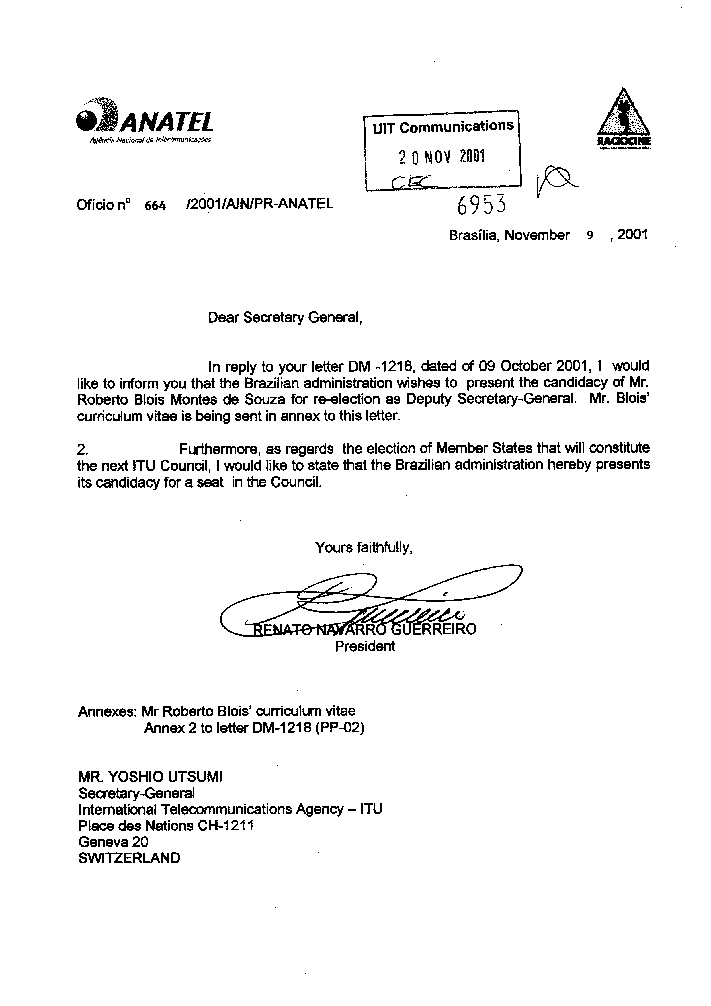
CURRICULUM VITAE

A. GENERAL INFORMATION  Name : Roberto Blois Montes de Souza  Nationality : Brazilian  Date of birth : 10 November, 1950  Place of birth : Rio de Janeiro, Brazil  B. EDUCATION  1974 : Electronics/Telecommunications Engineer  University of Brasilia. | 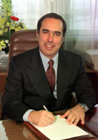
C. PROFESSIONAL EXPERIENCE
From February 1999 : Deputy Secretary-General of the International Telecommunication Union (ITU)
The ITU is the specialized agency of the United Nations system in charge of establishing the global framework for international telecommunications. In this capacity, the ITU brings governments and industry together to coordinate the establishment and operation of global telecommunication networks and services; it is responsible for standardization, coordination and development of international telecommunications including radiocommunications (terrestrial and space), as well as the harmonization of national policies.
1994 - 1999: Executive Secretary of Inter-American Telecommunication Commission - (CITEL) of the Organization of American States - (OAS).
CITEL is the specialized agency of the Organization of American States responsible for all activities related to telecommunications.
1990 - 1994 : Director of the Department of Private Telecommunication Services, Ministry of Communications of Brazil.
Responsible for the establishment of the policy, regulations and planning of all telecommunication services (space and terrestrial) that can be provided by the private sector, including broadcasting, paging, trunking, mobile services, MMDS and cable TV among others.
1987 - 1990 : Director of the National Telecommunication Department, Ministry of Communications of Brazil.
Responsible for all matters related to the authorization and licensing of telecommunication stations in Brazil, including spectrum management, equipment certification, radiomonitoring and the enforcement of the telecommunication regulations.
Also responsible for the orientation and supervision of all activities of the regional offices of the Ministry (one in each state of Brazil).
1979 - 1987 : Director of Broadcasting of the National Telecommunications Department, Ministry of Communications of Brazil.
Responsible for all legal and technical matters related to the authorization and licensing of broadcasting stations in Brazil.
1974 - 1979 : Engineer, Broadcasting Services Secretariat, Ministry of Communications of Brazil.
D. OTHER ACTIVITIES
1991 - 1993 : Representative of Brazil in the Permanent Executive Committee of the Interamerican Telecommunication Commission (CITEL) of the Organization of American States (OAS).
1990 - 1993 : Representative of Brazil in the Administrative Council of the International Telecommunication Union (ITU).
1987 - 1990 : Member of the Administrative Council of the Telephone Company of São Paulo.
1990 - 1993 : Chairman of the Administrative Council of the Telephone Company of Rio de Janeiro, São Paulo and Pelotas (Rio Grande do Sul), Brazil.
1975 - 1994 : As Representative of Brazil, participated in various meetings of the International Telecommunication Union (ITU), including Plenipotentiary Conferences, World and Regional Radiocommunication Conferences, Development Conferences, Council, groups of experts and world and regional fora of the ITU, and of the Interamerican Telecommunication Commission - (CITEL), having acted as head of the Brazilian Delegation on many occasions.
E. OTHER INFORMATION
Lecturer in various national and international policy, planning and technical seminars/workshops. (Some of these papers have been published).
Mr. Blois was distinguished with the Order of Merit of Communications by the President of Brazil in 1984 and was named Honorary Member of the Brazilian Air Force by the Ministry of the Air Force in 1991.

______________

