INTERNATIONAL TELECOMMUNICATION UNION
 | PLENIPOTENTIARY  CONFERENCE (PP-02) |  | Addendum 6 to  Document 5-E
 | PLENIPOTENTIARY  CONFERENCE (PP-02) |  | 12 March 2002
 | PLENIPOTENTIARY  CONFERENCE (PP-02) |  | Original: English
MARRAKESH, 23 SEPTEMBER - 18 OCTOBER 2002
PLENARY MEETING
Note by the Secretary-General
candidacy for the post of member
of the radio regulations board
Further to the information contained in Document 3, I have pleasure in transmitting to the Conference, in annex, the candidacy of:
Mr Momcilo R. SIMIC (Yugoslavia (Federal Republic of))
for the post of member of the Radio Regulations Board.

Yoshio UTSUMI
Secretary-General

Annex: 1

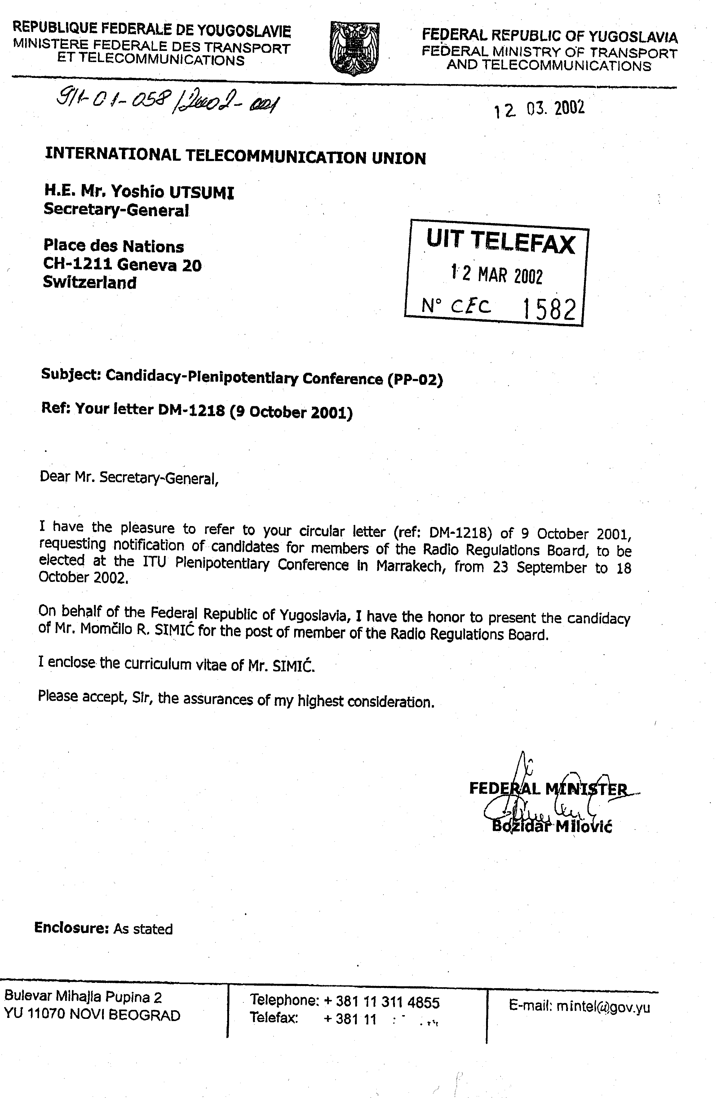
momcilo r. simic
yugoslav candidate for the post of member of
the Radio regulations board
CURRICULUM VITAE

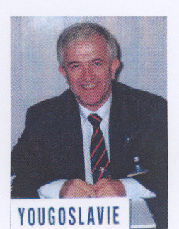

Personal
Family name: Simic
First name: Momcilo
Date of birth: 21 October 1944
Marital status: Married, two grown sons
Nationality: Yugoslav
Language: Serbian (mother tongue), English and French

Education
− Bachelor of Science Degree, Faculty of Electrical Engineering, Belgrade University;
− Several specialized courses on computer programming, software engineering and office systems.

Professional Experience
1992 - present Department Director, RTV of Serbia (RTS)
1990 - 1992 Assistant Director, Development and Frequency Planning, RTS
1987 - 1990 Assistant Director, Research and Development, RTB
1982 - 1987 Director, MF Transmitters, RTB
1976 - 1982 Chief Engineer, Development and Frequency Planning, RTB
1973 - 1976 Senior Engineer, Development and Frequency Planning RTB
1969 - 1973 Engineer, MF Transmitters, RTB

Other Professional Activities

1 International Activities

1.1 ITU
Mr Simic has been participating in the ITU activities for more than 25 years, mainly in ITU-R (CCIR) and partly in ITU-D. He is/was appointed as:
− Special Rapporteur SRG 10 A3
− Special Rapporteur SRG 10 D1
− Special Rapporteur SRG 9
− Rapporteur SG 6
Mr Simic participated in many ITU conferences and meetings, including those mentioned below:
− WARC HFBC 84
− WARC HFBC 87
− WARC 1992 (Coordinator for Europe and Africa "Satellite Sound Broadcasting, 1.5 GHz");
− WRC 1995;
− WRC 1997;
− WRC 2000;
− CCIR Plenary Assembly 1986;
− CCIR Plenary Assembly 1990, as well as in many SGs, TGs, WPs, etc.

1.2 EBU (European Broadcasting Union)
Mr Simic started his participation in EBU 1974 (WP A). He was:
− Chairman - DG R1/AMDS (AM Data System)
− Member - WP A
− Member - Sub-group R1 (Terrestrial Sound Broadcasting)
− Member - WP R/HF (HF Broadcasting)
− Member - Sub-group R1/HF (HF Broadcasting)
− Member - WP R/RDS (Radio Data System); Mr Simic received Special tribute 1992.
As expert for frequency management, Mr Simic was involved in the resolution of an international problem and received a special letter of thanks from EBU, as well as from the country concerned.

1.3 IEC (International Electrical Commission)
− Member - Sub-Committee No. 12 (Transmitting equipment)

1.4 Other International Organizations
− Chairman - European Committee of "TESLA WARDENCLIFFE PROJECT, INC.- USA"
− Ex officio member of the Executive Board of the Tesla Memorial Society - USA
− Frequency manager in High Frequency Coordination Conference (HFCC)

1.5 Regional level
− Chairman of the Session "General Principle of Cooperation" at the Third Meeting of Ministers Responsible for Telecommunications and Posts of the States of South-East Europe;
− Member of the Coordination Bureau of the Ministerial Meetings for Telecommunications and Posts of the States of South-East Europe.

2 National level
Mr Simic started his professional activities (out from his company) in 1971. He was a member or chairman of many expert groups, commissions, committees within different national organizations, associations and institutions, including those mentioned below:

2.1 SZS (Federal Institute for Standardization)
− Chairman - Commission for Transmitting equipment

2.2 JNK (Yugoslav National CCIR Committee)
− Chairman - SG 10

2.3 JRT (Yugoslav Radio-Television)
− Chairman - Commission for Transmitters and Communications
− Chairman - WP RDS
− Chairman - WP AM Broadcasting
− Chairman - WP New Techniques and Technologies
− Member - Technical Committee
− Member - Commission of the Executive Council YRT for satellite broadcasting.
Mr Simic received a special award of JRT for International technical cooperation and assistance to the LDC, as Project Leader and Expert Team Leader (1985).

2.4 Other activities
− Member - Program Committee of Telecommunication Forum (TELFOR)
− Member - Program Committee of International Conference on Telecommunications in Modern Satellite, Cable and Broadcasting Services (TELSIKS)
− Member - Program Committee of (JUZEL)
− Member - Yugoslav delegation for International Frequency Coordination
− Secretary - Organizing Committee of RDS Symposium
− Member - Federal Commission for the Broadcasting Law
− Chairman - RTS Expert Group for the Broadcasting Law.

Professional Publications
Mr Simic has written many professional papers. Some of the more significant papers are listed below:
1. "Determination of the electric field strength in the near field zone of high-power LF/MF antennas"
Co-author, CCIR Doc. 1/147 June 1989, CCIR Report 1117 (1990)
2. "Radio Data System"
Author, BONAC Technical Committee, Nicosia, April 1989
1. "AM Data System - Perspectives for the development of an international standard"
Author, Proceedings of ITU/EBU RDS Conference, Sofia, June 1993
2. "RDS Paging"
Author, TELSIKS 93, Nis, October 1993
3. "A MF transmitting with alternative cardioidal or non-directional radiation pattern"
Co-author, ETRAN, XL Conference, Budva, June 1996
4. "The Role of the ITU in Setting Broadcasting Standards"
Co-author, TELSIKS 97, Nis October 1997
5. "Coupled Horizontal Dipole Antennas above a Conducting Half-Space"
Co-author, International Symposium - EMC, Rome, September 1998
6. "EM Field in the Vicinity of Transmitting Mast Antennas Located on a Conducting Half-Space"
Co-author, International Symposium - EMC, Rome, September 1998
7. "Development Trend and Perspective of the Sound Broadcasting in 21st Century"
Author, TELSIKS 99, Nis, October 1999

Summary
Mr Simic has great experience in the frequency management (national and international level), as well as in the applications of the new techniques and technologies.
He is the recipient of many special prizes for technical solutions and applications, including the following:
− Annual Prize of Radio Belgrade for "Technical solution for improvement of loudness area of the Radio Belgrade Programs" - Belgrade, 1981.
− Annual Prize of Radio Belgrade for "Advancement of the Transmitting Techniques for Sound Broadcasting" - Belgrade, 1988.
− Annual Prize of RTV of Serbia for "The scientific work in the telecommunications" (sharing with Academicians, Prof. Dr J. Surutka and Prof. Dr A. Djordjevic) - Belgrade, 1998.
His professional and cooperative approach is greatly appreciated by all of his colleagues in the ITU.

__________

