INTERNATIONAL TELECOMMUNICATION UNION
 | PLENIPOTENTIARY  CONFERENCE (PP-02) |  | Addendum 5 to  Document 5-E
 | PLENIPOTENTIARY  CONFERENCE (PP-02) |  | 11 February 2002
 | PLENIPOTENTIARY  CONFERENCE (PP-02) |  | Original: English
MARRAKESH, 23 SEPTEMBER - 18 OCTOBER 2002
PLENARY MEETING
Note by the Secretary-General
CANDIDACY FOR THE POST OF MEMBER OF
THE RADIO REGULATIONS BOARD

Further to the information contained in Document 3, I have pleasure in transmitting to the Conference, in annex, the following candidacy for the post of member of the Radio Regulations Board:
Mr Gabor KOVACS (Republic of Hungary)

Yoshio UTSUMI
Secretary-General

Annex: 1
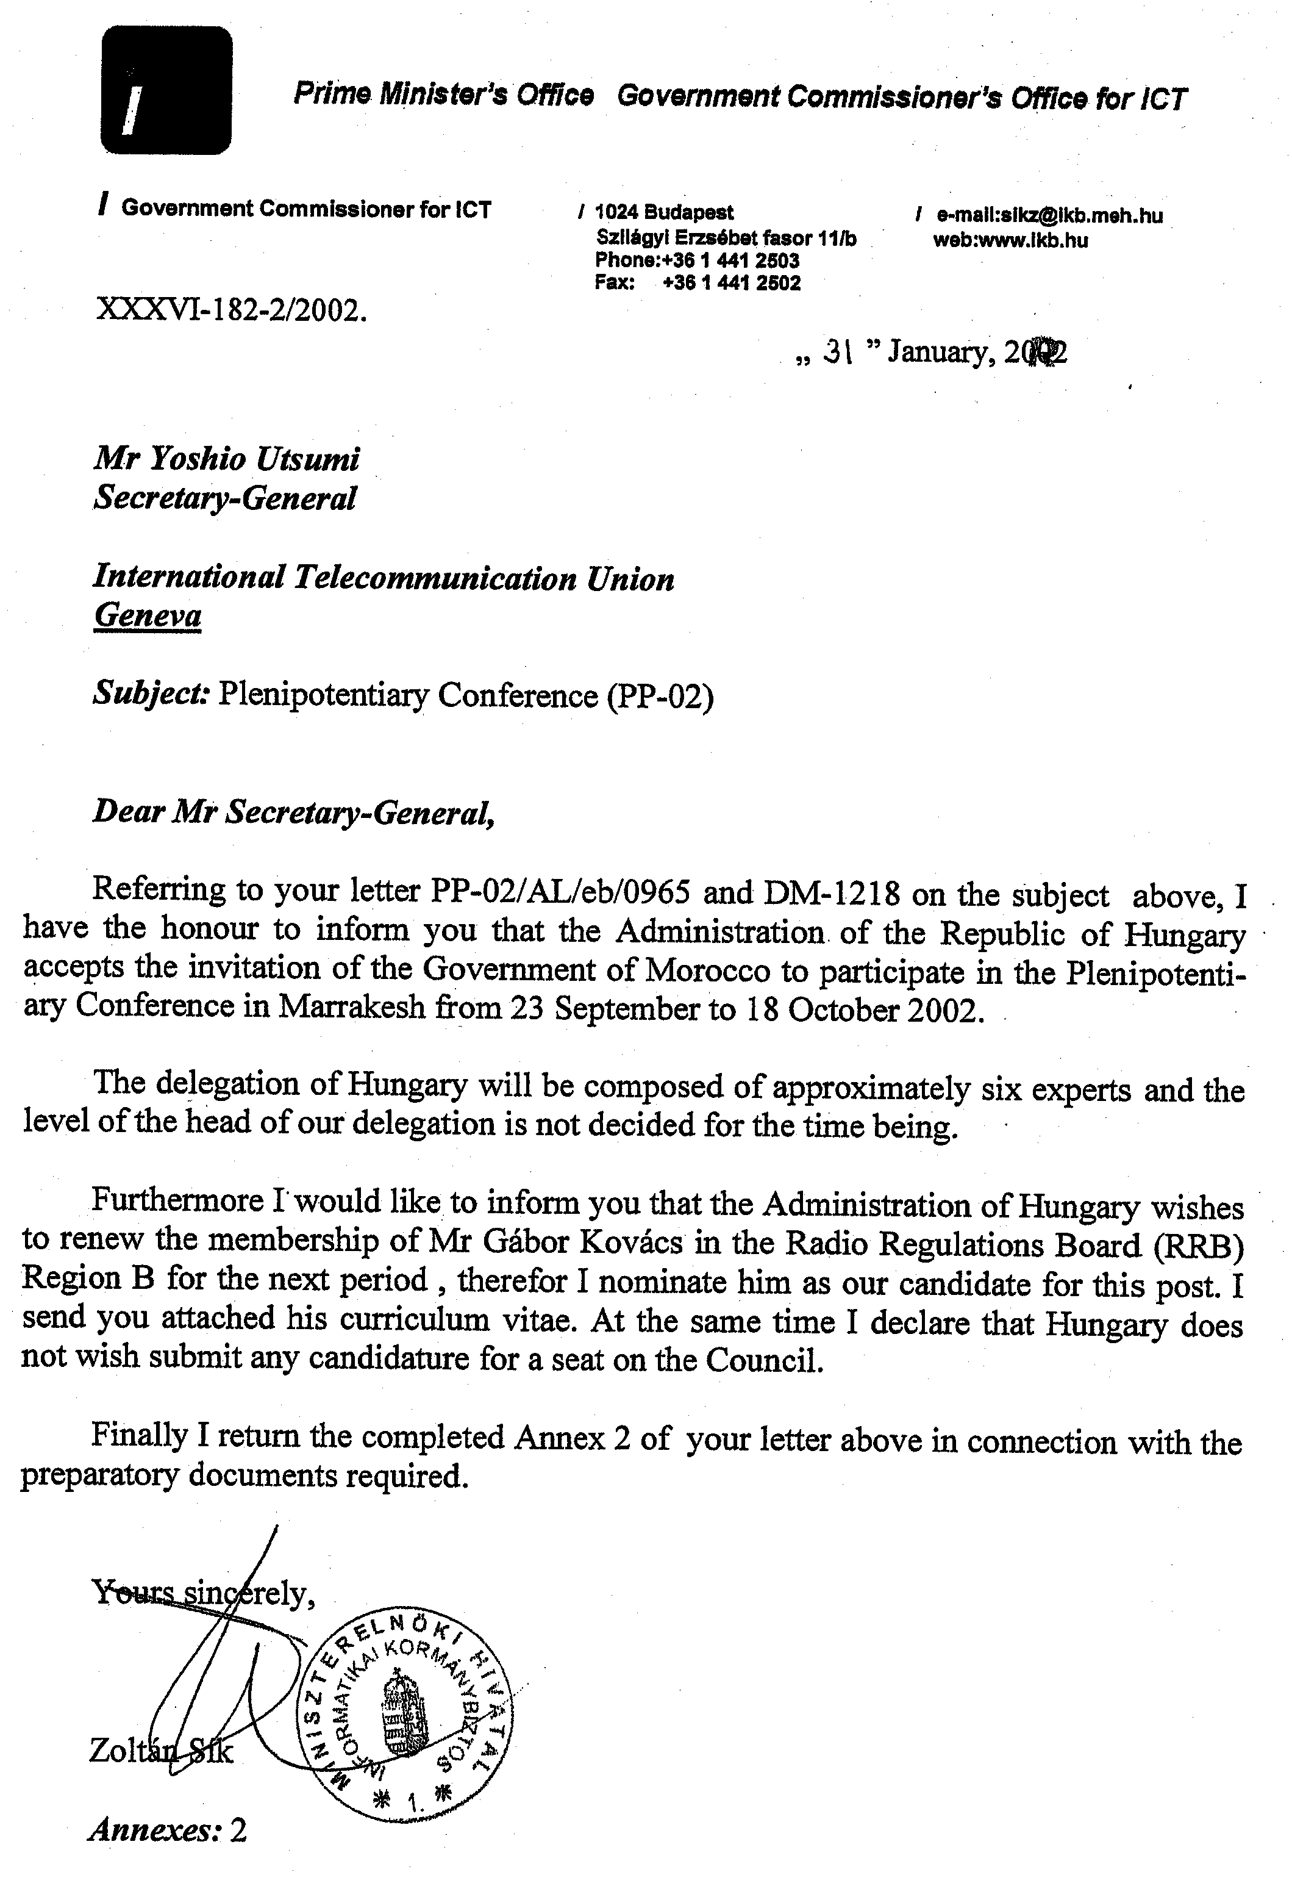
CURRICULUM VITAE of
Mr. Gabor KOVACS

Personal:  Date of birth: 12 March 1938  Marital status: Married  Children: Two grown up children  Nationality: Hungarian  Languages: French, English, Spanish, Hungarian (mother tongue) | 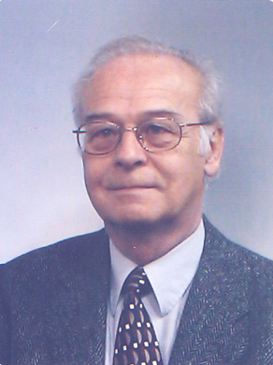

Studies:
1952-1956: Secondary School, Maturity
1956-1961: Technical University, Budapest, Diploma of electrical engineer
1970: Technical Doctor degree, Budapest
Several computer programming and management courses in the ITU

Professional experience:
1961-1970 Hungarian PTT
1961-1965: Technical Directorate of Radio and TV Broadcasting, Hungarian PTT
Engineer, Head of Section, responsible for Hungarian microwave links for TV programme distribution and multi-channel telephony
1965-1967: Technical High School (Instituto Osvaldo Herrera) Havana, Cuba
lecturer on TV broadcasting and microwave techniques
1967-1970: Technical Development Department, General Directorate of Hungarian PTT
chief engineer, responsible for development of TV and microwave networks
1967-1970: Technical University of Budapest
scientific research engineer (part-time), participation in research on colour television standards and equipment
1970-1977 ITU (IFRB)
1970-1977: International Frequency Registration Board (IFRB)
engineer, responsible for technical examinations, Conference preparation (MAR-74, MF-BC-75, BC-SAT-77), Technical Standards and Rules of Procedure
1977-1982: General Directorate of the Hungarian PTT
1977-1982: Frequency Management Division of the General Directorate of Hungarian PTT
Head of Division, responsible for Hungarian frequency management activities (broadcasting, fixed and mobile, space), frequency spectrum planning, establishment of national frequency regulations, international coordination, supervision of the Hungarian Frequency Management Office, national preparation for ITU Conferences and CCIR meetings
1982-1998: ITU (IFRB/BR)
International Frequency Registration Board (IFRB) and from March 1993:
Radiocommunication Bureau (BR)
1982-1987: Head of Division, responsible for terrestrial Fixed and Mobile Services Division
1987-1990: Head of Division, responsible for Space Services Division
1989-1990: Acting Head of the Regulatory and Engineering Department
1990-1998: Head of Department, responsible for the Space Services Department (until March 1998, when retired due to statutory age limitation)
Major achievements in relation to the above duties:
• direction and organisation of the work of the terrestrial and space services divisions and, after its establishment, the Space Services Department;
• responsible for major Conference preparatory and post-conference activities (MOB-83, HFBC-84/85, MOB-87, ORB-88, WARC-92, WRC-93, WRC-95, WRC-97, RARC-85);
• responsible for the general revisions of the Rules of Procedures and Technical Standards (1983-85 and 1995);
• responsible for the establishment of the IFRB Finding System (1983);
• responsible for the development of technical assistance procedures (RR1218) for the HF FX service (1985);
• preparation of the IFRB Handbook on Radio Regulatory Procedures (1987);
• user representation and coordination of the establishment and reformatting of the BR space relating data base (Space Network System);
• development of several internal BR procedures for the application of regulatory and technical provisions;
• responsible for the ITU-R Sector activities concerning Resolution 18 (PP-94);
• responsible for all space related activities of the BR in relation to the Radio Regulations Board (RRB).
1998 to date:
Member of the Presidential Advisory Board in the Hungarian Communication Authority
1998 November:
Elected by the ITU Plenipotentiary Conference as a Member of the Radio Regulations Board.
1999 to date:
Member of the Radio Regulations Board of the ITU

International activities:
ITU Conferences: Participation in almost all World Radiocommunication Conferences between 1975 and 2000, in particular:
• Chairman of the Technical Committee of the Conference WARC-1978
• Head of the Hungarian Delegation at CCIR Plenary Assembly (Kyoto, 1978)
• Secretary of Committees (C4, C5) of WARCs and RARCs between 1983 and 1995
• Spokesman of BR at WRC-97 (Committee 4, Resolution 18).

Radio Regulations Board:
Member of the Board elected to serve in the period 1999 to 2002.

CCIR and ITU-R:
Participation in Study Group activities (as national delegate and IFRB/BR representative) between 1968-1998 (SGs 1, 2, 4, 8, 10, 11).

Regional Coordination Activities:
On behalf of the Hungarian Administration: Central European Terrestrial Mobile Agreements, Coordinated Plans for TV networks, Coordination of Frequency Allocation Tables, ITU Conference Preparations.
As IFRB Representative at meetings of CITEL, EBU, INTERPOL, CEPT.

IFRB/BR Seminars:
Participation as lecturer or session chairman in almost all Seminars between 1975 and 1996.

United Nations (UN):
• ITU representative in the UN Committee on Peaceful Uses of Outer Space (COPUOS) and its Legal Sub-Committee between 1991-1997 (New York, Vienna);
• Chairman of the United Nations Inter-Agency meeting on Outer Space Activities (1993);
Several other missions giving lectures (as IFRB/BR representative):
Arab States Frequency Management Seminar (Tunis, 1985), Spectrum 20 (Montreal, 1989), Regional Seminar (Praia, Cape Verde, 1991), UN Workshop on Space Communications (Athens, 1993), European Workshop on GSO Orbit Studies (Brussels, 1993), Asia-Pacific Cable & Satellite Summit (Hong Kong, 1994), URSI - Com-Sphere (Eilat, Israel, 1995).

_________________

