INTERNATIONAL TELECOMMUNICATION UNION
 | PLENIPOTENTIARY  CONFERENCE (PP-02) |  | Addendum 3 to  Document 5-E
 | PLENIPOTENTIARY  CONFERENCE (PP-02) |  | 24 January 2002
 | PLENIPOTENTIARY  CONFERENCE (PP-02) |  | Original: English
MARRAKESH, 23 SEPTEMBER - 18 OCTOBER 2002

PLENARY MEETING
Note by the Secretary-General
CANDIDACY FOR THE POST OF MEMBER OF
THE RADIO REGULATIONS BOARD

Further to the information contained in Document 3, I have pleasure in transmitting to the Conference, in annex, the following candidacy for the post of member of the Radio Regulations Board:
Mr James R. CARROLL (United States of America)

Yoshio UTSUMI
Secretary-General

Annex: 1
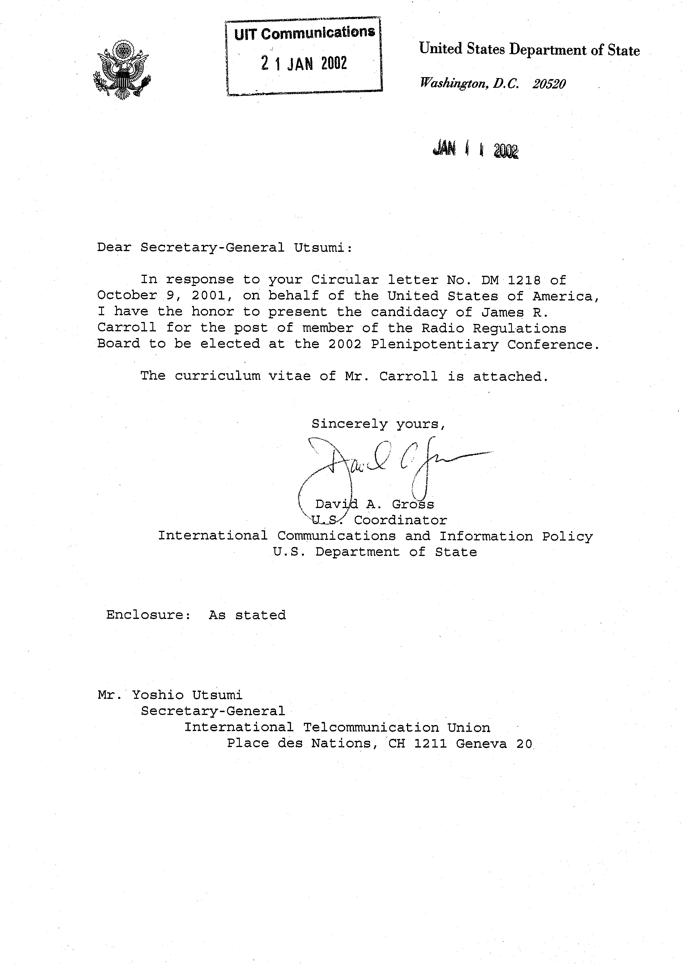
CURRICULUM VITAE
of
JAMES R. CARROLL

PERSONAL
Date of birth: 18 April 1931
Marital status: Married
Children: Three grown children, one son deceased
Nationality: U.S. Citizen
Place of birth: St. Paul, Minnesota, USA
Language: English

EDUCATION
Master of Science, Telecommunications Operations, The George Washington University, Washington, DC, 1980
Bachelor in General Studies, with distinction, The George Washington University (GWU), Washington, DC, 1978

Honours
• Alpha Sigma Lambda National Honour Society

Related studies
• Telecommunications Policy, Principles and Techniques: GWU School of Engineering and Applied Science
• International Law Agreements, Organizations, and Telecommunications Issues: NTIA
• International Negotiations: Department of State

PROFESSIONAL EXPERIENCE
April 1998 to present Consultant, Telecommunications Policy, Plans, Regulations and Procedures. Member of the Radio Regulations Board.
Dec. 1986 - March 1998 Program Director, Telecommunications Policy, Regulations and Procedures, SFA Inc., Largo, MD.
1986-2002 Member, Department of State International Telecommunication Advisory Committee (ITAC) and the ITAC Radiocommunication Sector National Committee.
1993-1998 Vice-Chairman, Federal Communications Commission Advisory Committee working groups preparing for WRC-95, and WRC-97.
1992-2002 Member, NTIA Radio Communication Subcommittee preparing for WRC-95, WRC-97, WRC-2000, WRC-03.
1984-1986 Project Manager, Telecommunications Strategic Plans and Policies, National Telecommunications and Information Administration (NTIA), Department of Commerce, Washington, DC.
• Chaired Inter-Agency Group and developed the first Federal Government Long-Range Plan for Management and Use of the Radio-Frequency Spectrum.
• Directed NTIA Spectrum Efficiency Task Group and prepared report entitled Development of a Methodology for Improved Use of the Electromagnetic Spectrum by Federal Agencies.
1974-1984 Communications Manager, Naval Electromagnetic Spectrum Center, Naval Telecommunications Command Headquarters, Washington, DC.
• Served as Special Assistant on international spectrum management activities and conferences
• Directed below 30 MHz Branch
• Preparations for WARC HFBC (Geneva, 1984)
• Preparations for WARC Maritime Mobile (Geneva, 1983)
• Preparations for WARC (Geneva, 1979)
• Preparations for WARC Aeronautical (Geneva, 1977)
1968-1974 Communications Manager, Naval Communications Station, Washington, DC and Defense Communications Station Cheltenham.

INTERNATIONAL ACTIVITIES
Mr Carroll is Chairman of the Radio Regulations Board for 2002 and was elected Vice-Chairman in 2000. He has served as a member of the Board since being elected at the Minneapolis Plenipotentiary Conference, 1998.
Mr Carroll has served as U.S. delegate and spokesman to numerous international conferences and meetings for satellite, fixed, maritime, mobile and aeronautical matters including those highlighted below.
• ITU
• Plenipotentiary Conference, Minneapolis, United States 1998
• Plenipotentiary Conference, Kyoto, Japan, 1994
• ITU Council Working Group for Satellite Notification Cost Recovery (SNCR) Geneva, January and June 1999
• ITU Council June 2000
• Radio Regulations Board (RRB)
• Attended all meetings of the Board, 1999, 2000, 2001, 2002.
• ITU-R Radio Conferences
• WRC-2000 (Istanbul, 2000, Member RRB)
• Radiocommunication Assembly (Istanbul, 2000, Member RRB)
• WRC-97 WRC-95, WRC-93 (Geneva)
• CPM-99, CPM-97, CPM-96, CPM-95 (Geneva)
• Radiocommunication Assembly (RA) (Geneva, 1995)
• Radiocommunication Assembly (Geneva, 1993)
• WARC-92 (Malaga-Torremolinos, 1992)
• CCIR JIWP for WARC-92 (Geneva, 1991)
• CCIR IWP/15 (other Study Group 8 WARC-92 matters) (Helsinki, Finland, 1990)
• World Administrative Radio Conference for the Mobile Services (Geneva, 1987) (WARC-MOB-87)
• Regional Administrative Radio Conference, Region 2 MF Broadcasting (Rio de Janeiro, Brazil, November-December 1981)
• Regional Administrative Radio Conference, Region 2 MF Broadcasting (Buenos Aires, Argentina, March 1980)
• Radio Region 1 and 3 Regional Administrative LF/MF Broadcasting Conference, (Geneva, October-November 1975), U.S. Special Team
• ITU-R special committees
• Radiocommunication Advisory Group (RAG) (Geneva, 1995, 1996, 1998, 1999, 2001)
• Special Committee for Regulatory and Procedural Matters (Geneva, 1996, 1997, 1999)
• Voluntary Group of Experts (VGE) for simplifying the Radio Regulations for treatment at WRC-95. Meetings in Geneva included VGE-5 in March 1993; VGE-6 in October 1993; and VGE-7 (final) in February-March 1994
• International Frequency Registration Board (IFRB) Seminar (Geneva, October 1978). Conducted Seminar on Geostationary Satellites and Frequency Management
• ITU-R study groups
• SG 8/WP 8B/8D 9 (Geneva 2001)
• Study Group 1, WPs 1A, B, C, TG 1/4 (Munich, Germany, 1998)
• SG 8/WPs 8B/8D (Geneva, 1997)
• WPs 8B/8D (Geneva, 1996)
• JWP 7-8/R (Geneva, 1996)
• TG 8/3 (Mobile-satellite service) (Geneva, Switzerland and Toronto, Canada, November and July 1994)
• TG 4/5 (Mobile-satellite service feeder links) (Washington, DC and Geneva, Switzerland, June and November 1994)
• TG 2/2 (Sharing between radio services) (Geneva, January/February, September, and December 1994)
• WPs 8B, 8C, 8D (Aeronautical and maritime services, radiolocation, mobile-satellite) (Geneva, December 1994 and October 1993)
• TG 12/4 (Radio service sharing) (Geneva, April 1993)
• WP 8D (Mobile-satellite) (Tokyo, January-February 1993)
• CCIR Study Group 8 meeting (December 1991)
• CCIR JIWP 10-3-6-8/1 (Sharing, broadcasting, maritime, aeronautical, and amateur radio services) (Geneva, 1990)
• CCIR Study Group 8 (Mobile and mobile-satellite), final meeting (Geneva, 1989)
• CCIR Study Group 8, interim meeting (Geneva, 1988)
• CCIR IWP 8/14 (Technical and operating characteristics in the mobile-satellite service) (Washington, 1988)
• Study Group 8, final meeting, Study Group 3, final meeting, Special Preparatory Meeting (SPM), Study Group 8, for 1983 MWARC (Geneva, 1981)
• Study Group 8, interim meeting (Geneva, 1976)
• Study Group 8, Interim Working Party (IWP) 8/2 (1975).

REGIONAL ACTIVITIES
Mr Carroll has extensive experience as a U.S. delegate and spokesman in regional forums including the following:
• The Organization of American States (OAS) Inter-American Telecommunications Conference (CITEL) PCC III, (Salinas Ecuador 2001), (Ottawa, Canada 2001), (Costa Rica, April 1999), (Lima, Peru, 1998), (Mexico, 1997), (Columbia, 1997), (Mexico, 1996), (Brazil, 1996), PTC III Interim Working Group (Washington, DC, 1991).
• COMCITEL Plenipotentiary Working Group, (Salinas Ecuador, 2001), (Washington DC, USA, 2001) (Lima, Peru, 1998).

SUMMARY
Mr Carroll has vast telecommunication management and operations experience at the national, regional and international levels. His extensive experience spans the entire telecommunication spectrum including regulatory and spectrum management with specialization in the terrestrial and satellite radio services for fixed, mobile, broadcasting, aeronautical mobile, maritime mobile, radiolocation and radionavigation applications.

_______________

