INTERNATIONAL TELECOMMUNICATION UNION
 | PLENIPOTENTIARY  CONFERENCE (PP-02) |  | Addendum 2 to  Document 5-E
 | PLENIPOTENTIARY  CONFERENCE (PP-02) |  | 3 January 2002
 | PLENIPOTENTIARY  CONFERENCE (PP-02) |  | Original: English
MARRAKESH, 23 SEPTEMBER - 18 OCTOBER 2002

PLENARY MEETING
Note by the Secretary-General
CANDIDACY FOR THE POST OF MEMBER OF
THE RADIO REGULATIONS BOARD

Further to the information contained in Document 3, I have pleasure in transmitting to the Conference, in annex, the following candidacy for the post of member of the Radio Regulations Board:
Mr Akhtar Ahmad BAJWA (Pakistan)

Yoshio UTSUMI
Secretary-General

Annex: 1

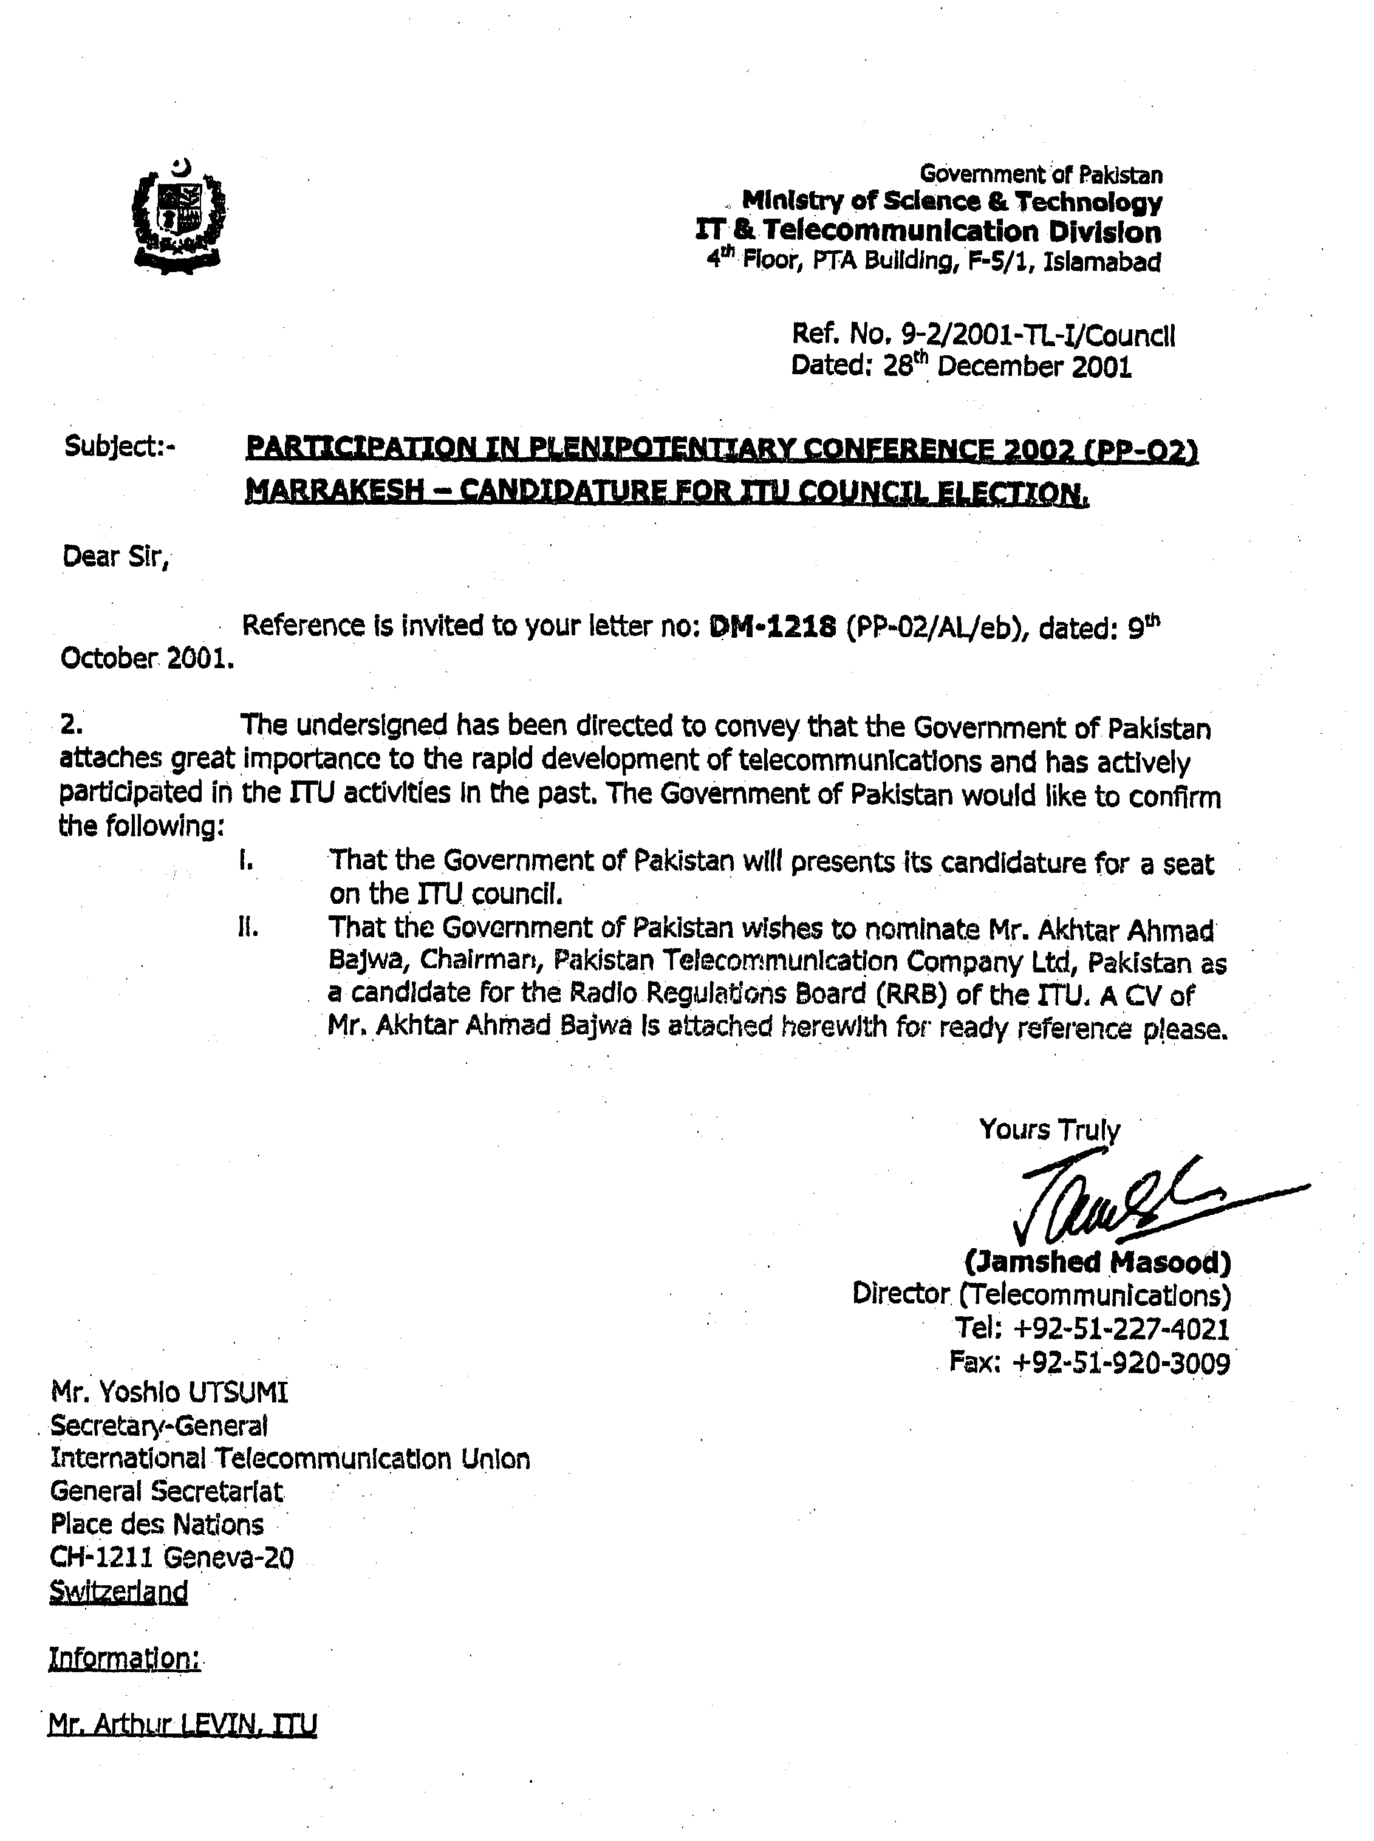

CURRICULUM VITAE

AKHTAR AHMAD BAJWA
CHAIRMAN & CHIEF EXECUTIVE
PAKISTAN TELECOMMUNICATION COMPANY LIMITED
(PAK TELECOM)

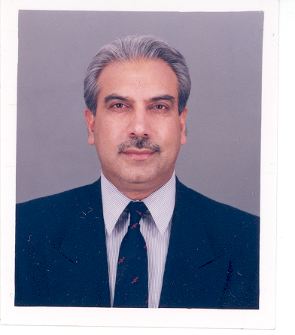

General information
Family Name | BAJWA
First Name | AKHTAR
Nationality | Pakistani
Date of Birth | 20-09-1943
Marital Status | Married with five children
Qualifications | B.Sc. (Hons) in Electrical Engineering from University of Engineering and Technology Lahore - 1964.

Higher management training/courses
• Two years Post Graduate training at PT&T Staff College, Haripur in telecommunications engineering disciplines - 1966-67
• Pakistan Administrative Staff College Higher Management Course
• Special Management System and Methods course for higher management organized by Cabinet Secretariat, Government of Pakistan.

Foreign training
• Satellite communications with German P.T.T. (Deutsche Bundespost) Darmstadt. West Germany - 1968
• Earth station technology with RCA Canada (Montreal) - 1970
• Broadcast satellites communication with ACTIM Paris France - 1983

Affiliations and memberships
• Executive Director of Asia Pacific Satellite Communications Council (APSCC) Seoul, South Korea - 1996-99
• Governor WorldTel Organization, Geneva
• Member IEEE
• Member Pakistan Engineering Council
• Member INSTEP

Languages
English | Speak | Write | Read
German | Speak | Write | Read
French | Speak | Write | Read
Urdu & Punjabi (Mother Tongue) | Speak | Write | Read

Experience in radiocommunications and frequency management
Out of the 35 years of professional career in the field of telecommunications, Mr Bajwa has been involved in the field of radiocommunications for over 20 years with specialization in satellite communications. He has worked in international organizations such as INTELSAT and the Algerian Ministry of Posts & Telecommunications as a Satellite Communication Expert for about nine years. In the area of Frequency Management, he has in the position of Chairman of Pakistan Wireless Board (Frequency Management Regulatory Body of the Ministry of Communications) held the responsibility of regulating frequency allocation, planning frequency management, and licensing of radiocommunications services in Pakistan. He has been involved in the frequency coordination process of PAKSAT satellite project and has been interacting closely with the ITU, INTELSAT, INMARSAT and other international and national organizations/administrations.
Represented Pakistan in several important ITU events like Space Coordination Management of ITU at Geneva in August 2001, ITU Plenipotentiary in 1998 at Minneapolis, USA (wherein Pakistan was elected as Member of the ITU Council) and ITU Frequency Coordination meeting at Geneva in 1995. Attended APT Regional Meetings at Thailand in 1997 and represented Pakistan in the 2nd study group meeting at Bangkok in 1979 and 1980. He has also represented Pakistan in several meetings of the Intelsat Board of Governors, Assembly of Parties and Meetings of Signatories.
He has attended as Pakistan's Governor in the WorldTel organization meetings in Geneva/South Africa.

Professional career
Chairman and Chief Executive Pak Telecom  A state-owned incumbent Telecom Operator with monopoly for provision of basic services including international communication  April 2001 to date | • Responsible for Technical, Operational, Financial and Administrative Management of the Company.  • Overall Management of PTCL subsidiaries i.e. Pakistan Telecom Mobile Limited (PTML), PAKNET (A leading Internet Service Provider), Telephone Industries of Pakistan (TIP) and Carrier Telephone Industries (CTI)  • Advice, Board of Directors as Chief Executive Officer and Chairman, on major strategic initiatives and overall Company policies.
Member operations  Nov. 1999 to April 2001 | • To oversee the maintenance and operations of international and domestic telecom services and associated infrastructure; to develop and implement policy guidelines, in line with the changing technological environment, with a view to ensuring provision of reliable and quality telecom services.
Member technical  Jan. 1998-Nov. 99 | • To formulate and implement company policies for the planning and development of telecom infrastructure in the country to meet the present and projected telecom needs both for domestic and international communication/services.
Director General International Communications  Mar. 1997-Jan. 98 | • Prepare plans for modernization and expansion of all international telecom facilities to meet the present and forecasted international services and traffic demand.  • Coordination with international/regional telecom organizations such as ITU, APT, INTELSAT, INMARSAT, C.T.O., APSCC, etc.  • Provide technical support and establish guidelines for finalizing service agreements with international telecom companies/administrations for technical arrangements, operations, accounting rates and settlement of accounts.
Managing Director TIP  July 1995-Feb. 1997 | • TIP, a manufacture of digital telephone exchanges, telephone sets, energy meters etc., its administrative, financial and technical matters relating to business were carried out as MD TIP.

Chief Engineer International Communications and Chairman Pakistan Wireless Board (Frequency Management Regulatory Body)  Jan. 1992 to July 1995 | • Responsible for planning and development of all overseas telecommunications facilities including satellite earth station, submarine cable system and international gateway exchanges. Also had correspondence with international telecom administrations/companies in matters relating to bilateral agreements, operations, expansions and development of new services.  • Has also been Chairman of the Pakistan Wireless Board, responsible for regulating frequency allocation, planning frequency management and licensing of radiocommunications services in Pakistan.
Deputation to INTELSAT Washington D.C. (1987-1992)
Responsible for testing and approval of Member countries' earth stations and assisting the Signatory Members of INTELSAT in planning and provisioning of INTELSAT satellite capacities for their domestic and international services (telephone, radio, data). The job involved extensive interaction with INTELSAT signatories, representatives and telecom operators of 144 countries as well as managing Engineering and Marketing Divisions within INTELSAT organization.
Project Director/Station Manager  Mallach earth station - 1983-1987 | • Responsible for implementation and management of the project to establish an INTELSAT Standard-A satellite earth station at Mallach, Islamabad to provide international voice, data and video services.
Director Planning Long Distance  1979-83 | • Conducted studies on the short-, mid- and long-term transmission/long-distance traffic requirements for domestic and international communications in the country. Identified and recommended necessary infrastructure requirements to support and meet the traffic demand; also conducted project feasibility and plans.
Deputation to Algerian Ministry of PTT (1975-1979)
Provided technical advice to the Algerian Ministry of Post & Telecommunications in its domestic satellite project (Algerian DOMSAT Project) to provide television and telecommunications coverage to the remote areas of Algeria, in particular, the Great Sahara Area. Coordinated with the American supplier M/s GTE for installation, testing and commissioning of the satellite earth station of DOMSAT Project.
Divisional Engineer Microwave, Satellite and Radiocommunications (1968-75)
Maintained and operated H.F. international and domestic radio links and INTELSAT satellite earth station in Pakistan.
Responsible for execution of the National High Capacity Microwave Backbone Network.
_______________

