INTERNATIONAL TELECOMMUNICATION UNION
 | PLENIPOTENTIARY  CONFERENCE (PP-02) |  | Addendum 15 to  Document 5-E
 | PLENIPOTENTIARY  CONFERENCE (PP-02) |  | 28 August 2002
 | PLENIPOTENTIARY  CONFERENCE (PP-02) |  | Original: English
MARRAKESH, 23 SEPTEMBER - 18 OCTOBER 2002
PLENARY MEETING
Note by the Secretary-General
CANDIDACY FOR THE POST OF MEMBER OF THE RADIO REGULATIONS BOARD
Further to the information contained in Document 3, I have pleasure in transmitting to the conference, in annex, the following candidacy for the post of member of the Radio Regulations Board:
Mr Dubby Douglas MUTESHA (Republic of Zambia).

Yoshio UTSUMI
Secretary-General

Annex: 1
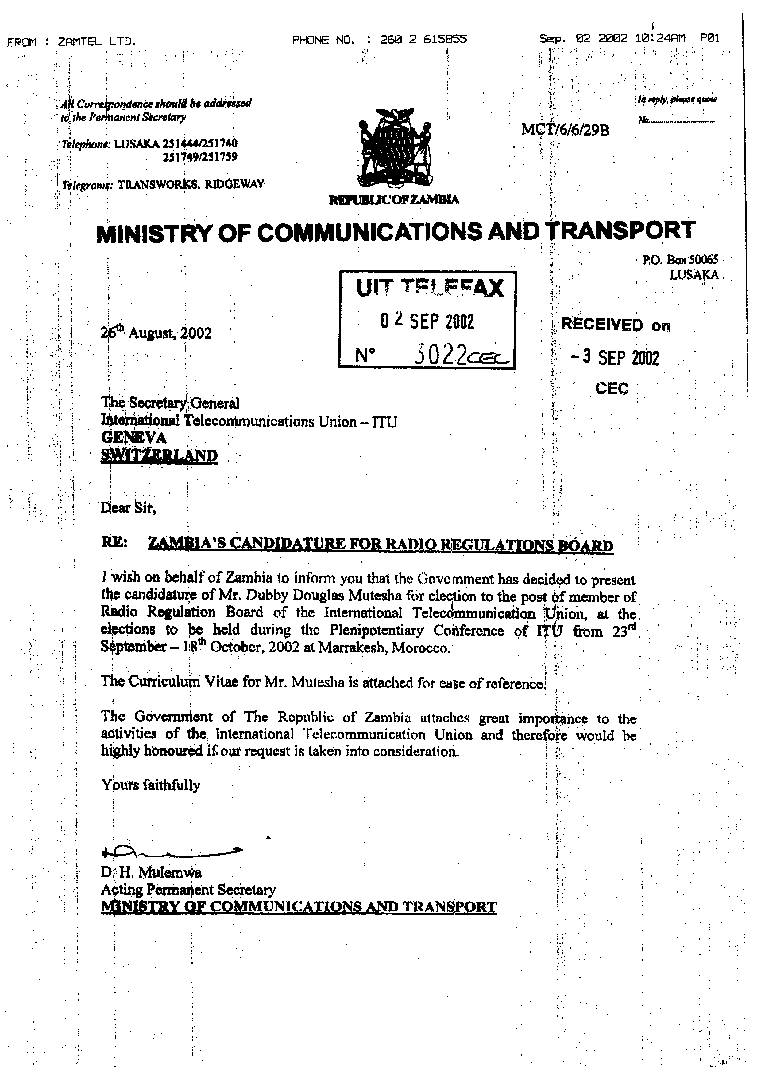
DUBBY DOUGLAS MUTESHA BEng MSc MEIZ
ZAMBIAN CANDIDATE FOR THE POST OF MEMBER OF THE RADIO REGULATION BOARD - ITU

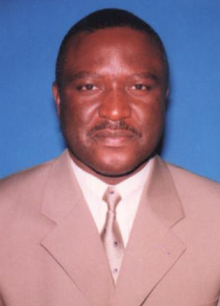CURRICULUM VITAE
Born in Luanshya, Zambia on 28th December 1960, Mr Dubby Douglas Mutesha obtained his Bachelor in Engineering (BEng.) Degree in Electronics and Telecommunications Engineering (Electrical Engineering) from September 1979 to August 1984 at the University of Zambia in Lusaka, Zambia. He further obtained a Master of Science (MSc) Degree in Telecommunications and Computer Technology and Management from September 1993 to December 1995 at the University of Maryland University College in the United States of America whilst working for International Telecommunication Satellite Organisation (INTELSAT) in Washington DC. USA.
Mr Mutesha is currently the Chief Executive Officer of Zambia Telecommunications (Zamtel) Company Limited the leading telecommunications company in the country. Zamtel is a National Telecommunications Operator (NTO), a service provider of communications Networks all around Zambia including the remote (Rural) areas of the country.
From August 1984 to March 1986, he worked for Kariba North Bank Power Station Company in Siavonga Zambia as a Trainee Communications Engineer and trained in Installation, Operation and Maintenance of Communication Systems at the Siavonga Power Station.
He also worked for Ericsson (Zambia) Limited, in Lusaka and Ndola, Zambia from March 1986 to September 1990 as a Telecommunications Engineer responsible for Installation, Testing, Integration, Commissioning, Operation and Maintenance of Ericson Communication Systems throughout Zambia. Later when the name changed to Horizon (Ericsson’s representative in Zambia) he was sent to the Northern Region by the same Company to work as Regional Technical Manager to be responsible for Northern Region Technical Management in Private Branch Exchanges PBXs, Intercoms, Facsimile, Radio, Security and Computer Systems.
As from October 1990 to date he has been working for the National Telecommunications Operator: Post and Telecommunications Corporation (Zambia) Limited/Zambia Telecommunications Company (Zamtel) Ndola. His first appointment was Principal Engineer, Internal Development Section in-charge of Project Management of Public and Private Switching, Radio and Transmission Systems and Rigging. He was later promoted to the position of Chief Engineer, Internal Development Section heading Zamtel’s Telecommunication Projects Implementation section throughout Zambia.
Mr. Mutesha was later transferred to another section; Radio and Transmission Planning still as Chief Engineer. Whilst with that section he headed Zamtel’s Radio and Transmission systems and Networks throughout Zambia that link the National and International Public Switched Telephone Network (PSTN). He led the planning and project management teams in preparations and evaluations of the Tender Documents for Digital Microwave Radio (DMR) Systems, Fibre Optics, Wireless Local Loop (WLL), Global Mobile Personal Communications by Satellite systems (GMPCS), Mobile Cellular, Advanced Mobile Phone System (AMPS) and Global System for Mobile (GSM) communications, VSATs, Domestic and International Satellite and Earth Station transmission systems. This section included liaison with ITU, INTELSAT, INMARSAT, RASCOM, Communications Authority of Zambia (CAZ) and GMPCS operators on telecommunications issues.
From July 1992 to December 1995 he was on attachment to the International Telecommunication Satellite (INTELSAT) Organisation (Zamtel being a Signatory to INTELSAT) in Washington D.C, U.S.A as:
- Professional Engineer, INTELSAT Telemetry, Tracking, Commanding, Monitoring, and Ranging, (TTCM&R) Facilities and Communication System Section dealing with Earth Station Radio Frequency (RF), Integration and Implementation for INTELSAT TTCM&R Ground Network Engineering Projects. Signal Processing Engineering.
- Professional Customer Support Engineer, INTELSAT Infrastructure and Customer Service involving Information Systems Management. Managing and serving INTELSAT Desktop (Hardware and Software) Computer Systems needs. INTELSAT Local and Wide Area Networks (LAN & WAN) administration.
With the above experiences he has had specialised training in Private Digital Communication Systems in Installation, Operation and Maintenance at Fatme Ericsson in Roma, Italy in March 1989. In January to February 1990 he went to Ericsson-Stockholm in Sweden to study Private and Public Digital Communication System Course in Installation, Operation and Maintenance. He further went to Korea Telecommunications Company in Tae-jeon, South Korea to further his studies on Public Digital Communication System in Installation, Operation and Maintenance from October to December 1991. In Washington D.C and Maryland, USA from July 1992 to December 1995 He did “Work Related Courses” in Telecommunications Industry (Structure and Environment), Strategy Development and Implementation, Legal, Regulatory and Management issues in Telecommunications, Business Research Methods, Time Management, Social Styles and Successful Teaming, Satellite, Data Communications Systems, Computer Networking Systems, Software Acquisition, Hardware and Software Operating systems, International Business Management and Engineering Economics.
He has got Computer skills in a number of operating systems and applications such as Microsoft Windows and office, Schedule, Access, Freelance, Lotus, Aldus Persuasion, PageMaker versions, (SPSS), Statistics Software, Ecco Professional, 1-2-3, 7, QuattroPro, Visio, HarvardGraphics, FoxPro, DbaseIV etc.
He is a professional Member of the Engineering Institution of Zambia (MEIZ)
Mr Mutesha has achieved and been awarded by Toastmaster International as Competent Toastmaster in the USA in 1994. He was accredited by Government of Republic of Zambia to participate at WRC97 in Geneva in Switzerland (November, 1997) and WRC 2000, Istanbul, Turkey (May, 2000). He was the Speaker on Emerging Wireless Local Loop (WLL) Technologies in Africa at Wireless ’98 Africa International Conference (AIC) at Sandton, Johannesburg RSA in 1998.He was appointed to the National Committee for Remote Sensing (satellite) in Zambia (1999) He was from 2001until the date of appointment as CEO (Zamtel) SADC Regional Information and Infrastructure (SRII) Project Manager (Zamtel) Zambia. He has been Chairman of COMESA COMTEL Negotiation Team (2001) in Zambia. He is currently Board Director of COMTEL Investment Company (COMESA).
He is married and has six children.
In conclusion Mr Dubby Douglas Mutesha’s professional interests are in Business Process Reengineering, Total Quality Improvement and Management, System Design and Analysis, Testing, Integration and Commissioning of Telecommunications and Computer Systems.
His vision is to effectively contribute to the Global Telecommunication Network Improvement and Development by investing the wealth of his educational knowledge, exposure, experience and expertise in the ITU Radio Regulation Board (RRB).

________

