INTERNATIONAL TELECOMMUNICATION UNION
 | PLENIPOTENTIARY  CONFERENCE (PP-02) |  | Addendum 14 to  Document 5-E
 | PLENIPOTENTIARY  CONFERENCE (PP-02) |  | 28 August 2002
 | PLENIPOTENTIARY  CONFERENCE (PP-02) |  | Original: English
MARRAKESH, 23 SEPTEMBER - 18 OCTOBER 2002
PLENARY MEETING
Note by the Secretary-General
CANDIDACY FOR THE POST OF MEMBER OF THE RADIO REGULATIONS BOARD
Further to the information contained in Document 3, I have pleasure in transmitting to the conference, in annex, the following candidacy for the post of member of the Radio Regulations Board:

Mr Ki-Soo LEE (Republic of Korea)

Yoshio UTSUMI
Secretary-General

Annex: 1
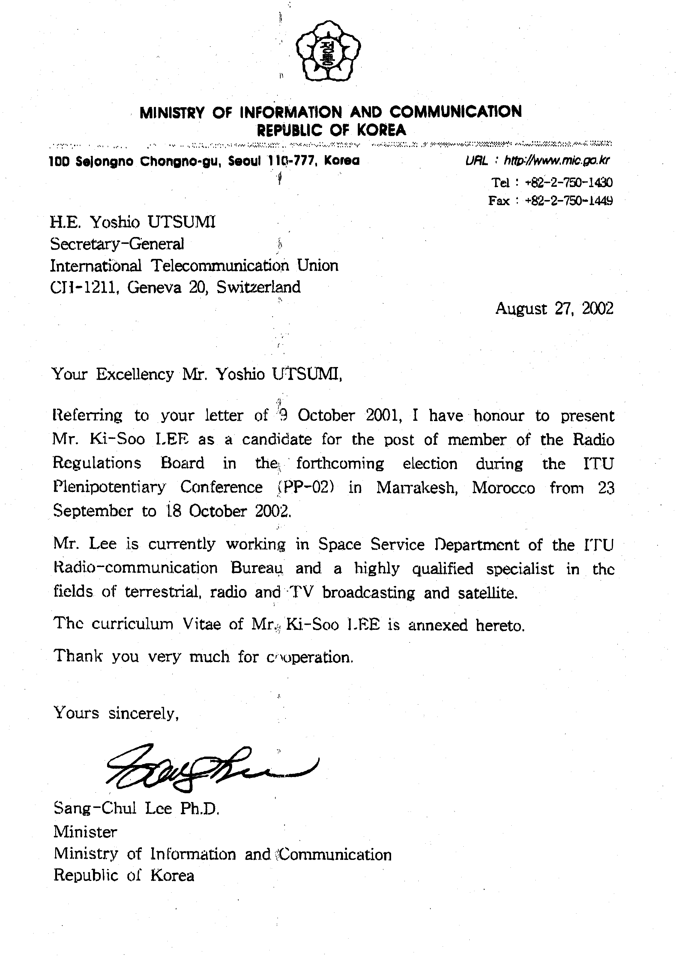
CURRICULUM VITAE
Mr Ki-Soo LEE

PERSONAL
Family name: | LEE | 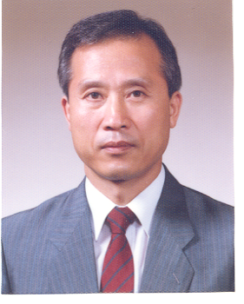
First name: | Ki-Soo
Date of birth | 7 September 1942
Nationality: | Korean (Republic of)
Civil status: | Married, with three children
Languages: | English, French, Spanish (basic knowledge) and Korean (mother tongue)

STUDIES
1958-1961: | Secondary School
1961-1965: | Bachelor of engineering, Hanyang University, Seoul
1977-1979: | Master of engineering, Myongji University, Seoul

PROFESSIONAL EXPERIENCE
1971-1977: | Joint Frequency Committee of the United Nations Command, Seoul, management of the frequency assignments of the radiocommunication systems.
1977-1981: | Korean Broadcasting System (KBS), Manager of Engineering Department,  Planning for installation of the broadcasting transmitting stations (TV, FM and AM radio) and M/W relay stations.
1981-2002 | ITU (IFRB/BR)  International Frequency Registration Board (IFRB)  Radiocommunication Bureau (BR) from March 1993
1981-1990: | International Frequency Registration Board (IFRB) engineer, responsible for  technical examination under Article 12 (former Article 17) of the RR;  development of computer software in order to improve and rationalize working methods in the area of Article 12.
1990-1992: | Member of HF Broadcasting Conference Preparation Group for the planning of the HF bands allocated to the broadcasting service.
1992-1995: | Space Services Department, engineer of Space Notification and Plans Division (SNP), responsible for regulatory and technical examination of frequency assignments under Appendix 30B; Article 9 (former Article 11) and Article 11 (former Article 13) which involves a complete analysis of the relevant coordination procedures as well as those relating to notifications for FSS and mobile-satellite services.
1995-2001: | Team leader, team responsible for regulatory and technical examination of the frequency assignments of satellite networks under Article 4 of Appendices 30 and 30A including publication of the relevant Special Sections.

01.05 -10.12.2001 | Acting Head of Space Notification and Plans Division (SNP).
11.12.2001 -30.9.2002 | Team leader, team responsible for regulatory and technical examination of the frequency assignments of satellite networks under Article 4 of Appendices 30 and 30A including publication of the relevant Special Sections.

INTERNATIONAL ACTIVITIES
ITU Conferences:
• Korean (Republic of) delegation at the World Administrative Radio Conferences in 1979 (WARC-79).
• Participation at WARC-84 for the planning of the HF bands allocated to the broadcasting service.
• Participation at WARC-87 for the planning of the HF bands allocated to the broadcasting service.
• BR representative at WRC-97; revision of Appendices 30 and 30A Regions 1 and 3 Broadcasting-Satellite Service and Feeder-link Plans.
• BR representative at WRC-2000 (GT1 PL1); replanning of Appendices 30 and 30A Plans for Regions 1 and 3 Broadcasting-Satellite Service and Feeder-links for the Broadcasting-Satellite Service.
ITU-R:
• Participation in study group activities (as IFRB/BR representative) between 1981-2002 (SGs 4, 6, 10, 11).
BR Seminars:
• Participation as a lecturer at BR Seminars in 1994, 1996 and 1998.

SUMMARY
Mr Ki-Soo LEE has worked in the ITU Radiocommunication Bureau for more than 21 years and has an in-depth knowledge of the Radio Regulations and the Rules of Procedure in the various fields of the radiocommunication services through his extensive working experience within ITU. Before he retired from ITU at the end of September 2002, he was a leader of the Broadcasting-Satellite Service Plans Team (Appendices 30 and 30A of the Radio Regulations) and acting Head of the Space Notification and Plans Division of BR during the period of 1 May - 10 December 2001. At the WRC-2000 Conference (Istanbul), he played an active role as a member of the Broadcasting-Satellite Service Replanning Team of the Radiocommunication Bureau for the successful revision of the Broadcasting-Satellite Service and the associated Feeder-link Plans and inclusion of the Lists of Regions 1 and 3. He has participated in the work of the various study groups and conferences within ITU. He was also involved in the preparation of draft new or revised Rules of Procedure which are directly connected to the work of the Radio Regulations Board. On the basis of his extensive working experience within ITU and his considerable professional knowledge of the Radio Regulations and the Rules of Procedure, he will be able to make a valuable contribution to resolving the issues addressed to the Radio Regulations Board.

_______________

