INTERNATIONAL TELECOMMUNICATION UNION
 | PLENIPOTENTIARY  CONFERENCE (PP-02) |  | Addendum 13 to  Document 5-E
 | PLENIPOTENTIARY  CONFERENCE (PP-02) |  | 31 July 2002
 | PLENIPOTENTIARY  CONFERENCE (PP-02) |  | Original: English
MARRAKESH, 23 SEPTEMBER - 18 OCTOBER 2002
PLENARY MEETING
Note by the Secretary-General
CANDIDACY FOR THE POST OF MEMBER OF THE RADIO REGULATIONS BOARD
Further to the information contained in Document 3, I have pleasure in transmitting to the conference, in annex, the following candidacy for the post of member of the Radio Regulations Board:

Mr S.A.T.M. BADRUL HOQUE (Bangladesh).

Yoshio UTSUMI
Secretary-General

Annex: 1

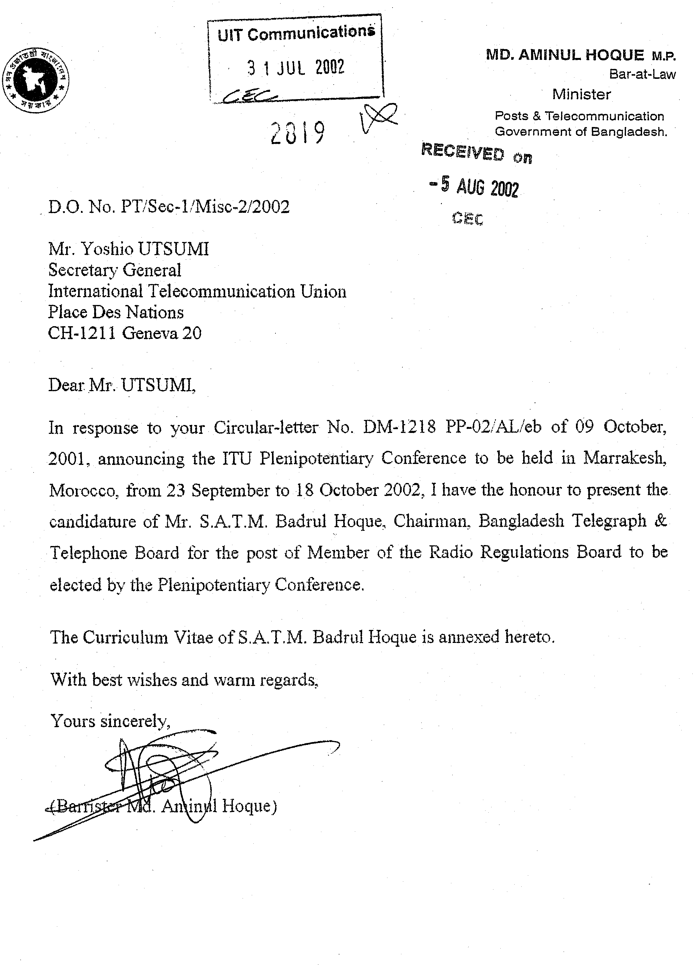

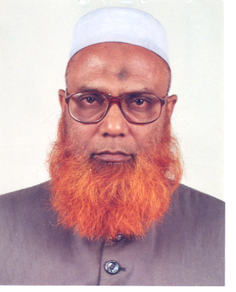
CURRICULUM VITAE

1. Name : S.A.T.M. BADRUL HOQUE
2. Date of birth : 14 December 1945
3. Present designation : Chairman, Bangladesh Telegraph
and Telephone Board
4. Nationality : Bangladeshi
5. Marital status : Married (three daughters, two sons)
6. Academic qualifications : B.Sc. Engineering (Electrical), 1966
Bangladesh University of Engineering and Technology, Dhaka
7. Knowledge of languages : Bengali, English, Urdu, Arabic (basic knowledge) and
Japanese (preliminary)
8. Professional training : a) Two years' post-graduate training in all branches of telecommunication engineering with specialization on radio-relay and multiplex systems/equipment in the Telecom Staff College, Pakistan.
b) Twelve months' specialized training in planning, installation, testing, operation and maintenance of microwave radio-relay systems, satellite communication systems and earth station equipment in Japan, France, Malaysia and Canada.
c) Three months' advanced course on administration and development at the Public Administration Training Centre, Dhaka, Bangladesh.
d) One month training in telecommunication management in the United States.
e) Two weeks' training in frequency spectrum management in Canada.
9. Membership of
professional/technical
societies : a) Fellow, Institution of Engineers, Bangladesh
b) Member, Asia Bunka Kaika Dosokai, Japan
c) Member, Institution of Electrical and Electronic Engineers (IEEE), United States
10. Publications in the
professional field : A good number of articles on telecommunication subjects specially related to microwave/satellite communication, mobile telephony and spectrum management, published in different telecommunication journals and newspapers, have been highly acclaimed in the telecommunication society.
11. Social activities : a) President, Bangladesh Telecom Engineers Association
b) Chairman, managing committees of several educational institutions (secondary, higher secondary and degree level)
c) Chairman, managing committees of several religious institutions and charitable organizations
12. Specialization : Radiocommunication (HF, VHF, microwave and satellite)
13. Experience : Thirty-three years' experience in various fields of telecommunications in different capacities such as Chairman, (head of the organization), Member (development and planning), General Manager (overseas communications), Station Manager (satellite earth stations), Director (international telecommunication services), Director (wireless services), Divisional Engineer (microwave construction), Divisional Engineer (carrier and wireless maintenance) of Bangladesh Telegraph and Telephone Board (the national telecommunication organization), major functions inter alia being:
a) formulation of policies concerning all radiocommunication matters as related to all types of satellite and terrestrial-based radiocommunication services, GMDSS, GMPCS spectrum coordination, radio-frequency planning, monitoring, licensing, etc.;
b) planning, design, installation, testing, operation and maintenance of HF, VHF, UHF, microwave and satellite radiocommunication systems and equipment;
c) preparation of technical specifications and tender schedules, technical and financial evaluation of bids, preparation of bill of quantities relating to above systems and equipment as head of different technical committees;
d) spectrum management and regulatory functions ad ex officio member of the National Frequency and Wireless Board;
e) imparting training to engineers and technicians in the above fields in the Telecom Staff College and telecommunication training centres as guest lecturer;
f) presentation of papers on the above subjects at different telecommunication seminars as a telecommunication expert;
g) all matters concerning regional and international telecommunication bodies like ITU, the Asia-Pacific Telecommunity, CTO, INTELSAT, Inmarsat, etc.;
h) working as an examiner of the Radio Regulations of maritime radio telecommunication operators and radiocommunication officers' certificate examinations.
14. International assignments
as a UN/ITU expert : Training expert on microwave radio-relay systems and multiplex equipment at Port of Spain, Trinidad & Tobago
15. International meetings and
conferences: : Attended and actively participated in several INTELSAT global telecommunication meetings, Inmarsat meetings, ITU WRC preparatory meetings, world radiocommunication conferences and ITU plenipotentiary conferences as head/deputy head of the Bangladesh delegation.

__________

