INTERNATIONAL TELECOMMUNICATION UNION
 | PLENIPOTENTIARY  CONFERENCE (PP-02) |  | Addendum 12 to  Document 5-E
 | PLENIPOTENTIARY  CONFERENCE (PP-02) |  | 11 July 2002
 | PLENIPOTENTIARY  CONFERENCE (PP-02) |  | Original: English
MARRAKESH, 23 SEPTEMBER - 18 OCTOBER 2002
PLENARY MEETING
Note by the Secretary-General
CANDIDACY FOR THE POST OF MEMBER OF THE RADIO REGULATIONS BOARD
Further to the information contained in Document 3, I have pleasure in transmitting to the conference, in annex, the following candidacy for the post of member of the Radio Regulations Board:

Mr Bruce R. EMIRALI (New Zealand).

Yoshio UTSUMI Secretary-General

Annex: 1
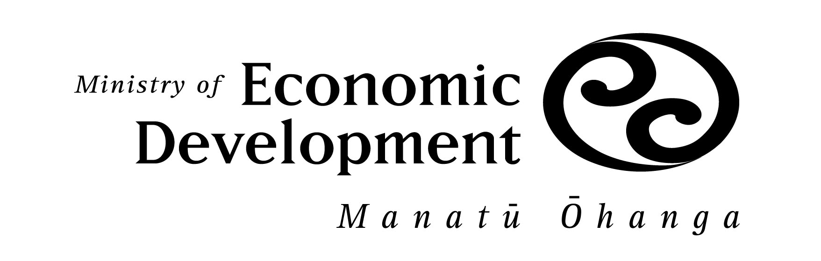

File: 4 ITU/7

11 July 2002
Secretary General
International Telecommunications Union
Place de Nations
1211 GENEVE

Dear Secretary General Utsumi

In response to your Circular Letter DM 1218 of 9 October 2001, on behalf of the Government of New Zealand, I have the honour to present the candidacy of Mr Bruce R Emirali for the position of member of the Radio Regulations Board to be elected at the Plenipotentiary Conference, Marrakesh.

A summary curriculum vitae of Mr Emirali is attached.

Yours sincerely

Ian R Hutchings

New Zealand co-ordinator

Resources and Networks Branch

Ministry of Economic Development

By e-mail

Curriculum vitae

Bruce R Emirali
New Zealand Candidate for
Radio Regulations Board

Date of birth: 7 April 1950
Family: Married, one son, one daughter
Nationality: New Zealand citizen
Language: English
Qualifications: Various military radio engineering qualifications including Military Diploma Radio Spectrum Management and Engineering - 1984

Professional experience
1986 to Present: Head Radio Spectrum Management New Zealand Defence Force (NZDF), Defence Headquarters Wellington NZ.
• Responsible for the allocation and assignment of all radio spectrum requirements for NZDF units nationally and internationally.
• Policy development for NZDF use of the Radio Spectrum.
• Specialist spectrum management services and advice to military deployments in Angola, Bosnia, East Timor, Papua New Guinea and Somalia during humanitarian relief and peace keeping operations.
• NZ representative and former chairman on the five nation (AUS, CA, NZ, US, UK) military frequency panel for frequency policy and coordination.
• NZ Member and chairman of selected working groups associated with NZ preparation for ITU radiocommunications conferences.
• Project officer NZDF SATCOM project.
1983-1986: Senior Frequency Management specialist headquarters Royal New Zealand Air Force (RNZAF) - Wellington NZ.
1980-1983: Senior Supervisor RNZAF Aeronautical Operations Communications facility - Christchurch NZ.
1980: Supervisor RAAF Aeronautical Operations Communications Centre - Sydney Australia.
1974-1979: Senior Supervisor RNZAF communications facility Auckland NZ. Also senior communications specialist RNZAF mobile communications unit.
1967-1974: Communications Specialist various RNZAF communications facilities.

International activities
Mr Emirali has participated in ITU radiocommunications conferences and radiocommunications assemblies for the last 15 years. As such he has an in-depth knowledge of the ITU procedures, the Radio Regulations, and the international spectrum management framework.
He has led NZ delegations to a number of international military frequency management meetings and forums. He has been chairman of the five nation (AUS, CAN, NZL, USA, UK) military Combined Communications-Electronics Board Frequency Panel for three separate periods (1990, 1995 and 2000).
As senior communications specialist in the RNZAF mobile communications unit Mr Emirali participated in many humanitarian operations throughout the Pacific region.

National activities
Chairman (2nd term) of the NZ industry Major Spectrum Users Advisory Group (an industry/commercial group that provides advice to the national spectrum authority and NZ Government on industry use of the radio spectrum).
Past Chair (3 times) and current member of the NZ Public Safety Radio Frequency Management Group; charged with overseeing the provision and management of spectrum for Public Safety agencies and Emergency services in NZ.
Board member NZ Telecommunications Educations Skills Standards Training Organisation - Responsible for development of qualifications and training standards for telecommunications in NZ.
Chairman and active participant of various NZ preparatory groups for WARCs and WRCs 1987-2002.
Military representative on NZ radiocommunications sector activities.
Military representative on the telecommunications planning team for the Commonwealth Heads of Government meeting and the more recent Asia Pacific Economic Community (APEC) meeting, NZ, 2000.

Summary
Mr Emirali has had over 34 years experience in radiocommunications. The last 16 years have been specifically in the field of spectrum management. In New Zealand he has been selected to chair various national groups concerned with spectrum utilization and the development of procedures for use of the spectrum on a coordinated basis. He has had significant experience in the ITU radiocommunications sector over many years and has participated in numerous ITU radiocommunications conferences (WARC and WRC).

_______________________

