INTERNATIONAL TELECOMMUNICATION UNION
 | PLENIPOTENTIARY  CONFERENCE (PP-02) |  | Addendum 11 to  Document 5-E
 | PLENIPOTENTIARY  CONFERENCE (PP-02) |  | 15 May 2002
 | PLENIPOTENTIARY  CONFERENCE (PP-02) |  | Original: English
MARRAKESH, 23 SEPTEMBER - 18 OCTOBER 2002
PLENARY MEETING
Note by the Secretary-General
candidacy for the post of member of
the radio regulations board
Further to the information contained in Document 3, I have pleasure in transmitting to the conference, in annex, the following candidacy for the post of member of the Radio Regulations Board:
Mr 'Shola TAYLOR (Federal Republic of Nigeria)

Yoshio UTSUMI
Secretary-General

Annex: 1
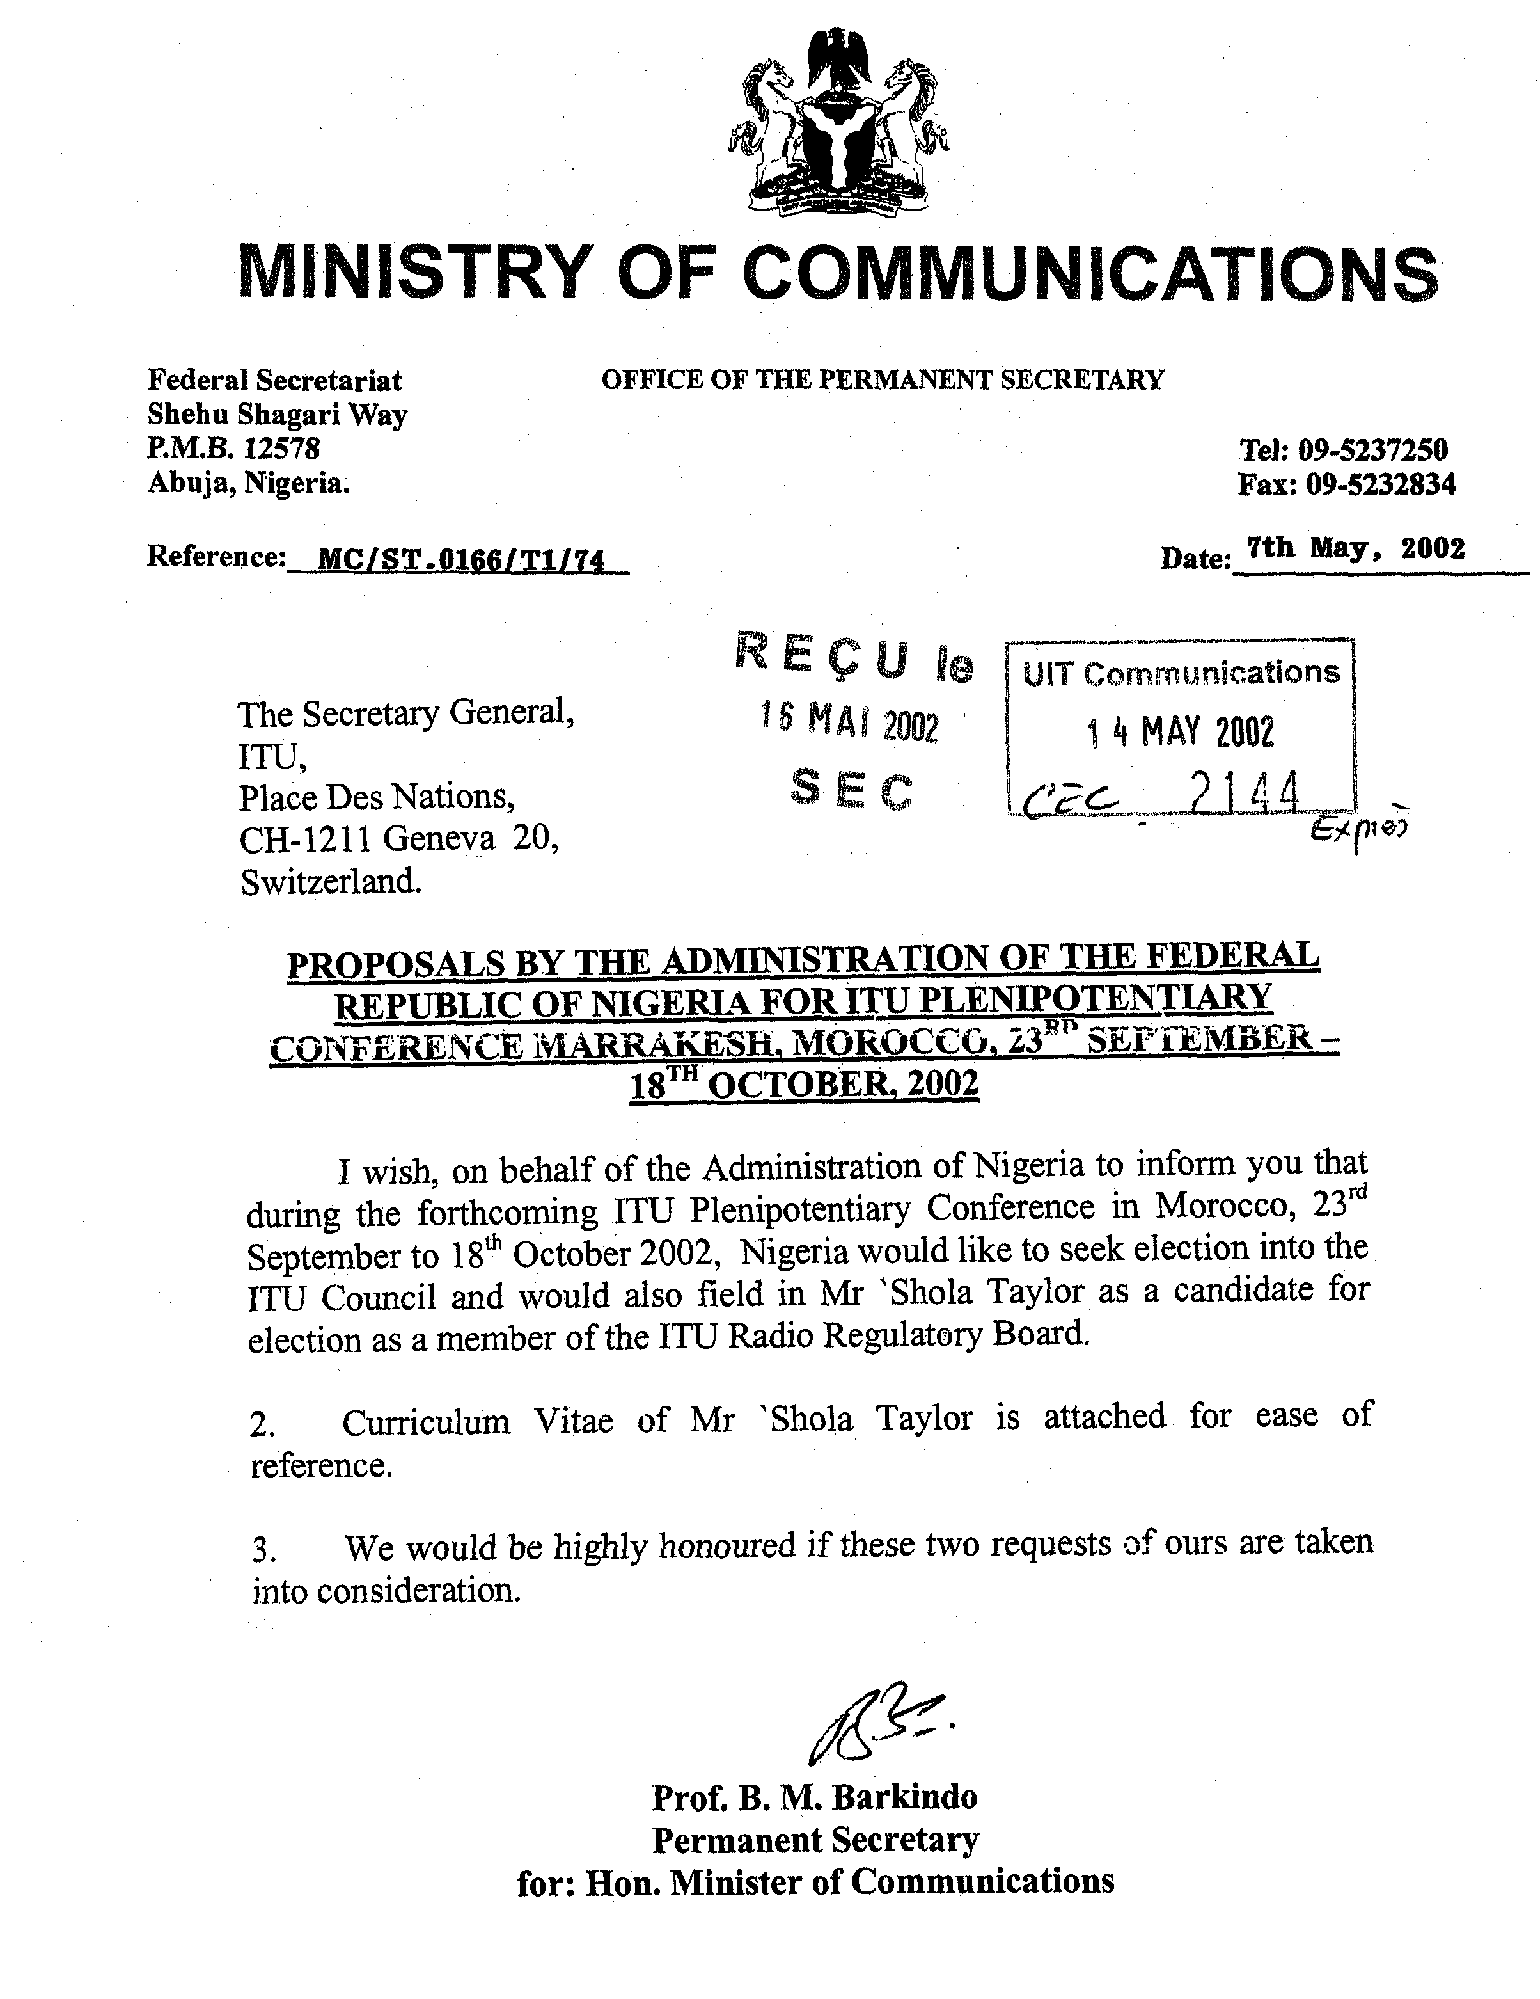
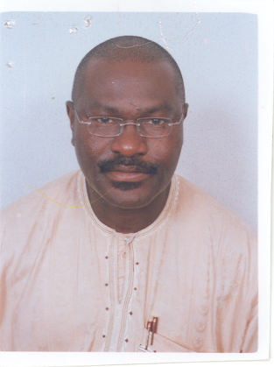
'Shola TAYLOR -
Candidate for Member of the ITU Radio Regulations Board

Summary
'Shola TAYLOR, a leading authority on telecommunications in Africa, has over 21 years of postgraduate professional experience in international telecommunications. During this period, he has developed an enviable network of professional associates within the global telecommunications industry and has become a particularly well known and widely respected figure in the international telecommunications community, particularly in Africa.
He has extensive experience in radiocommunication matters, having worked at Intelsat, Washington DC USA, International Telecommunication Union, Geneva, Switzerland, Inmarsat, London UK, and the Nigerian Telecommunications Limited. He previously served as a member of the Board of the Nigerian Communications Commission.
One of his remarkable achievements during his service at the ITU was the successful completion of the feasibility study for an African satellite system. He also conceived and spearheaded the SPACECOM project, which has now become the framework for the promotion of satellite communications technology in developing countries.
He was recently appointed to serve as a Member of the e-Africa Commission, a body set up by African Leaders to promote information and communication technology (ICT) infrastructure in Africa.
He is currently CEO of Kemilinks International Ltd, Nigeria, a consultancy firm focused on the development of ICT in Africa.
His rich background places him in a unique position to serve as a Member of the Radio Regulations Board of the ITU.

Personal details
Name: 'Shola TAYLOR
Marital status: Married
Date of birth: 22 January 1956
Nationality: Nigerian

Work experience

1979-1980 Ultra Electronic Communications Ltd, UK
Communications Development Engineer, Ultra Electronic Communications Limited, UK. Member of the engineering team responsible for the design and development of VHF transmitters. He proposed a number of design improvements some of which were adopted to achieve optimum performance of VHF transmitters. He also carried out several tests to ensure that equipment that were to be deployed performed very efficiently.

1981-1985 Nigerian Telecommunications Ltd, Nigeria
Telecommunication Engineer, Nigerian Telecommunication Limited, Nigeria. He participated in many engineering projects, and more specifically, preparation of specifications for transmission systems - both terrestrial and satellite. He was a member of many teams that conducted the evaluation of bids for satellite communication earth stations and microwave transmission and switching systems. He was appointed by the Nigerian Minister of Communications as Secretary of the task force that reviewed the domestic satellite systems in Nigeria with a view to enhancing the system for more efficient use. He also prepared the system design for the first business satellite systems used in Nigeria.

1985-1987 Intelsat, Washington DC, USA
Technical Staff Member (Intersystem Coordination and ITU Satellite filings), International Telecommunication Satellite Organisation (Intelsat) Washington DC. He was mainly responsible for preparing various technical documentation required for registration of Intelsat satellites. These included the Advance Publication Information and the Request for Coordination in preparation for filing of those systems. He also carried out some interference analysis to aid the Intelsat team responsible for coordination of planned Intelsat satellites with other satellite systems.

1987-1994 International Telecommunication Union, Geneva, Switzerland
Director, RASCOM project (RASCOM = Regional African Satellite Communication System), International Telecommunication Union. He was responsible for conducting the feasibility studies for a regional African satellite system. At the ITU, he directed the activities of several international experts, consultants and over 600 national experts that participated in the feasibility study, which remains to date, as the most comprehensive ever undertaken on the subject of African telecommunications. During the study, he liaised extensively with the then International Frequency Radio Board (IFRB) of the ITU, as well as all the CEOs of the major private regional and international satellite systems - Intelsat, Inmarsat, Intersputnik, Intelsat, Arabsat, Eutelsat, and PanAmSat. After successful completion of the RASCOM study, he was appointed the Coordinator, for the worldwide SPACECOM project, an initiative which he conceived and designed to assist developing countries to maximize the potential of satellite communications technology in the expansion of their telecommunications infrastructure. He was responsible for designing the framework for the project and succeeded in obtaining substantial private sector support for its implementation.

1994-1999 Inmarsat Ltd, UK
Regional Director for Africa, Inmarsat Ltd, UK. He was responsible for promoting and developing the Inmarsat business in Africa. He assisted Inmarsat in formulating proposals to ITU World Radio Conferences and implemented many Inmarsat projects in Africa. He was very active in assisting many African countries in adopting policy and regulatory frameworks designed to accelerate the development of their communications infrastructure.

1999- to date Kemilinks International Ltd, Nigeria
CEO, Kemilinks International. He is currently responsible for directing the consultancy services of Kemilinks International in the areas of policy and regulations in the information and communication technology sector in Africa.

Other appointments
He served as a Member of the Board of the Nigerian Communications Commission, the telecommunication regulatory agency in Nigeria.
'Shola TAYLOR is currently a member of the e-Africa Commission, a body set up by African leaders to advise on how the potential of ICT can best be utilized for Africa.
He was elected in Accra Ghana in 1999 as the Coordinator of the African Telecom Think Tank, a world-wide association of African professionals active in the telecom sector.
He is a member of the Institute of Directors, UK.
He is an adviser to the Minister of Communications South Africa.

Educational qualifications
Master of Science in Telecommunication Systems, University of Essex, UK
Bachelor of Science in Electrical Engineering, University of East London, UK

Abuja, Nigeria 10 April 2002

