INTERNATIONAL TELECOMMUNICATION UNION
 | PLENIPOTENTIARY  CONFERENCE (PP-02) |  | Addendum 10 to  Document 5-E
 | PLENIPOTENTIARY  CONFERENCE (PP-02) |  | 16 May 2002
 | PLENIPOTENTIARY  CONFERENCE (PP-02) |  | Original: French
MARRAKESH, 23 SEPTEMBER - 18 OCTOBER 2002
PLENARY MEETING
Note by the Secretary-General
CANDIDACY FOR THE POST OF MEMBER OF THE RADIO REGULATIONS BOARD
Further to the information contained in Document 3, I have pleasure in transmitting to the conference, in annex, the following candidacy for the post of member of the Radio Regulations Board:
Mr Aboubakar ZOURMBA (Republic of Cameroon).

Yoshio UTSUMI
Secretary-General

Annex: 1
REPUBLIC OF CAMEROON
Ministry of Posts and Telecommunications
General Secretariat
Department of Planning and Telecommunications Studies

Ref: 0000953/MPT/SG/DPE
Yaoundé, 10 May 2002

The Minister of Posts and Telecommunications
to
Secretary-General of the
International Telecommunication Union
Subject: Plenipotentiary Conference
Marrakesh, Morocco, 23 September-18 October 2002

Dear Sir,
I have the honour to inform you that the Republic of Cameroon reconfirms its participation in the Plenipotentiary Conference to take place from 23 September to 18 October 2002 in Marrakesh, Morocco, and its intention to stand for election to a seat on the ITU Council.
As a participant in the Plenipotentiary Conference, the Republic of Cameroon wishes to submit the candidacy of Mr Aboubakar ZOURMBA for the post of member of the Radio Regulations Board. Mr ZOURMBA, whose curriculum vitae is attached, presently occupies the post of Deputy Director-General of the Agence de Régulation des Télécommunications (Telecommunication Regulatory Agency) of Cameroon.
Yours faithfully,

(Signed)
Maximin Paul Nkdue Nkongo
Minister

(Official seal of the Minister of Posts and Telecommunications)

cc: ART
Archives

REPUBLIC OF CAMEROON
Peace - Work - Fatherland

PLENIPOTENTIARY CONFERENCE
(Marrakesh, Morocco, 23 September-18 October 2002)
______________
ABOUBAKAR ZOURMBA
Candidate for the post of member of the Radio Regulations Board
______________
CURRICULUM VITAE

YAOUNDÉ, APRIL 2002

Aboubakar ZOURMBA  Deputy Director General  Agence de Régulation des Télécommunications  P.O. Box 6132 Yaoundé, Cameroon  Telephone: (237) 223 03 80 | 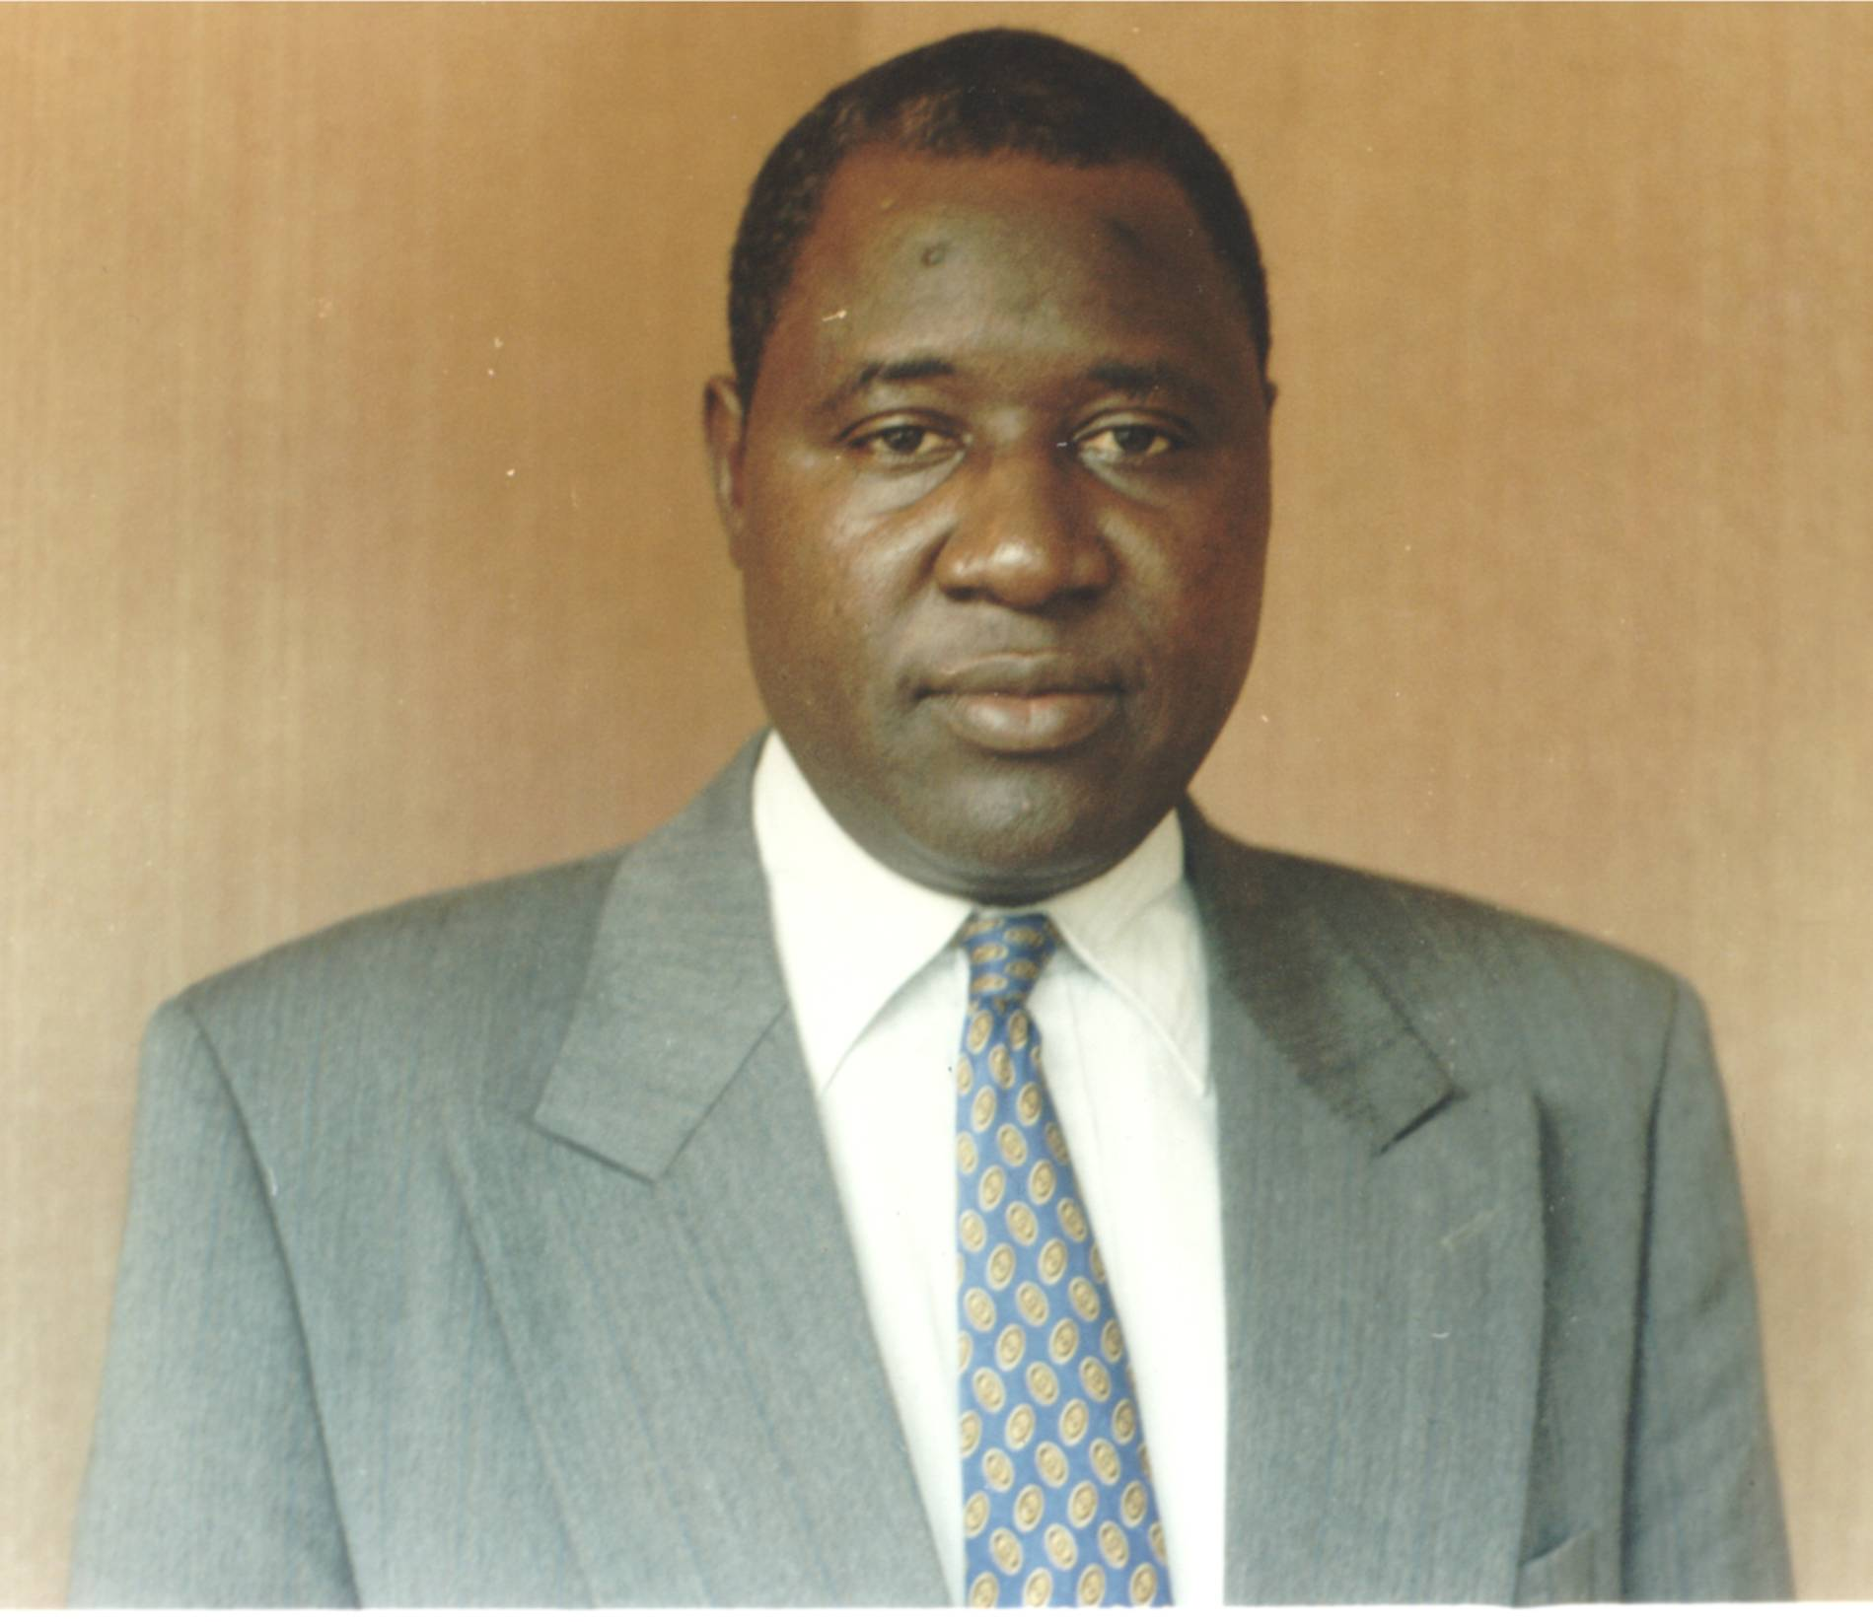

1 PERSONAL DATA
Surname and first name: ZOURMBA, Aboubakar
Profession: Telecommunication engineer
Date and place of birth: 1958, Holoum Daba Guider, Cameroon
Nationality: Cameroon
Civil status: Married, one son

2 TRAINING
1986-1988: | Master of Science (MSc) in Telecommunications Technology, Aston University, Birmingham, United Kingdom.
1980-1983: | Engineer in Telecommunication Work (ITT), Cameroon Higher National School of Posts and Telecommunications (ENSPT), Yaoundé, Cameroon.

3 PROFESSIONAL EXPERIENCE
Since 1999: | Deputy Director-General, Agence de Régulation des Télécommunications, Yaoundé, Cameroon.
Since 2000: | Head, Spectrum Management Department, Agence de Régulation des Télécommunications, concurrently Deputy Director-General, Yaoundé, Cameroon.
1998-1999: | Provincial Delegate (Deputy Director) of Posts and Telecommunications for South-West Province, Buéa, Cameroon.
1990-1998: | Assistant Manager for Spectrum Management and Private Undertakings, Ministry of Posts and Telecommunications, Yaoundé, Cameroon.
1989-1990: | Research and Development Engineer (Head of Service), Centre d'Etudes des Télécommunications (CETCAM), Yaoundé, Cameroon.
1984-1986: | Head of Service, Provincial Deputy for Telecommunications for Extreme-North Province, Maroua, Cameroon.
1983-1984: | Maintenance Officer, Garoua Telephone Exchange, Cameroon.

4 ITU ACTIVITIES

• Activities in the ITU Radiocommunication Sector:
− Vice-Chairman of Working Group of the Plenary 2, WRC-2000
− Deputy Head of Cameroon's delegation to WRC-97, RA-97 and WRC-2000
− Member of Cameroon's delegation to WARC-1992, WRC-93, WRC-95, RA-93 and RA-95
− Participant in the work of Study Group 1 (Spectrum management) since 1995
− Participant in the work of the CPM and radiocommunication seminars and meetings

• Activities in the ITU Telecommunication Standardization Sector
− Vice-Chairman of the Telecommunication Standardization Advisory Group (TSAG) since WTSA-2000
− Member of Cameroon's delegation to WTSA-2000

• Activities in the ITU Telecommunication Development Sector
− Member of Cameroon's delegation to WTDC-02
− National Coordinator from Cameroon for the project to develop national Maritime Radiocommunication Master Plans for African countries south of the Sahara under BDT supervision (1992-1996)

• Activities in the ITU Council
− Participant in the sessions of ITU Council since 1999

5 OTHER ACTIVITIES
− Participant in the telecommunication activities of INTELSAT, Inmarsat, RASCOM, ATU, COPTAC, ASECNA, IMO, ICAO, CTO, CAPTEF
− Part-time lecturer, Director and Jury Member for dissertations at ENSPT, ENSP and IRIC
− Preparation of fascicles on signalling in telecommunications.

THE RADIO REGULATIONS BOARD

1 Introduction
The next Plenipotentiary Conference (PP-02) of the International Telecommunication Union (ITU), which will take place from 23 September to 18 October 2002 in Marrakesh, Morocco, will inter alia elect the members of the Radio Regulations Board (RRB). With a view to that election, and in addition to being a candidate for re-election as a Member State of the ITU Council, the Republic of Cameroon presents to PP-02 the candidacy of Mr Aboubakar ZOURMBA for the post of RRB member. This paper contains a brief presentation of the RRB within ITU's Radiocommunication Sector and of Mr Zourmba's candidacy.

2 The Radio Regulations Board within the Radiocommunication Sector
ITU is a United Nations specialized agency dealing with telecommunications. Its goals include international cooperation, technical assistance for developing countries, and the development and promotion of telecommunication services for all the world's peoples. To that end, it deals with international spectrum management, global standardization and the harmonization of efforts to develop and study telecommunications. Its structure consists of a General Secretariat, the Telecommunication Development Sector (ITU-D), the Telecommunication Standardization Sector (ITU-T) and the Radiocommunication Sector (ITU-R).
The fundamental mission of the Radiocommunication Sector is to fulfil ITU's goal in terms of radiocommunications using frequencies. The Sector conducts studies, allocates bands, allots frequencies, registers assignments and settles cases of harmful interference. It carries out those activities in order to enhance use of the radio spectrum. For that purpose, its structure comprises world radiocommunication conferences (WRC), radiocommunication assemblies (RA), radiocommunication study groups, the Radiocommunication Advisory Group (RAG), the Radiocommunication Bureau (BR), which has an elected Director, and the RRB, which has 12 elected members.
The international rules governing the use of radio frequencies are established at WRC and enshrined in the Radio Regulations, which has international treaty status. The Radiocommunication Sector, and notably the Radiocommunication Bureau, conduct spectrum management activities in accordance with the provisions of the Radio Regulations, some of which can require clarification, more detailed explanation, guidance or simplification. Indeed, WRC decisions are the product of heated debate and therefore constitute compromises that can contain contradictions and ambiguities. The work of clarifying and explaining falls to RRB, and the result of that work is rules of procedure.
RRB is in charge of approving the rules of procedure, which include technical criteria and are used in the application of the Radio Regulations inter alia to register frequency assignments made by States. RRB also examines cases of harmful interference and any other matter that cannot be resolved through the application of the rules of procedure. The members of RRB serve as custodians of an international public trust and they carry out their duties independently and part time. Those duties are exclusively international.
For a country like Cameroon, membership in RRB serves to improve its skill at spectrum management and its knowledge of what is happening in other countries, to strengthen its human resources capabilities and to enhance the country's diplomatic presence. It is an honour and a recognition conferred by the international community.

3 Cameroon's candidacy for membership of the Radio Regulations Board
Africa is a tropical continent straddling the equator. Travelling north or south from the equator, one encounters dense equatorial forest, grassland and desert. This varied geographical environment also includes mountains, high plateaux and plains, is bordered by the Atlantic Ocean, the Indian Ocean, the Mediterranean and the Red Sea, and is crossed by several rivers, including the Nile, the Niger, the Congo and the Zambezi. These geographical characteristics have an effect on radio propagation.
Africa's approximately 700 million inhabitants are distributed among 53 countries, most of which are developing. Its economy is generally based on raw materials and the primary sector. Financing is based on aid and on repayment of the debt, which is presently a serious concern. Initiatives such as the NEPAD (the New Partnership for Africa's Development) and HIPC (Highly Indebted Poor Countries) are examples of attempted solutions. The economic situation goes a long way to explaining the lack of basic infrastructure in Africa, including in telecommunications.
One approach to the lack of telecommunication infrastructure has been liberalization/privatization to attract expertise and private sector funds; a frequent result is the separation of the three aspects of telecommunication management, namely sectoral policy/strategy, regulation and operation. Radiocommunications play a pivotal role in the transition process because of their mobility, the fact that they cover vast and remote areas and the rapid deployment of less costly wireless communications.
Cameroon (475 000 square kilometres, 15 million inhabitants) is a central African country situated between 2° North and 12° North. It has a coastline of about 400 kilometres on the Atlantic Ocean to the south-west, dense equatorial forest in the south, mountains and high plateaux in the west and centre, and grasslands in the north; hence its sobriquet "Africa in miniature".
In Cameroon, the telecommunication sector has been liberalized, with the Ministry of Posts and Telecommunications in charge of sector policy, the Agénce de Régulation des Télécommunications in charge of regulation and the private sector in charge of operations. The audiovisual sector has also been liberalized under the coordination of the Ministry of Communication. The telecommunication sector presently consists of an incumbent operator, which is being privatized, two mobile telephony operators, about 50 added-value service operators (Internet, paging systems, trunking systems, telecentres, resale traffic, satellite systems, etc.), and audiovisual operators (TV distribution, FM radio).
The services offered include telephony (about 500 000 subscribers), telegraphy, telex, packet data transmission, Internet access (about 10 000), trunking, paging, satellite terminals, maritime and aeronautical radio services, broadcasting, etc.
The Ministry of Posts and Telecommunications coordinates spectrum management in Cameroon (and therefore also radiocommunication activities). That coordination covers national allocation by an interministerial body and assignment and control by those assigning the frequencies (administrations or public bodies).
Although certain frequency bands are saturated, the radio spectrum is underused in Cameroon and indeed throughout Africa. There is therefore a huge potential for development. The HF/VHF/UHF/SHF ranges, in particular between 5 MHz and 20 GHz, are largely used for a variety of telecommunication services and applications. Owing to propagation phenomena, the MF (300-3 000 GHz) range is practically unusable, especially in dense equatorial forest. Saturation is a problem in the HF (especially in the 5-9 MHz band), VHF (87.5-108 MHz and 146-174 MHz) and UHF (around 2 GHz) ranges.
Mr Aboubakar Zourmba, whose candidacy Cameroon submits for the post of RRB member, has the necessary training and experience in telecommunication management and a solid practical grounding in spectrum management. Mr Zourmba is a telecommunication engineer trained in Cameroon and Great Britain; he holds the rank of head telecommunication engineer in Cameroon's civil service. He has a total of 19 years of experience in telecommunications and has been in positions of authority for the past 16 years, including two years in studies (planning, economic analysis, implementation follow-up), three years in operations (including maintenance of microwave radio links) and 11 years in spectrum management, which consists in:
• studying national allocations and channelling (allocating) the bands attributed for radiocommunication services and applications;
• assigning frequencies to requesting radio stations (receiving and examining requests for frequency assignments, delivering frequency assignment agreements, invoicing and receiving the fees due, any notification and coordination);
• monitoring transmissions or carrying out inspections in order to ensure compliance with regulations, with a view to solving operational problems (operating certificate, harmful interference) and for educational purposes (awareness, advice, consultation, information, training);
• contributing to technical, operating and procedural standardization (acquisition of equipment conforming to the relevant ITU-R Recommendations, making available existing standards).
Mr Zourmba has the profile to contribute, in his modest way, to the activities of ITU's Radiocommunication Sector as an RRB member. As he himself says, "as a member of the Radio Regulations Board, I will spare no effort to earn the trust of the international community and to honour my country, Cameroon, by performing the tasks entrusted to me to the best of my abilities and possibilities".

4 Conclusion
The Republic of Cameroon wishes to express its gratitude to the ITU Plenipotentiary Conference 2002 and submits to it the candidacy of Mr Aboubakar Zourmba for the post of member of the Radio Regulations Board, which is charged inter alia with approving the rules of procedure required to apply the provisions of the Radio Regulations and the decisions of the relevant conferences and assemblies.
Mr Aboubakar Zourmba has the confidence of his country, Cameroon, and the necessary qualifications and experience. He deserves your trust.

