INTERNATIONAL TELECOMMUNICATION UNION
 | PLENIPOTENTIARY  CONFERENCE (PP-02) |  | Document 5-E  14 November 2001  Original: English
MARRAKESH, 23 SEPTEMBER - 18 OCTOBER 2002

PLENARY MEETING
Note by the Secretary-General
CANDIDACY FOR THE POST OF MEMBER OF
THE RADIO REGULATIONS BOARD
Further to the information contained in Document 3, I have pleasure in transmitting to the Conference, in annex, the following candidacy for the post of member of the Radio Regulations Board:
Mr Abihudi NEWTON NALINGIGWA (Tanzania)

Yoshio UTSUMI
Secretary-General

Annex: 1

THE UNITED REPUBLIC OF TANZANIA
TANZANIA COMMUNICATIONS COMMISSION
Telegram : TUMEWASILI, Dar Es Salaam  Telephone : 255 51 118947-52  Fax : 255 51 116664  Telex : 41858 COMCOM TZ |  | P.O. Box 474  DAR ES SALAAM  TANZANIA

Ref. No. TCU/U.1 Vol.X/12 8 November 2001
Secretary-General
International Telecommunication Union
Place des Nations
CH-1211 Geneva 20
SWITZERLAND
Fax: +41 22 733 7256

Subj: PLENIPOTENTIARY CONFERENCE (PP-02)
We acknowledge with thanks receipt of your invitation letter to participate at the forthcoming Plenipotentiary Conference (PP-02) in Marrakesh, the Kingdom of Morocco, 23 September to 18 October 2002.
We would like to confirm that Tanzania will participate at the forthcoming Plenipotentiary Conference and that Tanzania will contest for the seat in the ITU Council.
As regards to the election of the member of the Radio Regulations Board (RRB), Tanzania would like to present the candidature of COL. ABIHUDI NEWTON NALINGIGWA, the Director General of Tanzania Communications Commission for a membership in the Radio Regulations Board.
Attached herewith, please find the curriculum vitae of Col. A.N. Nalingigwa for your reference.
Please find our document requirements in Annex 2 of your letter, duly filled for your action. We shall forward to you the credentials and proposals for amendments of the Constitution and Convention, if any, as scheduled.
Yours sincerely,
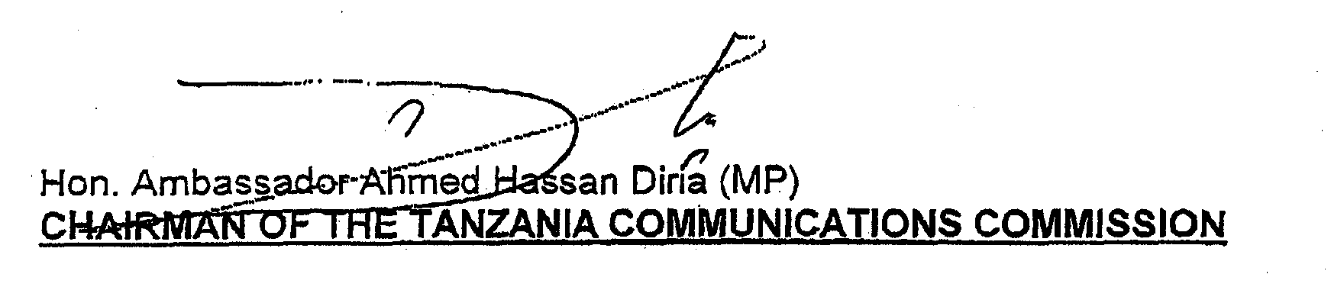
CURRICULUM VITAE

Name | : | Col. Abihudi Newton Nalingigwa
Date and place of birth | : | 2 November 1949, Singida, Tanzania
Marital status | : | Married with three children
EDUCATION | : | General Certificate of Education
 | : | - Alliance High School Dodoma - 1965-1968
 | : | Advanced Certification of Education
 | : | - Mkwawa High School Iringa - 1969-1970
 | : | University of Dar el Salaam - B.Sc.  (Hons) - 1971-1974
 | : | University of Bradford (UK) - M.Sc.  Electronics - 1979-1981
PROFESSIONAL TRAINING |  | Computer Software and Hardware courses
 |  | - A3 Software package - UNISYS CANADA - 1986
 |  | - B20 Software package - UNISYS CANADA - 1986
- A3 and B20 Hardware Package - UNISYS
CANADA - 1986
 |  | - Advanced Digital Microwave Transmission - ANTWERP - 1992
 |  | - Digital Switching - WEYBRIDGE (UK) - 1992
 |  | - Time Division Multiple Access Radio (MADRID) - 1992
 |  | - Telecommunications Management - (Canada) - 1998
 |  | - Regulation and privatization - (USA) - 1999
PROFESSIONAL EXPERIENCE |  | - Planning of Independent Telecom Network - 1982
 |  | - Reinstallation of Zimbabwe National Army Tactical Communication Network - 1983-1986
 |  | - Installation of TPDFs Computer Network - 1986-1991
 |  | - Installation of TPDF Independent Telecom Network - 1982-1994
 |  | - Commander of a Signal Regiment in TPDF - 1995-1998

 |  | - Director General of Tanzania Communications Commission - 1998 - to date
OTHER RESPONSIBILITIES |  | - Member of the National Frequency Management Team - 1982-1993
 |  | - Board Director of Tanzania Telecommunications Company - 1994-1996
PAPERS WRITTEN |  | - Merits and demerits of bipolar transistors versus VMOS in Cosite Transmitter performance
 |  | - Laser technology and its military applications

__________

